Sunayana Babudas

FS20-6830

Vivek Singh

Assignment 3

Code:

# Creating matrix A

a1 = c(1,4,7)

a2 = c(2,5,8)

a3 = c(3,6,9)

A = array(data = c(a1,a2,a3),dim = c(3,3))

A

# Creating matrix B

b1 = c(1,2,7)

b2 = c(2,1,8)

b3 = c(3,7,9)

B = array(data = c(b1,b2,b3), dim = c(3,3))

B

# Elemental multiplication

product = A*B

product

# Matrix multiplication

matrix_product = A%*%B

matrix_product

#Install and load imager package

install.packages('imager')

library('imager')

image=load.image(file.choose('header-gradbus51.jpg'))

image

plot(image)

# Gtrends data for Apple 2019

install.packages('gtrendsR', dependencies = T)

library('gtrendsR')

Apple = gtrends("Apple", time = "2019-01-01 2019-12-31")

Apple$interest_over_time

Gtrends = plot(Apple$interest_over_time$date, Apple$interest_over_time$hits, type = 'o', xlab = "Date", ylab = "No. of hits", col = "forestgreen")

# Loading weekly prices from Yahoo for Apple 2019

APPL = read.csv(file = "/Users/sunayanababudas/Desktop/AAPL_weekly.csv", header = TRUE, sep = ",")

APPL

Open = plot(APPL$Open, type = "o", col = "darkblue", xlab = "Index", ylab = "Open Prices")

Results Screenshot:

**Matrix multiplication**

**ABH image**

**Google trends info for Apple - 2019**

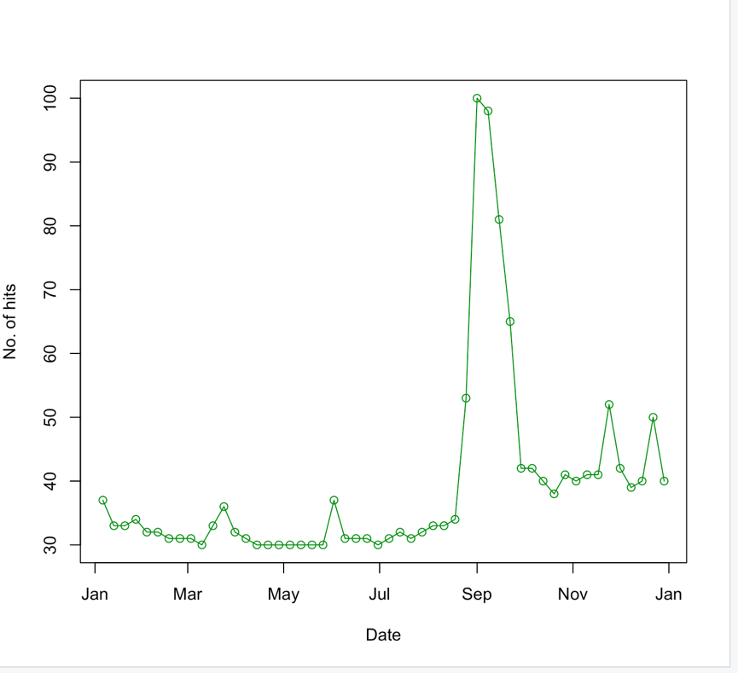

**Yahoo prices for Apple – 2019**

**Comments:**

As seen above in the two graphs, there is no correlation or a significant relationship between the two graphs. This is because regardless of the no. of hits, the open prices keep rising and there is nothing in the Google trends plot that can explain the sudden dip in opening prices in the middle.