**Optimizations**

1> Enable Sticky sessions.

A> Sign in to AWS console

B> Select EC2

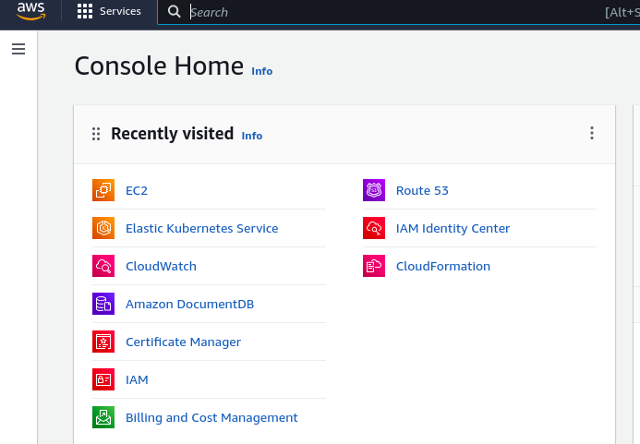

C> On the Left hand Plane scroll down until u see Target groups select the appropriate target group for the Saral app

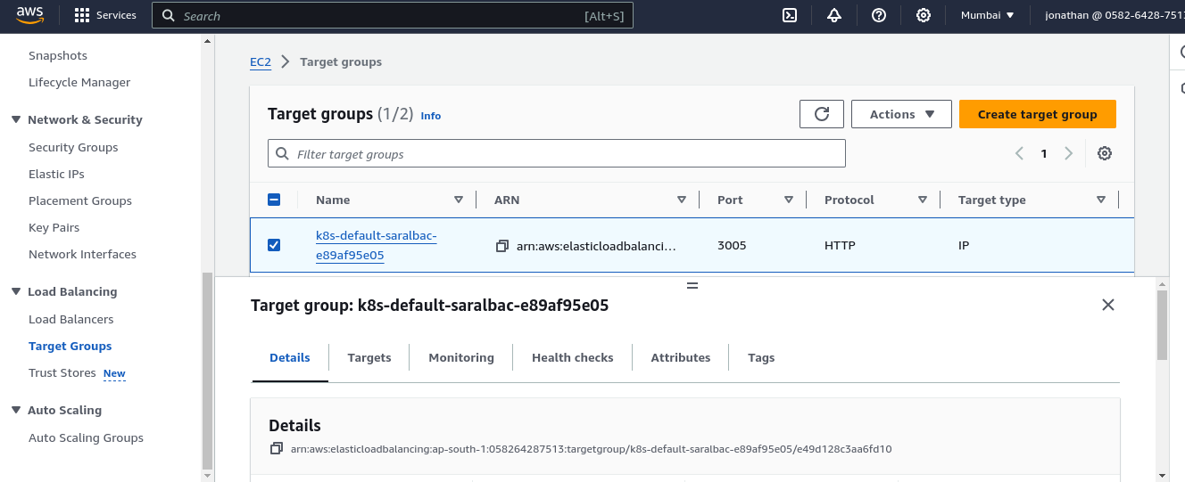

D> Go tot he Attributes tab and click edit

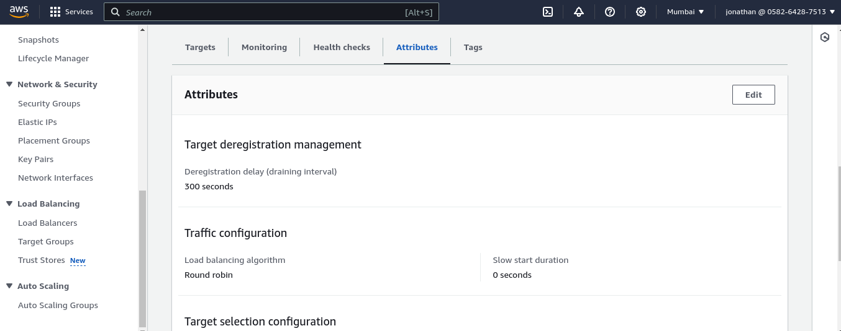

E> After clicking edit Select Target Selection Configuration and check the “Turn on Stickness” and then save

