数据预测与建模
刘若水
2024-11-05
library(brms)
library(dplyr)
library(ggplot2)
library(bayesplot)
library(psych)
library(car)
library(lmtest)
library(MASS)
一、描述性统计
h2_data <- read.csv("D:\\mycodelife\\workshop\\course_task\\Salary Data.csv")
检视数据
summary(h2_data)
## Current.Salary Beginning.Salary Previous.Experience Education
## Min. : 16350 Min. : 9750 Min. : 0.00 Min. : 8.00
## 1st Qu.: 23325 1st Qu.:12000 1st Qu.: 17.75 1st Qu.:12.00
## Median : 27825 Median :14250 Median : 60.50 Median :12.00
## Mean : 33633 Mean :16939 Mean : 95.61 Mean :13.22
## 3rd Qu.: 35775 3rd Qu.:16575 3rd Qu.:139.25 3rd Qu.:15.00
## Max. :103750 Max. :60000 Max. :460.00 Max. :19.00
describe(h2_data)
## vars n mean sd median trimmed mad min
## Current.Salary 1 100 33632.60 17289.55 27825.0 30215.12 8517.54 16350
## Beginning.Salary 2 100 16938.60 8347.83 14250.0 15107.25 3335.85 9750
## Previous.Experience 3 100 95.61 105.48 60.5 76.01 78.58 0
## Education 4 100 13.22 2.72 12.0 13.32 4.45 8
## max range skew kurtosis se
## Current.Salary 103750 87400 2.24 5.47 1728.96
## Beginning.Salary 60000 50250 2.63 8.08 834.78
## Previous.Experience 460 460 1.55 2.08 10.55
## Education 19 11 -0.12 -0.30 0.27
二、绘制因变量和自变量的散点图
pairs(h2_data, main = "Pairwise Scatter Plots")
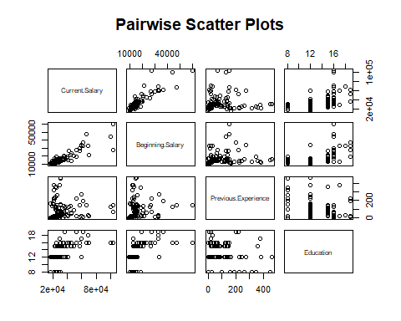 该图能反映Current Salary与其他变量的关联
三、给出模型形式
1.构建模型
model <- lm(h2_data$Current.Salary ~ h2_data$Beginning.Salary + h2_data$Previous.Experience + h2_data$Education, data = h2_data)
检视模型
summary(model)
##
## Call:
## lm(formula = h2_data$Current.Salary ~ h2_data$Beginning.Salary +
## h2_data$Previous.Experience + h2_data$Education, data = h2_data)
##
## Residuals:
## Min 1Q Median 3Q Max
## -21900 -3583 -577 1418 49548
##
## Coefficients:
## Estimate Std. Error t value Pr(>|t|)
## (Intercept) -4139.2377 4203.3582 -0.985 0.3272
## h2_data$Beginning.Salary 1.7302 0.1138 15.203 <2e-16 ***
## h2_data$Previous.Experience -10.9071 7.7710 -1.404 0.1637
## h2_data$Education 719.1221 351.7339 2.045 0.0436 *
## ---
## Signif. codes: 0 '***' 0.001 '**' 0.01 '*' 0.05 '.' 0.1 ' ' 1
##
## Residual standard error: 7791 on 96 degrees of freedom
## Multiple R-squared: 0.8031, Adjusted R-squared: 0.7969
## F-statistic: 130.5 on 3 and 96 DF, p-value: < 2.2e-16
2.是否满足Gauss-Markov假设
（1）检查线性性是否成立
# 绘制残差图
plot(model$fitted.values, model$residuals, main = "Residual Plot", xlab = "Fitted Values", ylab = "Residuals")
abline(h = 0, col = "red")
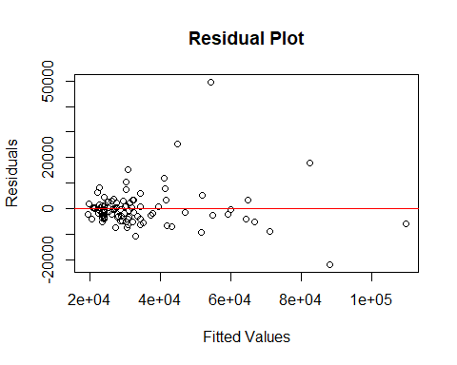 如图，图中残差在 0 附近随机分布，则线性性假设可能成立。
（2）检查是否存在多重共线性
vif(model)
## h2_data$Beginning.Salary h2_data$Previous.Experience
## 1.472233 1.095796
## h2_data$Education
## 1.490282
VIF大于1且没有超过5，说明具有相关性且不存在多重共线性
（3）检查同方差性
bptest(model)
##
## studentized Breusch-Pagan test
##
## data: model
## BP = 7.2635, df = 3, p-value = 0.06396
p>0.05，可能满足同方差假设
（4）检查残差的独立性
dwtest(model)
##
## Durbin-Watson test
##
## data: model
## DW = 1.6712, p-value = 0.04704
## alternative hypothesis: true autocorrelation is greater than 0
残差偏离2，可能存在残差相关性
（5）残差的正态性
shapiro.test(model$residuals)
##
## Shapiro-Wilk normality test
##
## data: model$residuals
## W = 0.73658, p-value = 4.198e-12
p<0.05，说明残差不满足正态性
综上所述，不满足Gauss-Markov假设，因此OLS估计是有偏的，需要采取其他估计
四、采用Robust回归
前文假定误差协方差矩阵满足$σ^{2}I$，但是经过检验可能为$σ^{2}Σ$，因此需要采用其他估计方法。
1.M估计
M估计通过调整回归系数估计的损失函数，使模型对离群点不敏感。常见的损失函数包括Huber损失（对小残差使用平方惩罚，对大残差使用线性惩罚）和Tukey损失。
model_rlm <- rlm(h2_data$Current.Salary ~ h2_data$Beginning.Salary + h2_data$Previous.Experience + h2_data$Education, psi = psi.huber) # 使用Huber损失
summary(model_rlm)
##
## Call: rlm(formula = h2_data$Current.Salary ~ h2_data$Beginning.Salary +
## h2_data$Previous.Experience + h2_data$Education, psi = psi.huber)
## Residuals:
## Min 1Q Median 3Q Max
## -18716.17 -2480.96 -31.55 2146.05 51884.32
##
## Coefficients:
## Value Std. Error t value
## (Intercept) -1694.7814 2287.9118 -0.7408
## h2_data$Beginning.Salary 1.6732 0.0619 27.0098
## h2_data$Previous.Experience -7.2503 4.2298 -1.7141
## h2_data$Education 502.3916 191.4508 2.6241
##
## Residual standard error: 3576 on 96 degrees of freedom
显著性不明显。比较其与OLS的区别
# 绘制残差图比较
par(mfrow = c(1, 2))
plot(resid(model), main = "OLS Residuals")
plot(resid(model_rlm), main = "Robust Regression Residuals")
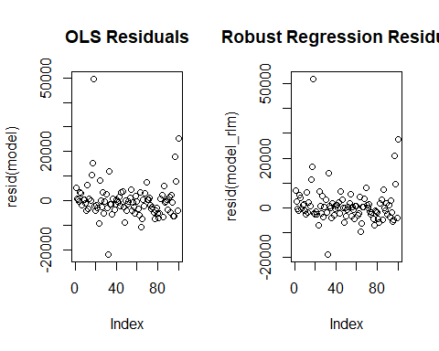
可见，没有明显的区别。
2.加权最小二乘回归
weights <- 1 / abs(h2_data$Current.Salary - predict(lm(h2_data$Current.Salary ~ h2_data$Beginning.Salary + h2_data$Previous.Experience + h2_data$Education))) # 权重示例
# 使用lm()函数指定权重
model_wls <- lm(h2_data$Current.Salary ~ h2_data$Beginning.Salary + h2_data$Previous.Experience + h2_data$Education, weights = weights)
summary(model_wls)
##
## Call:
## lm(formula = h2_data$Current.Salary ~ h2_data$Beginning.Salary +
## h2_data$Previous.Experience + h2_data$Education, weights = weights)
##
## Weighted Residuals:
## Min 1Q Median 3Q Max
## -135.13 -53.42 -18.60 40.72 227.03
##
## Coefficients:
## Estimate Std. Error t value Pr(>|t|)
## (Intercept) -3.331e+03 9.089e+02 -3.665 0.000406 ***
## h2_data$Beginning.Salary 1.680e+00 5.048e-02 33.281 < 2e-16 ***
## h2_data$Previous.Experience -9.797e+00 2.143e+00 -4.572 1.44e-05 ***
## h2_data$Education 6.883e+02 8.193e+01 8.401 3.99e-13 ***
## ---
## Signif. codes: 0 '***' 0.001 '**' 0.01 '*' 0.05 '.' 0.1 ' ' 1
##
## Residual standard error: 66.92 on 96 degrees of freedom
## Multiple R-squared: 0.9479, Adjusted R-squared: 0.9463
## F-statistic: 582.7 on 3 and 96 DF, p-value: < 2.2e-16
效果非常好，所有系数均显著。说明采用加权最小二乘回归效果较好。
五、采用逐步回归
1.前向选择
null_model <- lm(h2_data$Current.Salary ~ 1, data = h2_data)
stepwise_model_forward <- step(model,
scope = list(lower = null_model, upper = model),
direction = "forward")
## Start: AIC=1796.06
## h2_data$Current.Salary ~ h2_data$Beginning.Salary + h2_data$Previous.Experience +
## h2_data$Education
summary(stepwise_model_forward)
##
## Call:
## lm(formula = h2_data$Current.Salary ~ h2_data$Beginning.Salary +
## h2_data$Previous.Experience + h2_data$Education, data = h2_data)
##
## Residuals:
## Min 1Q Median 3Q Max
## -21900 -3583 -577 1418 49548
##
## Coefficients:
## Estimate Std. Error t value Pr(>|t|)
## (Intercept) -4139.2377 4203.3582 -0.985 0.3272
## h2_data$Beginning.Salary 1.7302 0.1138 15.203 <2e-16 ***
## h2_data$Previous.Experience -10.9071 7.7710 -1.404 0.1637
## h2_data$Education 719.1221 351.7339 2.045 0.0436 *
## ---
## Signif. codes: 0 '***' 0.001 '**' 0.01 '*' 0.05 '.' 0.1 ' ' 1
##
## Residual standard error: 7791 on 96 degrees of freedom
## Multiple R-squared: 0.8031, Adjusted R-squared: 0.7969
## F-statistic: 130.5 on 3 and 96 DF, p-value: < 2.2e-16
2.后向选择
stepwise_model_backward <- step(model, direction = "backward")
## Start: AIC=1796.06
## h2_data$Current.Salary ~ h2_data$Beginning.Salary + h2_data$Previous.Experience +
## h2_data$Education
##
## Df Sum of Sq RSS AIC
## <none> 5.8270e+09 1796.1
## - h2_data$Previous.Experience 1 1.1958e+08 5.9466e+09 1796.1
## - h2_data$Education 1 2.5372e+08 6.0807e+09 1798.3
## - h2_data$Beginning.Salary 1 1.4029e+10 1.9856e+10 1916.7
summary(stepwise_model_backward)
##
## Call:
## lm(formula = h2_data$Current.Salary ~ h2_data$Beginning.Salary +
## h2_data$Previous.Experience + h2_data$Education, data = h2_data)
##
## Residuals:
## Min 1Q Median 3Q Max
## -21900 -3583 -577 1418 49548
##
## Coefficients:
## Estimate Std. Error t value Pr(>|t|)
## (Intercept) -4139.2377 4203.3582 -0.985 0.3272
## h2_data$Beginning.Salary 1.7302 0.1138 15.203 <2e-16 ***
## h2_data$Previous.Experience -10.9071 7.7710 -1.404 0.1637
## h2_data$Education 719.1221 351.7339 2.045 0.0436 *
## ---
## Signif. codes: 0 '***' 0.001 '**' 0.01 '*' 0.05 '.' 0.1 ' ' 1
##
## Residual standard error: 7791 on 96 degrees of freedom
## Multiple R-squared: 0.8031, Adjusted R-squared: 0.7969
## F-statistic: 130.5 on 3 and 96 DF, p-value: < 2.2e-16
由于变量较少，且本身不具有显著的多重共线性，因此采用逐步回归效果较差，和直接使用OLS没有显著区别。

