|  |  |
| --- | --- |
| **Unit / Module Description:** | Robotic Controller Shield for Ultra96v2 Module |
| **Unit / Module Number:** | Robo96 |
| **Document Issue Number:** | 1.1_07072020 |
| **First Issue Date:** | 22/06/2020 |
| **Original Author:** | I. Matic |

**Robo96 Shield**

Expansion Shield for Ultra96v2 with 9-Axis IMU, Motor Driver, GPS, Barometric Sensor and USB2.0

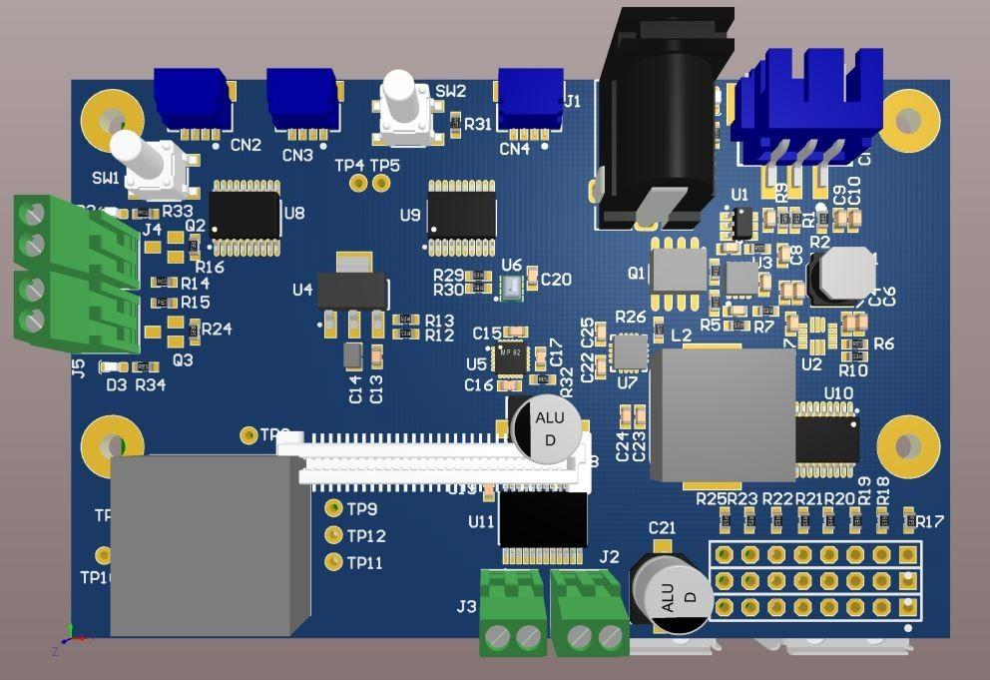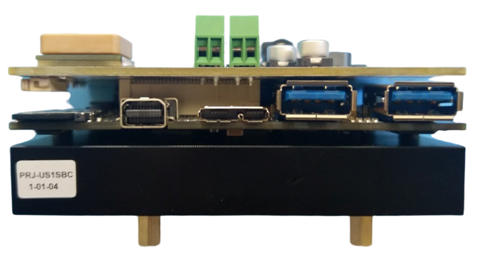

|  |  |
| --- | --- |
| Sundance Multiprocessor Technology Ltd, Chiltern House, Waterside, Chesham, Bucks. HP5 1PS.  This document is the property of Sundance and may not be copied nor communicated to a third party without prior written permission.  © Sundance Multiprocessor Technology Limited 2020 |  |

**Revision History**

|  |  |  |  |
| --- | --- | --- | --- |
| **Issue** | **Changes Made** | **Date** | **Initials** |
| 1.0 | First draft. | 22/06/2020 | IM |
| 1.01 | Various formatting | 06/07/2020 | FC |
| 1.02 | Implemented changes based on provided comments | 06/07/2020 | IM |
| 1.1 | Internal revision. | 07/07/2020 | PM |

**Table of Contents**

1 Introduction 5

1.1 Main Features 6

2 Schematics and explanations 7

2.1 Ultra96v2 Interface 7

2.1.1 Low-Speed Connector 7

2.1.2 High-speed connector 9

2.1.3 Logic Level Translation 10

2.2 Power Supplies 13

2.2.1 Power Connectors 13

2.2.2 Battery Charging 15

2.2.3 Battery protection 16

2.2.4 5V Servo Supply 18

2.2.5 3V3 Regulator 19

2.3 Robot Interface 20

2.3.1 9-axis IMU sensor 20

2.3.2 Barometric pressure sensor 21

2.3.3 Motor Driver 22

2.3.4 GPS Module 23

2.3.5 Auxiliary Outputs 24

2.3.6 Encoder Inputs 25

2.3.7 Servo/ESC Output Headers 26

3 Dimensions 27

4 Safety 28

5 Design Release and Quality 28

6 EMC 28

7 Ordering information 28

**Figures**

Figure 1: Robo96 Block Diagram 6

Figure 2: Low-Speed Communication Connector 7

Figure 3: High-Speed Communication Connector 9

Figure 4: Logic Level translation between 1.8V and 3.3V signals 10

Figure 5: Logic Level translation between 1.8V and 5V signals 11

Figure 6: DC in connector for supplying the power to the Robo96 Board 13

Figure 7: Battery connector for 2S 7.4 Li-Po Balanced battery pack 14

Figure 8: Note for the battery connector shown in the previous figure 14

Figure 9: 2S Li-Po battery charger circuit 15

Figure 10: Battery over-charge and over-discharge protection circuit 16

Figure 11: Battery overvoltage protection and balancing circuit 17

Figure 12: 5V Servo Supply Buck Converter 18

Figure 13: 3.3V Regulator 19

Figure 14: 9-axis IMU sensor 20

Figure 15: Barometric Pressure Sensor 21

Figure 16: Motor Driver 22

Figure 17: GPS/GNSS Module 23

Figure 18: Auxiliary outputs 24

Figure 19: Encoder Inputs 25

Figure 20: Servo/ESC Output Headers 26

Figure 21: Width Measurement of Robo96 Board 27

Figure 22: Length Measurement of Robo96 Board 27

Tables

Table 1: Pinout of Low-Speed Ultra96v2 interface connector [CN8] 8

Table 2: Mapping of Voltage Level Translated signals and their voltage levels 12

Table 3: Signal Mapping for Controlling the Motor Driver 22

Table 4: UART Bus Signal Mapping for GPS/GSNN Receiver Module [U12] 23

Table 5: Signal Mapping for Auxiliary Outputs 24

Table 6: Signal Mapping for Encoder Inputs 25

Table 7: Signal Mapping for Servo/ESC Output Connector 26

# Introduction

This document describes the hardware features and some operational details of the Robo96 Shield. The Robo96 Shield is an expansion board compatible with the Ultra96v2[1] computer board, manufactured by Avnet.

The Robo96 board can be plugged to the Ultra96v2 via the 2x20 Pin 2mm Pitch header connector accessing the low-speed communication signals and a 2x30 Pin Board to Board connector providing the high-speed communication interface the two boards.

Both of connectors mentioned above follow the **96Boards Consumer Edition Low-Cost Hardware Platform Specification[2]** specified by Linaro (community boards group).

## Main Features

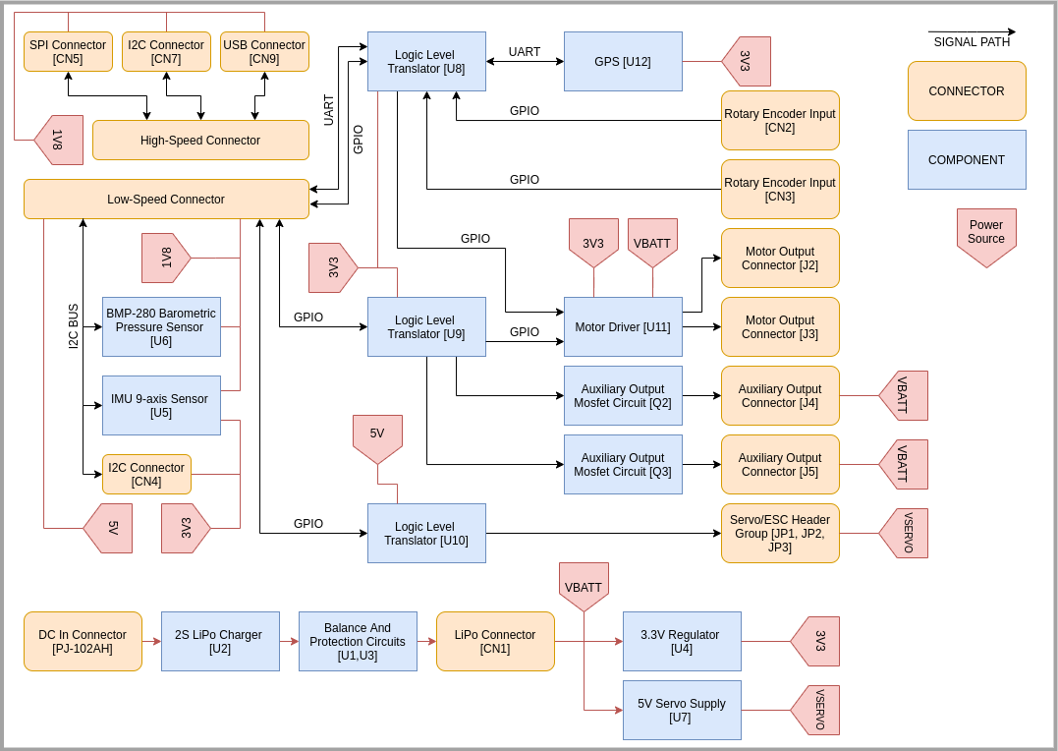

Figure : Robo96 Block Diagram

The Robo96 board is an expansion board designed to plug-and-play into the Ultra96v2 computer board and expand the Ultra96v2 capabilities by adding various sensors and motor servo controllers.

Robo96 board provides:

1. External 2S 7.4V battery connector. The Robo96 also incorporates battery charging and battery protection circuitry.
2. Multiple TXB0108PWR[3] Bi-directional Voltage-Level translators for:
   1. Driving the servo motors.
   2. Driving the control lines of H-Bridge controllers.
   3. Buffering the Encoder Inputs.
   4. Driving the auxiliary output MOSFETs.
3. Ability to drive 2 DC motors through the H-Bridge driver accomplished by TB6612FNG[4].
4. 2 encoder pair inputs via the JST connectors.
5. 2 ground switched auxiliary outputs (Battery voltage level) through the PCB Terminal Block.
6. 9 axis ICM-20948[5] IMU motion tracking sensor
7. SAM-M8[6] GPS/GNSS receiver

# Schematics and explanations

## Ultra96v2 Interface

### Low-Speed Connector

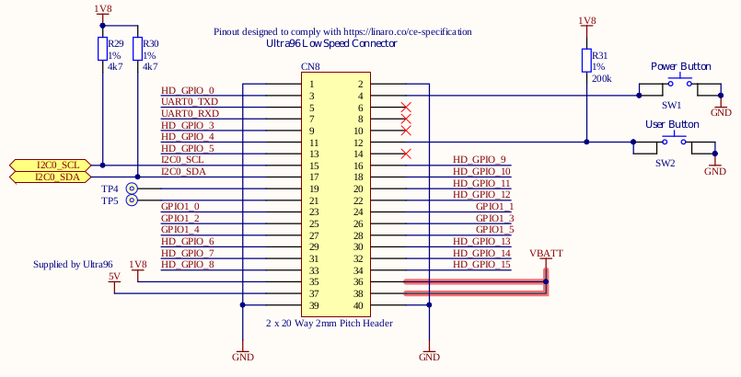

Figure 2: Low-Speed Communication Connector

The Low-Speed Communication Connector **CN8** (NRPN202MAMS-RC[7])is used to connect the Robo96 and Ultra96v2 computer board. The connector carries low-speed GPIO signals, I2C and UART bus from the Ultra96v2 computer board.

This connector follows the **96Boards Consumer Edition Low-Cost Hardware Platform Specification Standard**[8] mentioned in Introduction.

Table 1: Pinout of Low-Speed Ultra96v2 interface connector [CN8]

|  |  |  |  |
| --- | --- | --- | --- |
| Pin | Usage | Pin | Usage |
| 1 | GND | 2 | GND |
| 3 | HD_GPIO_0 | 4 | SW1 (NO switch to GND) |
| 5 | UART0_TXD | 6 | NC |
| 7 | UART0_RXD | 8 | NC |
| 9 | HD_GPIO_3 | 10 | NC |
| 11 | HD_GPIO_4 | 12 | SW2 (NO switch to GND, pulled up to 1V8, R31) |
| 13 | HD_GPIO_5 | 14 | NC |
| 15 | I2C0_SCL (pulled up to 1V8, R29) | 16 | HD_GPIO_9 |
| 17 | I2C0_SDA (pulled up to 1V8, R30) | 18 | HD_GPIO_10 |
| 19 | Test Point | 20 | HD_GPIO_11 |
| 21 | Test Point | 22 | HD_GPIO_12 |
| 23 | GPIO1_0 | 24 | GPIO1_1 |
| 25 | GPIO1_2 | 26 | GPIO1_3 |
| 27 | GPIO1_4 | 28 | GPIO1_5 |
| 29 | HD_GPIO_6 | 30 | HD_GPIO_13 |
| 31 | HD_GPIO_7 | 32 | HD_GPIO_14 |
| 33 | HD_GPIO_8 | 34 | HD_GPIO_15 |
| 35 | 1V8 | 36 | VBATT |
| 37 | 5V | 38 | VBATT |
| 39 | GND | 40 | GND |

### High-speed connector

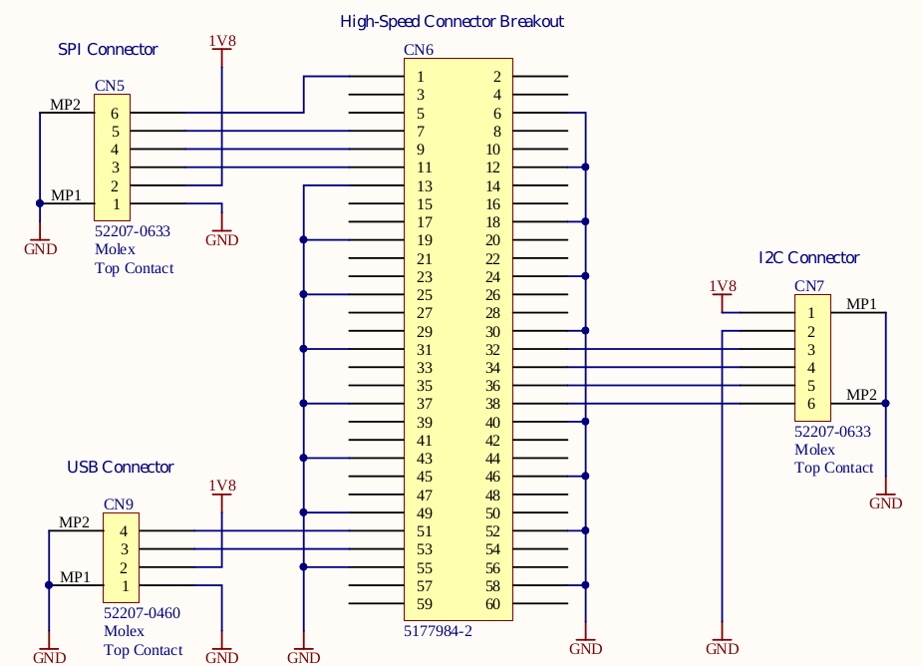

Figure 3: High-Speed Communication Connector

The High-Speed Breakout connector **CN6** (Tyco 5177984-2[9]) is split into multiple other connectors, enabling connection of additional peripherals to the Ultra96v2 computer board even with the Robot96 board present on top of it. The following connectors are:

* + - 1. **CN5** Connector for SPI BUS (Molex 52207-2433[10])
      2. **CN7** Connector for I2C BUS (Molex 52207-0633[11])
      3. **CN9** Connector for USB (Molex 52207-0460[12])

This connector follows the **96Boards Consumer Edition Low-Cost Hardware Platform Specification Standard** [13]mentioned in Introduction.

**Please note that all connectors mentioned above are directly connected to the Ultra96v2 computer board and operate at the 1.8V level.**

### Logic Level Translation

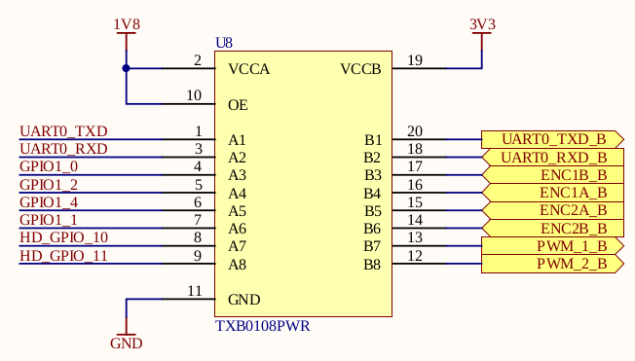

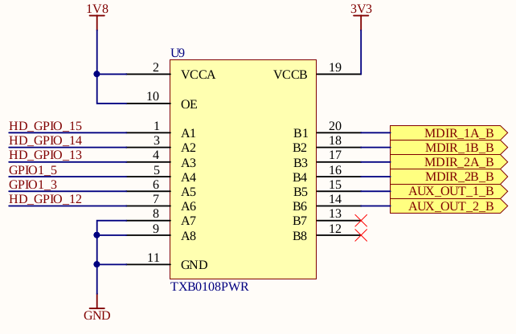

Figure 4: Logic Level translation between 1.8V and 3.3V signals

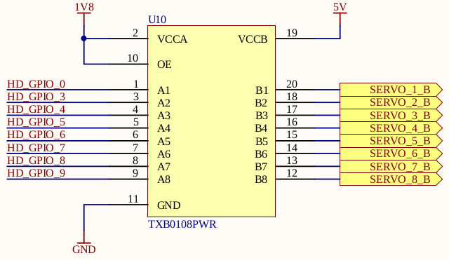

Figure 5: Logic Level translation between 1.8V and 5V signals

To provide the Voltage Logic Level translation between Ultra96v2 computer board, which has the nominal voltage value of 1.8V and various other components on the Robo96 board, the TXB0108PWR[14], bi-directional Voltage Translators with automatic direction sensing are used.

The board contains a total of three Level Shifters (described in **Introduction**) which provide different voltage levels for various components on board. One of the translators (U10) is used to control servo motors directly from the Ultra96v2 computer board.

The following table shows all translated signals and their corresponding voltage levels:

Table 2: Mapping of Voltage Level Translated signals and their voltage levels

|  |  |  |  |  |  |
| --- | --- | --- | --- | --- | --- |
| IC | VCCa | Signal name | VCCb | Signal name | Used for |
| U8 | 1.8V | UART0_TXD | 3.3V | UART0_TXD_B | UART FOR GPS [SAM-M8] |
| U8 | 1.8V | UART0_RXD | 3.3V | UART0_RXD_B | UART FOR GPS [SAM-M8] |
| U8 | 1.8V | GPIO1_0 | 3.3V | ENC1B_B | ENCODER INPUT 1 [CN2] |
| U8 | 1.8V | GPIO1_2 | 3.3V | ENC1A_B | ENCODER INPUT 1 [CN2] |
| U8 | 1.8V | GPIO1_4 | 3.3V | ENC2A_B | ENCODER INPUT 2 [CN3] |
| U8 | 1.8V | GPIO1_1 | 3.3V | ENC2B_B | ENCODER INPUT 2 [CN3] |
| U8 | 1.8V | HD_GPIO_10 | 3.3V | PWM_1_B | MOTOR DRIVER [U11] (1st CHANNEL) |
| U8 | 1.8V | HD_GPIO_11 | 3.3V | PWM_2_B | MOTOR DRIVER [U11] (2nd CHANNEL) |
| U9 | 1.8V | HD_GPIO_15 | 3.3V | MDIR_1A_B | MOTOR DRIVER [U11] (1st CHANNEL) |
| U9 | 1.8V | HD_GPIO_14 | 3.3V | MDIR_1B_B | MOTOR DRIVER [U11] (1st CHANNEL) |
| U9 | 1.8V | HD_GPIO_13 | 3.3V | MDIR_2A_B | MOTOR DRIVER [U11] (2nd CHANNEL) |
| U9 | 1.8V | GPIO1_5 | 3.3V | MDIR_2B_B | MOTOR DRIVER [U11] (2nd CHANNEL) |
| U9 | 1.8V | GPIO1_3 | 3.3V | AUX_OUT_1_B | AUX OUT MOSFET [Q2] |
| U9 | 1.8V | HD_GPIO_12 | 3.3V | AUX_OUT_2_B | AUX OUT MOSFET [Q3] |
| U10 | 1.8V | HD_GPIO_0 | 5V | SERVO_1_B | SERVO HEADER [JP1] |
| U10 | 1.8V | HD_GPIO_3 | 5V | SERVO_2_B | SERVO HEADER [JP1] |
| U10 | 1.8V | HD_GPIO_4 | 5V | SERVO_3_B | SERVO HEADER [JP1] |
| U10 | 1.8V | HD_GPIO_5 | 5V | SERVO_4_B | SERVO HEADER [JP1] |
| U10 | 1.8V | HD_GPIO_6 | 5V | SERVO_5_B | SERVO HEADER [JP1] |
| U10 | 1.8V | HD_GPIO_7 | 5V | SERVO_6_B | SERVO HEADER [JP1] |
| U10 | 1.8V | HD_GPIO_8 | 5V | SERVO_7_B | SERVO HEADER [JP1] |
| U10 | 1.8V | HD_GPIO_9 | 5V | SERVO_8_B | SERVO HEADER [JP1] |

## Power Supplies

### Power Connectors

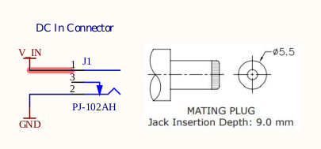

Figure 6: DC in connector for supplying the power to the Robo96 Board

Main connector **J1** (PJ-102AH[15]) for powering the Robo96 board is a DC barrel jack style connector on the side of the board. It is used to provide power to the Robo96 and to charge the Li-Po battery connected to the board.

The jack is configured in a fashion that makes the central conductor be a positive contact, and the barrel part to be ground contact of the connector.

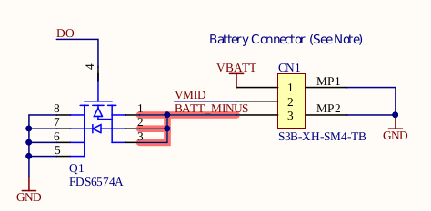

Figure 7: Battery connector for 2S 7.4 Li-Po Balanced battery pack

The 2S 7.4V Li-Po battery pack is connected to the three-pin battery connector **CN1** (S3B-XH-SM4TB[16]).

**Before connecting the battery to the board make sure that the pinout of the battery connector is properly configured.**

The battery pack connected is charged via the appropriate charging circuits present on the board. In addition to all charging functionalities, the board also incorporates all battery protection features.

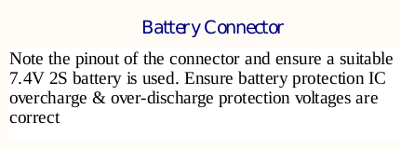

Figure 8: Note for the battery connector shown in the previous figure

### Battery Charging

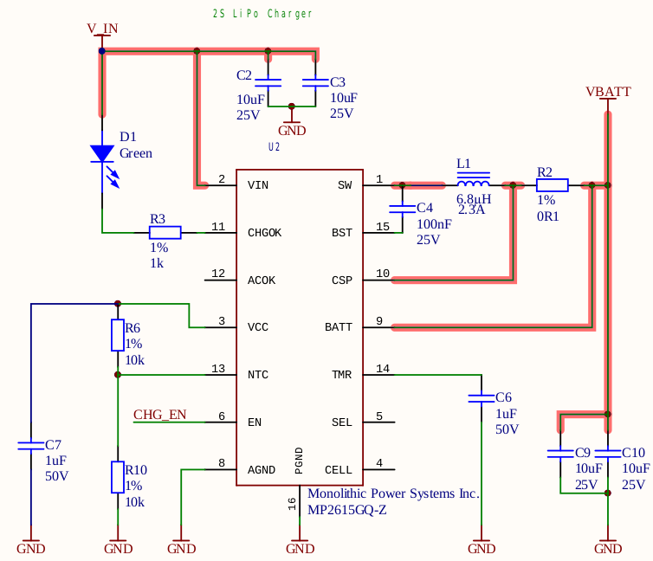

Figure 9: 2S Li-Po battery charger circuit

To safely charge up the connected battery, Robo96 board possess the 2S Li-Po battery charging circuitry implemented using the MP2615GQ-Z[17] **[U2]**. The MP2615 is a high-efficiency Switch Mode battery charger, capable of delivering 2A of charge current.

The charger operates in CC/CV[18] charging mode.

### Battery protection

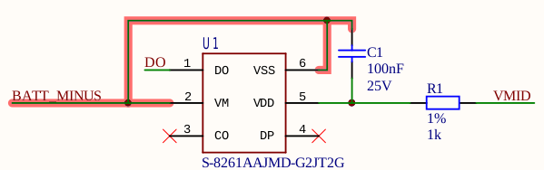

Figure 10: Battery over-charge and over-discharge protection circuit

In addition to battery charging, Robo96 provides over-charge and over-discharge protection. These functionalities are accomplished using the Battery Protection IC Device, S-8261AAJMD-G2JT2G[19] **[U1]**.

All protections above work by **U1** driving the **Q1** MOSFET (shown in Figure 6). When a fault state occurs, **U1** closes the **Q1,** effectively cutting the battery from the circuit.

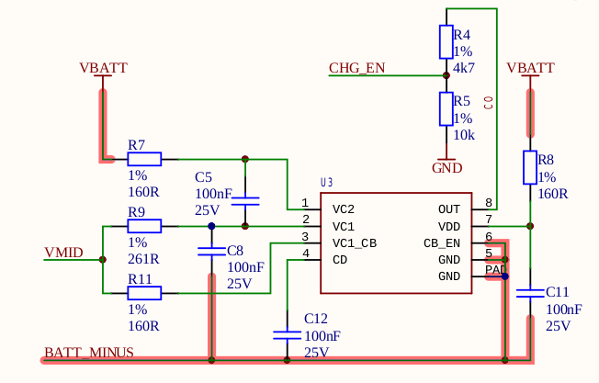

Figure 11: Battery overvoltage protection and balancing circuit

In addition to battery protection mentioned above, the Robo96 provides a battery overvoltage protection and cell balancing capabilities implemented via another Battery Protection IC Device, MP2615GQ-Z[20] **[U3]**.

### 5V Servo Supply

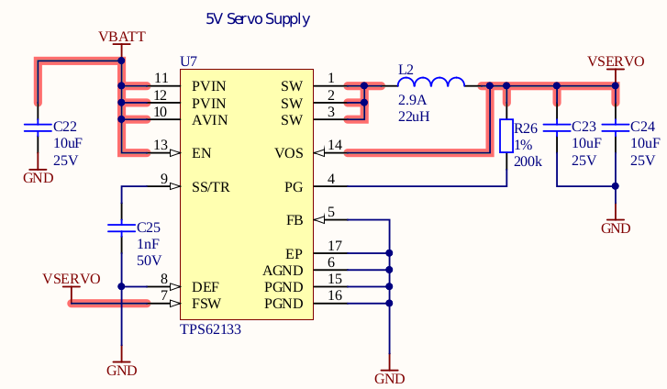

Figure 12: 5V Servo Supply Buck Converter

To provide high current capable power supply for driving the servo motors, the Step-Down Buck Converter TPS62133[21] [**U7**] is used.

The Step-Down Buck Converter is powered from the Li-Po battery connected to the Robo96 board via the Li-Po connector **[CN1]** mentioned earlier.

The advantage of using the Step-Down Buck Converter to create a 5V servo power supply is better efficiency and lower footprint on the PCB board.

### 3V3 Regulator

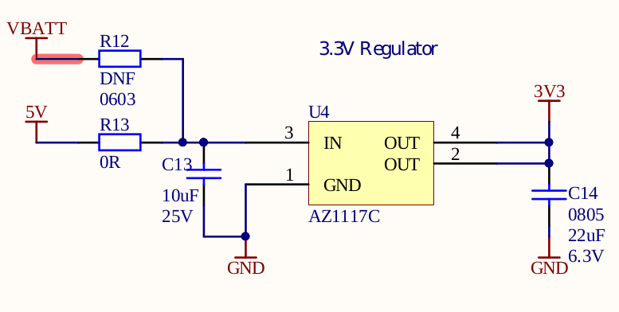

Figure 13: 3.3V Regulator

To provide clean and ripple-free 3.3V power rail for other components on the Robo96 board, the AZ1117C **[22][U4]** linear voltage regulator is used.

Advantage of using the linear voltage regulator is ripple-free 3.3V voltage rail at the board, which can be used for components that require low noise, high-quality power supply.

## Robot Interface

### 9-axis IMU sensor

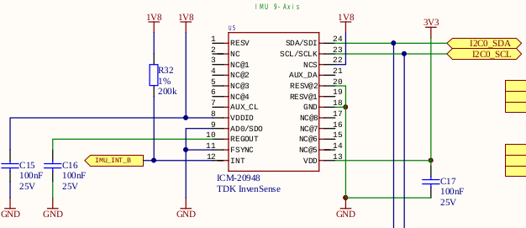

Figure 14: 9-axis IMU sensor

The Robo96 board provides an onboard 9-axis IMU sensor, implemented using the TDK ICM-20948 [23]IC device **[U6]**. The ICM-20948 is a 3-axis gyroscope, 3-axis accelerometer, 3-axis compass, and a digital motion processor.

The device is powered from the 3.3V power rail, created by the AZ1117C **[U4]** linear regulator mentioned earlier.

**Even if the device is powered from 3.3V power rail, the logic level for I2C bus is 1.8V.**

The ICM-20946 is interfaced trough the I2C bus which goes directly to the Ultra96v2 computer board via the Low-Speed Communication connector. **[CN-8]**. The I2C address of this device is dependent on the voltage level present on the AD0 pin (Pin 9).

In this configuration, the address of the ICM-20948 is **0X68** (1101000 in binary representation.

### Barometric pressure sensor

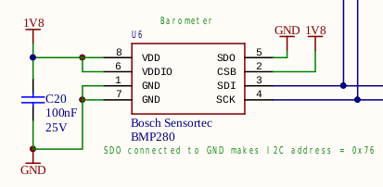

Figure 15: Barometric Pressure Sensor

The Robo96 board provides an onboard barometric pressure sensor, implemented using the Bosch BMP280 [24]IC device **[U6]**.

The BMP280 is an absolute barometric pressure sensor of small dimensions and low power consumption.

This device is powered from 1.8V power rail, provided from the Ultra96v2 computer board trough Low-Speed Communication connector **[CN-8]**.

The ICM-20946 is interfaced trough the I2C bus which goes directly to the Ultra96v2 computer board via the Low-Speed Communication connector. **[CN-8]**. The I2C address of this device is dependent on the voltage level present on the SDO pin of the device (pin 5).

In this configuration, the address of the BMP280 is **0X76** (1110110 in binary representation.

### Motor Driver

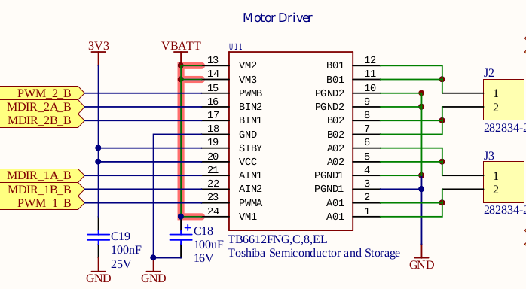

Figure 16: Motor Driver

The Robo96 board provides an onboard H-Bridge Motor Driver for two DC brushed motors, implemented using the Toshiba TB612FNG[25] Driver IC **[U11]**.

Power for the driver is supplied from the Li-Po battery, connected to the Robo96 board via the Li-Po battery connector **[CN1]**.

The driver is controlled from the Ultra96v2 computer board trough the Low-Speed Communication connector **[CN-8]** with voltage level translation from 1.8V to 3.3V using the Voltage Level Translator **[U8, U9]**.

The table below shows the appropriate signal lines for each channel of the Motor Driver:

Table 3: Signal Mapping for Controlling the Motor Driver

|  |  |  |  |  |  |
| --- | --- | --- | --- | --- | --- |
| CN-8 Pin | 1V8 Signal Name | 3V3 Signal Name | Channel | Purpose | Connector |
| 34 | HD_GPIO_15 | MDIR_1A_B | 1 | Direction control | J1 |
| 32 | HD_GPIO_14 | MDIR_1B_B | 1 | Direction control | J1 |
| 30 | HD_GPIO_13 | MDIR_2A_B | 2 | Direction control | J2 |
| 28 | GPIO1_5 | MDIR_2B_B | 2 | Direction control | J2 |
| 18 | HD_GPIO_10 | PWM_1_B | 1 | Speed control | J1 |
| 20 | HD_GPIO_11 | PWM_2_B | 2 | Speed control | J2 |

### GPS Module

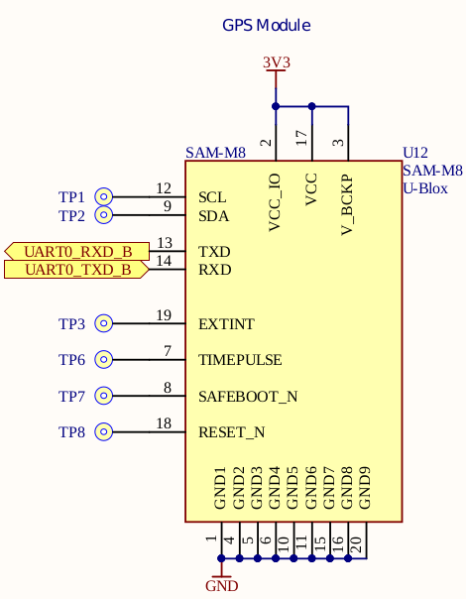

Figure 17: GPS/GNSS Module

The Robo96 board provides an onboard GPS/GNSS receiver module, implemented using the U-Blox SAM-M8Q [26]device **[U12]**. The SAM-M8Q module offers high sensitivity and minimal acquisition times in an ultra-compact form factor.

The device is powered from the 3.3V power rail, created by the AZ1117C **[U4]** linear regulator mentioned earlier.

The driver is interfaced trough the **UART0** bus, available on the Robo96 board trough the Low-Speed Communication connector **[CN-8]** with voltage level translation from 1.8V to 3.3V using the Voltage Level Translator **[U8]**.

Table 4: UART Bus Signal Mapping for GPS/GSNN Receiver Module [U12]

|  |  |  |
| --- | --- | --- |
| CN-8 Pin | 1V8 Signal Name | 3V3 Signal Name |
| 5 | UART0_TXD | UART0_TXD_B |
| 7 | UART0_RXD | UART0_RXD_B |

### Auxiliary Outputs

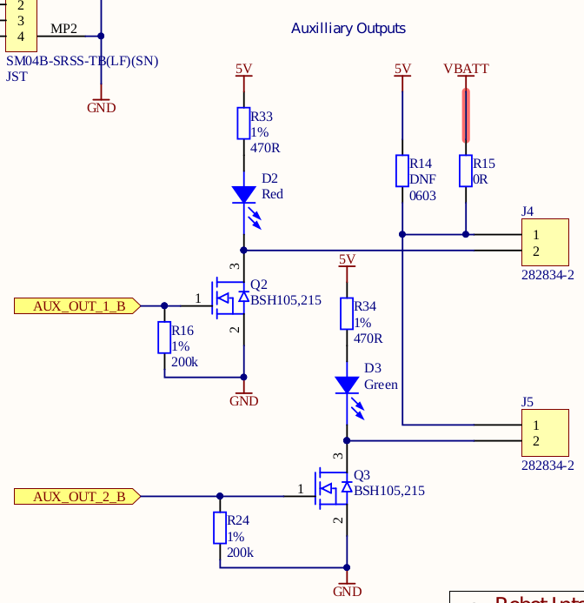

Figure 18: Auxiliary outputs

The Robo96 board provides two auxiliary MOSFET ground-switched outputs for powering external devices such as solenoids, relays, contactors, etc. The MOSFETS used for switching are Philips BSH105[27] **[Q2, Q3]**, providing maximum 1A of switching current. The state of auxiliary outputs is indicated via two light-emitting diodes.

MOSFETS outputs are driven from the Ultra96v2 computer board through the Low-Speed Communication connector **[CN-8]** with voltage level translation from 1.8V to 3.3V using the Voltage Level Translator **[U9]**.

Table 5: Signal Mapping for Auxiliary Outputs

|  |  |  |  |  |  |
| --- | --- | --- | --- | --- | --- |
| CN-8 Pin | 1V8 Signal Name | 3V3 Signal Name | MOSFET | Connector | Indication LED |
| 26 | GPIO1_3 | AUX_OUT_1_B | Q2 | J4 | D2 (Red) |
| 22 | HD_GPIO_12 | AUX_OUT_2_B | Q3 | J5 | D3 (Green) |

### Encoder Inputs

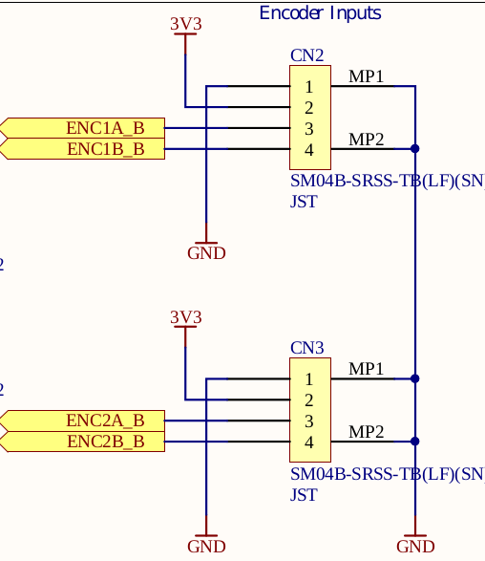

Figure 19: Encoder Inputs

Robo96 board provides two encoder inputs which can be used to obtain the input from devices like Rotary Encoders, Position sensors, Speed sensors, etc.

Two encoder input channels are accessible through two SM04B-SRSS-TB [28] connectors **[CN2, CN3]**.

Encoder inputs are passed to the Ultra96v2 computer board through the Low-Speed Communication connector **[CN-8]** with voltage level translation from 1.8V to 3.3V using the Voltage Level Translator **[U8]**.

Table 6: Signal Mapping for Encoder Inputs

|  |  |  |  |  |
| --- | --- | --- | --- | --- |
| CN-8 Pin | 1V8 Signal Name | 3V3 Signal Name | Encoder Channel | Connector |
| 23 | GPIO1_0 | ENC1A_B | 1 | CN2 |
| 25 | GPIO1_2 | ENC1B_B | 1 |
| 27 | GPIO1_4 | ENC_2A_B | 2 | CN3 |
| 24 | GPIO1_1 | ENC_2B_B | 2 |

### Servo/ESC Output Headers

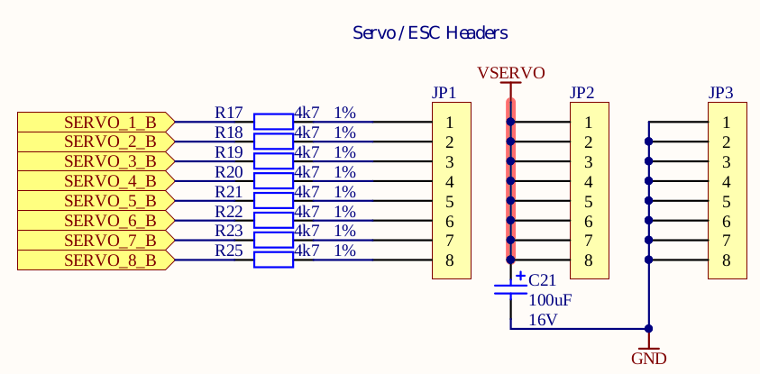

Figure 20: Servo/ESC Output Headers

Robo96 board provides 8 servo output channels which can be used to control Servo motors or Electronic Speed Controllers.

Servo outputs are driven from the Ultra96v2 computer board through the Low-Speed Communication connector **[CN-8]** with voltage level translation from 1.8V to 5V using the Voltage Level Translator **[U9]**.

Table 7: Signal Mapping for Servo/ESC Output Connector

|  |  |  |  |
| --- | --- | --- | --- |
| CN-8 Pin | 1V8 Signal Name | 5V Signal Name | Servo Channel |
| 3 | HD_GPIO_0 | SERVO_1_B | 1 |
| 9 | HD_GPIO_3 | SERVO_2_B | 2 |
| 11 | HD_GPIO_4 | SERVO_3_B | 3 |
| 13 | HD_GPIO_5 | SERVO_4_B | 4 |
| 29 | HD_GPIO_6 | SERVO_5_B | 5 |
| 31 | HD_GPIO_7 | SERVO_6_B | 6 |
| 33 | HD_GPIO_8 | SERVO_7_B | 7 |
| 16 | HD_GPIO_9 | SERVO_8_B | 8 |

# Dimensions

Figure : Width Measurement of Robo96 Board

Figure : Length Measurement of Robo96 Board

Size of Robo96 board follows the size and mounting hole positions of Ultra96 Computer board.

Sizes of the Robo96 is **85mm x 54mm**.

# Safety

This module presents no hazard to the user when in normal use.

# Design Release and Quality

Verification, Review and Validation Procedures to be carried out in accordance with the Sundance Quality Procedures (ISO9001-2015).

# EMC

The Robo96 is designed to operate from within an enclosed host system, which is built to provide EMC shielding. Operation within the EU EMC guidelines is not guaranteed unless it is installed within an adequate enclosure.

This module is protected from damage by fast voltage transients originating from outside the host system which may be introduced through the output cables.

# Ordering information

**Robo96-C** - Commercial Temperature

**Robo96-I** - Industrial Temperature

1. <https://www.96boards.org/product/ultra96/>
2.
3. Available online, <https://www.ti.com/lit/ds/symlink/txb0108.pdf>, last accessed 23/06/2020
4. Available online, <https://toshiba.semicon-storage.com/info/docget.jsp?did=10660&prodName=TB6612FNG>, last accessed 23/06/2020
5. Available online,<https://invensense.tdk.com/download-pdf/icm-20948-datasheet-2>, last accessed 23/06/2020
6. Available online, <https://www.u-blox.com/sites/default/files/SAM-M8Q_DataSheet_%28UBX-16012619%29.pdf>, last accessed 23/06/2020
7. Available online, <https://drawings-pdf.s3.amazonaws.com/10495.pdf>, last accessed 23/06/2020
8. Available online, <https://linaro.co/ce-specification>, last accessed 23/06/2020
9. Available online, <https://www.farnell.com/datasheets/447467.pdf>, last accessed 24/06/2020
10. Available online, <https://www.farnell.com/datasheets/2791595.pdf>, last accessed 24/06/2020
11. Available online, <https://www.farnell.com/datasheets/2701436.pdf>, last accessed 24/06/2020
12. Available online, <https://www.farnell.com/datasheets/1865823.pdf>, last accessed 24/06/2020
13. Available online, <https://linaro.co/ce-specification>, last accessed 23/06/2020
14. Available online, <https://www.ti.com/lit/ds/symlink/txb0108.pdf>, last accessed 23/06/2020
15. Available online, <https://www.mouser.co.uk/datasheet/2/670/pj-102ah-1778518.pdf>, last accessed 24/06/2020
16. Available online, <https://www.farnell.com/datasheets/2057209.pdf>, last accessed 24/06/2020
17. Available online, <https://www.mouser.com/datasheet/2/277/MP2615_r1.0-1384386.pdf>, last accessed 24/06/2020
18. Constant Current / Constant Voltage
19. Available online, <https://www.ablic.com/en/doc/datasheet/battery_protection/S8261_E.pdf>, last accessed 24/06/2020
20. Available online, <https://www.ti.com/lit/ds/symlink/bq29209.pdf>, last accessed 24/06/2020
21. Available online, <https://www.ti.com/lit/ds/symlink/tps62133.pdf>, last accessed 24/05/2020
22. Available online, <https://www.diodes.com/assets/Datasheets/AZ1117C.pdf>, last accessed 24/06/2020
23. Available online, <https://invensense.tdk.com/wp-content/uploads/2016/06/DS-000189-ICM-20948-v1.3.pdf>
24. Available online, <https://www.bosch-sensortec.com/media/boschsensortec/downloads/datasheets/bst-bmp280-ds001.pdf>
25. Available online, <https://toshiba.semicon-storage.com/info/docget.jsp?did=10660&prodName=TB6612FNG>
26. Available online, <https://www.u-blox.com/sites/default/files/SAM-M8Q_DataSheet_%28UBX-16012619%29.pdf>
27. Available online, <http://www.farnell.com/datasheets/454160.pdf>
28. Available online, <http://www.farnell.com/datasheets/2082363.pdf>, last accessed 30/06/2020