Exp No: 16
SERIAL INTERRUPT USING UART KEYBOARD INPUT IN KEIL

AIM:
To write and simulate an Embedded C program using serial interrupt in 8051 microcontroller such that while a message is continuously transmitted, any key pressed from the keyboard generates an interrupt and is displayed through UART.

APPARATUS / SOFTWARE REQUIRED:
- PC with Windows OS
- Keil μVision IDE
- 8051 Simulator (Keil built-in)
- Serial Window (UART #1)

THEORY:
The 8051 microcontroller provides a serial interrupt that occurs when:
- RI (Receive Interrupt flag) is set after receiving a character, or
- TI (Transmit Interrupt flag) is set after transmission.
In this experiment:
- UART is configured in Mode 1 (8-bit UART)
- Timer 1 is used to generate baud rate (9600)
- Serial interrupt is enabled using ES bit
- When a key is typed in the Keil Serial Window, the received character sets RI
- The Serial Interrupt Service Routine (ISR) is executed immediately
This demonstrates interrupt-driven serial communication, which is more efficient than polling.

PROGRAM:
#include <reg51.h>
unsigned char received_char;
bit receive_flag = 0;
/* Serial Interrupt Service Routine */
void serial_ISR(void) interrupt 4
{
if (RI)
{
RI = 0;
received_char = SBUF;
receive_flag = 1;
}
if (TI)
{
TI = 0;
}
}
/* Send one character through UART */
void send_char(unsigned char ch)
{
ES = 0; /* Disable serial interrupt temporarily */
SBUF = ch;
while(TI == 0);
TI = 0;
ES = 1; /* Enable serial interrupt */
}
/* Send a string through UART */
void send_string(char *str)
{
while(*str)
{
send_char(*str);
str++;
}
}
/* Delay */
void delay(void)
{
unsigned int i;
for(i = 0; i < 50000; i++);
}
void main(void)
{
/* UART configuration */
SCON = 0x50; /* UART Mode 1, 8-bit, REN enabled */
TMOD = 0x20; /* Timer 1, Mode 2 */
TH1 = 0xFD; /* 9600 baud rate */
TR1 = 1; /* Start Timer 1 *
/* Enable serial interrupt */
EA = 1;
ES = 1;
/* Initial value */
TI = 0;
while(1)
{
/* Continuously transmit message */
send_string("Hello World\r\n");
/* Check whether a key was received */
if(receive_flag)
{
receive_flag = 0;
send_string("\r\n>>> INTERRUPT RECEIVED: ");
send_char(received_char);
send_string("\r\n");
}
delay();
}
}

OUTPUT :
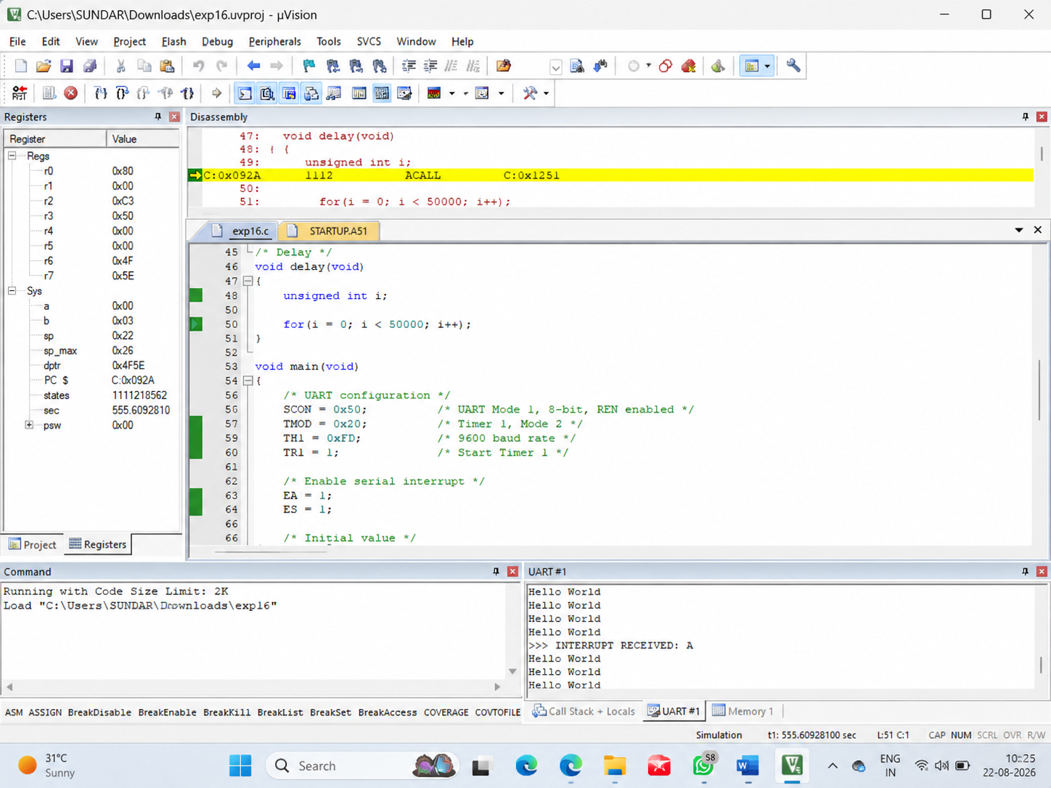
RESULT :
Thus the serial interrupt using UART was Successfully implemented and verified in keil simulator.

