Exp No : 11
STUDY OF GPIO&BIT ADDRESSING INAT89C51
AIM :
To write an Embedded C Program for STUDY OF GPIO&BIT ADDRESSING INAT89C51
SOFTWARE REQUIRED :
- KEIL
PROGRAM :
#include <reg51.h>
sbit LED1=P1^0;
sbit LED2=P1^1;
void delay(
{
unsigned int i,j;
for(i=0;i<200;i++)
for(j=0;j<1000;j++)
void main(){
while(1)
{
LED1=1;
LED2=0;
delay();
LED1=0;
LED2=1;
delay();
}
}

Circuit Diagram:
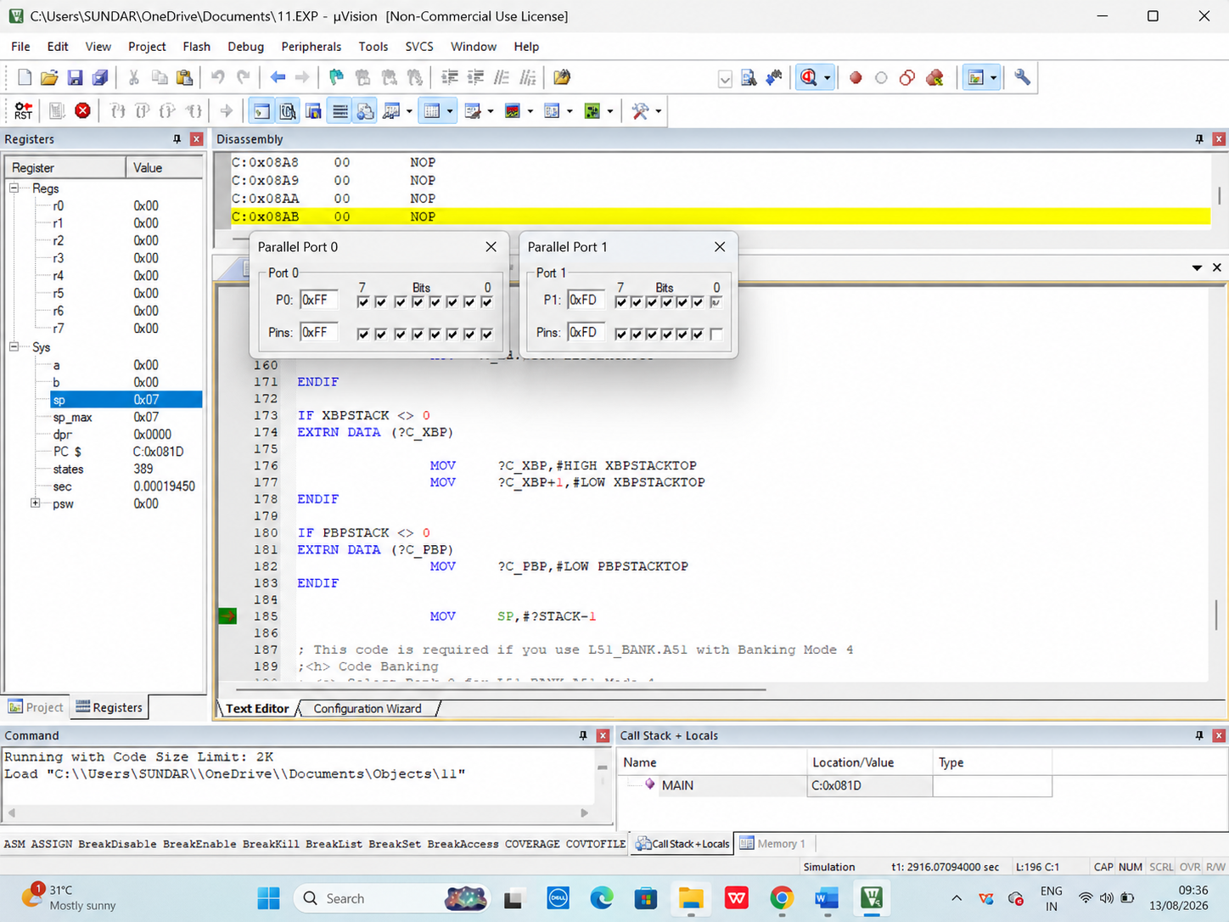

RESULT :
Thus the program has been successfully verified and executed.

