EXP NO. 30
RTOS TASK SCHEDULING
AIM:
To simulate Round-Robin scheduling.
SOFTWARE REQUIRED:
- Ubuntu (or WSL Ubuntu)
- g++
- CMake
- SystemC
PROGRAM:
#include <systemc.h>
SC_MODULE(rtos_scheduler) {
void task1() {
while(true) {
cout << "Task1 Running at "
<< sc_time_stamp() << endl;
wait(1, SC_SEC);
}
}
void task2() {
while(true) {
cout << "Task2 Running at "
<< sc_time_stamp() << endl;
wait(1, SC_SEC);
}
}
SC_CTOR(rtos_scheduler) {
SC_THREAD(task1);
SC_THREAD(task2);
}
};
int sc_main(int argc, char* argv[]) {
rtos_scheduler obj("Scheduler");
sc_start(6, SC_SEC);
return 0;
}
OUTPUT:
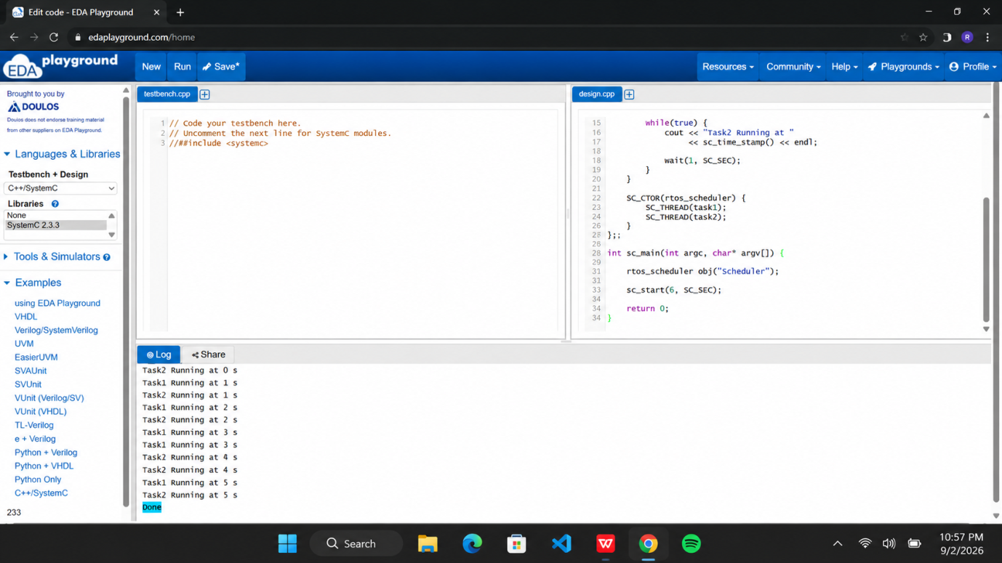

RESULT:
Thus the Round-Robin scheduling was executed using SystemC and verified.

