Exp No : 12
EMBEDDED C PROGRAM TO MULTIPLY TWO 16-BIT BINARY NUMBERS
AIM :
To write an Embedded C program to multiply two 16-bit numbers using Keil software
SOFTWARE REQUIRED :
- KEIL
PROGRAM :
#include <reg51.h>
void main()
{
while(1)
{
unsigned int num1,num2;
unsigned long int product;
num1=0x2222;
num2=0xBBBB;
product=(unsigned long int)num1*num2;P0=product &0xff;
P1=(product &0xff00)>>8;
P2=(product &0xff0000)>>16;P3=(product &0xff000000)>>24;
}
}

Circuit Diagram:
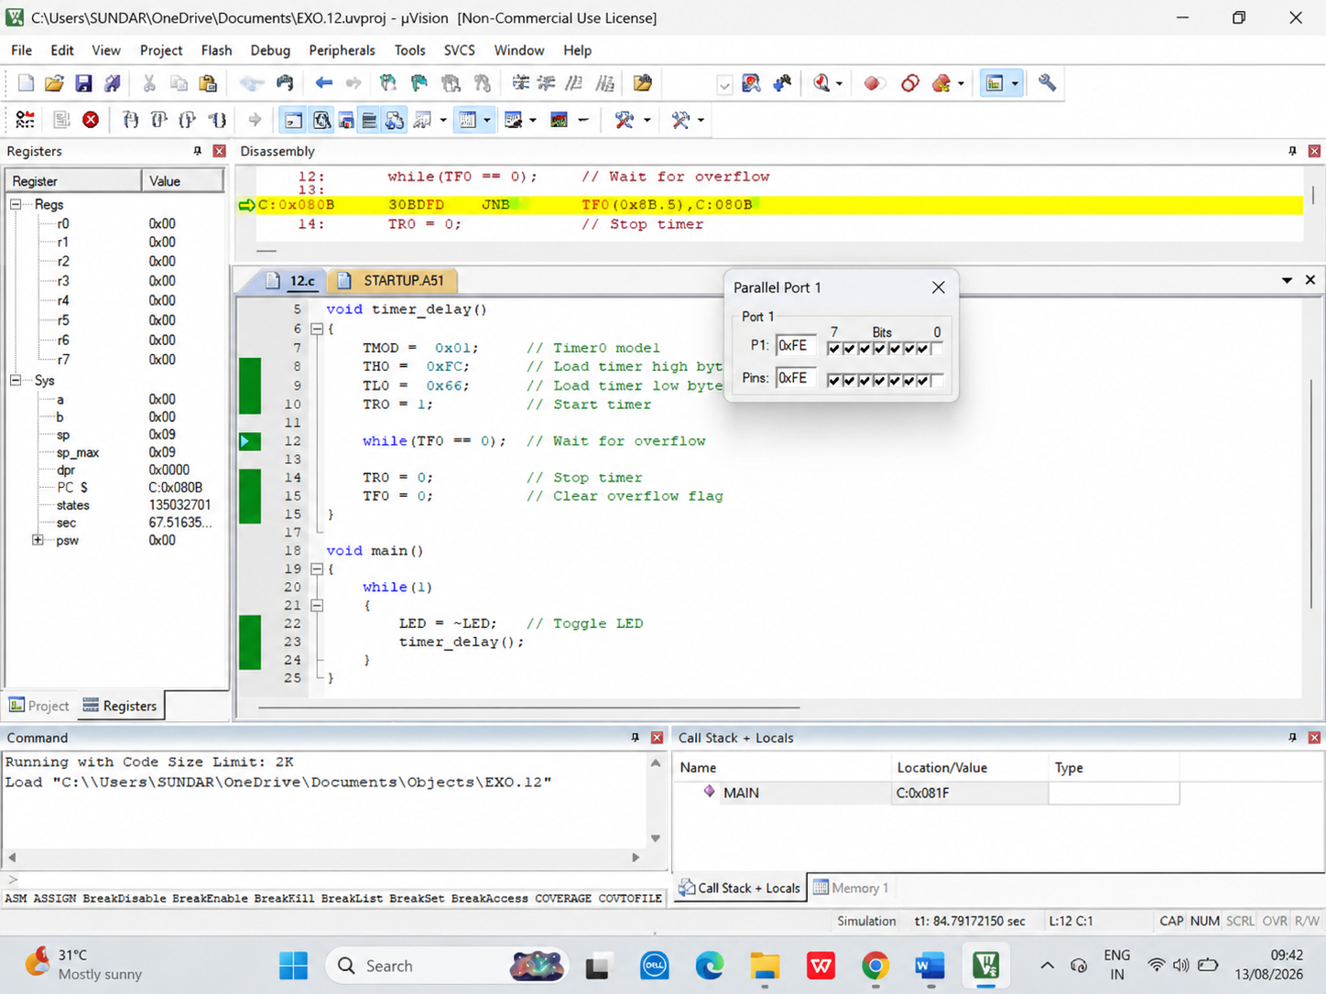

RESULT :
Thus the program has been successfully verified and executed.

