Exp No : 15
EMBEDDED C PROGRAM TO CONVERT THE HEXADECIMAL DATA 0XCFH
TO DECIMAL AND DISPLAY THE DIGITS ON PORTS P0, P1 AND P2
AIM :
To write an Embedded C program to EMBEDDED C PROGRAM TO CONVERT THE HEXADECIMAL DATA 0XCFH TO DECIMAL AND DISPLAY THE DIGITS ON PORTS P0, P1 AND P2
SOFTWARE REQUIRED :
- KEIL
PROGRAM :
#include <reg51.h>
void main(void)
{
unsigned char hexa=0x08;
unsigned char hundreds,tens,units;
ACC=hexa;
B=10;
ACC=ACC/B;
units=B;
B=10;
ACC=ACC/B;
tens=B;
hundreds=ACC;
{
PO=units;
PI=tens;
P2=hundreds;
while(1);
}
Circuit Diagram:
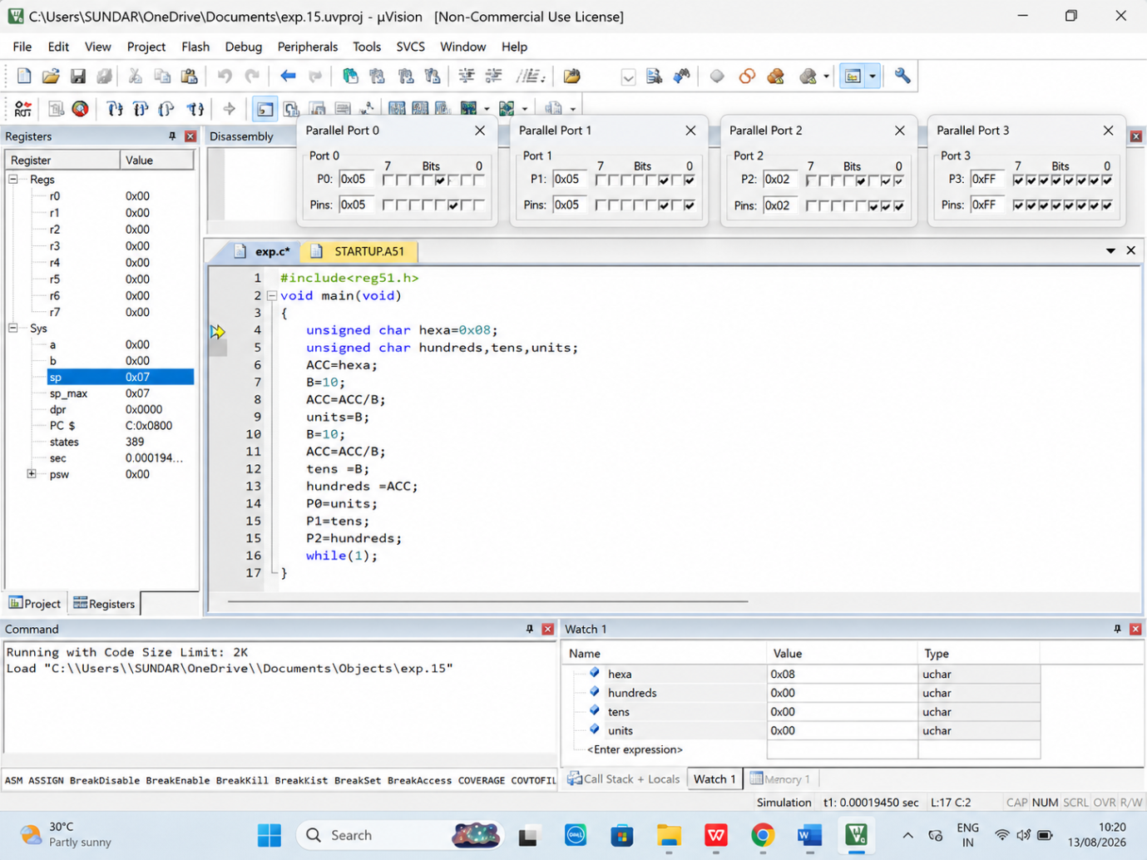

RESULT :
Thus the program has been successfully verified and executed.

