Exp No : 13
EMBEDDED C PROGRAM TO ADD AN ARRAY OF 16-BIT NUMBERS AND
STORE THE 32-BIT RESULT IN INTERNAL RAM
AIM :
To write an Embedded C program to EMBEDDED C PROGRAM TO ADD AN ARRAY OF 16-BIT NUMBERS AND
STORE THE 32-BIT RESULT IN INTERNAL RAM
SOFTWARE REQUIRED :
- KEIL
PROGRAM :
#include <reg51.h>
void main(void)
unsigned int i;
array[00x00 unsigned int array[5]={0x1111,0x2222,0x8888,0x4444,0xABCD};
unsigned long sum=0;
for(i=0;i<5;i++){
sum=sum+array[i];
}
P0=(unsigned char)(sum&0xFF);//Lower 8 bits
P1=(unsigned char)(sum>>8)&0xFF);
//Next 8 bits
P2=(unsigned char)(sum>>16)&0xFF);
//Upper 8 bits
{
while(1);//keep output stable
}

Circuit Diagram:
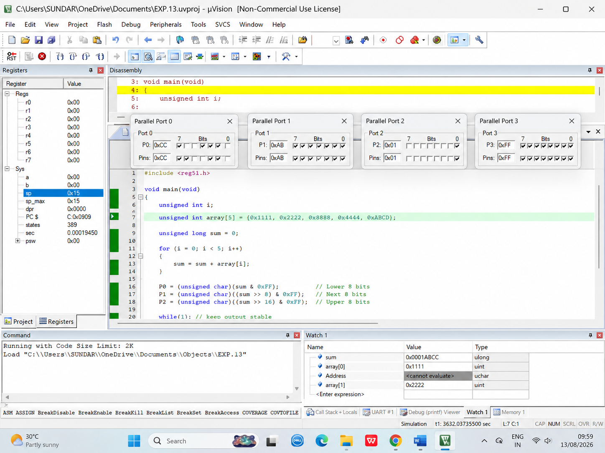

RESULT :
Thus the program has been successfully verified and executed.

