EXP NO. 25
PRODUCER-CONSUMER PROBLEM USING SYSTEMC
AIM:
To implement and simulate the Producer–Consumer problem using SystemC.
SOFTWARE REQUIRED:
- Ubuntu / WSL Linux
- g++ Compiler
- CMake
- SystemC Library
ALGORITHM:
- Start the simulation.
- Create Producer and Consumer modules.
- Create a FIFO channel of fixed size.
- Connect producer output to FIFO.
- Connect consumer input to FIFO.
- Producer writes data into FIFO.
- Consumer reads data from FIFO.
- Run simulation for fixed duration.
- Stop simulation.
PROGRAM:
#include <systemc.h>

// Producer Module
SC_MODULE(Producer) {

sc_fifo_out<int> out;

void produce() {
for (int i = 1; i <= 5; i++) {
cout << "Produced: " << i << endl;
out.write(i);
wait(1, SC_SEC);
}
}

SC_CTOR(Producer) {
SC_THREAD(produce);
}
};

// Consumer Module
SC_MODULE(Consumer) {

sc_fifo_in<int> in;

void consume() {
int value;

while (true) {
in.read(value);
cout << "Consumed: " << value << endl;
wait(1, SC_SEC);
}
}

SC_CTOR(Consumer) {
SC_THREAD(consume);
}
};

int sc_main(int argc, char* argv[]) {

sc_fifo<int> fifo(5);

Producer producer("Producer");
Consumer consumer("Consumer");

producer.out(fifo);
consumer.in(fifo);

sc_start(10, SC_SEC);

return 0;
}

OUTPUT:
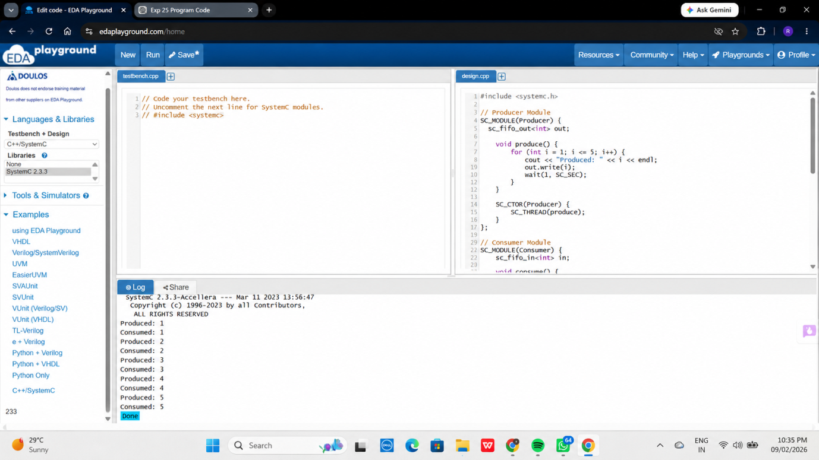

RESULT:
Thus, the Producer–Consumer problem was successfully implemented and simulated using SystemC. Proper synchronization between concurrent processes was achieved using FIFO communication.

