Exp No : 14
EMBEDDED C PROGRAM TO DISPLAY “HELLO WORLD” MESSAGE
AIM :
To write an Embedded C program to EMBEDDED C PROGRAM TO DISPLAY “HELLO WORLD” MESSAGE
SOFTWARE REQUIRED :
- KEIL
PROGRAM :
#include <reg51.h>#include <stdio.h>
void main(void){
SCON=0x50;/*SCON:mode 1,8-bit UART,enable revr*/TMOD=0x20;/*TMOD:timer 1,mode 2,8-bit reload*/TH1=0xFD;/*TH1:reload
value for 9600 baudrate */
TR1=1; /*TR1:timer 1 run*/
TI =1;/*TI:set TI to send first char of UART*/while(1)
{
printf("Hello World!\n");
}

Circuit Diagram:
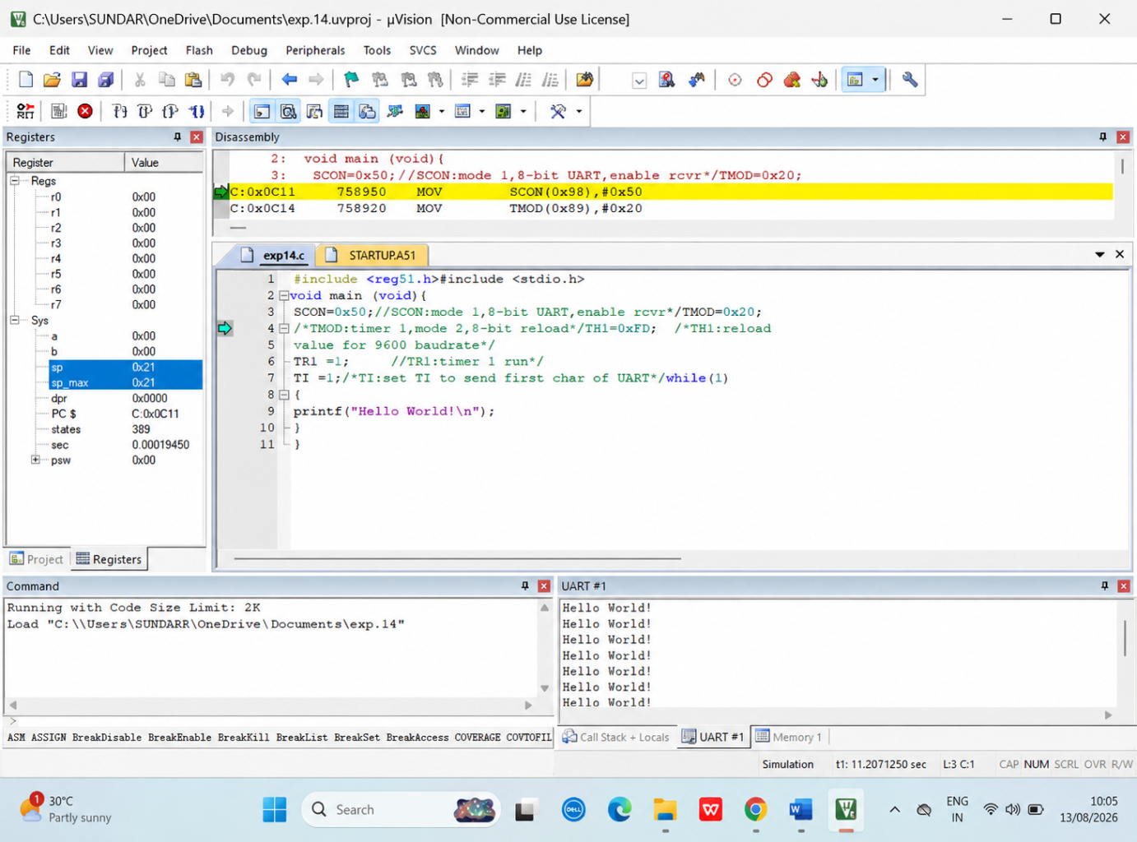

RESULT :
Thus the program has been successfully verified and executed.

