EXP-6: ARDUINO TO 16x2 LCD DISPLAY USING PROTEUS

AIM:
To write an Embedded C program to interface Arduino Uno and 16 x 2 LCD display using Arduino Uno and Proteus

SOFTWARE REQUIRED:
- Proteus 8 software.
- Arduino IDE software

PROGRAM:

#include <LiquidCrystal.h> LiquidCrystal lcd (7, 8, 9, 10, 11, 12);
// your PWM numbers may be different

void setup() {

lcd.begin(16, 2);

lcd.print("put your message here");

}

void loop () {

for (int i=0; 1<13; i++)
}

lcd.scrollDisplayLeft(); delay(700);

}
}

OUTPUT:

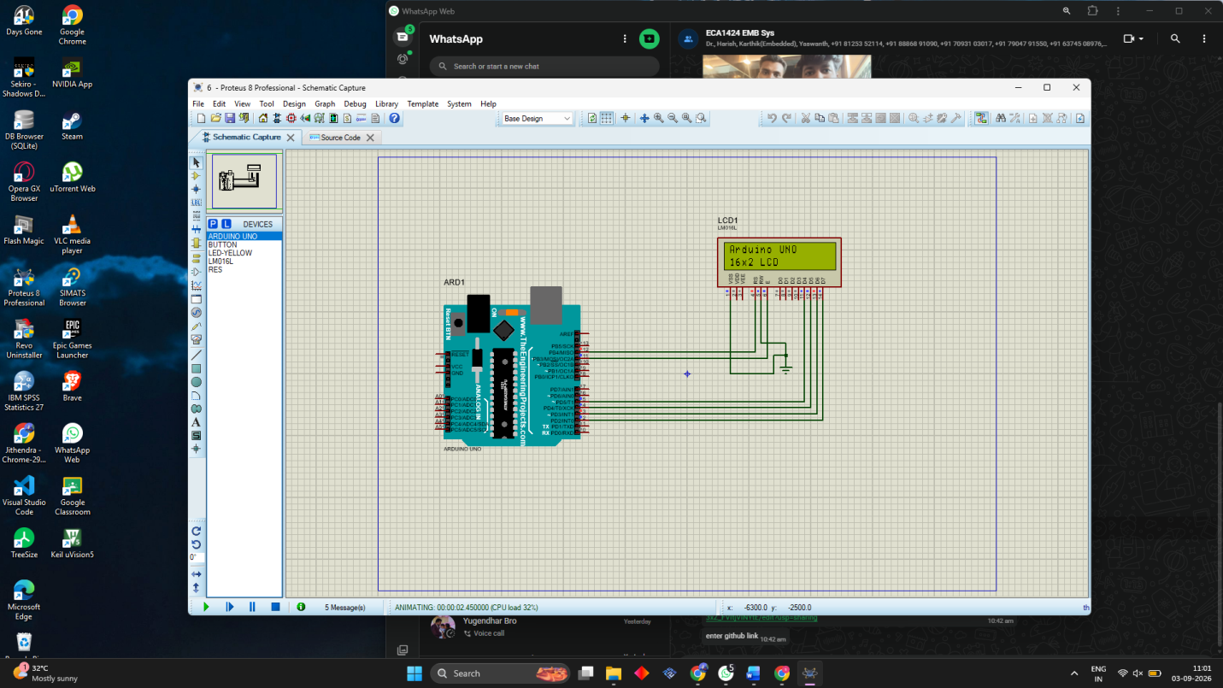

RESULT:
Thus the program has been successfully verified and executed.

