Model Selection:
Before you can use your model, you need to define the parameter values θ₀ and θ_{1.} How can you know which values will make your model perform best? To answer this question, you need to specify a performance measure.
You can either define a utility function (or fitness function) that measures how good your model is, or you can define a cost function that measures how bad it is. For linear regression problems, people typically use a cost function that measures the distance between the linear model’s predictions and the training examples; the objective is to minimize this distance.
Training a model means running an algorithm to find the model parameters that will make it best fit the training data, and hopefully make good predictions on new data.

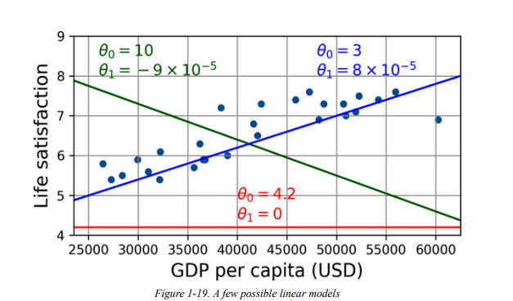
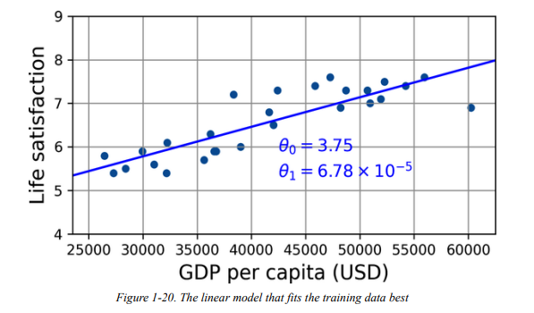

Feature Engineering:
A critical part of the success of a machine learning project is coming up with a good set of features to train on. This process, called feature engineering.
It involves the following steps:
- Feature selection (selecting the most useful features to train on among existing features)
- Feature extraction (combining existing features to produce a more useful one —as we saw earlier, dimensionality reduction algorithms can help)
- Creating new features by gathering new data

Overfitting the Training Data:
Say you are visiting a foreign country and the taxi driver rips you off. You might be tempted to say that all taxi drivers in that country are thieves. Overgeneralizing is something that we humans do all too often, and unfortunately machines can fall into the same trap if we are not careful.
In machine learning this is called overfitting: it means that the model performs well on the training data, but it does not generalize well and poor performance in test data.
Figure 1-23 shows an example of a high-degree polynomial life satisfaction model that strongly overfits the training data. Even though it performs much better on the training data than the simple linear model, would you really trust its predictions?
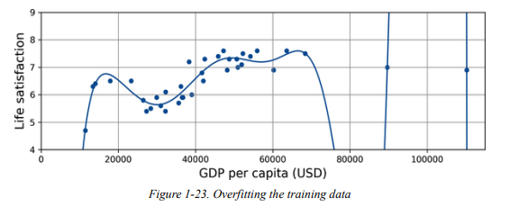
Overfitting happens when the model is too complex relative to the amount and noisiness of the training data. Here are possible solutions:
- Gather more training data.
- Reduce the noise in the training data (e.g., fix data errors and remove outliers).
Regularization:
To Reduce the risk of overfitting is called regularization. For example, the linear model we defined earlier has two parameters, θ₀ and θ_{1.}This gives the learning algorithm two degrees of freedom to adapt the model to the training data.
it can tweak both the height (θ₀) and the slope (θ₁) of the line.
If we forced θ₁ = 0, the algorithm would have only one degree of freedom and would have a much harder time fitting the data properly: all it could do is move the line up or down to get as close as possible values to the training instances,
The amount of regularization to apply during learning can be controlled by a hyperparameter.

A hyperparameter is a parameter of a learning algorithm (not of the model). As such, it is not affected by the learning algorithm itself; it must be set prior to training and remains constant during training. If you set the regularization hyperparameter to a very large value, you will get an almost flat model (a slope close to zero);
the learning algorithm will almost certainly not overfit the training data, but it will be less likely to find a good solution. Tuning hyperparameters is an important part of building a machine learning system.

Underfitting the Training Data:
underfitting is the opposite of overfitting: it occurs when your model is too simple to learn the underlying structure of the data.
so its predictions are bound to be inaccurate, even on the training examples.

main options for fixing this problem:

- Select a more powerful model, with more parameters.
- Feed better features to the learning algorithm (feature engineering).
- Reduce the constraints on the model (for example by reducing the regularization hyperparameter).

once you have trained a model, you don’t trust blindly, it generalizes to new cases. You want to evaluate it and fine-tune it if necessary.
Let’s see how to do that.

Testing and Validating:
A better option is to split your data into two sets: the training set and the test set. As these names imply, you train your model using the training set, and you test it using the test set.
The error rate on new cases is called the generalization error (or out-of-sample error),
and by evaluating your model on the test set, you get an estimate of this error. This value tells you how well your model will perform on new instances or unseen data.

If the training error is low (i.e., your model makes few mistakes on the training set) but the generalization error is high, it means that your model is overfitting the training data.

Hyperparameter Tuning and Model Selection:

The question is, how do you choose the value of the regularization hyperparameter?

One option is to train 100 different models using 100 different values for this hyperparameter.
Suppose you find the best hyperparameter value that produces a model with the lowest generalization error —say, just 5% error. You launch this model into production,
but unfortunately, it does not perform as well as expected and produces 15% errors. What just happened?

The problem is that you measured the generalization error multiple times on the test set, and you adapted the model and hyperparameters to produce the best model for that particular set. This means the model doesn’t perform as well on new data.

Solution for this,

A common solution to this problem is called holdout validation.
you simply hold out part of the training set to evaluate several candidate models and select the best one.
The new hold-out set is called the validation set (or the development set, or dev set).

More specifically, you train multiple models with various hyperparameters on the reduced training set (i.e., the full training set minus the validation set), and you select the model that performs best on the validation set. After this holdout validation process, you train the best model on the full training set (including the validation set), and this gives you the final model. Lastly, you evaluate this final model on the test set to get an estimate of the generalization error.

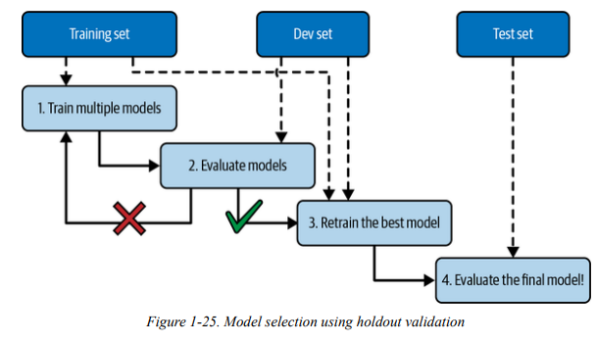

This solution usually works quite well. However, if the validation set is too small, then the model evaluations will be imprecise: you may end up selecting a suboptimal model by mistake. Conversely, if the validation set is too large, then the remaining training set will be much smaller than the full training set. Why is this bad? Well, since the final model will be trained on the full training set, it is not ideal to compare candidate models trained on a much smaller training set. It would be like selecting the fastest sprinter to participate in a marathon. One way to solve this problem is to perform repeated cross-validation, using many small validation sets. Each model is evaluated once per validation set after it is trained on the rest of the data. By averaging out all the evaluations of a model, you get a much more accurate measure of its performance. There is a drawback, however: the training time is multiplied by the number of validation sets.

