MIGRATION RUNBOOK
Jira ISSP (Jira CIB Cluster) → Jira TtCAAS1443 (Jira GROUP Cluster)
Cross-Cluster, Cross-Version Jira Data Migration — ~11,000 Issues
Document Owner: ______________________ (Migration Owner)
Status: Draft for Kickoff | Version: 0.1 | Date: September 6, 2026

Table of Contents
(Right-click below and choose "Update Field" in Word to populate page numbers.)

1. Executive Summary
This runbook defines the end-to-end approach to migrate approximately 11,000 Jira issues from project ISSP on the Jira CIB cluster to project TtCAAS1443 on the Jira GROUP cluster. The two clusters run different Jira versions with different hidden custom field IDs, different workflow schemes, and different priority scales (3-tier vs. 5-tier). The target project is already live, with roughly 1,000 net-new issues created by users since cutover of daily work began.
The approach treats this as a governed ETL (Extract–Transform–Load) program rather than a Jira export/import exercise. It uses a mapping-driven migration engine, an AI-assisted classification layer to resolve ambiguous status and priority mappings, and a batch-and-freeze cutover strategy so that neither the source team's historical record nor the target team's live, in-flight work is disrupted.
As the migration owner, you are accountable for: mapping sign-off, engaging both platform admin teams, sequencing batches to avoid collision with the 1,000 live tickets, running validation/reconciliation, and formal go/no-go decisions at each phase gate.

2. Objectives & Success Criteria
- Migrate all ~11,000 ISSP issues (fields, comments, attachments, history where feasible, links) into TtCAAS1443 with zero data loss.
- Preserve traceability: every migrated issue is tagged with its original key and a permanent mapping record is kept.
- Zero disruption to the 1,000+ new issues already live in TtCAAS1443 — no key collisions, no accidental overwrites, no downtime for active users.
- Zero disruption to the source system during migration — ISSP remains usable (read-only near the end) until cutover is confirmed.
- Workflow states and priorities are translated using an agreed, auditable mapping — not a lossy best-guess.
- Migration is repeatable and idempotent — any batch can be safely re-run without creating duplicates.
- Manual effort is minimized by automating field/status/priority mapping and by using AI classification only where mapping is genuinely ambiguous, with human review on low-confidence cases only.

3. Scope & Assumptions

In Scope
- All issues under ISSP project (open, closed, resolved) — approx. 11,000 records.
- Issue fields (standard + custom), comments, attachments, issue links, and status/priority translation.
- Workflow state remapping (e.g., Accepted → In Progress in source vs. Accepted → Selected for Development in target).
- Priority remapping (3-tier source: High/Medium/Low → 5-tier target scale).

Out of Scope (unless explicitly added)
- Dashboards, boards, filters, and automation rules — these are recreated natively in Jira GROUP, not migrated as data.
- Historical Jira CIB audit/security logs outside issue changelogs.

Assumptions
- Both clusters expose REST API access (Jira Cloud/Data Center REST v2 or v3) with service-account credentials available to the migration engine.
- Business SMEs from both teams are available for mapping sign-off and low-confidence review queues.
- A short read-only freeze window on ISSP is acceptable for the final delta batch.

4. Governance & RACI
A single accountable owner (you) is essential given two independent platform teams and a live target system. The table below defines Responsible / Accountable / Consulted / Informed for each work stream.
Work Stream | Responsible (R) | Accountable (A) | Consulted (C) | Informed (I)
Overall migration ownership & go/no-go | You (Migration Owner) | Sponsor | Both team leads, Platform Admins | All stakeholders
Source system (Jira CIB / ISSP) admin access & freeze | Source Platform Admin | You | Source team lead | Source team
Target system (Jira GROUP / TtCAAS1443) admin access | Target Platform Admin | You | Target team lead | Target team
Field / workflow / priority mapping definition | Business SME (both teams) | You | Platform Admins | -
Migration engine build (ETL scripts) | Engineering / Automation Lead | You | - | Platform Admins
AI-assisted classification tuning & review queue | Automation Lead + SMEs | You | - | -
Validation & reconciliation | QA / Validation Lead | You | Both team leads | -
Cutover communication to end users | You | Sponsor | - | Both teams, all Jira GROUP users
Rollback decision | You | Sponsor | Platform Admins | Both teams
Recommendation: stand up a short-lived "Migration Control Tower" — a small cross-functional pod (you + 1 automation engineer + 1 QA + 1 rep per platform team) that meets daily during active batch execution and weekly otherwise.

5. Migration Architecture
The diagram below shows the overall data flow. The Migration Control Tower sits between the two clusters and is the only component that writes to the target — end users continue to read/write TtCAAS1443 directly and are never blocked.
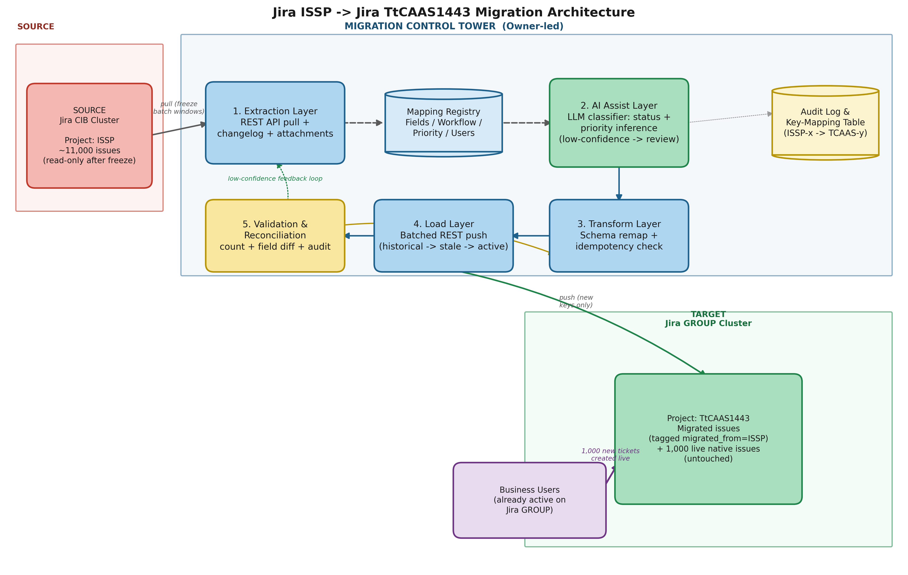

Component Walkthrough
- 1. Extraction Layer — pulls issues from ISSP via REST API in controlled batches (by status/date range), including changelog history and attachments; never writes back to source.
- 2. AI Assist Layer — an LLM-based classifier reads issue text, labels, and changelog context to suggest the correct target workflow status and priority when the mapping is not a clean 1:1. Confident suggestions are auto-applied; low-confidence cases are routed to a human review queue instead of guessed.
- 3. Transform Layer — applies the signed-off field/workflow/priority/user mapping and performs an idempotency check against the Mapping Registry so a batch can be safely re-run.
- 4. Load Layer — pushes transformed issues into TtCAAS1443 in the sequence: historical (closed/resolved) → stale open → active in-flight, always letting Jira auto-assign new keys so it can never collide with the 1,000 live native issues.
- 5. Validation & Reconciliation — automated count and field-level diff checks after every batch, feeding an audit log and the permanent source-key → target-key mapping table used for traceability.

6. Phased Execution Plan
Phase | Key Activities | Owner | Duration
Phase 0 — Discovery & Access | Get API/admin access to both clusters; export full field schema (incl. hidden custom field IDs) and workflow scheme from both; inventory all 11,000 issues by status/age/component. | You + both Platform Admins | 1 week
Phase 1 — Mapping Definition | Build and get SME sign-off on: field map, workflow-status map, 3→5 priority map, user/group map. Identify ambiguous cases for AI-assist. | SMEs + You | 1–1.5 weeks
Phase 2 — Engine Build & AI Tuning | Build extraction/transform/load scripts against mapping tables; build and calibrate the AI classifier on a labeled sample; add idempotency + audit logging. | Automation Lead | 2 weeks (parallel with Phase 1 tail)
Phase 3 — Pilot Batch | Migrate ~100 closed/resolved issues first (zero collision risk). Full validation. SME sign-off on accuracy before scaling. | You + QA + SMEs | 3–4 days
Phase 4 — Bulk Historical Migration | Migrate all closed/resolved issues (likely the bulk of 11,000) in scheduled batches; no freeze needed since these are immutable. | Automation Lead + QA | 1–1.5 weeks
Phase 5 — Active/Open Issue Cutover | Short read-only freeze on ISSP open issues (announce in advance); migrate remaining open/in-progress issues; final delta sync; unfreeze source as read-only archive. | You + both team leads | 2–3 days (freeze window: hours, not days)
Phase 6 — Post-Migration Validation & Closeout | Full reconciliation (counts, field diff, attachment/link integrity); publish mapping/audit report; decommission or archive ISSP per retention policy; retrospective. | You + QA | 1 week
Total estimated duration: ~6–8 weeks end-to-end, most of it parallelizable. The only hard blocking window for end users is the short freeze in Phase 5.

7. Mapping Strategy
All three mapping tables below must be signed off by SMEs from both teams before Phase 2 engineering begins. These are illustrative examples — the full mapping is maintained as a living spreadsheet/registry, not only in this document.

7.1 Field Mapping (illustrative sample)
Source Side | Value | Target Side | Value | Notes
ISSP Field (source) | customfield_10231 ("Business Unit") | TtCAAS1443 Field (target) | customfield_20144 ("Business Unit") | Direct 1:1, ID differs
ISSP Field (source) | customfield_10450 ("Root Cause") | TtCAAS1443 Field (target) | customfield_20390 ("RCA Category") | 1:1 with value-list re-map
ISSP Field (source) | Epic Link | TtCAAS1443 Field (target) | Parent Link (new hierarchy model) | Structural change — needs script logic, not simple copy

7.2 Workflow Status Mapping
Source Status (ISSP) | Target Status (TtCAAS1443) | Notes
Open | Open | Direct
Accepted | Selected for Development | Direct (per confirmed workflow diff)
In Progress | In Progress | Direct
In Review | In Review | Direct
Blocked | In Progress (+ "Blocked" flag/label) | Target has no separate Blocked state — AI/rule flags via label
Resolved / Closed | Done | Direct, closed-date preserved in comment/audit field

7.3 Priority Mapping (3-tier → 5-tier)
Source Priority | Target Priority (candidate) | Resolution Approach
High | Highest or High | AI classifies using issue text/severity keywords + historical SLA breach flag; low-confidence → human review
Medium | Medium or Low | Same as above — Medium is the ambiguous middle tier needing AI assist
Low | Low or Lowest | AI classifies using age, comment volume, and label signals

7.4 User Mapping — Departed / Left-Organization Users
A material gap in early planning: Jira's Assignee field can be left blank (Unassigned), but Reporter is a mandatory field and cannot be null. Departed users need different handling per field — this must be signed off alongside the other three maps, not treated as an edge case discovered mid-migration.
Field | User Found in Target Directory | User Has Left the Organization
Assignee | Direct map to target username | Set to Unassigned — requires "Allow Unassigned Issues" enabled on TtCAAS1443 (verify in Phase 0, before any load)
Reporter | Direct map to target username | Reporter cannot be blank. Map to a designated fallback account (e.g. migration-archive@company.com) AND preserve the real original name in a dedicated custom field (e.g. "Original Reporter (Archived)") plus an audit log entry
Watchers | Direct map, added as watcher | Dropped silently from the watcher list; count of removed watchers logged per issue for audit purposes
Prerequisite check: confirm "Allow Unassigned Issues" is enabled in TtCAAS1443's project permissions during Phase 0 discovery — if it is not, the Assignee fallback rule above cannot be applied and issues will fail to create.

8. AI-Assisted Automation — Where and Why
AI is used narrowly, for the parts of this migration that are genuinely ambiguous, not as a blanket automation layer over the whole pipeline. This keeps trust high and avoids silently mis-mapping business-critical fields.
- Priority disambiguation: the 3→5 tier mapping is not deterministic for the middle values. An LLM reads issue summary, description, comment sentiment, historical SLA/severity signals and proposes a target priority with a confidence score.
- Workflow status inference: for legacy issues where changelog history is inconsistent or a status was skipped, the classifier infers the most likely equivalent target status from the changelog narrative.
- Duplicate/near-duplicate detection: flags ISSP issues that closely resemble something already logged natively in TtCAAS1443 since go-live, so the team can link rather than duplicate.
- Confidence thresholding: anything above the agreed confidence threshold (e.g., 90%) is auto-applied and logged; everything below is routed to a lightweight human review queue (a simple spreadsheet or Jira review project), never silently guessed.
- Reconciliation anomaly detection: after load, a model-assisted diff check flags outlier issues (unusual field combinations, missing mandatory fields) for manual spot-check instead of relying only on rule-based validation.
This keeps manual effort limited to reviewing the minority of ambiguous cases and to periodic spot-checks — not re-keying or manually triaging all 11,000 issues.

9. Cutover Strategy — Protecting Both Live Systems

Protecting the Target (Jira GROUP / TtCAAS1443) and its 1,000 new issues
- Never predict or reuse target issue keys — always let Jira auto-assign the next available key so migrated issues can never collide with the 1,000 native issues already created.
- Tag every migrated issue with a marker field/label, e.g. migrated_from = ISSP-<original key>, so migrated vs. native issues remain distinguishable forever.
- Load in batches ordered by risk: closed/resolved first (immutable, zero collision risk), then stale open issues, then active in-flight issues last.
- Run loads during low-traffic windows and monitor API rate limits so target performance for live users is unaffected.

Protecting the Source (Jira CIB / ISSP)
- Migration engine is read-only against the source at all times.
- Only the final delta batch (open/active issues) requires a short read-only freeze on ISSP, announced at least 1 week in advance, to guarantee no changes are missed between extraction and cutover.
- After validation passes, ISSP is kept as a read-only archive (not deleted) for an agreed retention period as the rollback safety net.

10. Risk Register
Risk | Likelihood | Impact | Mitigation
Priority mapping ambiguity causes incorrect target priority | Med | Med | AI classification + confidence threshold + SME review queue for low-confidence cases
Key collision with the 1,000 live native issues | Low | High | Never predict target keys; always auto-assign; tag migrated issues distinctly
Data drift during migration window (users editing ISSP mid-migration) | Med | Med | Short read-only freeze for final delta batch only; batch historical data first (immutable)
Hidden custom field IDs mis-mapped, causing silent data loss | Med | High | Full schema export & mapping sign-off before engineering; automated field-diff validation post-load
Attachment/comment loss due to API limits | Low | Med | Batch size tuning, retry logic, post-load attachment count reconciliation
Target system performance impact on live users during load | Low | Med | Load during low-traffic windows; rate-limit-aware batching; monitor target cluster health
Scope creep (dashboards/automations assumed in-scope) | Med | Low | Explicit out-of-scope statement in this runbook, signed off at kickoff
Departed users left in Assignee/Reporter cause failed issue creation (Reporter cannot be null) | Med | High | User directory reconciliation in Phase 0; Assignee -> Unassigned (with permission pre-check); Reporter -> fallback account + original name preserved in custom field

11. Validation & Reconciliation Plan
- Count reconciliation: source issue count per status/component vs. migrated count in target, per batch.
- Field-level sampling diff: automated comparison of a statistically significant sample per batch (e.g., 5–10%) across all mapped fields.
- Attachment & link integrity check: verify attachment counts/checksums and that issue links resolve to the correct migrated target keys.
- SME spot-check sign-off: business SMEs review a sample of migrated issues per batch, focused on status and priority correctness.
- AI-assisted anomaly flagging: outlier issues (missing mandatory fields, unusual field combinations) are flagged automatically for manual review.
- Final closeout reconciliation: full count and integrity check across all ~11,000 issues before ISSP is set to permanent read-only archive.

12. Rollback & Contingency Plan
- Source (ISSP) is never deleted or modified — it remains available as the system of record until final sign-off, providing a natural rollback point.
- Every migrated issue is traceable via the migrated_from tag and the permanent key-mapping registry, so a bad batch can be identified precisely.
- Because loads are idempotent, a failed or incorrect batch can be deleted from the target (migrated issues only, identified by tag) and re-run after fixing the mapping — without affecting native TtCAAS1443 issues.
- Go/no-go checkpoints at the end of Phase 3 (pilot) and Phase 5 (cutover) give explicit points to halt and remediate before scaling further.

13. Communication Plan
Communication | Audience | Owner | Timing
Kickoff & scope confirmation | Both team leads, Sponsor, Platform Admins | You | Start of Phase 0
Mapping sign-off request | SMEs, both teams | You | End of Phase 1
Pilot batch results | Both team leads, Sponsor | You + QA | End of Phase 3
Freeze window announcement (ISSP read-only) | All ISSP users | You + Source Platform Admin | 1 week before Phase 5, then day-of reminder
Cutover complete / go-live confirmation | All TtCAAS1443 users, Sponsor | You | End of Phase 5
Final closeout & retrospective | All stakeholders | You | End of Phase 6

14. Timeline & Milestones
Timeframe | Milestone
Week 1 | Phase 0 — Discovery & Access
Weeks 2–3 | Phase 1 — Mapping Definition (SME sign-off)
Weeks 2–4 | Phase 2 — Engine Build & AI Tuning (parallel)
Week 4 | Phase 3 — Pilot Batch + Go/No-Go
Weeks 5–6 | Phase 4 — Bulk Historical Migration
Week 7 | Phase 5 — Active Issue Cutover (freeze window)
Week 8 | Phase 6 — Final Validation & Closeout

15. Appendix — Owner Checklist & Tooling

Tooling Checklist
- REST API service accounts on both clusters (read-only on source, write on target).
- Migration engine: Python/Node scripts driven by mapping tables (not a generic Jira Cloud Migration Assistant, which assumes matching schemas).
- External mapping/audit registry (database or spreadsheet) tracking source key → target key + batch + timestamp.
- LLM API access for the AI Assist Layer (priority/status/duplicate classification).
- Review queue mechanism for low-confidence AI suggestions (lightweight — spreadsheet or a dedicated review project).

Owner's First-Two-Weeks Checklist
- Confirm sponsor and secure admin/API access commitments from both Platform Admin teams.
- Stand up the Migration Control Tower pod and set a recurring cadence (daily during batches, weekly otherwise).
- Kick off schema/workflow/priority discovery and begin the mapping registry.
- Communicate scope, timeline, and the upcoming freeze window expectation to both teams early — this is the most common source of resistance if sprung late.
- Agree the AI confidence threshold and review-queue process with SMEs before any classification runs at scale.

