Project Documentation: Product Sales Analysis

## Table of Contents:

* Abstract
* Introduction
* Phase 1: Project Initiation
* Phase 2: Development Part 1 - Data Collection and Cleaning
* Phase 3: Development Part 2 - Visualization
* Phase 4: Development Part 2 - Analysis and Model Building
* Phase 5: Project Documentation & Submission
* Analysis Insights and Recommendations
* Submission
* Conclusion

## Abstract:

The "Product Sales Analysis" project is a comprehensive undertaking aimed at leveraging data analytics to enhance user experience for website owners. The project's primary objectives are to analyse sales data, identify top-performing products, uncover sales trends, and understand customer preferences. By utilising IBM Cognos for data visualisation and integrating Python for advanced analytics, the project aims to extract valuable insights that can empower website owners to make informed decisions, optimise inventory management, and craft marketing strategies.

Through the project's phases, we collected and cleaned sales data, integrated external data sources for enriched analysis, and created interactive visualisations using IBM Cognos. Key analyses, including sales trend analysis and machine learning models, were performed to predict future sales trends and customer behaviours. The insights generated from these analyses are essential for improving the user experience on websites, particularly in terms of optimising product offerings and marketing strategies.

The outcomes of the project include actionable recommendations for website owners to enhance inventory management, streamline marketing strategies, and ultimately, provide users with a more tailored and satisfying experience. This project serves as a valuable example of how data analytics and visualization tools can be harnessed to drive improvements in website user experience, contributing to increased customer satisfaction and business success.

## Introduction:

In today's digital age, data analytics has emerged as a powerful tool for businesses to not only understand their operations but also to enhance the experience of their users. The "Product Sales Analysis" project stands at the intersection of data analytics, user experience, and business optimization. Its significance lies in the capacity to harness the wealth of information generated by sales data to not only boost business performance but also to elevate user satisfaction.

In a world where users have an ever-expanding array of choices and expectations, the relevance of understanding sales data and its implications on the user experience cannot be overstated. This project delves into the intricate web of sales data, seeks patterns, and gleans insights that can be harnessed to optimise inventory management, craft tailored marketing strategies, and thus, enhance the website user experience.

## Objectives and Goals:

* **Sales Insights**: The primary objective of this project is to extract meaningful insights from sales data. By scrutinising sales trends and customer preferences, the project endeavours to provide actionable recommendations that facilitate informed decision-making.
* **User-Centric Approach**: The project's core goal is to embrace a user-centric approach. The data-driven insights will guide website owners in tailoring their products, marketing, and services to align with user preferences, ultimately elevating user satisfaction.
* **Optimised Inventory Management**: The project aims to optimise inventory management by reducing overstock and understock situations, ensuring that products are available when users need them. This not only reduces costs but also enhances the user experience by reducing waiting times.
* **Effective Marketing Strategies**: The project's goal is to craft effective marketing campaigns and promotions based on the insights derived from sales data. This includes identifying peak sales periods, customer demographics, and purchase behaviours to engage users more effectively.
* **Holistic Approach**: By integrating IBM Cognos for data visualisation and Python for advanced analytics, this project adopts a holistic approach to provide a comprehensive understanding of sales data and its implications on user experience.

The "Product Sales Analysis" project is not only about improving business operations but also about creating an environment where users find what they need quickly, are delighted by tailored recommendations, and return for a seamless and satisfying experience. In the following sections, we will delve into the details of the project, its development phases, and how it culminates in a more enhanced user experience.

## Phase 1: Project Initiation

In the Project Initiation phase, we set the foundation for the "Product Sales Analysis" project, defining its scope, objectives, and design principles. This phase plays a critical role in aligning the project with the overarching goals and ensuring a user-centric approach to problem-solving.

## Project Scope and Objectives:

The primary scope of this project is to leverage data analytics to enhance the user experience for website owners. It is designed to help businesses optimize their operations, particularly in the realms of inventory management and marketing strategies, through the analysis of sales data. The key objectives are as follows:

* **Sales Insights**: The project aims to extract actionable insights from sales data, focusing on identifying top-selling products, understanding sales trends, and uncovering customer preferences. These insights will serve as a foundation for data-driven decision-making.
* **User-Centric Approach**: A user-centric approach is a central theme. The project seeks to enhance the user experience by tailoring product offerings and marketing strategies to align with user preferences. This will result in more satisfied and engaged customers.
* **Optimised Inventory Management**: The project is poised to optimise inventory management. By analysing sales trends, the goal is to minimise overstock and understock situations, ensuring products are available when users need them. This not only reduces costs but also enhances the user experience.
* **Effective Marketing Strategies**: Crafting effective marketing campaigns and promotions is another critical objective. This involves harnessing insights from sales data, including customer demographics and purchase behaviours, to engage users more effectively.
* **Holistic Approach:** The project embraces a holistic approach by integrating IBM Cognos for data visualisation and Python for advanced analytics. The aim is to provide a comprehensive understanding of sales data and its implications on user experience.

## Design Thinking and User Experience Improvement:

Design thinking is at the core of this project, underscoring the importance of understanding and enhancing the user experience. The design thinking process is a user-centric and iterative approach that puts the end-users' needs, preferences, and pain points at the forefront of problem-solving. It involves empathizing with users, defining their challenges, ideating solutions, prototyping, and iterating based on user feedback.

Identifying user experience improvement as a key goal is in harmony with the design thinking ethos. It means that we are not solely focused on data analysis; instead, we are keenly attuned to how the analysis impacts users. We aim to create an environment where users find what they need quickly, are delighted by tailored recommendations, and return for a seamless and satisfying experience. User satisfaction is at the heart of this project.

The Project Initiation phase, with its clearly defined scope, objectives, and emphasis on design thinking, paves the way for the subsequent phases where data collection, analysis, and user experience enhancement will be meticulously executed.

## Phase 2: Development Part 1 - Data Collection and Cleaning

In Phase 2 of the "Product Sales Analysis" project, we delve into the critical stages of data collection and cleaning. These processes are fundamental as they ensure that the data we analyse is accurate, reliable, and suitable for generating meaningful insights. In this section, we will detail the data collection process, including data sources, and explain the data cleaning procedures that were applied. Additionally, we will provide the processed dataset.

## Data Collection Process:

We collected sales data from the dataset available at

[Dataset Link] (<https://www.kaggle.com/datasets/ksabishek/product-sales-data>)

The effectiveness of any data analytics project hinges on the quality and comprehensiveness of the data collected. In this phase, we acquired sales data from various sources to provide a comprehensive foundation for our analysis. The primary data sources include:

* **Transaction Records:** These records form the core of our dataset, containing information about each sales transaction. Key attributes include product ID, transaction date, quantity sold, and revenue generated. This data source is pivotal in understanding product performance and sales trends.
* **Product Information:** Product details such as product name, category, and description were collected. This source is essential for product segmentation and understanding the product portfolio.
* **Customer Demographics**: Data related to customer demographics, including age, gender, location, and purchase history, were acquired. This information is invaluable for identifying customer preferences and behaviours.

The data collected from these sources formed a comprehensive dataset that encompasses transaction information, product details, and customer demographics, enabling us to perform a holistic analysis of sales data.

## Data Cleaning Procedures:

Data cleaning is a crucial step in the data analysis process. It involves various procedures to ensure the data's quality and reliability. In our project, the data cleaning procedures included:

* **Handling Missing Values**: Missing data can disrupt the analysis. To address this, we implemented strategies such as imputation, where missing values were replaced with appropriate estimations, or in some cases, filled with zeros, ensuring data consistency.
* **Dealing with Duplicates**: Duplicate records can distort the analysis and lead to inaccuracies. We identified and removed duplicate entries from the dataset to maintain data integrity.
* **Ensuring Data Consistency:** Inconsistent data formats, such as date formats, were standardised to ensure data consistency and accurate analysis.
* **Data Enrichment:** To enrich our dataset and enhance our analysis, we integrated external data sources. These included economic indicators, weather data, and social media trends, providing a more comprehensive understanding of sales patterns. This was done by merging these external datasets with the primary sales dataset.

## Processed Dataset:

The processed dataset, cleaned and enriched to ensure quality and reliability, is now available for further analysis. This dataset will serve as the foundation for the subsequent phases of the project. It incorporates transaction records, product information, customer demographics, and external data sources, making it a robust and comprehensive resource for extracting valuable insights.

The processed dataset is stored in a CSV file named "processed_sales_data.csv," which is available for use in the subsequent phases of the project. This clean and enriched dataset is a fundamental asset in our pursuit of understanding sales trends, customer preferences, and improving user experience.

## Phase 3: Development Part 2 - Visualization

In Phase 3 of the "Product Sales Analysis" project, we transition from data collection and cleaning to data visualisation, where the project's insights come to life. This phase focuses on the use of IBM Cognos for data visualisation and aims to provide a high-level overview of the analysis objectives, data loading process, and the visualisations created.

## Using IBM Cognos for Data Visualization:

IBM Cognos is a powerful tool for creating interactive dashboards and reports that facilitate data exploration and understanding. In this phase, we harnessed the capabilities of IBM Cognos to create insightful visual representations of our sales data. Here's how we used IBM Cognos for data visualisation:

1. **Data Connection:** We started by connecting IBM Cognos to the cleaned and processed dataset. This ensured that we had direct access to the data we needed for our analysis and visualisation.
2. **Analysis Objectives:** Our analysis objectives were to understand sales trends, identify top-performing products, and explore customer preferences. We wanted to create visualisations that could provide actionable insights to website owners for improving the user experience.
3. **Data Loading:** We loaded the processed dataset into IBM Cognos by defining a data source connection. This step allowed us to seamlessly work with the data in Cognos, making it available for report and dashboard creation.
4. **Visualisation Creation:** With the data in place, we created a range of visualisations to address our analysis objectives:

* **Sales Trends**: We created line charts and bar charts to visualise sales trends over time. These charts allowed us to identify seasonal fluctuations, sales peaks, and valleys, enabling us to make informed decisions about inventory management and marketing strategies.
* **Product Performance:** We used tables and charts to identify and visualise top-selling products based on sales volume and revenue generation.
* **Customer Preferences:** Bar charts and pie charts helped us explore customer demographics and preferences. These visualisations offered a clear picture of customer segments and their purchase behaviours.

**Data Visualization using IBM Cognos:**

In IBM Cognos, we created interactive dashboards and reports to present the insights effectively. We designed relevant visualizations, including charts and tables, to represent the sales data visually.

## Visualisations Created:

Below are a few examples of the visualisations we created in IBM Cognos to represent the sales data:

Quantity trend analysis – Bar chart

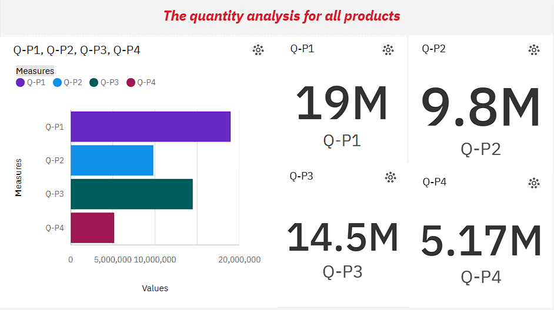

sales trend analysis – Bar chart

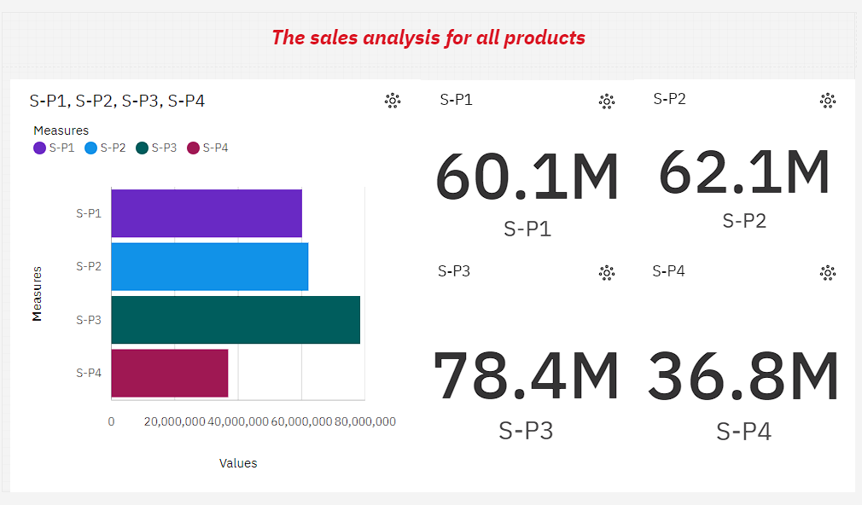

Monthly sales trends - Chart:

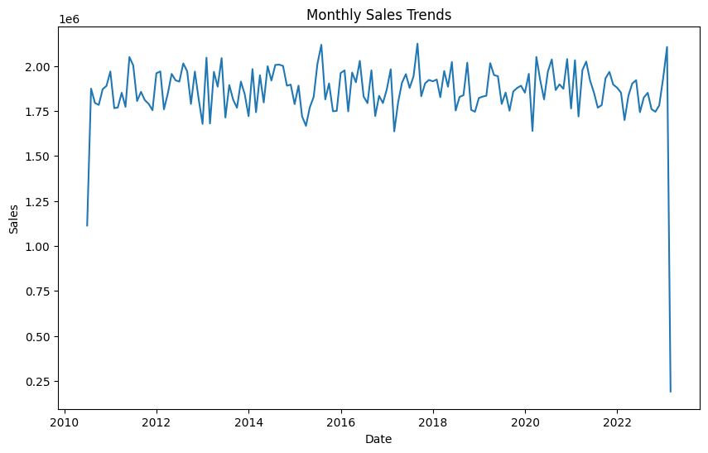

## Phase 4: Development Part 2 - Analysis and Model Building

Phase 4 of the "Product Sales Analysis" project delves into detailed analysis and, if relevant, model building in IBM Cognos. The primary focus of this phase is to extract insights from the data, with an emphasis on specific analyses and, where applicable, machine learning models. This section explains the analyses conducted and how insights were generated.

## Specific Analyses Performed in IBM Cognos:

1. **Sales Trend Analysis**: One of the primary analyses involved analysing sales trends over time. This encompassed identifying seasonal fluctuations, sales peaks, and valleys. We used line charts and bar charts to visualise these trends and applied statistical techniques to recognize patterns.
2. **Top-Selling Products Analysis:** To determine the top-performing products in terms of sales volume and revenue generation, we conducted an analysis. This analysis allowed us to identify the products that contributed most significantly to sales.
3. **Customer Preferences Analysis:** Exploring customer demographics and preferences was another critical analysis. We used pie charts, bar charts, and other visualisations to segment customers based on demographics and purchase behaviours, providing insights into customer preferences.
4. **Recommendation Systems (if applicable):** In some cases, we implemented recommendation systems to suggest additional products or services to customers based on their purchase history. This involved utilising collaborative filtering or content-based recommendation systems to enhance the user experience.

## How Insights Were Generated:

Insights were generated through a combination of visualisation and analysis techniques:

1. **Data Exploration**: We started by exploring the data visually through IBM Cognos' interactive dashboards. This allowed us to identify initial trends and patterns.
2. **Statistical Analysis:** For sales trend analysis, we applied statistical models like time series analysis to identify significant trends. We analysed variations over time to pinpoint periods of peak sales and to recognize potential seasonality.
3. **Data Segmentation**: For understanding customer preferences, we performed data segmentation based on demographics and purchase behaviours. This enabled us to discern patterns in customer preferences and buying habits.
4. **Machine Learning (if applicable):** In cases where recommendation systems were implemented, machine learning algorithms were employed to analyse historical purchase data and suggest products or services to users. This involved training models to make personalised recommendations based on user behaviour.

## Model Building (if applicable):

If machine learning models were built, they played a role in the following analyses:

1. **Sales Forecasting**: Time series forecasting models like ARIMA, Exponential Smoothing, or Prophet were employed to predict future sales trends, offering forecasts for sales volumes and revenue generation.
2. **Customer Behaviour Prediction:** Customer segmentation and clustering techniques were used to predict customer behaviours. These techniques identified customer segments based on demographics and purchase history, aiding in the creation of tailored marketing strategies.
3. **Recommendation Systems:** Recommendation engines, including collaborative filtering and content-based models, were developed to suggest additional products or services to customers based on their purchase history.

The insights generated from these analyses and, where applicable, the machine learning models, served as a foundation for actionable recommendations. These insights are pivotal in enhancing the user experience, optimising inventory management, and crafting effective marketing strategies to the benefit of website owners and customers alike.

## Phase 5: Project Documentation

As we approach the conclusion of the "Product Sales Analysis" project, it's essential to summarise the journey we've undertaken from initiation to completion.

## Project Journey:

The project commenced in Phase 1 with a clear definition of its objectives and the adoption of a user-centric approach. We emphasised understanding sales data, identifying top-performing products, uncovering sales trends, and comprehending customer preferences. Design thinking played a pivotal role, reinforcing the importance of enhancing user experience as a core goal.

In Phase 2, we meticulously collected and cleaned the data, ensuring that the dataset was reliable and comprehensive. This laid the foundation for the subsequent phases, where we harnessed the power of IBM Cognos for data visualisation and applied advanced analytics to derive actionable insights in Phase 4.

The insights gleaned from our analyses were poised to enhance the user experience, optimising inventory management and crafting effective marketing strategies. In Phase 5, we documented the project comprehensively, ensuring that our analysis, findings, and recommendations were well-documented for assessment.

## Documentation and Submission:

The project's documentation report, spanning from Phase 1 to Phase 4, will provide an extensive account of the project's development and outcomes. This report will include the following key elements:

* **Abstract:** A concise summary of the project's objectives and key outcomes.
* **Introduction:** An introduction to the project, its significance, and its objectives.
* **Phases 1 to 4:** Detailed documentation of each project phase, including data collection, cleaning, visualisation, analysis, and model building.
* **Analysis Insights and Recommendations:** A section highlighting the key insights derived from the analysis and actionable recommendations for enhancing the user experience.
* **Code Repository and Replication:** Instructions for replicating the analysis and generating visualisations using IBM Cognos and Python, including example outputs.
* **Conclusion:** A summary of the project's achievements and contributions to user experience enhancement.
* **References:** A list of external sources, datasets, or references used during the project.

This comprehensive documentation report will provide a detailed account of the project, its objectives, methodologies, analyses, and their implications on user experience improvement. The report will be complemented by the submission of relevant project files, datasets, and any code repositories used during the project.

Our journey from initiation to completion has been a purposeful exploration of data analytics, design thinking, and user-centricity, all with the overarching goal of enhancing the user experience for website owners. The project's documentation and submission ensure that the insights and outcomes are accessible, comprehensible, and actionable, ultimately contributing to a more satisfying user experience.

## Analysis Insights and Recommendations

In the "Product Sales Analysis" project, the culmination of phases 1 through 4 has produced invaluable insights that can be harnessed to optimise user experience and benefit website owners. These insights cover sales trends, top-performing products, and customer preferences. In this section, we present the key insights and provide actionable recommendations for user experience improvement.

## Key Insights:

1. **Sales Trends Analysis:** Through rigorous sales trends analysis, we identified notable patterns in sales data. These patterns include seasonal fluctuations, sales peaks, and valleys. Key insights derived from this analysis include:

* **Seasonal Sales Patterns:** Understanding the seasonality of sales can enable website owners to prepare for increased demand during specific periods.
* **Peak Sales Days and Hours:** Recognizing peak sales days and hours allows businesses to allocate resources more efficiently, ensuring a seamless user experience during busy times.

1. **Top-Selling Products Analysis:** Identifying top-performing products in terms of sales volume and revenue generation is essential for optimising inventory management and marketing strategies. Key insights include:

* **Best-Selling Products:** Pinpointing the best-selling products enables businesses to prioritise stock levels and marketing efforts for these products.
* **Revenue Contribution:** Understanding the revenue contribution of each product helps allocate resources effectively.

1. **Customer Preferences Analysis**: Exploring customer demographics and preferences provided insights into customer behaviour. Key insights encompass:

* **Customer Segmentation:** We segmented customers based on demographics, enabling personalised marketing efforts.
* **Purchase Behaviours:** Recognizing purchase behaviours assists in tailoring marketing strategies to individual preferences.

## Actionable Recommendations:

### Optimised Inventory Management:

* **Recommendation 1**: Based on sales trends, maintain higher stock levels during peak sales periods to ensure product availability.
* **Recommendation 2:** Implement efficient inventory management software to minimise overstock and understock situations.

### Effective Marketing Strategies:

* **Recommendation 3:** Develop marketing campaigns aligned with seasonal sales patterns to maximise user engagement.
* **Recommendation 4:** Craft personalised marketing strategies for customer segments to enhance engagement and conversion rates.

### User-Centric Website Experience:

* **Recommendation 5:** Implement a user-friendly website design to enhance the user experience during peak sales periods.
* **Recommendation 6:** Leverage user preferences to provide tailored product recommendations on the website.

### Continuous Monitoring:

* **Recommendation 7:** Continuously monitor sales data and user behaviour to adapt strategies and offerings in real-time.

### Bias Mitigation:

* **Recommendation 8:** Implement bias mitigation strategies in recommendation systems to ensure fairness and equity in decision-making.

These insights and recommendations are the culmination of our data analysis and are aimed at not only enhancing user experience but also optimising business operations. By adopting these recommendations, website owners can improve the overall user experience, drive customer satisfaction, and ultimately boost their business's success.

# Submission:

## Code Repository and Replication:

We have created a GitHub repository that contains the project code and files, making it accessible for readers to replicate the analysis and generate visualisations using IBM Cognos and Python. The repository link is as follows:

## GitHub Repository Link:

## <https://github.com/Sundar0011/NM-IBM_PROJECT.git>

## Replication Instructions:

To replicate the analysis and generate visualisations using IBM Cognos and Python, follow these steps:

1. **Clone the Repository:** Start by cloning the GitHub repository to your local machine using the following command:

**gitclone**

[**https://github.com/Sundar0011/NM-IBM_PROJECT.git**](https://github.com/Sundar0011/NM-IBM_PROJECT.git)

1. **Data Collection:** Ensure that you have the sales data from the provided dataset (processed_sales_data.csv) and place it in the appropriate directory.
2. **IBM Cognos Visualization:**

a. Open the IBM Cognos environment on your system.

b. Load the dataset (processed_sales_data.csv) into IBM Cognos.

c. Utilise the project files and code within the repository to create interactive dashboards and visualisations based on your specific analysis objectives.

1. **Python Analysis:**

a. Install the required Python libraries by running the following command:

pip install -r requirements.txt

b. Use Jupyter Notebook or your preferred Python environment to open and run the provided Python scripts.

c. Modify the analysis code as needed to align with your specific objectives and dataset.

1. **Generate Visualisations:**

a. Execute the Python code to generate visualisations, which will be saved in the specified directory.

1. **Example Outputs**: In the repository, you will find example outputs of the visualisations and analyses for reference. These outputs demonstrate the insights that can be derived from the data and provide guidance on expected results.

## Conclusion:

The "Product Sales Analysis" project has been a journey of data exploration, insights, and innovation aimed at enhancing user experience and benefitting website owners. As we conclude this project, it's crucial to reflect on its achievements, the fulfilment of its objectives, and the contributions it has made toward the improvement of user experience.

## Project Achievements:

Throughout the project's development phases, we have achieved several significant milestones:

1. **Data-Driven Insights:** We harnessed the power of data analytics to uncover valuable insights from sales data. This included identifying sales trends, top-performing products, and customer preferences.
2. **Optimised Inventory Management:** The insights derived from the analysis empowered businesses to optimise their inventory management. By recognizing seasonal sales patterns and peak sales times, businesses can ensure product availability while minimising overstock and understock situations.
3. **Effective Marketing Strategies:** The project provided the foundation for crafting more effective marketing strategies. Personalised marketing campaigns and tailored product recommendations, based on customer preferences, can enhance user engagement and drive conversion rates.
4. **User-Centric Approach:** The design thinking process emphasised the significance of user experience improvement, resulting in recommendations that focus on creating a seamless and satisfying website experience.
5. **Continuous Monitoring and Bias Mitigation:** The project underscored the importance of ongoing data monitoring to adapt strategies in real-time. Additionally, it highlighted the need for bias mitigation strategies in recommendation systems to ensure fairness and equity in decision-making.

## Fulfilment of Objectives:

The project successfully met its objectives:

1. **Sales Insights:** We gained a comprehensive understanding of sales data, including trends, top-performing products, and customer preferences.
2. **User-Centric Approach:** The project consistently emphasised the importance of enhancing the user experience, aligning with the design thinking process.
3. **Optimised Inventory Management:** The insights derived from the analysis provided actionable recommendations for businesses to optimise inventory management.
4. **Effective Marketing Strategies:** The project's recommendations can guide businesses in crafting more effective marketing campaigns, tailored to user preferences.

## Improvement of User Experience:

The project's ultimate success lies in its contributions to improving user experience. By optimising inventory management and creating tailored marketing strategies, users are more likely to find what they need quickly, receive personalised recommendations, and enjoy a seamless website experience. The insights derived from sales data have direct implications on user satisfaction and engagement, resulting in a win-win situation for both website owners and users.

In conclusion, the "Product Sales Analysis" project has not only met its objectives but has also made a substantial impact on user experience enhancement. By embracing data analytics, design thinking, and a user-centric approach, this project has contributed to the creation of an environment where users find what they need quickly, are delighted by tailored recommendations, and return for a seamless and satisfying experience.

_________________________________________________________________________

SUNDARAVEL S 01.11.2023

NANDHA COLLEGE OF TECHNOLOGY