- The University Course Registration System is designed to manage student enrollments, courses, departments, and faculty members. The database consists of five tables:
- Department: Stores information about university departments, such as the Department ID and Department Name.
- Student: Stores student details, including Student ID, Name, and the Department to which the student belongs.
- Faculty: Stores faculty information, including Faculty ID and Faculty Name.
- Course: Stores course details such as Course ID, Course Name, and the faculty member responsible for teaching the course.
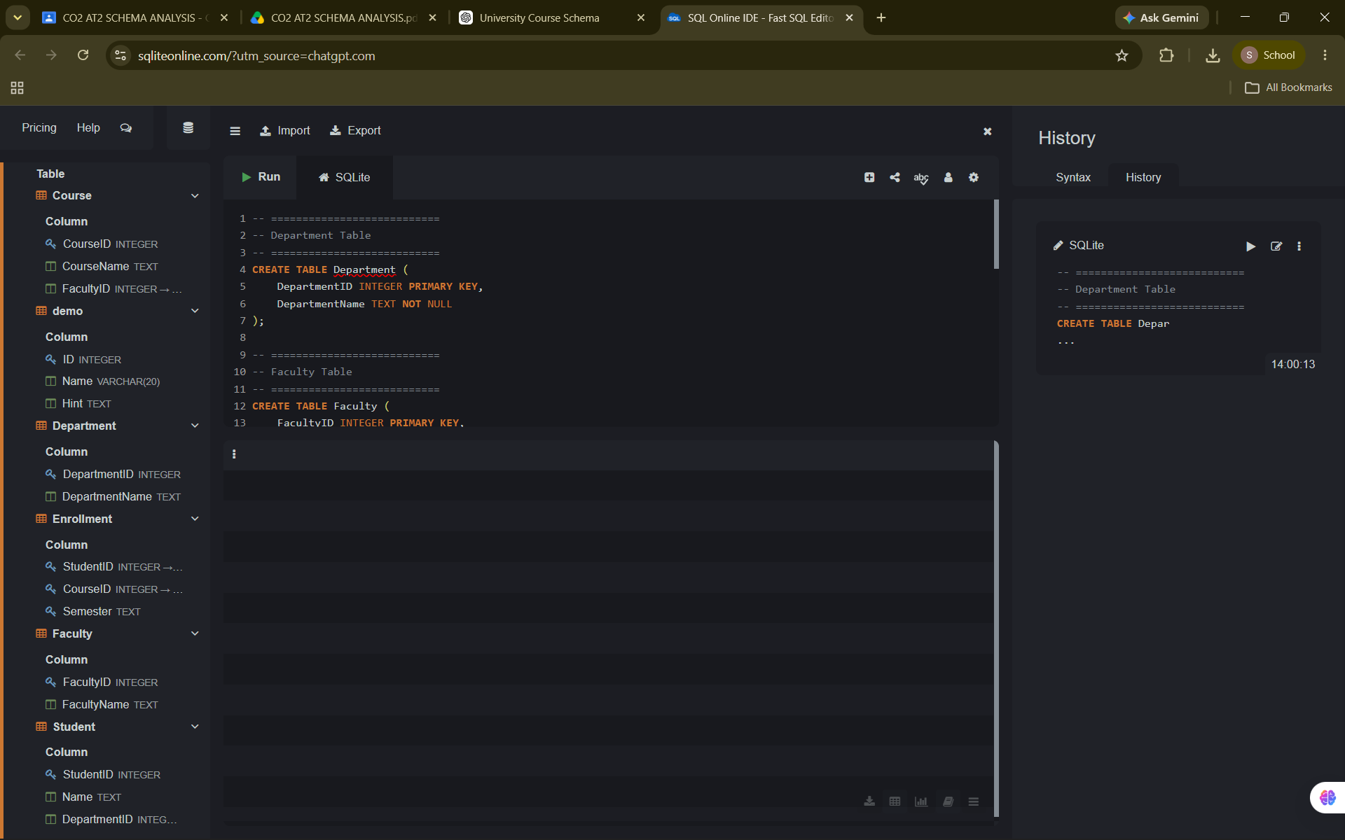
Hospital Management System – Schema Description
The Hospital Management System is designed to manage patient records, doctors, appointments, and prescriptions. The database consists of four tables:
- Patient: Stores patient information such as Patient ID, Name, and Age.
- Doctor: Stores doctor details including Doctor ID, Doctor Name, and Specialization.
- Appointment: Records appointments between patients and doctors, including the appointment date. It connects the Patient and Doctor tables using foreign keys.
- Prescription: Stores the medicines prescribed during a particular appointment. Each prescription is linked to an appointment using the Appointment ID.
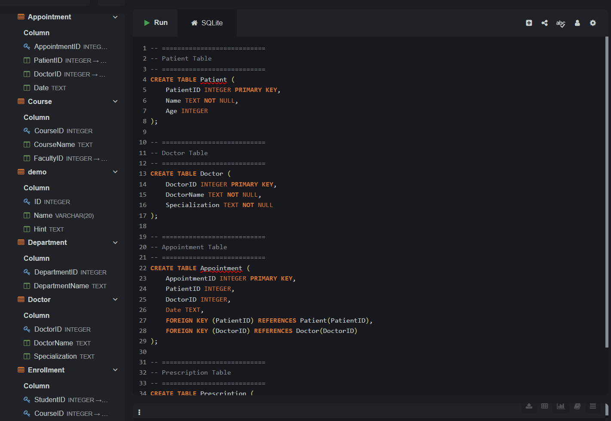
Online Shopping System – Schema Description
The Online Shopping System is designed to manage customers, products, orders, and the products included in each order. The database consists of four tables:
- Customer: Stores customer information such as Customer ID and Name.
- Product: Stores product details including Product ID, Product Name, and Price.
- Order: Records customer orders with the Order ID, Customer ID, and Order Date.
- OrderDetails: Acts as a junction table between the Order and Product tables. It stores the products included in each order along with the quantity of each product.
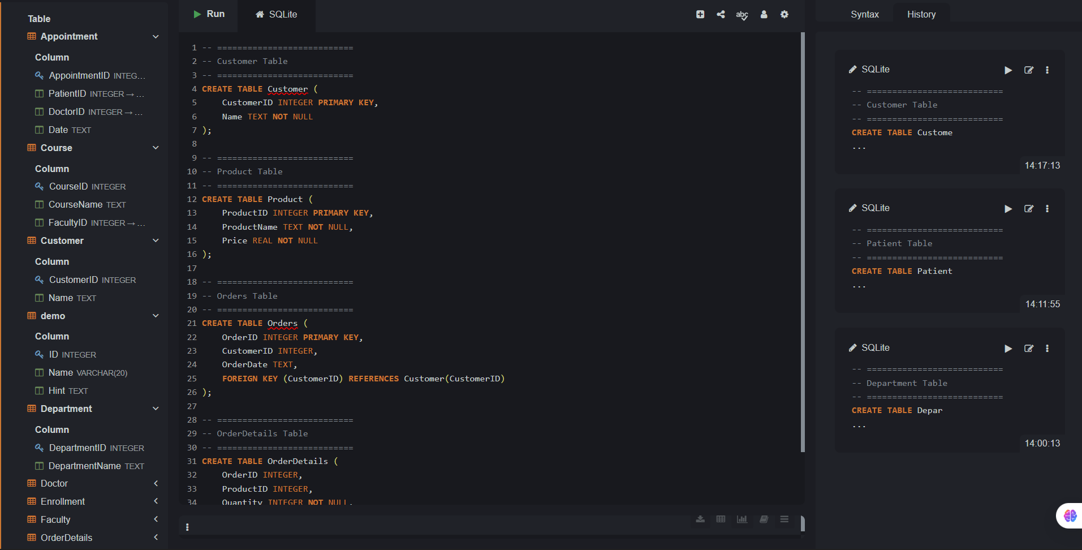
Library Management System – Schema Description
The Library Management System is designed to manage library members, books, and book borrowing records. The database consists of three tables:
- Member: Stores member information such as Member ID and Name.
- Book: Stores book details including Book ID, Title, and Author.
- Issue: Acts as a junction table between the Member and Book tables. It records which member borrowed which book, along with the issue date and return date.
The schema uses primary keys to uniquely identify records and foreign keys to establish relationships between tables. The Issue table supports the many-to-many relationship between members and books, allowing members to borrow multiple books and books to be borrowed by different members over time.
