✅ File read successfully. Cleaning data...

✅ Data cleaning complete.

---------------------------------------------

📚 **Summary: Total Books in Each Genre** 📚

Book_category

Unknown 802

Default 235

Nonfiction 172

Sequential Art 121

Add a comment 104

Fiction 95

Young Adult 81

Fantasy 72

Food and Drink 47

Mystery 45

Childrens 45

Romance 44

Historical Fiction 39

Classics 32

History 30

Poetry 28

Womens Fiction 28

Horror 27

Science Fiction 23

Science 21

Music 19

Travel 18

Thriller 17

Humor 17

Business 16

Autobiography 15

Philosophy 15

Art 13

Psychology 12

Religion 10

Spirituality 9

Biography 9

Christian Fiction 9

Self Help 8

Sports and Games 7

Health 6

New Adult 6

Christian 4

Contemporary 4

Politics 3

Historical 3

Parenting 2

Novels 2

Suspense 2

Paranormal 2

Adult Fiction 2

Crime 1

Erotica 1

Cultural 1

Short Stories 1

Academic 1

---------------------------------------------

📊 Generating chart: Total Books by Genre...

/tmp/ipython-input-4048839351.py:40: FutureWarning: A value is trying to be set on a copy of a DataFrame or Series through chained assignment using an inplace method.

The behavior will change in pandas 3.0. This inplace method will never work because the intermediate object on which we are setting values always behaves as a copy.

For example, when doing 'df[col].method(value, inplace=True)', try using 'df.method({col: value}, inplace=True)' or df[col] = df[col].method(value) instead, to perform the operation inplace on the original object.

df['Quantity'].fillna(0, inplace=True)

/tmp/ipython-input-4048839351.py:41: FutureWarning: A value is trying to be set on a copy of a DataFrame or Series through chained assignment using an inplace method.

The behavior will change in pandas 3.0. This inplace method will never work because the intermediate object on which we are setting values always behaves as a copy.

For example, when doing 'df[col].method(value, inplace=True)', try using 'df.method({col: value}, inplace=True)' or df[col] = df[col].method(value) instead, to perform the operation inplace on the original object.

df['Book_category'].fillna('Unknown', inplace=True)

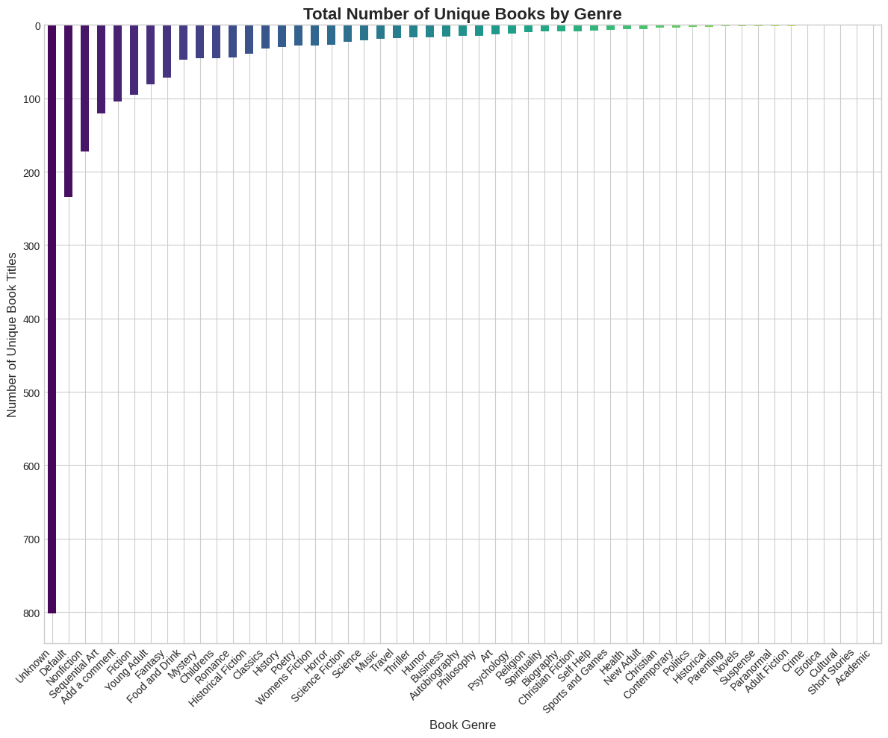📊 Generating chart: Total Stock by Genre...

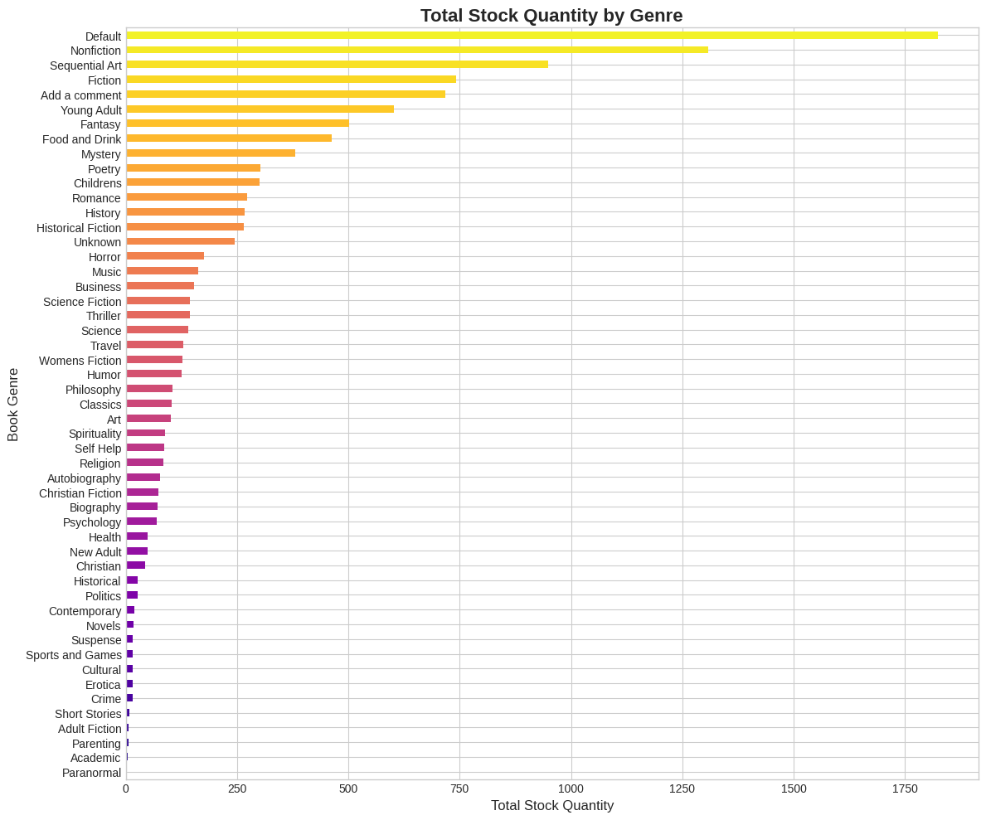📊 Generating chart: Issued Books by Genre...

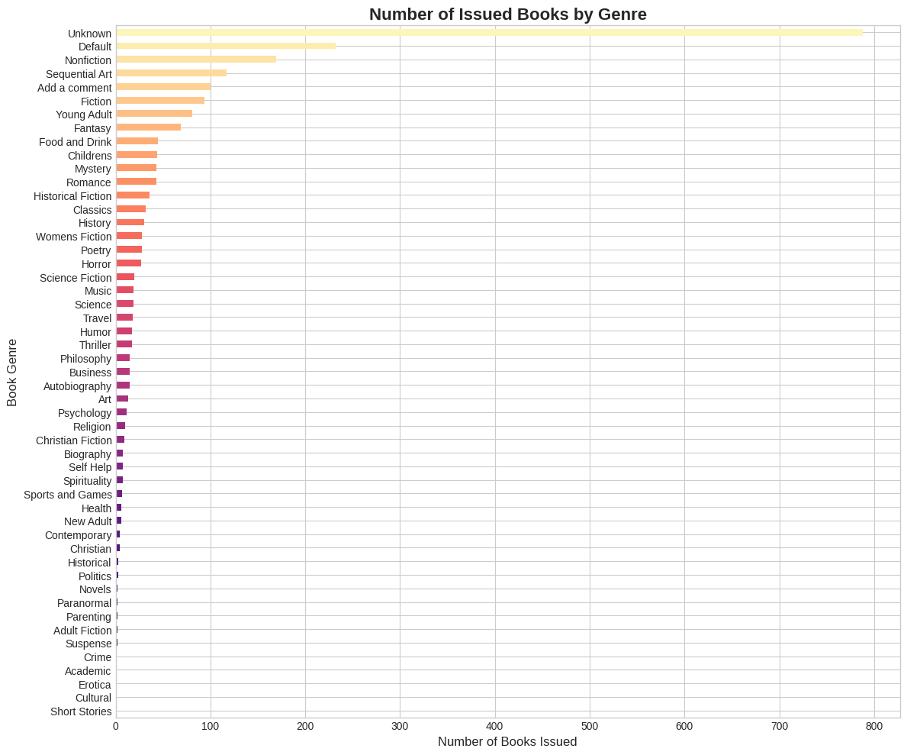💰 Generating chart: Average Price per Genre...

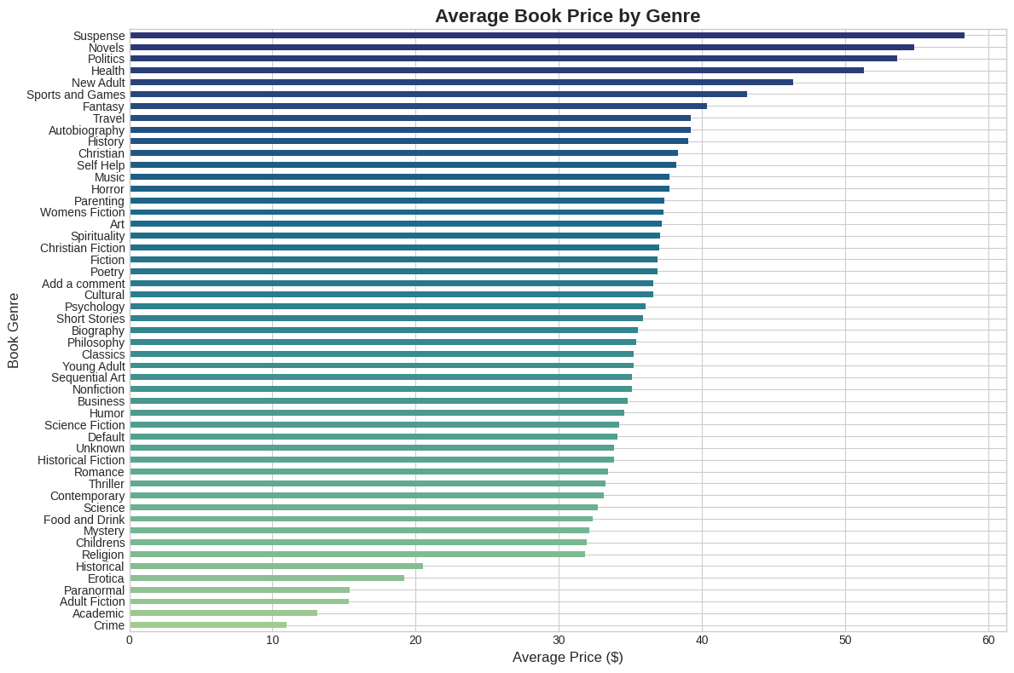🏆 **Top 10 Most Expensive Books** 🏆

Title Book_category Price

NaN Romance 59.99

The Perfect Play (Play by Play #1) Romance 59.99

Last One Home (New Beginnings #1) Fiction 59.98

Last One Home (New Beginnings #1) Fiction 59.98

Last One Home (New Beginnings #1) Fiction 59.98

Civilization and Its Discontents Psychology 59.95

Civilization and Its Discontents Psychology 59.95

Civilization and Its Discontents Psychology 59.95

The Barefoot Contessa Cookbook Food and Drink 59.92

The Barefoot Contessa Cookbook Food and Drink 59.92

---------------------------------------------

⭐ Generating chart: Distribution of Star Ratings...

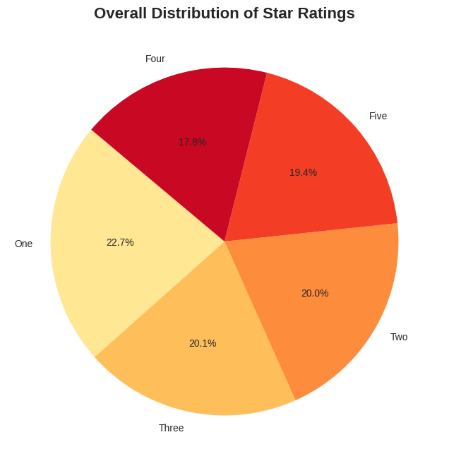🌟 Generating chart: Average Star Rating per Genre...

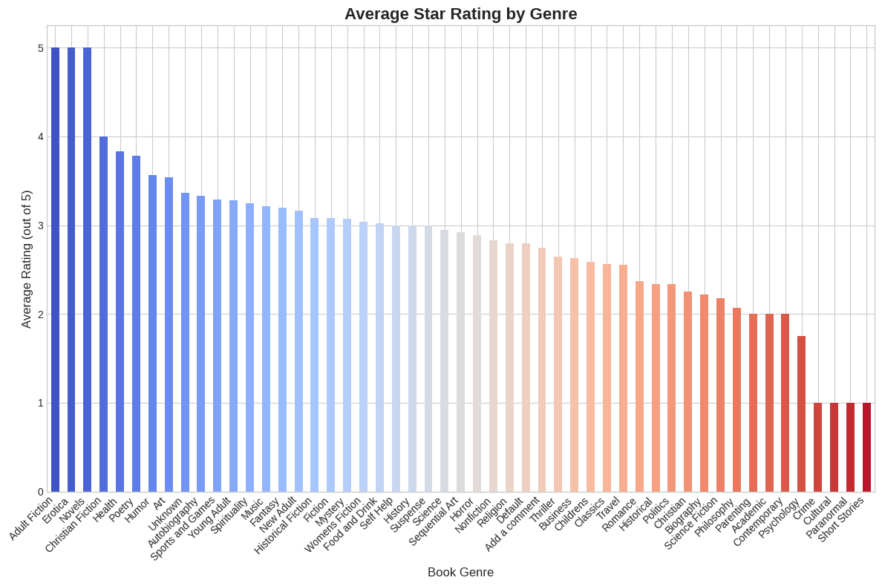📈 Generating chart: Issued-to-Stock Ratio (Popularity)...

