**Image after using Mediapipe**

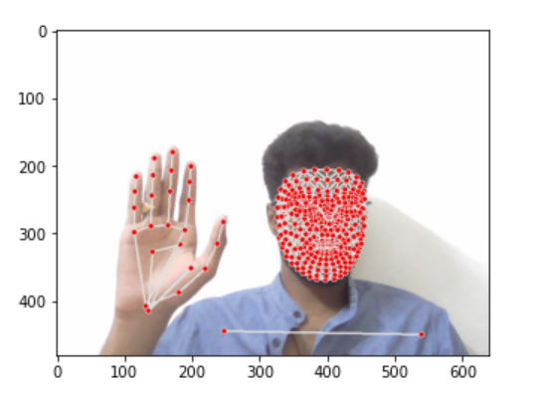

**Training using LSTM model**

|  |  |
| --- | --- |
|  |  |
|  |  |

**Final Outcome After Training**

|  |  |
| --- | --- |
|  |  |

**Thank You**