## CREATE CHATBOT IN PYTHON

**Phase 3 Submission DocumentProjectTitle :**Creatingchatbot

# Phase3:DevelopmentPart 1

**Topic:**Startbuilding a chat bot by preparing the environment and implementing basic user interactions.

# Creating Chatbot

**Introduction:**

Building a chatbot using a specific dataset involves several steps,including setting up the environment and implementing basic userinteractions. In this example, we will demonstrate how to create achatbotusingadatasetobtainedfromKaggle.We'llutilizePythonandlibrariessuchasChatterBottofacilitatethis process.

By following the steps in this example, you'll learn how to set up theenvironment,loadandpreprocesstheKaggledataset,andimplementbasic user interactions with your chatbot. While our chatbot'scapabilities will be confined to the dialogues present in the dataset,this project serves as a foundation for understanding how to leverageexternaldatasets forchatbottraining.

# GivenDataset:

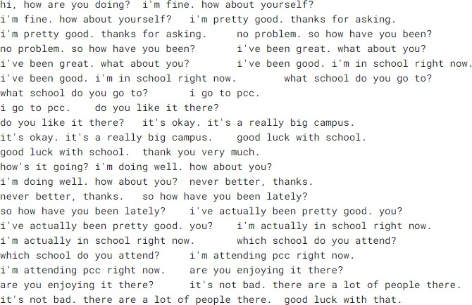

To build a chatbot using the dataset from Kaggle, you can followthesesteps:

## DownloadandPreparetheDataset:

Download the dataset from Kaggle(http[s://www.k](http://www.kaggle.com/datasets/grafstor/simple-dialogs-for-)agg[le.co](http://www.kaggle.com/datasets/grafstor/simple-dialogs-for-)m[/datasets/grafstor/simple-dialogs-for-](http://www.kaggle.com/datasets/grafstor/simple-dialogs-for-)chatbot).

## InstallDependencies:

Install the necessary Python libraries for working with data andbuildingachatbot.We'll usepandas,ChatterBot,andChatterBot'snaturallanguageprocessing library,spacy.

## pipinstallpandas

## pipinstallchatterbot

**pip installchatterbot_corpus**

**pip install flask**

## CreateaPythonScript:

CreateaPythonscript,e.g.,chatbot_with_dataset.py.

## Implement the chatbot:

## Program:

importpandasaspd

fromchatterbotimportChatBot

from chatterbot.trainers import ListTrainerdata=pd.read_csv('dialogues.csv')chatbot=ChatBot('MyBot')

trainer = ListTrainer(chatbot)dialogs = data['User'] + data['Bot']trainer.train(dialogs.tolist())conversation_history=[]

defchat_with_bot():

print("Hello!I'myourchatbot.Youcanstartaconversation,ortype'exit'toquit.")

whileTrue:

user_input=input("You:")

if user_input.lower() == 'exit':print("Bot: Goodbye!")break

elif user_input.lower() == 'history':print("Bot: Conversation History")forentryinconversation_history:

print(entry)

elif user_input.lower() == 'clear history':conversation_history.clea()

print("Bot: Conversation history )

else:

response=chatbot.get_response(user_input)

conversation_history.append(f"You: {user_input}")conversation_history.append(f"Bot:{response}")

print("Bot:",response)

chat_with_bot()

## Runthe Chatbot:

Run the Python script by executing python chatbot_with_dataset.py interminal orIDE.

# SampleOutput:

### Hello! I'm your chat bot. You can start

### a conversation,or type' exit' to quit**.**

**You:**hi,howareyoudoing?

**Bot:**i’m fine how about yourself ?

**You:**What's the weather like

today?

### **Bot:** I'm not sure about the weather. I'm just a chatbot.

**You:**history

### **Bot:**Conversation History

**You:**hi,how are you doing?

**Bot:**i’m fine how about yourself ?

You**:**What's the weather like today?

### **Bot:** I'm not sure about the weather. I'm just a chatbot.

**You:**clear history

### **Bot:**Conversation history cleared.

**You:** exit

**Bot:** Goodbye!

# keytasks involvedin creatinga chatbot:

## Define Purposeand Use Case:

Determine the specific purpose and use case for your chatbot.Consider whether itwill provide customersupport, answer frequently asked questions, assist with tasks, or engage in casualconversations.

## Select a Platform:

Decide on the platform where your chatbot will be deployed.This could be a website, messaging apps (e.g., Facebook Messenger,WhatsApp),or a custom application.

## Choose the Technology Stack:

Select the technologies and tools you'll use to build the chatbot, including programming languages, libraries, andframeworks. Common choices include Python,JavaScript,Node.js,and machine learning libraries like TensorFloworPyTorch.

## Data Collection and Preprocessing:

Collect and preprocess data for training your chatbot. This may involve gathering conversation datasets,cleaning and formatting the data,and extracting relevant information.

## Train the Chatbot:

Train your chatbot using appropriate datasets. This training caninvolve supervised learning, reinforcement learning, or rule-basedapproaches,dependingon thecomplexityofyourchatbot.

## Natural LanguageProcessing(NLP):

Implement Natural Language Processing techniques to enable thechatbot to understand and generate human-like text. This may includetasks like tokenization, entity recognition, sentiment analysis, andintentdetection.

# Conclusion:

Building a chatbot is an exciting and complex endeavor with thepotential to revolutionize various industries and enhance userexperiences. In this process, we've explored the fundamental steps andconsiderationsinvolved increatinga chatbot