**ATTENDIX**

**A PROJECT REPORT**

**ON**

**“Attendix”**

Version: 1.0

FOR

**“KEPREVOS ENTERPRISE AND BUSINESS SOLUTION”**

BY

**BALA KRISHNAN**

**GOPIKA**

**HARI SUNDAR**

**ABSTRACT**

Attendix project aims to develop a comprehensive and user-friendly software solution designed to streamline and enhance the efficiency of HR processes within an organization. The primary objective of this system is to automate and integrate various HR functions such as employee data management, recruitment, performance evaluation, attendance tracking, payroll processing, and benefits administration. The Attendix leverages modern web technologies to provide an intuitive interface for HR professionals, employees, and management. It offers a centralized platform that facilitates seamless communication, data sharing, and decision-making. Key features of the system include a secure employee database, automated recruitment workflows, performance appraisal modules, attendance and leave management, payroll calculations, and customizable reporting tools. By implementing the Attendix, organizations can reduce manual administrative tasks, minimize errors, and ensure compliance with regulatory requirements. The system's analytics capabilities provide valuable insights into workforce trends and performance metrics, aiding in strategic planning and resource allocation. Ultimately, the Attendix contributes to a more efficient, transparent, and responsive HR function, enhancing overall organizational productivity and employee satisfaction. The development of this system involves a thorough analysis of current HR processes, user requirements, and industry best practices. The project follows an agile methodology to ensure continuous improvement and adaptability to evolving organizational needs. The Attendix project stands to significantly improve HR operations, making it an indispensable tool for modern businesses.

**TABLE OF CONTENT**

|  |  |  |
| --- | --- | --- |
| **MODULES NO** | **TITLE** | **PAGE**  **NO** |
|  | **ABSTRACT** | **iii** |
|  |  |  |
|  |  |  |
|  |  |  |
|  |  |  |
|  |  |  |
|  |  |  |
|  |  |  |
|  |  |  |
|  |  |  |
|  |  |  |
|  |  |  |
|  |  |  |
|  |  |  |
|  |  |  |
|  |  |  |
|  |  |  |
|  |  |  |
|  |  |  |
|  |  |  |
|  |  |  |
|  |  |  |
|  |  |  |
|  |  |  |
|  |  |  |
|  |  |  |
|  |  |  |
|  |  |  |
|  |  |  |

**MODULE 1**

1. **LOGIN PAGE :**
   1. **SIGN PAGE:**

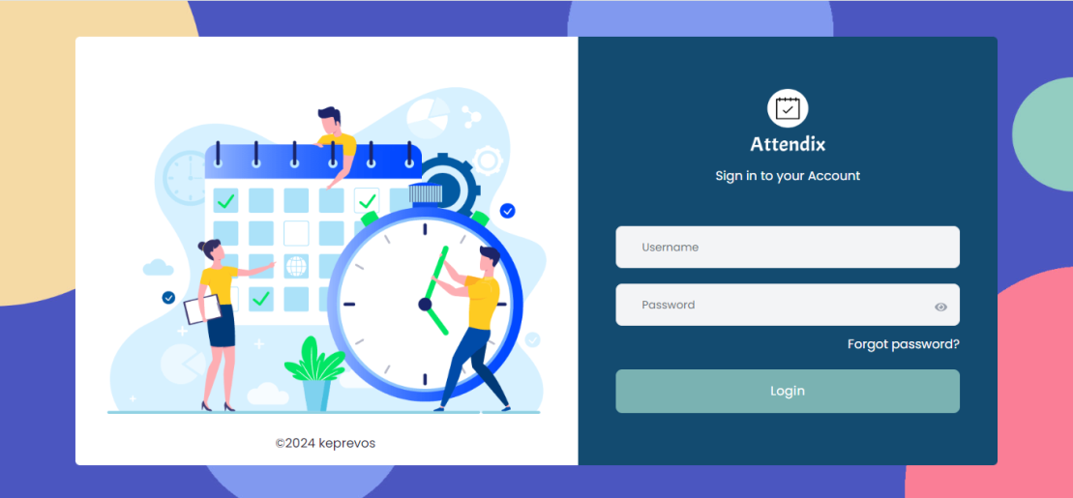

The Attendix sign-in page allows users to access their accounts by entering their credentials. The design focuses on simplicity and user-friendliness, featuring a clear interface and relevant illustrations to enhance the user experience.

**Left Section: Illustration**

* + **Purpose**: Visually represents the application's focus on scheduling and time management.
  + **Elements**:
    - **Calendar**: Indicates dates, likely for attendance tracking or event scheduling.
    - **Clock**: Emphasizes the importance of time management.
    - **Characters**: Show interaction with the calendar and clock, making the page more engaging.

**Right Section: Sign-In Form**

* + **Header**:
    - **Logo**: A calendar icon representing the Attendix application.
    - **Title**: "Attendix" to indicate the application name.
    - **Subtitle**: "Sign in to your Account" provides clear instructions to the user.
  + **Form Fields**:
    - **Username**:
      * **Type**: Text input field.
      * **Placeholder**: "Username".
    - **Password**:
      * **Type**: Password input field.
      * **Placeholder**: "Password".
      * **Eye Icon**: Allows users to toggle visibility of the password.
  + **Links**:
    - **Forgot Password**:
      * **Text**: "Forgot password?"
      * **Function**: Redirects users to the password recovery process.
  + **Button**:
    - **Login**:
      * **Type**: Submit button.
      * **Text**: "Login".
      * **Function**: Submits the entered credentials for authentication.

1. **Footer**
   * **Text**: copyright holder and year.

**Functions and Interactions**

* **Username Input**: Users enter their username.
  + **Validation**: Ensure this field is not empty before submission.
* **Password Input**: Users enter their password.
  + **Validation**: Ensure this field is not empty before submission.
  + **Password Visibility Toggle**: Users can click the eye icon to show or hide the password.
* **Forgot Password Link**: Redirects users to a password recovery page.
* **Login Button**: Submits the form data for authentication.
  + **Validation**: Check that both username and password fields are filled out.
  + **Action**: Send a POST request to the server with the credentials.

**Design and User Experience**

* **Responsive Design**: Ensure the page is accessible and functions well on various devices and screen sizes.
* **Accessibility**:
  + Use ARIA labels for form fields.
  + Ensure contrast ratios meet accessibility standards.
  + Provide keyboard navigation for all interactive elements.
  1. **FORGOT EMAIL PAGE:**

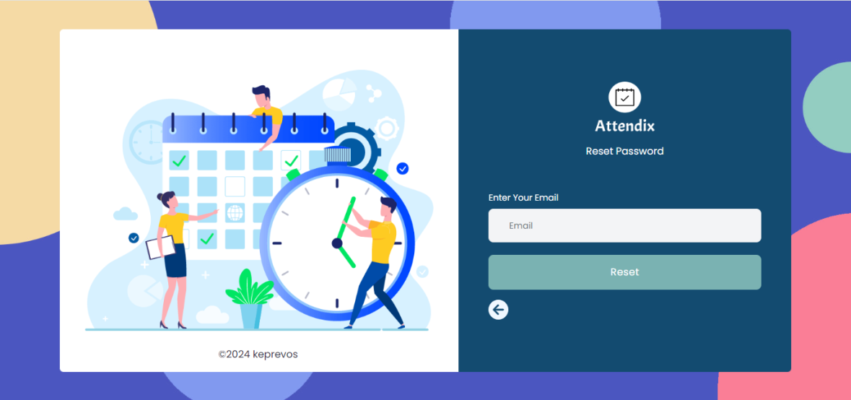

**Reset Password Form**

* + **Header**:
    - **Logo**: A calendar icon representing the Attendix application.
    - **Title**: "Attendix" to indicate the application name.
    - **Subtitle**: "Reset Password" provides clear instructions to the user.
  + **Form Fields**:
    - **Enter Email**:
      * **Type**: Text input field.
      * **Placeholder**: "Email".
  + **Button**:
    - **Rest**:
      * **Type**: Submit button.
      * **Text**: "Rest".
      * **Function**: Send OTP to Given Email Address For validation.
    - **Back:**
      * **Type:** Icon
      * **Function :** Navigate to Sign In Page
  1. **OTP VALIDATION PAGE:**

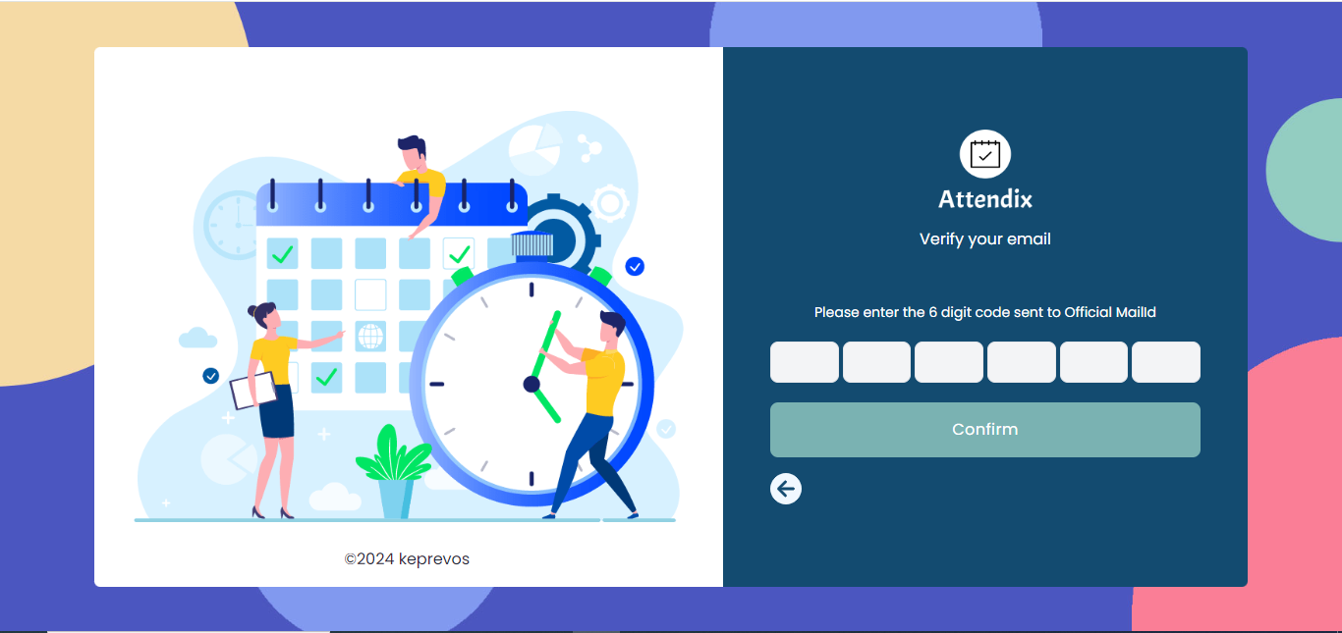

The right side of the Attendix email verification page is designed to guide users through the process of verifying their email addresses. Here's a detailed description of the elements and their functions:

#### Right Section: Verification Form

* **Header:**
  + **Icon**: A calendar icon, similar to the one on the sign-in page, reinforcing the Attendix brand identity.
  + **Title**: "Attendix" to indicate the application name.
  + **Subtitle**: "Verify your email" instructing users on the purpose of this page.
* **Instruction:**
  + **Text**: "Please enter the 6 digit code sent to Official Mail Id" provides clear guidance on what the user needs to do.
* **Input Fields:**
  + **Code Input Boxes**:
    - **Description**: Six individual input boxes where users enter the 6-digit verification code.
    - **Function**: Each box accepts a single digit, ensuring the code is entered correctly and completely.
* **Button:**
  + **Confirm**:
    - **Type**: Submit button.
    - **Text**: "Confirm".
    - **Function**: Submits the entered verification code for validation.
* **Navigation:**
  + **Back Arrow Icon**:
    - **Function**: Allows users to navigate back to the previous page if needed.
  1. **PASSWORD RESET PAGE:**

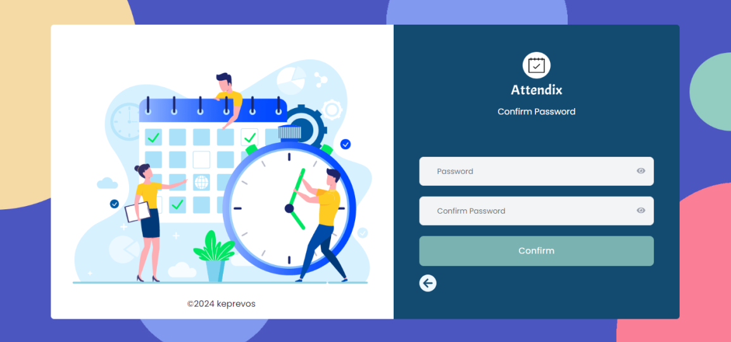

The right side of the Attendix password confirmation page is designed to facilitate users in setting or confirming their password. Below is a detailed description of the elements and their functions:

#### Right Section: Password Confirmation Form

* **Header:**
  + **Icon**: A calendar icon, consistent with the Attendix brand.
  + **Title**: "Attendix" to indicate the application name.
  + **Subtitle**: "Confirm Password" instructing users on the purpose of this page.
* **Form Fields:**
  + **Password Input**:
    - **Label**: "Password".
    - **Type**: Password input field.
    - **Placeholder**: "Password".
    - **Eye Icon**: Allows users to toggle the visibility of the password.
    - **Function**: Users enter their new or current password.
  + **Confirm Password Input**:
    - **Label**: "Confirm Password".
    - **Type**: Password input field.
    - **Placeholder**: "Confirm Password".
    - **Eye Icon**: Allows users to toggle the visibility of the password.
    - **Function**: Users re-enter their password for confirmation.
* **Button:**
  + **Confirm**:
    - **Type**: Submit button.
    - **Text**: "Confirm".
    - **Function**: Submits the entered passwords for validation and confirmation.
* **Navigation:**
  + **Back Arrow Icon**:
    - **Function**: Allows users to navigate back to the previous page if needed.