E-Commerce Order Management System – Project Documentation
- Overview
This project demonstrates a microservices-based Order Management System (OMS) built using Spring Boot, MySQL, and AWS.
It simulates an e-commerce workflow where users can place orders, check inventory, and track order statuses.
The system is designed for scalability, maintainability, and independent deployments.

- Architecture
The application consists of two microservices:
Service | Responsibility
Inventory Service | Manages product details and stock quantities.
Order Service | Handles order creation, status updates, and interacts with Inventory Service to validate stock.
Communication:
- The Order Service uses Feign Client to call the Inventory Service.
- Both services maintain independent databases in AWS RDS.
Deployment:
- Each service is deployed on AWS Elastic Beanstalk.
High-Level Flow:
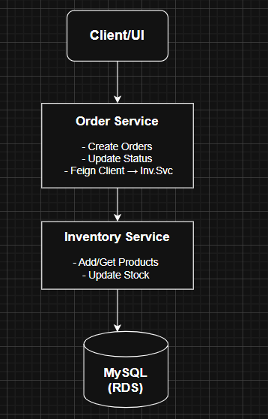

- Tech Stack
- Language: Java 17
- Framework: Spring Boot
- Database: MySQL (AWS RDS)
- Communication: Feign Client (REST)
- Build Tool: Maven
- Deployment: AWS Elastic Beanstalk
- Testing: Postman

- Core Features
- Place new orders
- Validate and reduce inventory stock
- Update order status (PENDING, SHIPPED, DELIVERED)
- Prevent overselling through synchronized updates
- Error handling for insufficient stock and invalid orders

- API Endpoints

- Inventory Service
Method | Endpoint | Description
POST | /api/inventory | Add a new product
GET | /api/inventory | Get all products
GET | /api/inventory/{id} | Get product by ID
PUT | /api/inventory/{id}/add-stock?quantity={q} | Increase stock
PUT | /api/inventory/{id}/reduce?quantity={q} | Reduce stock

- Order Service
Method | Endpoint | Description
POST | /api/orders | Place a new order
GET | /api/orders/{id} | Get order by ID
PUT | /api/orders/{id}/status?status={STATUS} | Update order status

- Database Schema
Inventory Table
Field | Type | Description
product_id | BIGINT (PK) | Product identifier
product_name | VARCHAR | Product name
stock_quantity | INT | Available stock
price | DOUBLE | Product price
last_updated | DATETIME | Timestamp of last change
Orders Table
Field | Type | Description
order_id | BIGINT (PK) | Unique order identifier
user_id | BIGINT | Customer ID
total_amount | DOUBLE | Total order value
order_status | ENUM | Current order status
created_at | DATETIME | Creation timestamp
updated_at | DATETIME | Last update timestamp
Order Items Table
Field | Type | Description
id | BIGINT (PK) | Order item ID
product_id | BIGINT | Product reference
quantity | INT | Quantity ordered
total_price | DOUBLE | Price × quantity
order_id | BIGINT (FK) | References orders table

- How to Run Locally
- Create Databases
- CREATE DATABASE order_db;
- CREATE DATABASE inventory_db;
- Update application.properties
  - In inventory-service → use inventory_db
  - In order-service → use order_db
- Start Both Services
- mvn spring-boot:run
- Test APIs using Postman (collection included in /postman folder).

- AWS Deployment
Service | Environment | URL
Inventory Service | Elastic Beanstalk | http://65.0.244.55
Order Service | Elastic Beanstalk | http://13.200.70.246
Database | AWS RDS | Two MySQL instances (one per service)

- Postman Collection
- /postman/ecommerce-oms-collection.json
- /postman/ecommerce-oms-prod-environment.json
Import both into Postman and select the Prod environment to test live APIs.

Author
Sundar Mandali
Backend Developer | Java | Spring Boot | Microservices
Email: mandalisundar859@gmail.com
GitHub: https://github.com/sundarmandali

