SOFTWARE ENGINEERING AND PROJECT MANAGEMENT
(21CSC303J)
A PROJECT REPORT
ON
SRSify AI — AI-Powered SRS Generator
Submitted by
DEEPA K RA2311026050053

Under the Guidance of
Dr.M. Padma Priya ,Ph.D
Assistant Professor Department of Computer Science & Engineering

In partial fulfilment for the award of the degree
Of
BACHELOR OF TECHNOLOGY
IN
COMPUTER SCIENCE AND ENGINEERING WITH SPECIALIZATION IN ARTIFICIAL INTELLIGENCE AND MACHINE LEARNING
Of

FACULTY OF ENGINEERING AND TECHNOLOGY
SRM Institute of Science and Technology
Tiruchirappalli, Tamil Nadu – 621105
MAY 2026

SRM INSTITUTE OF SCIENCE AND TECHNOLOGY TIRUCHIRAPPALLI
BONAFIDE CERTIFICATE

Certified that this project report titled SRSify AI — AI-Powered SRS Generator is the Bonafide work of Deepa K RA2311026050053, who carried out the project work under my supervision.

Certified further that, to the best of my knowledge, the work reported herein does not form part of any other project report or dissertation on the basis of which a degree or award was conferred on an earlier occasion on this or any other candidate.

SIGNATURE

Dr.M.Padma Priya
GUIDE
Assistant Professor
Department of Computer Science & Engineering

Signature of the Internal Examiner
SIGNATURE

Dr.R.Balaji Ganesh
HEAD OF THE DEPARTMENT
Department of Artificial Intelligence and Machine Learning

Signature of the External Examiner

TABLE OF CONTENTS
Date | S.No | Title | Page No | Signature
06-Jan-2026 | Ex1 | Problem Definition | 1
06-Jan-2026 | 1.1 | Introduction | 1
06-Jan-2026 | 1.2 | Problem Statement | 2
06-Jan-2026 | 1.3 | Proposed Solution | 3
06-Jan-2026 | 1.4 | Objectives | 4
06-Jan-2026 | 1.5 | Scope of the Project | 5
13-Jan-2026 | Ex2 | Literature Review | 6
13-Jan-2026 | 2.1 | Existing Systems | 6
13-Jan-2026 | 2.2 | Limitations | 7
13-Jan-2026 | 2.3 | Research Gap | 8
13-Jan-2026 | 2.4 | Proposed System | 9
20-Jan-2026 | Ex3 | System Analysis | 10
20-Jan-2026 | 3.1 | Stakeholders | 10
20-Jan-2026 | 3.2 | User Personas | 11
20-Jan-2026 | 3.3 | Functional Requirements | 12
20-Jan-2026 | 3.4 | Non-Functional Requirements | 13
20-Jan-2026 | 3.5 | Feasibility Study | 14
27-Jan-2026 | Ex4 | System Design | 15
27-Jan-2026 | 4.1 | Architecture Overview | 15
27-Jan-2026 | 4.2 | Module Design | 16
27-Jan-2026 | 4.3 | Data Flow Diagram | 17
27-Jan-2026 | 4.4 | User Interface Design | 18
03-Feb-2026 | Ex5 | UML Diagrams | 19
03-Feb-2026 | 5.1 | Use Case Diagram | 19
03-Feb-2026 | 5.2 | Activity Diagram | 20
03-Feb-2026 | 5.3 | Sequence Diagram | 21
03-Feb-2026 | 5.4 | Component Diagram | 22
10-Feb-2026 | Ex6 | Implementation | 23
10-Feb-2026 | 6.1 | Development Environment | 23
10-Feb-2026 | 6.2 | Frontend Implementation | 24
10-Feb-2026 | 6.3 | Backend Implementation | 25
10-Feb-2026 | 6.4 | AI Integration | 26
17-Feb-2026 | Ex7 | Testing | 27
17-Feb-2026 | 7.1 | Testing Types | 27
17-Feb-2026 | 7.2 | Test Cases | 28
17-Feb-2026 | 7.3 | Results | 29
24-Feb-2026 | Ex8 | Results and Output | 30
24-Feb-2026 | 8.1 | Sample Input | 30
24-Feb-2026 | 8.2 | Generated Output | 31
24-Feb-2026 | 8.3 | Performance Analysis | 32
03-Mar-2026 | Ex9 | Project Management | 33
03-Mar-2026 | 9.1 | Methodology | 33
03-Mar-2026 | 9.2 | Timeline | 34
03-Mar-2026 | 9.3 | Risk Management | 35
10-Mar-2026 | Ex10 | Conclusion | 36
10-Mar-2026 | 10.1 | Conclusion | 36
10-Mar-2026 | 10.2 | Future Work | 37
17-Mar-2026 | Ex11 | References | 38

EX1: PROBLEM DEFINITION
1.1 Introduction
In today’s fast-paced software development environment, proper documentation plays a crucial role in ensuring the success of any project. One of the most important documents in the software development lifecycle is the Software Requirements Specification (SRS). It defines the system’s functionality, constraints, and overall behavior in a structured format.
However, preparing an SRS document manually is a time-consuming and complex process, especially for students and beginners who lack experience in technical documentation. It requires a clear understanding of system design, requirement gathering, and proper formatting standards such as IEEE guidelines.
To address this challenge, the proposed system SRSify AI is developed. It is an intelligent web-based application that automatically generates a complete SRS document from a simple natural language input provided by the user. By leveraging advanced AI models, the system simplifies the documentation process and enables users to focus more on innovation rather than manual writing.

1.2 Problem Statement
Despite the importance of SRS documents, many individuals face difficulties in creating them due to the following reasons:
- Lack of knowledge about standard SRS formats such as IEEE standards
- Difficulty in identifying and organizing functional and non-functional requirements
- Time-consuming manual documentation process
- Inconsistency and errors in writing technical documents
- Limited tools available for automated SRS generation
As a result, students and developers often produce incomplete or poorly structured documentation, which affects the overall quality of the software project.

1.3 Proposed Solution
To overcome the above challenges, the system SRSify AI is proposed. It is an AI-powered SRS generator that converts a user’s project idea into a structured and professional SRS document.
- The system works as follows:
- The user provides a project idea in natural language
- The system processes the input using an AI model
- A structured SRS document is generated automatically

- The output includes:
  - Introduction and system description
  - Functional and non-functional requirements
  - User personas
  - System architecture overview
  - Diagrams (Use Case and Architecture)
This solution significantly reduces manual effort, improves accuracy, and ensures compliance with standard documentation practices.

1.4 Objective:
The main objectives of the project are:
- To automate the generation of Software Requirements Specification documents
- To reduce the time and effort required for documentation
- To generate structured and standardized SRS documents
- To assist students and developers in understanding system requirements
- To provide additional outputs such as personas and system diagrams
- To improve the overall quality and consistency of software documentation

1.5 Scope of the Project
The scope of the SRSify AI project includes:
- Accepting user input in natural language format
- Generating a complete SRS document based on the input
- Displaying the output in an organized and readable format
- Providing visualization through diagrams
- Exporting the generated document as PDF or Markdown
Limitations:
- The system depends on AI-generated responses, which may require minor manual corrections
- It does not replace expert-level requirement engineering completely
- Internet connection is required for AI processing

EX2: LITERATURE REVIEW
2.1 Existing Systems
Software Requirements Specification (SRS) documentation has traditionally been created manually using tools such as Microsoft Word, Google Docs, and other text editors. These tools provide flexibility for writing documents but do not offer automation or intelligent assistance in structuring SRS content.
In recent years, some advanced tools and platforms have emerged to assist in documentation and requirement management, such as:
- Jira – Used for requirement tracking and project management
- Confluence – Used for documentation and knowledge sharing
- IBM Rational DOORS – Enterprise-level requirement management tool
Additionally, with the rise of Artificial Intelligence, tools like ChatGPT and Google Gemini can generate text-based content, including documentation, based on user input.

2.2 Limitations of Existing Systems
Despite the availability of these tools, several limitations still exist:
- Manual Effort: Traditional tools require users to write the entire SRS manually
- Lack of Standardization: Users may not strictly follow IEEE SRS format
- Complexity: Tools like IBM Rational DOORS are complex and not beginner-friendly
- No Full Automation: Most tools assist in writing but do not fully generate complete SRS documents
- Limited Integration of AI: AI tools provide generic responses but lack structured output specifically for SRS
These limitations make it difficult for students and beginners to create professional and well-structured SRS documents efficiently.

2.3 Research Gap
From the analysis of existing systems, the following research gaps are identified:
- Lack of a fully automated SRS generation system
- Absence of tools that combine AI with structured IEEE documentation format
- Limited support for generating diagrams (Use Case, Architecture) automatically
- No integrated system that provides personas, requirements, and documentation together
- Difficulty in converting natural language ideas into structured technical documents

This gap highlights the need for a system that can bridge the difference between user ideas and formal documentation.
2.4 Proposed System (SRSify AI)
To address the identified gaps, the proposed system SRSify AI is developed as an intelligent solution.
Key Features of Proposed System:
- Accepts project ideas in natural language
- Uses AI to generate structured SRS documents
- Follows standard documentation practices
- Generates:
  - Functional & Non-functional requirements
  - User personas
  - System diagrams using Mermaid
- Provides export options (PDF & Markdown)

Advantages over Existing Systems:
Feature | Existing Systems | SRSify AI
Automation | No | Yes
AI Integration | Partial | Advanced
Diagram Generation | No | Yes
Ease of Use | Moderate | High
Time Efficiency | Low | High

The proposed system significantly improves productivity, accuracy, and usability in SRS document generation.

EX3: SYSTEM ANALYSIS
3.1 Stakeholders
Stakeholders are individuals or groups who are directly or indirectly affected by the system.
Primary Stakeholders
- Students
Use the system to generate SRS documents for academic projects
- Software Developers
Use generated SRS as a reference for development
- Project Managers
Use SRS for planning, tracking, and managing project requirements
Secondary Stakeholders
- Faculty/Professors
Evaluate the generated documentation
- Organizations/Startups
Use the system for quick requirement documentation
Stakeholder Needs
- Easy-to-use interface
- Accurate and structured SRS output
- Time-saving solution
- Exportable documents

3.2 User Personas
Personas represent typical users of the system.
Persona 1: Student User
- Name: Ananya
- Role: Engineering Student
- Goal: Quickly generate SRS for academic submission
- Problem: Lack of knowledge in writing technical documentation
Persona 2: Developer
- Name: Rahul
- Role: Junior Software Developer
- Goal: Understand project requirements clearly
- Problem: Needs structured documentation
Persona 3: Faculty
- Name: Dr. Meena
- Role: Professor
- Goal: Evaluate student project documentation
- Problem: Needs standardized and clear reports

3.3 Functional Requirements
Functional requirements define what the system should do.
FR1: User Input
- System should allow users to enter project ideas
FR2: SRS Generation
- System should generate structured SRS documents
FR3: Persona Generation
- System should generate user personas
FR4: Diagram Generation
- System should generate:
- Use Case Diagram
- System Architecture Diagram
FR5: Display Output
- System should display results in organized format
FR6: Export Feature
- System should allow export as:
  - PDF
  - Markdown

3.4 Non-Functional Requirements
Non-functional requirements define system quality.
Performance
- System should generate output within 15–30 seconds
Usability
- Interface should be user-friendly and responsive
Reliability
- System should handle errors gracefully
Scalability
- System should support multiple users
Security
- API keys should be securely stored

3.5 Feasibility Study
Technical Feasibility
- Technologies used:
  - Next.js
  - AI API (Gemini)
- Easily implementable with modern tools
- Feasible
Economic Feasibility
- Uses free hosting (Vercel/Netlify)
- Low AI cost (~$1–2 per 1000 users)
- Cost-effective
Operational Feasibility
- Simple UI → easy to use
- No technical expertise required
- User-friendly
Schedule Feasibility
- Can be developed within short time (2–4 weeks)
- Time feasible

EX4: SYSTEM DESIGN
4.1 Architecture Overview
The SRSify AI system follows a client-server architecture where the frontend, backend, and AI service work together to generate the SRS document.
Architecture Components:
- Frontend (Client Side)
Built using Next.js
  - Handles user input
  - Displays generated output
Backend (Server Side)
- Implemented using Next.js API routes
- Processes user requests
- Communicates with AI service
AI Service
Uses Google Gemini
- Generates structured SRS content
- Returns JSON response
Rendering Engine
Uses Mermaid
- Converts text into diagrams
Working Flow
- User enters project idea
- Request sent to backend API
- Backend calls AI model
- AI generates SRS content
- Response sent back to frontend
- Output displayed to user

4.2 Module Design
The system is divided into the following modules:
1. Input Module
- Accepts user input (project idea)
- Validates input
2. Processing Module
- Sends request to backend
- Handles API communication
3. AI Generation Module
- Interacts with Gemini API
- Generates:
  - SRS content
  - Personas
  - Diagrams
4. Output Module
- Displays generated SRS
- Organizes content into tabs
5. Export Module
- Converts output into:
  - PDF
  - Markdown

4.3 Data Flow Diagram (DFD Description)
The Data Flow Diagram illustrates how data moves through the system.
DFD Explanation
- User provides input
- Input is processed by the system
- Data is sent to AI service
- AI processes and returns structured output
- Output is displayed to user
Key Elements
- External Entity: User
- Processes: Input, Processing, AI Generation, Output
- Data Flow: Project idea → SRS document

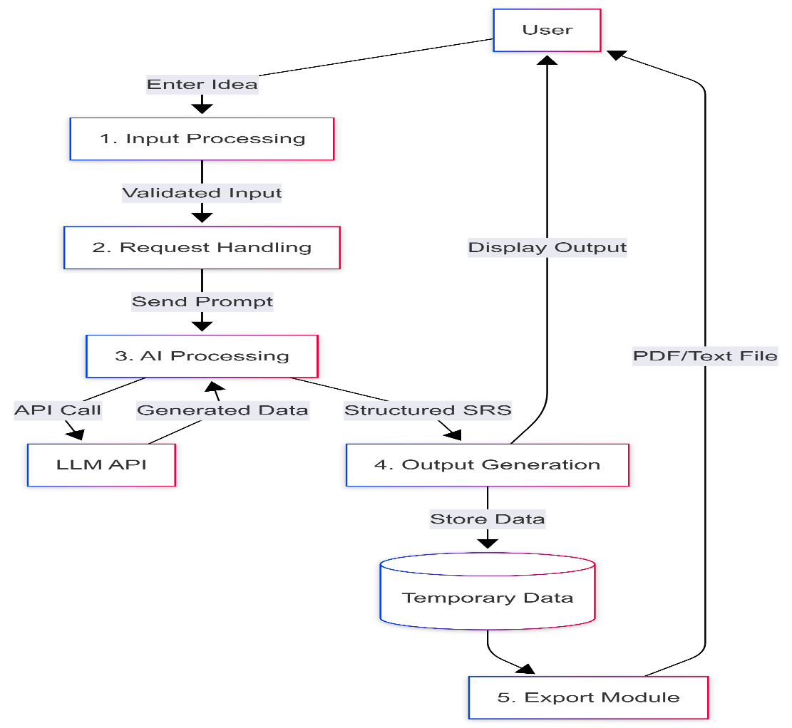
Fig.1 DFD diagram
4.4 User Interface Design
The user interface is designed to be simple, modern, and responsive.
UI Components
- Input Section
  - Text area for entering project idea
  - Generate button
- Output Section
  - Tabbed view:
    - Document
    - Personas
    - Diagrams
- Export Options
  - Download as PDF
  - Download as Markdown

Design Features
- Clean layout using Tailwind CSS
- Responsive design (mobile + desktop)
- Easy navigation between tabs
- Error messages for invalid input
User Experience Goals
- Minimal learning curve
- Fast interaction
- Clear presentation of results

EX5: UML DIAGRAMS
5.1 Use Case Diagram
The Use Case Diagram represents the interaction between the user and the system.
Description:
The primary actor is the User, who interacts with the system to perform various operations such as entering a project idea, generating the SRS document, viewing outputs, and exporting the results.
Use Cases
- Enter Project Idea
- Generate SRS
- View Document
- View Personas
- View Diagrams
- Export Report
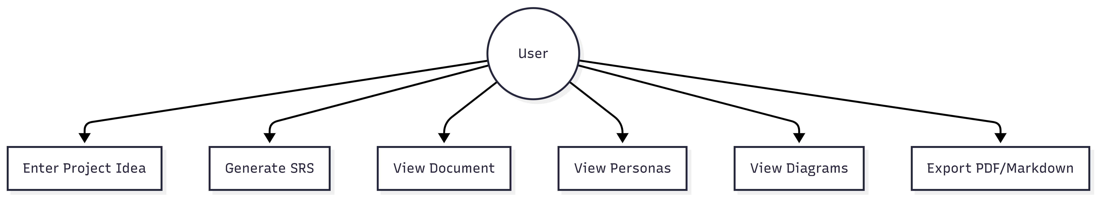Fig.2 Use Case Diagram

5.2 Activity Diagram
The Activity Diagram shows the workflow of the system.
Description:
It illustrates the sequence of actions starting from user input to displaying the generated SRS output.
Workflow Steps
- User enters project idea
- System validates input
- Request sent to backend
- AI generates content
- Output is processed
- Results displayed

Diagram
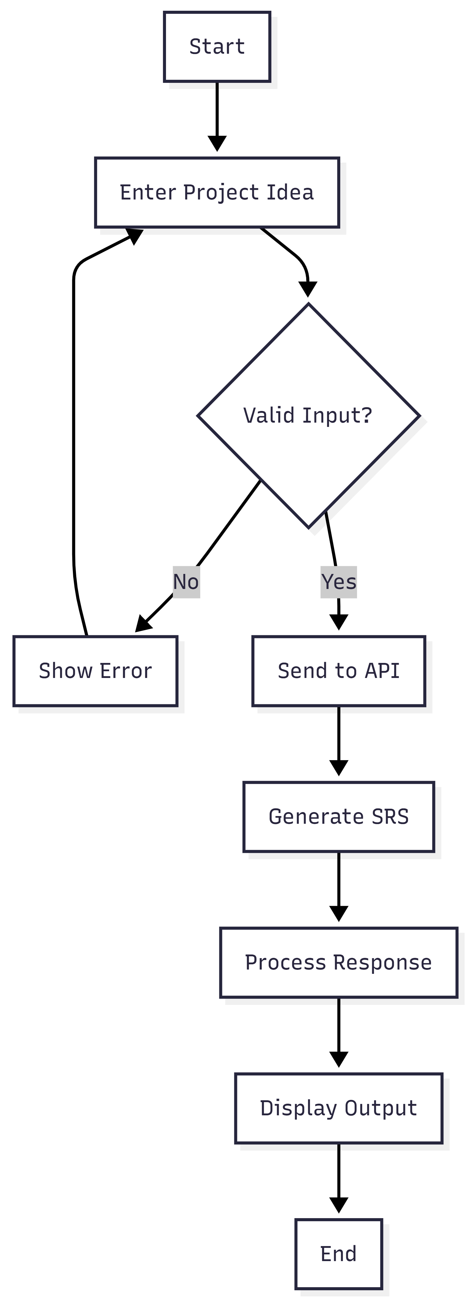
Fig.3 Activity Diagram
5.3 Sequence Diagram
The Sequence Diagram shows interaction between different components over time.
Description:
It represents communication between the user, frontend, backend, and AI system.
Sequence Flow
- User enters input
- Frontend sends request
- Backend processes request
- AI generates response
- Response returned to user
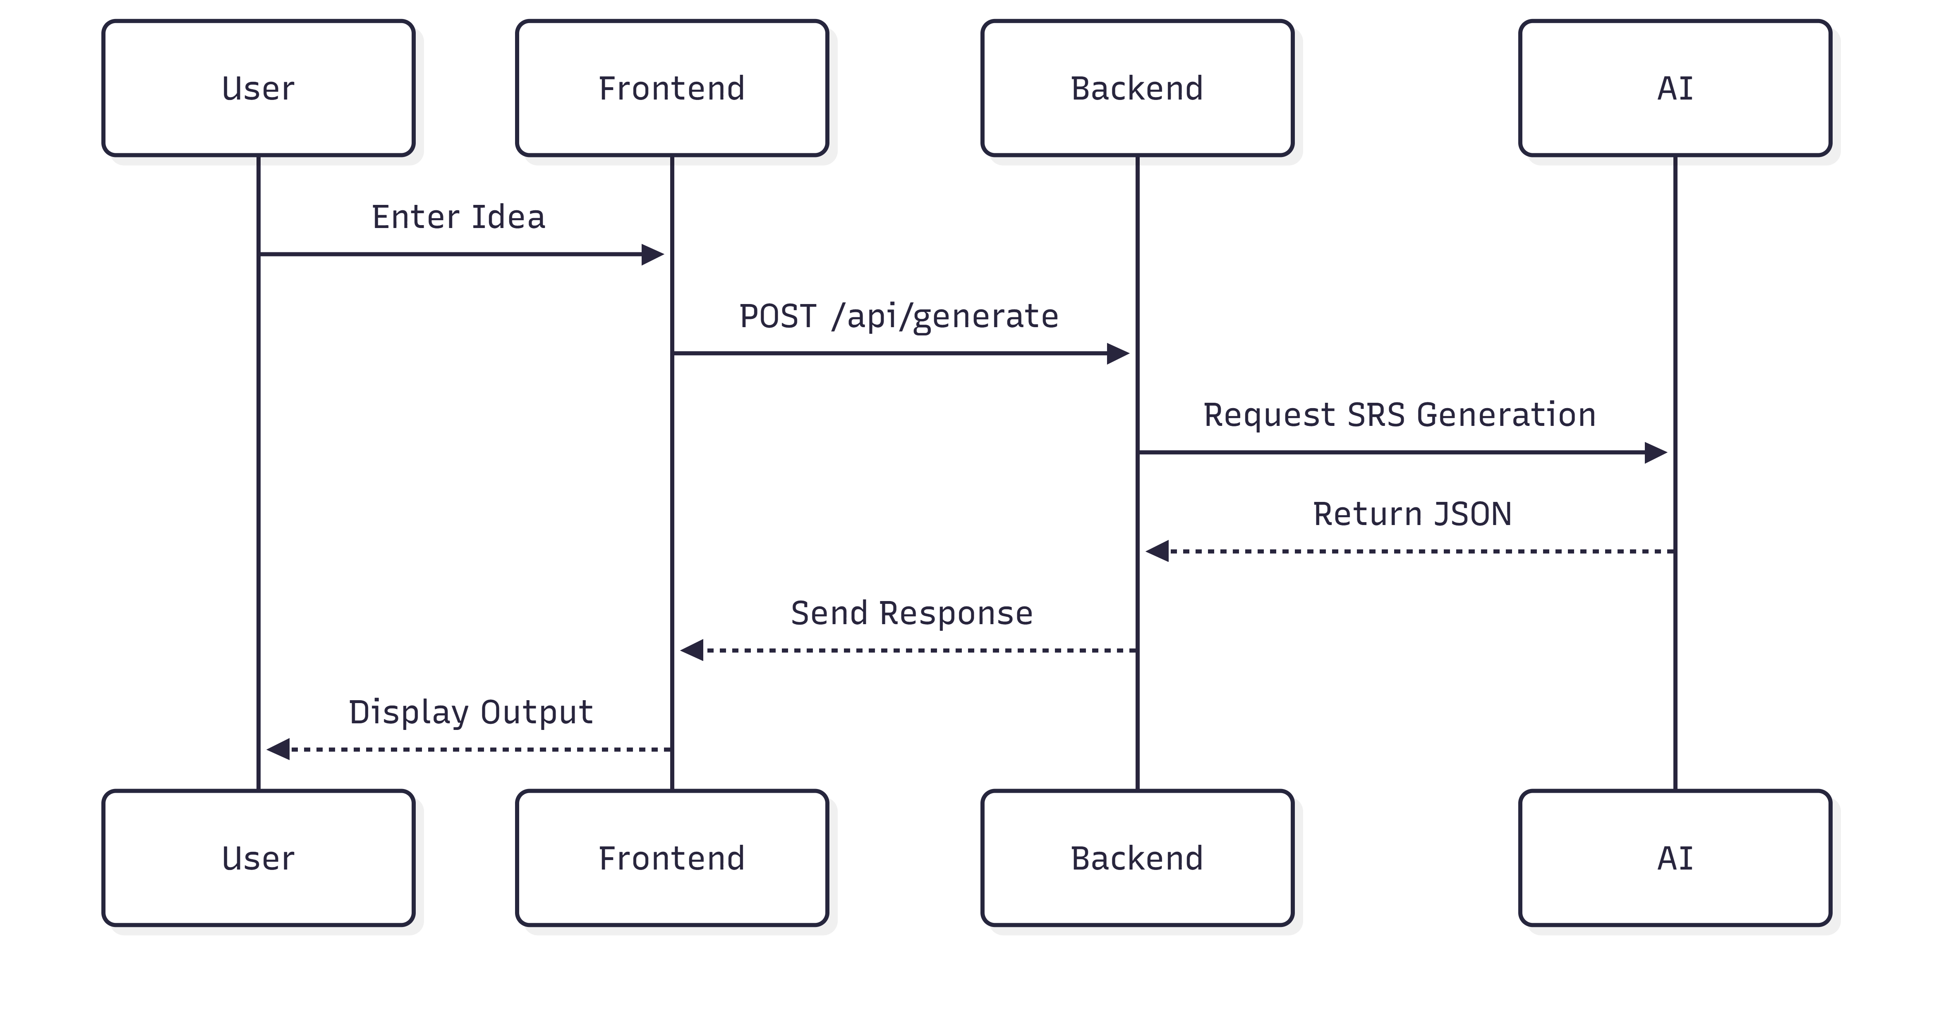
Fig.4 Sequence Diagram

5.4 Component Diagram
The Component Diagram shows system components and their relationships.
Description:
It highlights how different modules interact within the system.
Components
- Frontend UI
- Backend API
- AI Service
- Diagram Renderer
- Export Module

Diagram
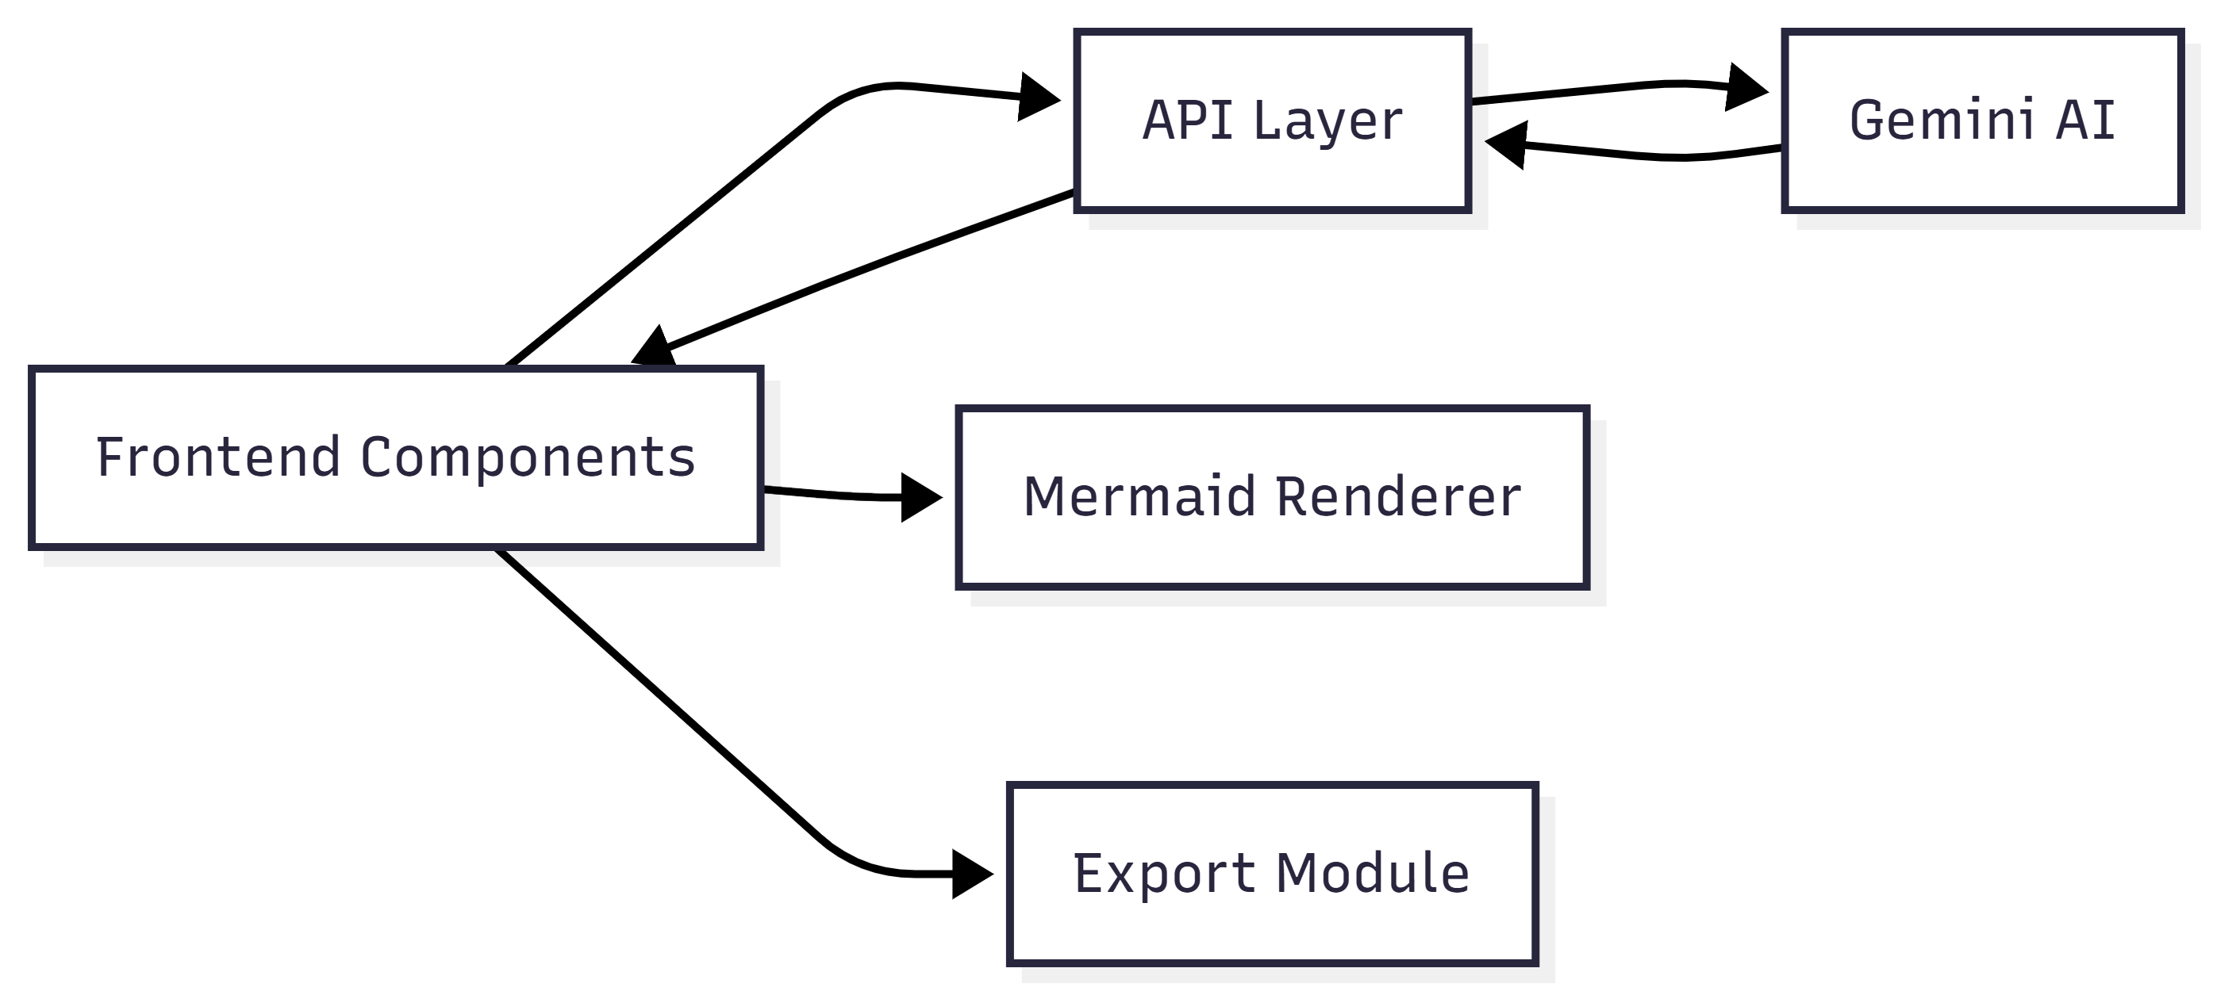
Fig.5 Component Diagram

EX6: IMPLEMENTATION
6.1 Development Environment
The SRSify AI system is developed using modern web technologies that support scalability, performance, and ease of development.
Hardware Requirements
- Processor: Intel i3 or above
- RAM: Minimum 4GB
- Storage: 500MB free space
Software Requirements
- Operating System: Windows / Linux / macOS
- Browser: Chrome, Edge, or Firefox
- Code Editor: Visual Studio Code
Technologies Used
- Frontend Framework: Next.js
- Styling: Tailwind CSS
- Backend: Next.js API Routes
- AI Integration: Google Gemini
- Diagram Rendering: Mermaid
- PDF Export: jsPDF & html2canvas

6.2 Frontend Implementation
The frontend is responsible for user interaction and displaying results.
Features Implemented
- Text area for entering project ideas
- Generate button for triggering SRS creation
- Tab-based output view:
  - Document
  - Personas
  - Diagrams
Key Components
- PromptInput Component
  - Handles user input
  - Sends API request
- SRSViewer Component
  - Displays structured output
  - Handles tab navigation
Design Approach
- Responsive UI using Tailwind CSS
- Clean and user-friendly layout
- Error handling for invalid inputs

6.3 Backend Implementation
The backend handles data processing and AI communication.
API Endpoint
- Route: /api/generate
- Method: POST
Backend Functions
- Receives user input
- Validates request
- Constructs AI prompt
- Calls AI API
- Returns structured JSON response
Security Features
- API key stored in .env.local
- No exposure of sensitive data to frontend

6.4 AI Integration
The system integrates AI to automate SRS generation.
AI Model Used
- Google Gemini (Gemini 2.5 Flash)
Working of AI Integration
- User input is sent to backend
- Backend constructs structured prompt
- AI processes the request
- Returns JSON output containing:
  - SRS document
  - Personas
  - Diagrams
Prompt Engineering
- AI is instructed to follow strict JSON format
- Ensures structured and consistent output
- Prevents formatting errors
Advantages of AI Integration
- Reduces manual effort
- Generates accurate documentation
- Saves time
- Improves consistency

EX7: TESTING
7.1 Testing Types
Testing ensures that the system works correctly and meets user requirements.
1. Unit Testing
- Individual components are tested separately
- Example: Input field validation
2. Integration Testing
- Checks interaction between frontend and backend
- Ensures API communication works correctly
3. System Testing
- Tests the complete system as a whole
- Verifies full workflow from input to output
4. User Acceptance Testing (UAT)
- Conducted by users (students/developers)
- Ensures system meets user expectations

7.2 Test Cases
Test Case Table
Test Case ID | Description | Input | Expected Output | Result
TC1 | Valid Input | "AI-based learning app" | SRS generated successfully | Pass
TC2 | Empty Input | "" | Error message displayed | Pass
TC3 | Invalid Input | Special characters only | Validation error | Pass
TC4 | API Response | Valid request | JSON response received | Pass
TC5 | Diagram Rendering | Valid Mermaid code | Diagram displayed | Pass
TC6 | Export PDF | Click export | PDF downloaded | Pass
TC7 | Export Markdown | Click export | .md file downloaded | Pass

7.3 Results
The system was tested under various scenarios, and the following observations were made:
- The system successfully generates SRS documents for valid inputs
- Error handling works effectively for invalid inputs
- Diagrams are correctly rendered using Mermaid
- Export features (PDF and Markdown) function properly
- Response time is within acceptable limits (15–30 seconds)
Overall Result
The system performs efficiently and meets all functional and non-functional requirements.

EX8: RESULTS AND OUTPUT
8.1 Sample Input
The system accepts a project idea in natural language from the user.
Example Input:
“A smart habit tracking application that helps users monitor daily activities, set goals, and receive reminders.”
This input is entered into the text area provided in the user interface.
8.2 Generated Output
Based on the input, the system generates a structured SRS document.
Output Includes:
1. Introduction
- Overview of the habit tracking system
- Purpose and scope
2. System Description
- Features and functionalities
- User interactions
3. Functional Requirements
- Add habits
- Track progress
- Set reminders
4. Non-Functional Requirements
- Performance
- Usability
- Security
5. User Personas
- Example: Student, Working Professional
6. Diagrams
- Use Case Diagram
- System Architecture Diagram

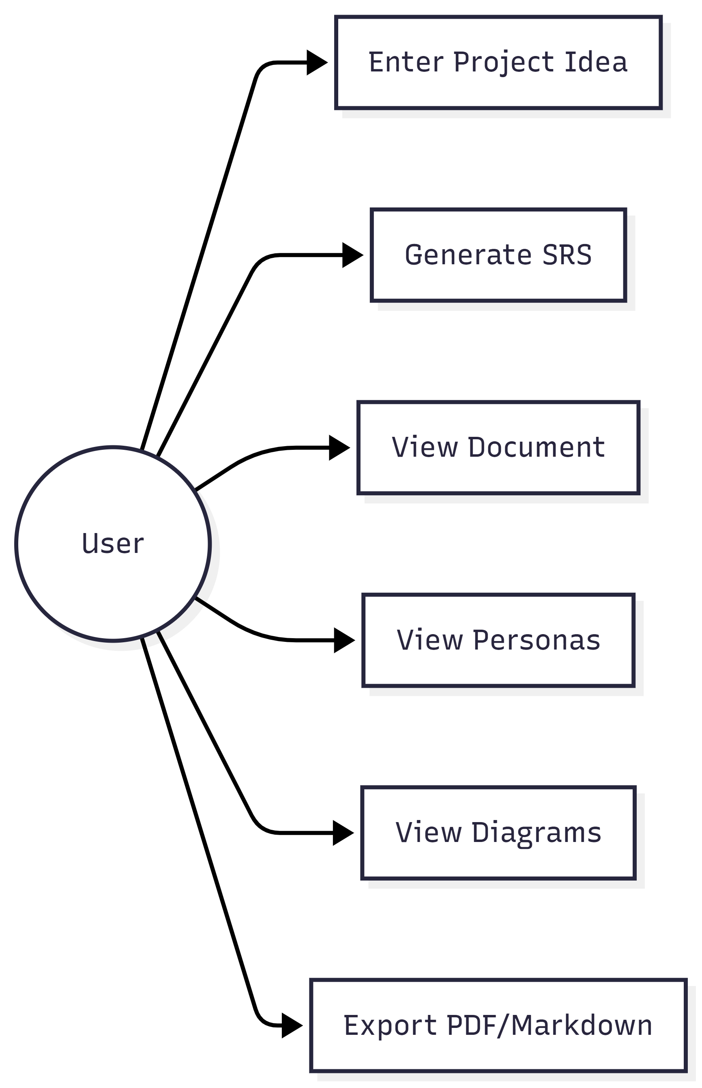
Fig.6 Use Case Diagram
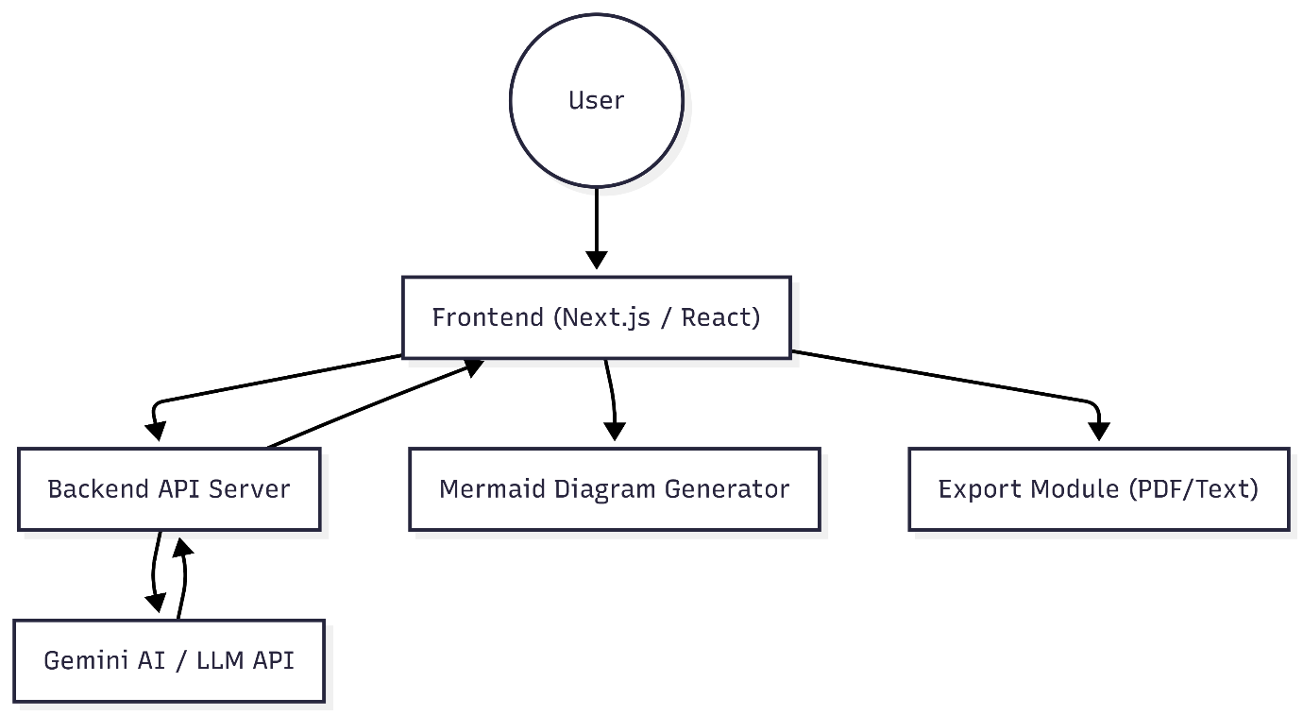
Fig.7 System Architecture Diagram
Sample Output (Short Preview)
The system allows users to create and manage daily habits, track their progress over time, and receive reminders to maintain consistency. It provides a user-friendly interface and ensures efficient performance.
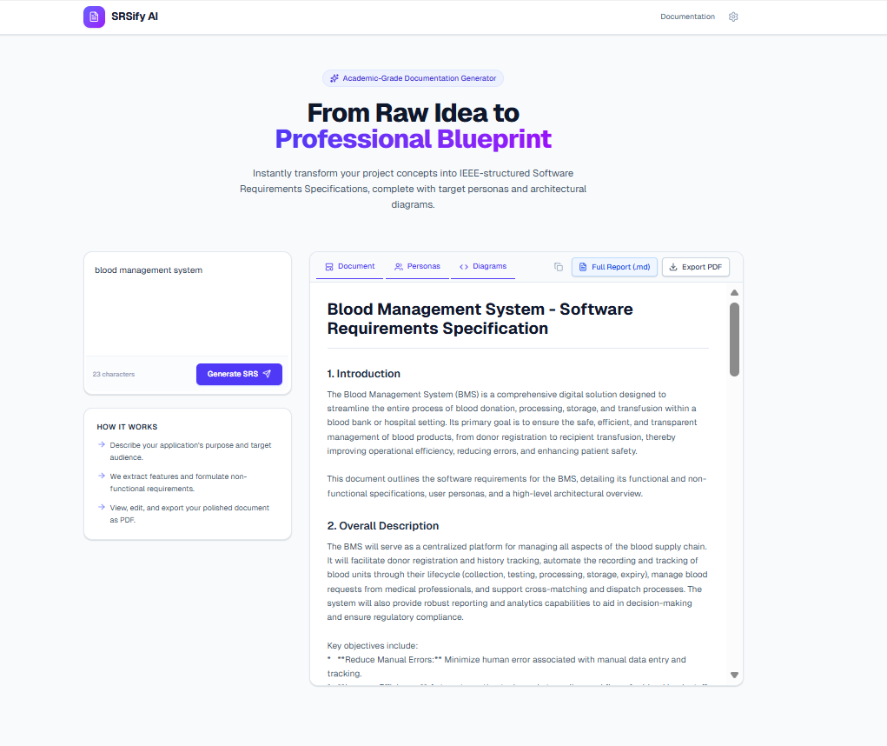
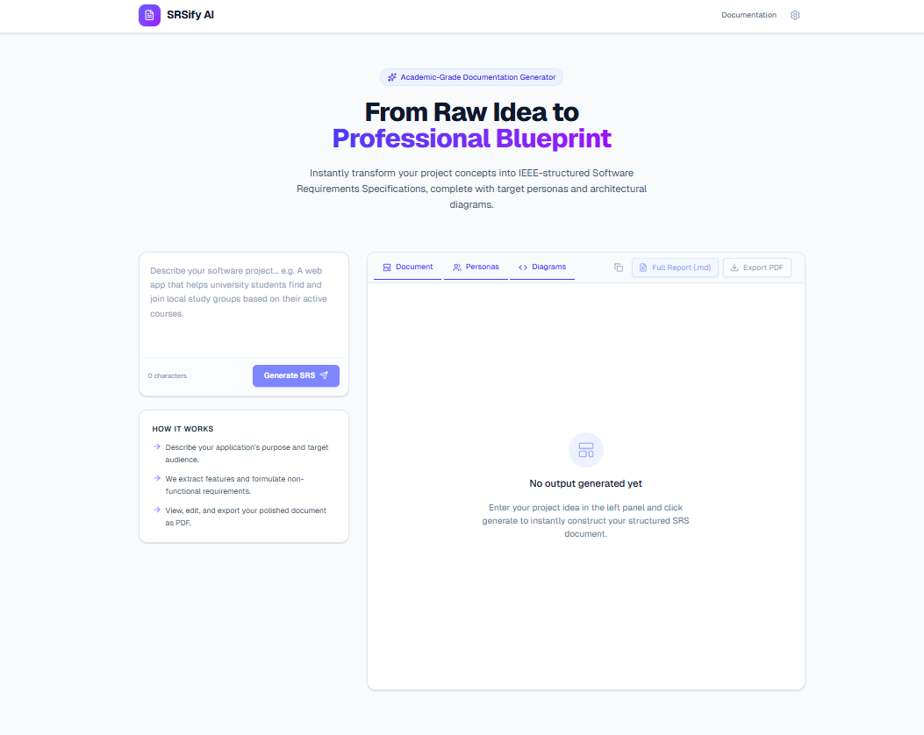
Fig.8 Output
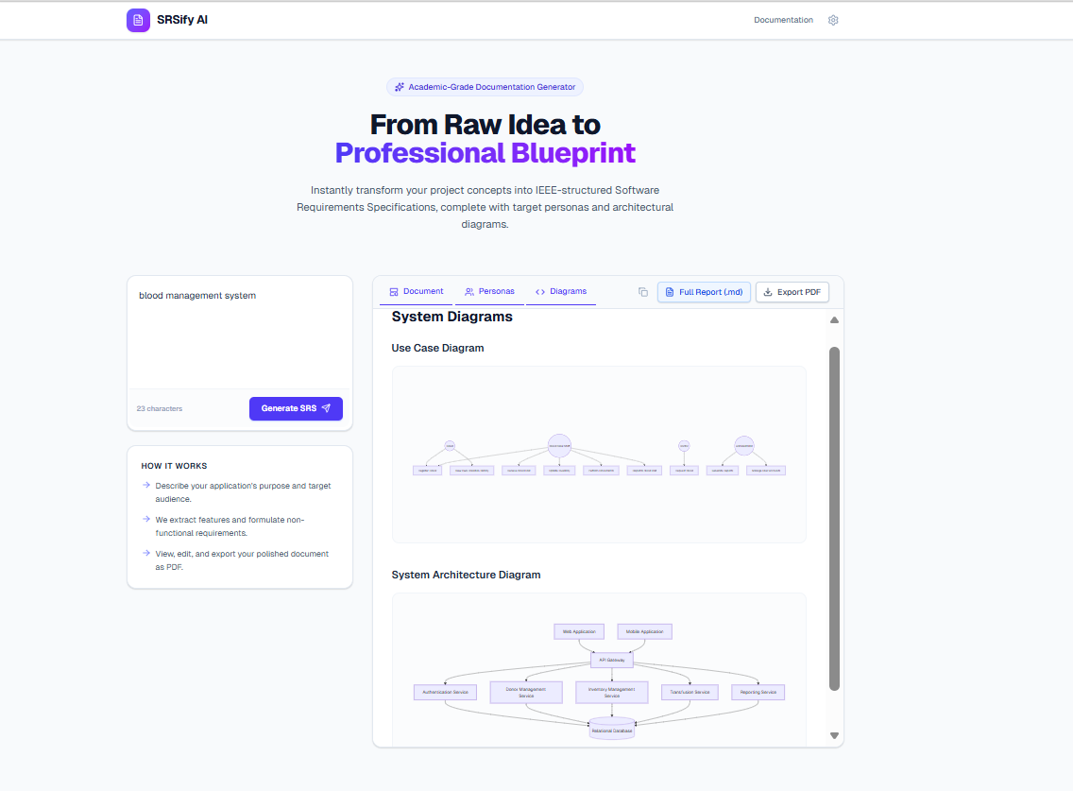
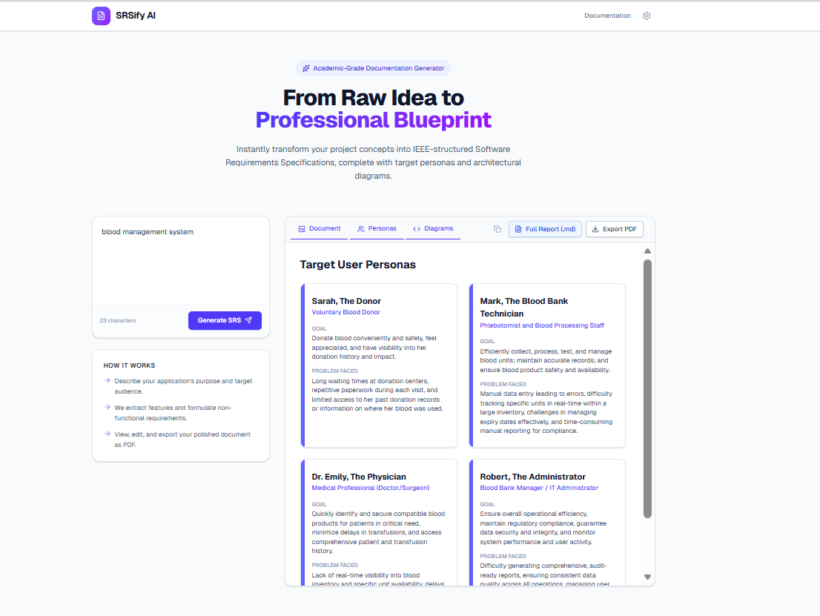
Fig.9 Generated Outputs

8.3 Performance Analysis
The performance of the system was evaluated based on the following parameters:
Response Time
- Average time: 15–30 seconds
- Depends on input complexity
Accuracy
- Generates structured and relevant SRS content
- Minor manual corrections may be required
Usability
- Easy-to-use interface
- Suitable for beginners and professionals
Scalability
- Can support multiple users
- Can be deployed on cloud platforms
- Overall Performance

The system performs efficiently and meets user expectations in terms of speed, accuracy, and usability.

EX9: PROJECT MANAGEMENT
9.1 Methodology
The development of SRSify AI follows the Agile methodology.
Why Agile?
- Flexible and iterative development
- Allows continuous improvements
- Easy to incorporate changes
Agile Phases Used
Planning
- Define project idea
- Identify requirements
Design
- System architecture
- UI/UX design
Development
- Frontend and backend implementation
- AI integration
Testing
- Functional and system testing
Deployment
- Hosting the application
Advantages of Agile
- Faster development
- Better user feedback
- Continuous improvement

9.2 Timeline
The project was completed in a structured timeline.
Project Timeline (4 Weeks)
Week | Activity
Week 1 | Requirement analysis & planning
Week 2 | System design & UI development
Week 3 | Backend & AI integration
Week 4 | Testing & deployment

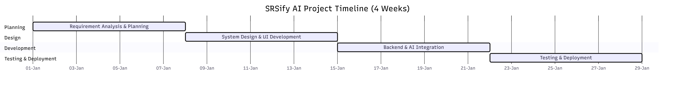
Fig.10 Gantt Chart
9.3 Risk Management
Risk management identifies and reduces potential project risks.
Identified Risks
Risk | Impact | Mitigation
API failure | High | Use error handling
Incorrect AI output | Medium | Manual verification
Network issues | Medium | Retry mechanism
Security risks | High | Secure API keys
Performance delay | Medium | Optimize API calls

Risk Handling Strategy
- Proper validation of input
- Error handling in backend
- Secure storage of API keys
- Performance monitoring

Conclusion of Risk Management
All major risks are identified and controlled effectively, ensuring smooth project execution.

EX10: CONCLUSION
10.1 Conclusion
The SRSify AI project successfully demonstrates the use of Artificial Intelligence in automating the generation of Software Requirements Specification (SRS) documents. The system simplifies a traditionally complex and time-consuming task by converting a simple project idea into a structured and professional document.
The application effectively integrates modern technologies such as Next.js, Google Gemini, and Mermaid to deliver a seamless and efficient user experience.
All the major objectives of the project have been achieved:
- Automated SRS document generation
- Structured and standardized output
- Inclusion of personas and diagrams
- User-friendly interface
- Export functionality
The system proves to be a valuable tool for students, developers, and project managers by improving productivity and ensuring consistency in documentation.

10.2 Future Work
Although the system performs efficiently, there are several areas for improvement:
- Integration of more advanced AI models for higher accuracy
- Support for additional diagram types (ER diagrams, Class diagrams)
- Multi-language support
- Real-time collaboration features
- Cloud storage for saving generated documents
- Mobile application version
These enhancements can further improve the usability and capabilities of the system.

EX11: REFERENCES
1. IEEE Recommended Practice for Software Requirements Specifications (IEEE 830)
2. https://www.codepractice.io/ieee-structure-of-srs-document
3. https://bharatbuild.ai/blog/how-to-write-srs-document
4. https://github.com/jam01/SRS-Template
5. https://www.slideshare.net/slideshow/srs-template-ieee-229390904/229390904
6. https://en.wikipedia.org/wiki/Mermaid_(software)
7. https://github.com/topics/srs-document
8. https://www.studocu.com/in/document/software-engineering/ieee-srs-document

