Target = 5 microsec burst & 45 microsec flat
Samp_rate = 32000000
Burst_rate = 160 = 5 microsec
Rep_rate= 1600 = 45 microsec
In gnu radio companion blocks:
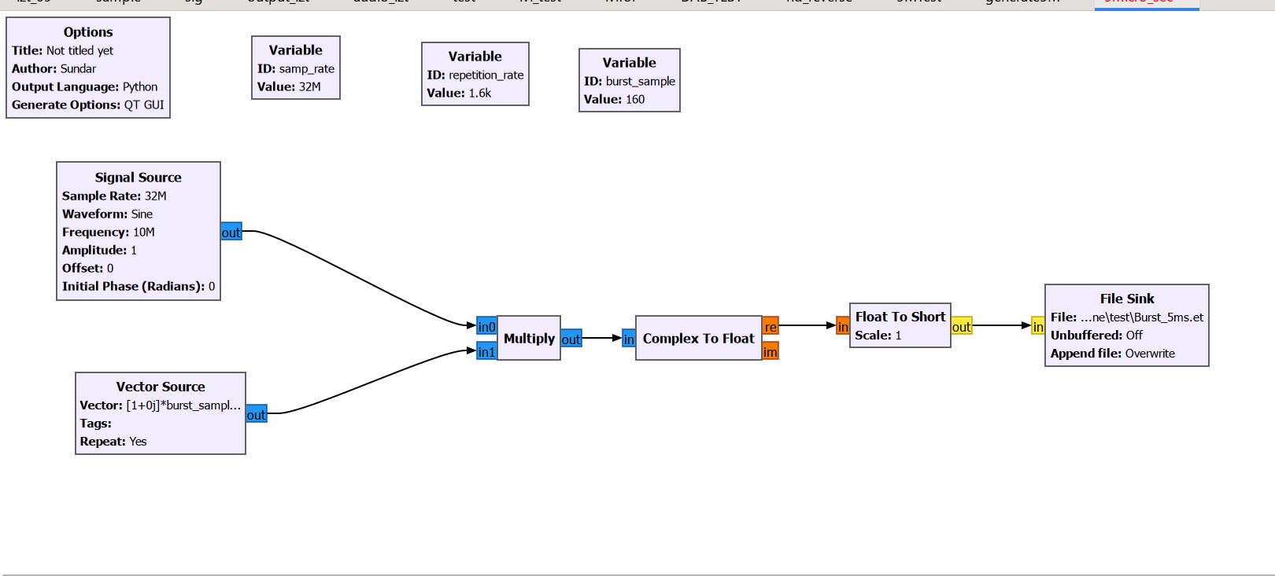
Output from gnu radio 