**Find type of object:**

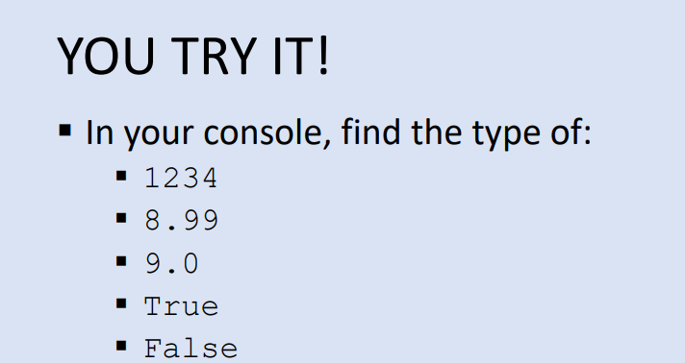

**ANSWER:**

>>> type(1234)

<class 'int'>

>>> type(8.99)

<class 'float'>

>>> type(9.0)

<class 'float'>

>>> type(True)

<class 'bool'>

>>> type(False)

<class 'bool'>

**Type Conversion:**

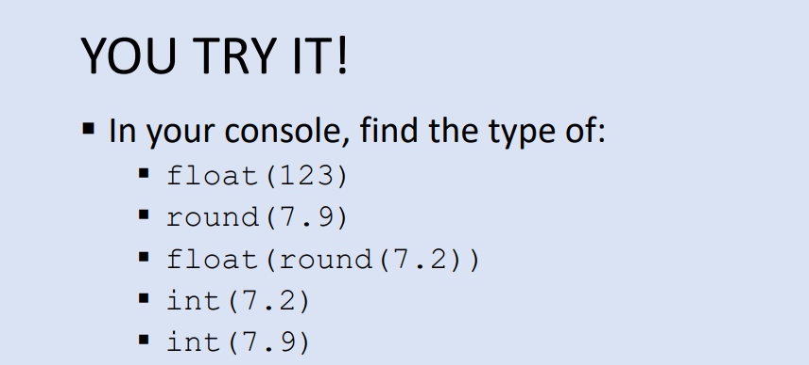

**ANSWER:**

>>> float(123)

123.0

>>> round(7.9)

8

>>> float(round(7.2))

7.0

>>> int(7.2)

7

>>> int(7.9)

7

**Expressions:**

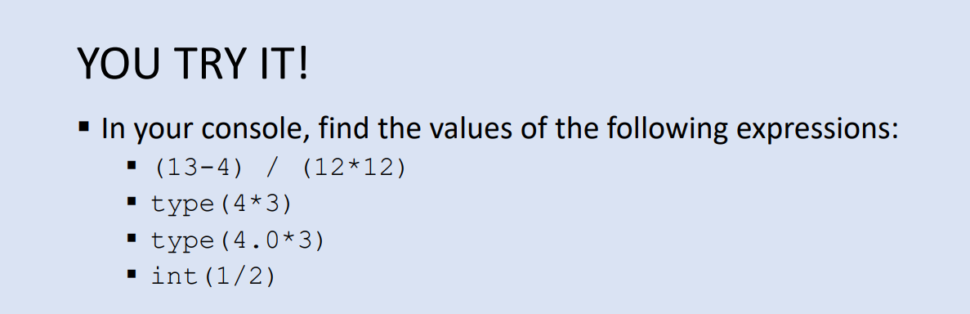

**ANSWER:**

>>> (13-4)/(12*12)

0.0625

>>> type(4*3)

<class 'int'>

>>> type(4.0*3)

<class 'float'>

>>> int(1/2)

0

**Variables:**

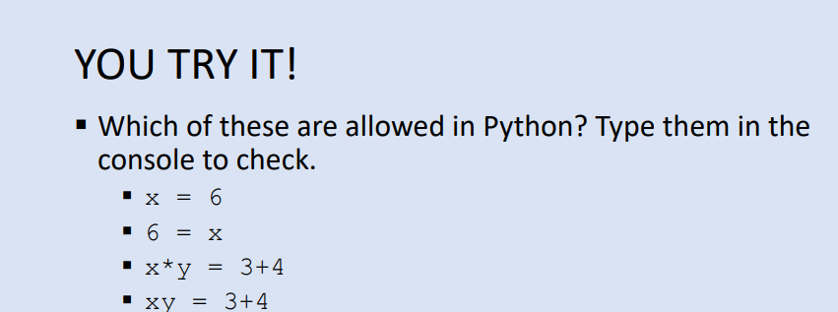

**ANSWER:**

>>> x=6

>>> x

6

>>> 6=x

File "<stdin>", line 1

SyntaxError: can't assign to literal

>>> x*y=3+4

File "<stdin>", line 1

SyntaxError: can't assign to operator

>>> xy=3+4

>>> xy

7

**Execution of code**

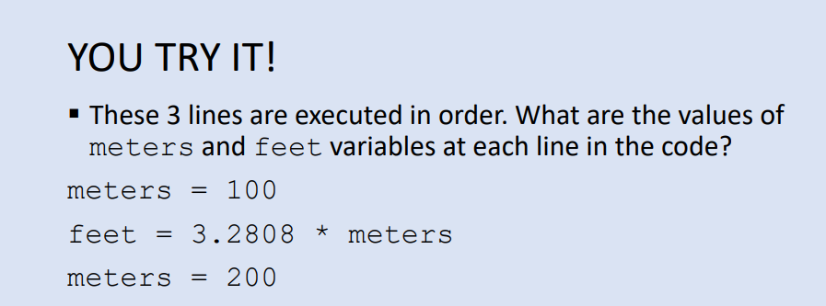

**ANSWER:**

Using Python tutor

Step 1:

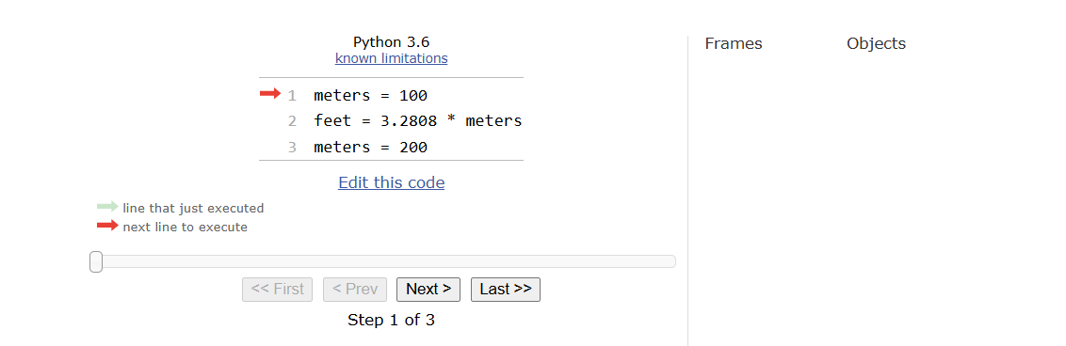

Step 2:

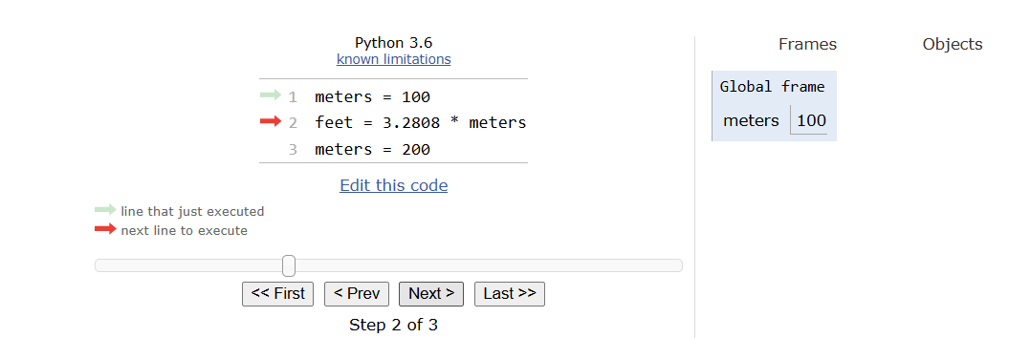

Step 3:

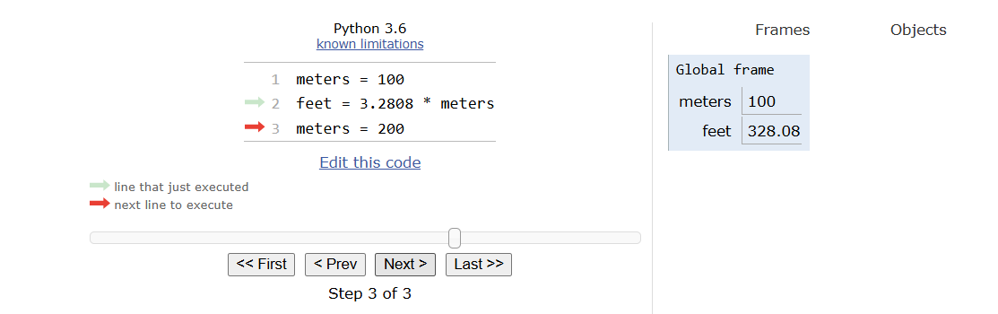

Step 4:

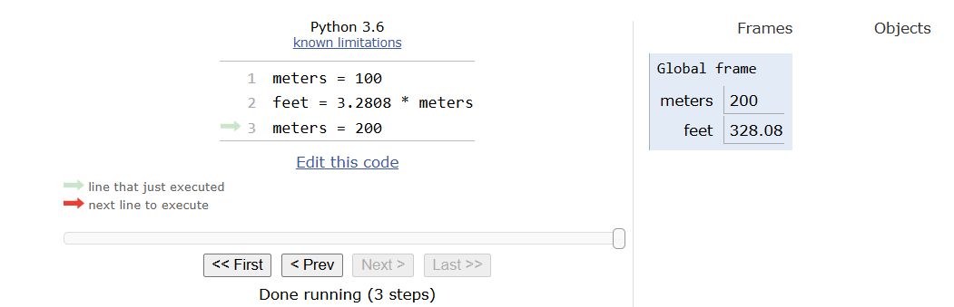

**Swapping:**

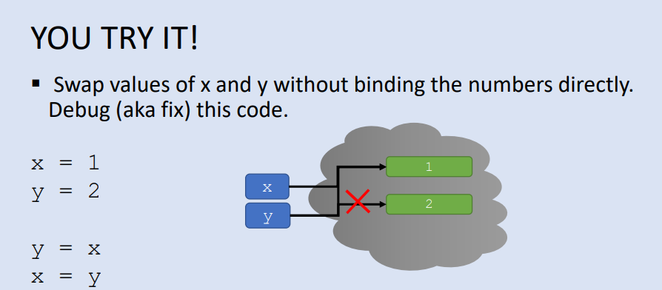

**ANSWER:**

Step 1:

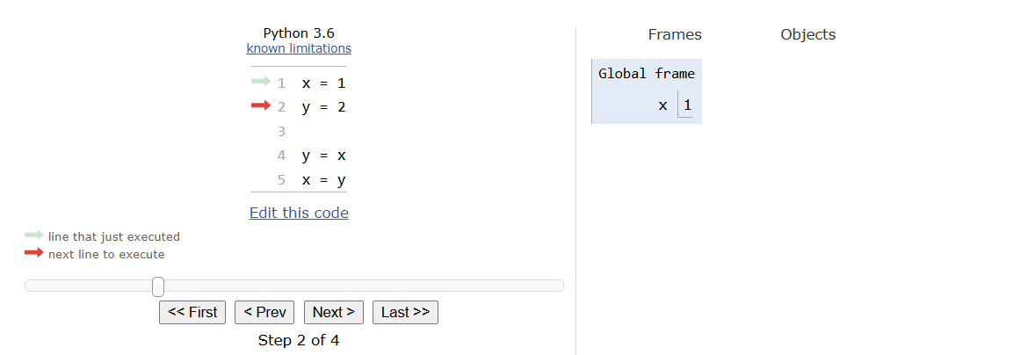

Step 2:

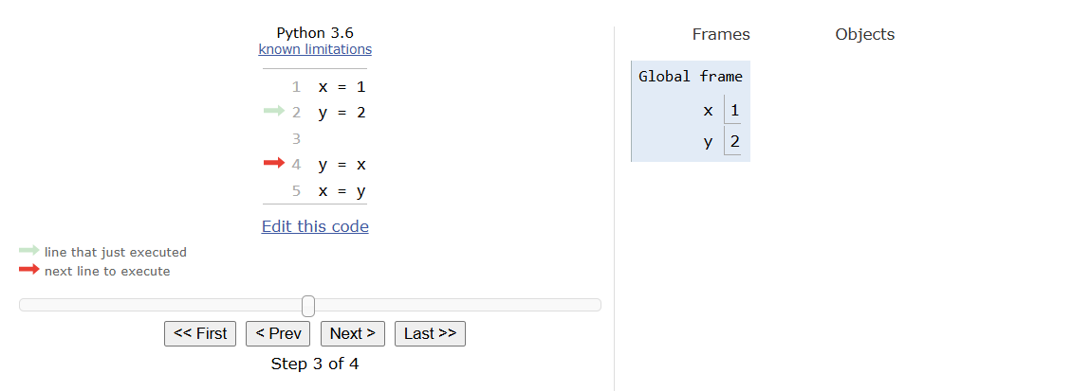

Step 3:

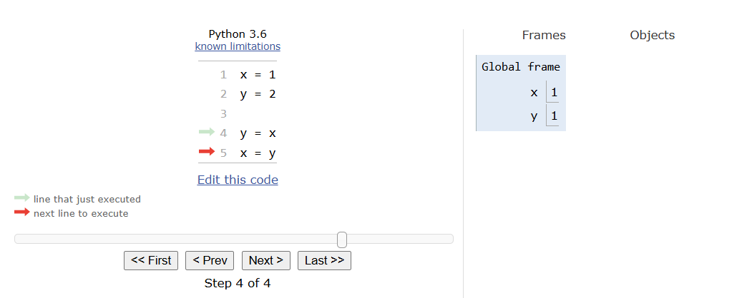

Step 4:

