Git Hub
What is Git?
Git is a version control system.It will note it down each an every step moment.

What is Git Hub and why it is used?
Git Hub is a code hosting platform for version control and collaboration. It lets you and others work together on projects from anywhere. This tutorial teaches you Git Hub essentials like repositories, branches, commits, and pull requests. ... Create and use a repository. Start and manage a new branch.

Git Comments
ls -->is inside git folder structural
Gitog -->is to check all the logs inside the folder in each commit as well

For example;
Git checkout commit id

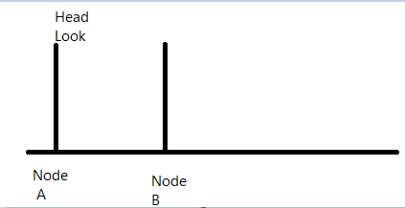

Git status ->locally pushing code update status

Branch

Git understanding Branch
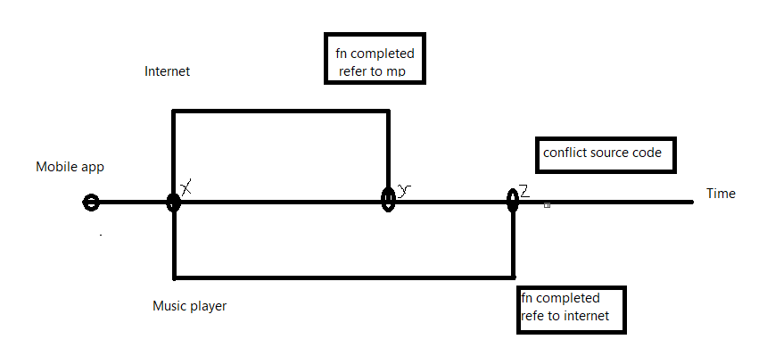

Git Making branch

To create branch

Git checkout -b ‘name;

To check the branch available status

Git branch

How to switch to branch

Git checkout “branch name”

How to delete the Branch

Git branch -d “branch name”

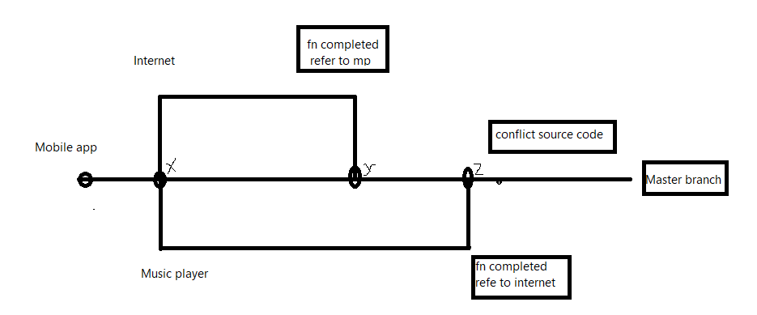
To merge the branch

Git merger ‘branch name’

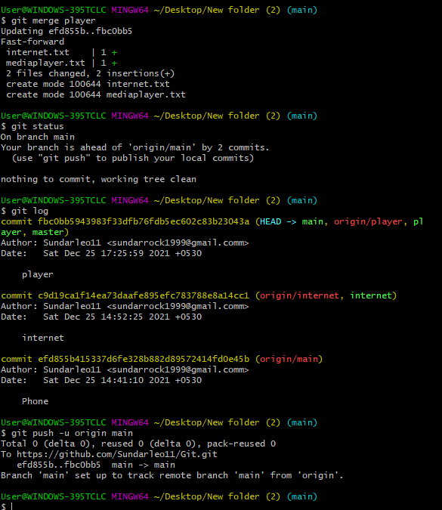

Git conflict in branch

When two teams going to work same project but different files.while merge the time will get conflict
Example below
Team 1
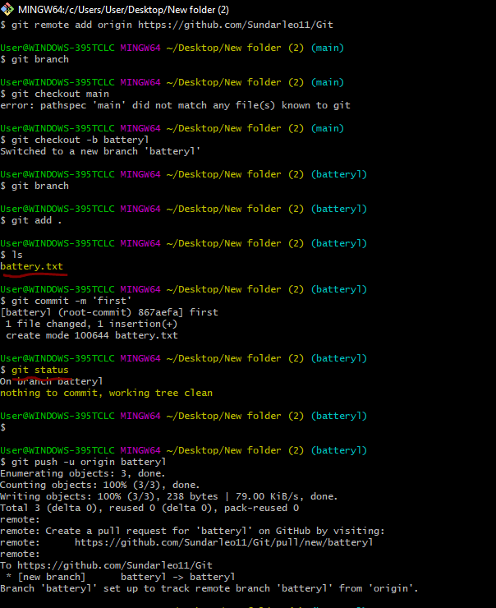
Team 2
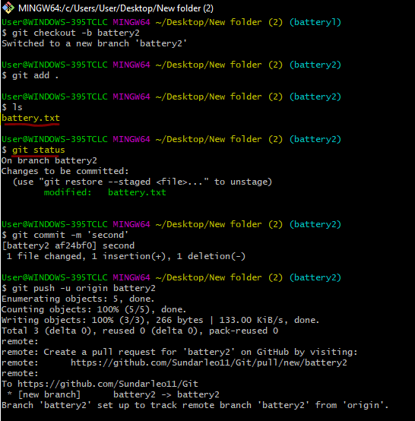

To merge the two branch
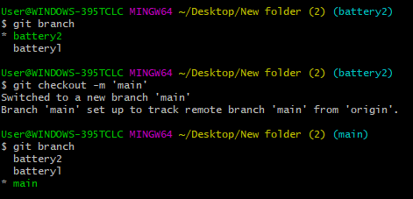

Here both branch same code modified.that is one of conflict.the re-push the main branch.
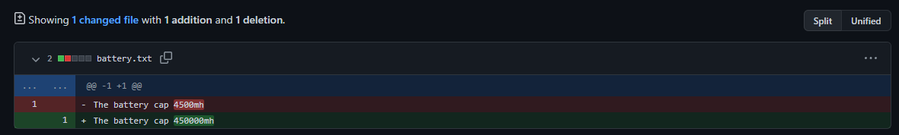
Then select version of battery.

Git understand work flows

Small scale System

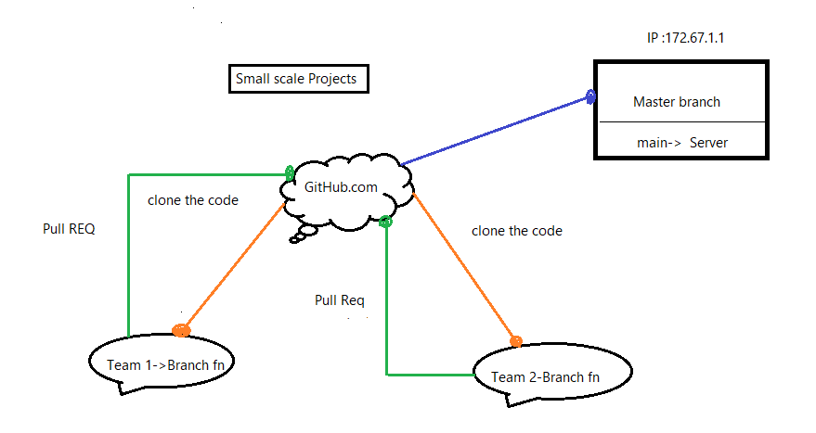

Large scale System

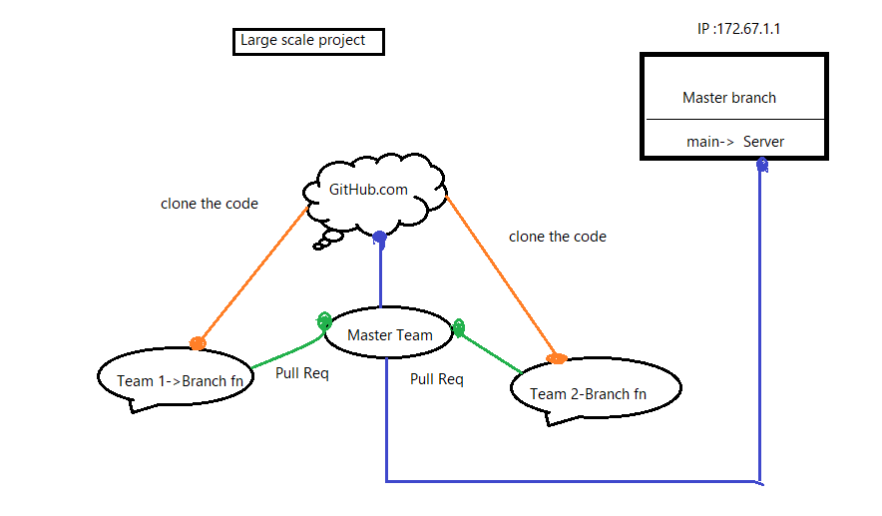

Flow
