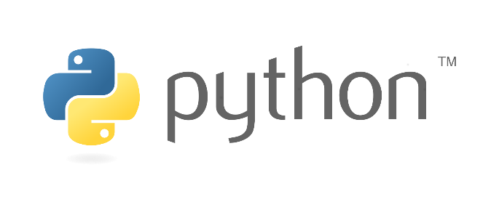

Python is a high-level, general-purpose, and very popular programming language. Python programming language (latest Python 3) is being used in web development, Machine Learning applications, along with all cutting-edge technology in Software Industry.

**PRINT:**

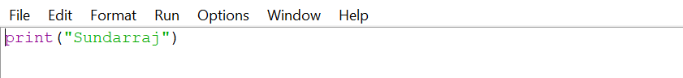



**VARIABLES:**

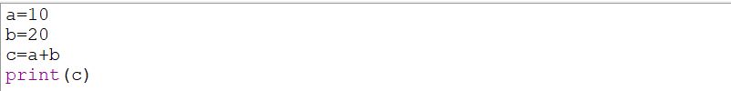



**STRING:**

















**CASTING:**

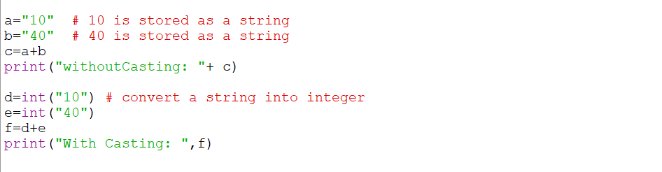

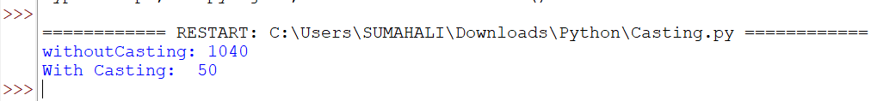

**USER INPUT:**

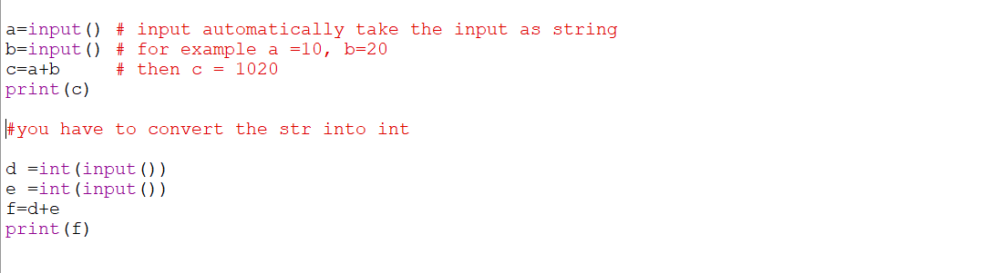

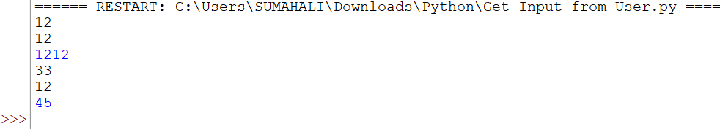

**USER INPUT INDICATION:**

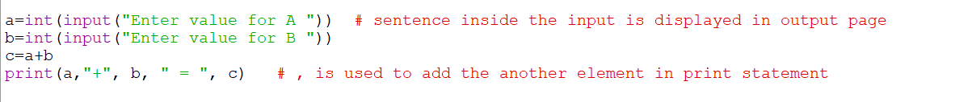

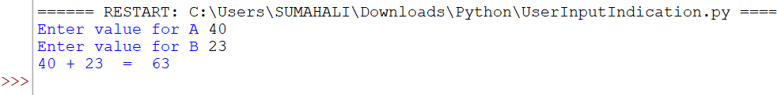

**IF – ELSE:**

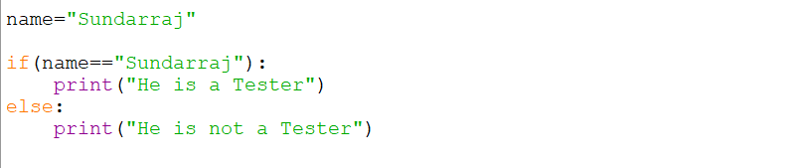



**ELIF:**

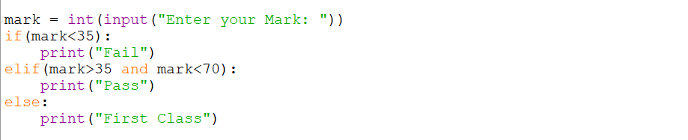



**AND OPERATOR:**

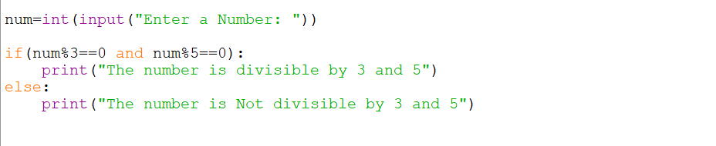

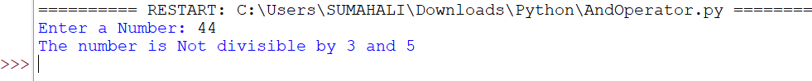

**OR OPERATOR:**

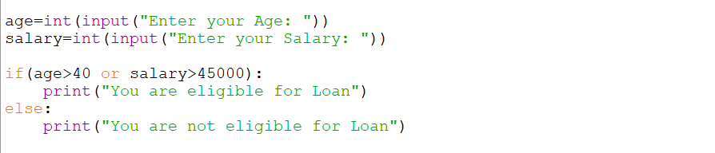

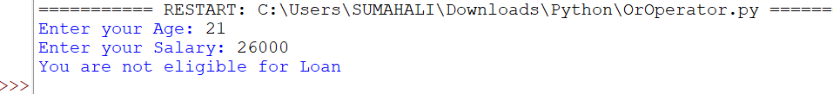

**FOR LOOP:**

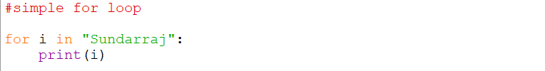

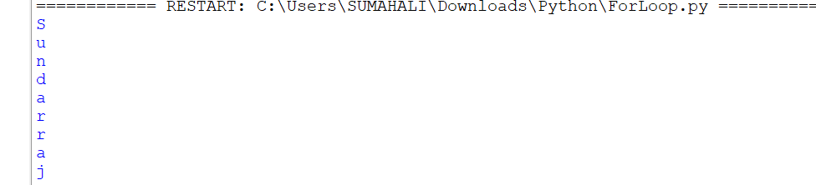

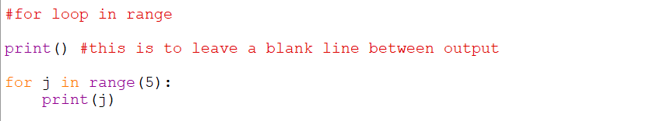

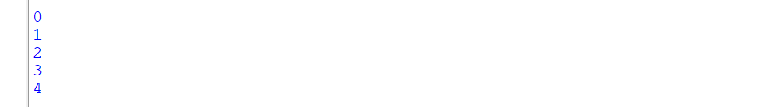



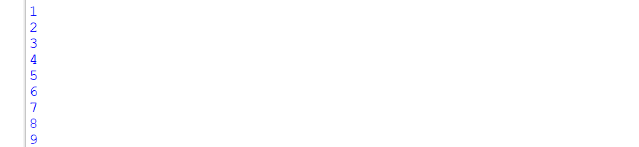

**NESTED FOR LOOP:**

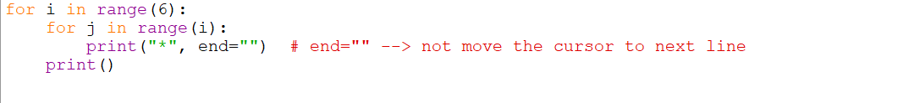

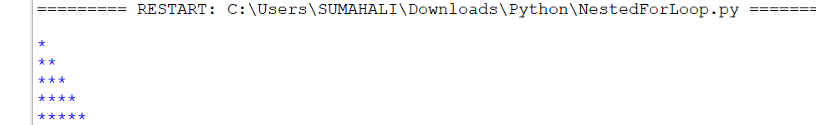

**COMMENTS:**



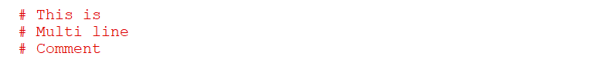

**FOR EACH LOOP:**

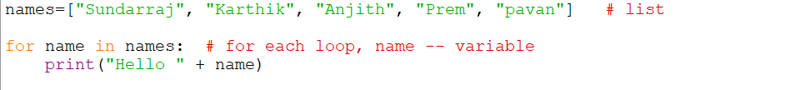

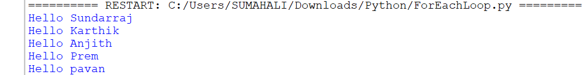

**WHILE LOOP:**

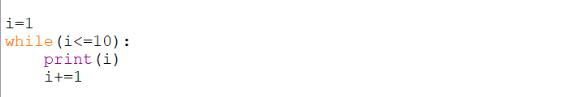

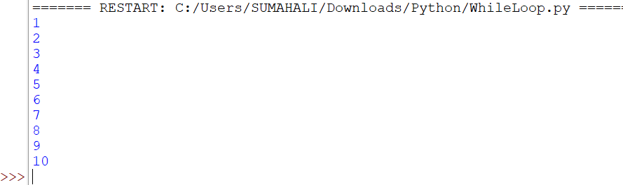

**COLLECTION:**

**LIST:**

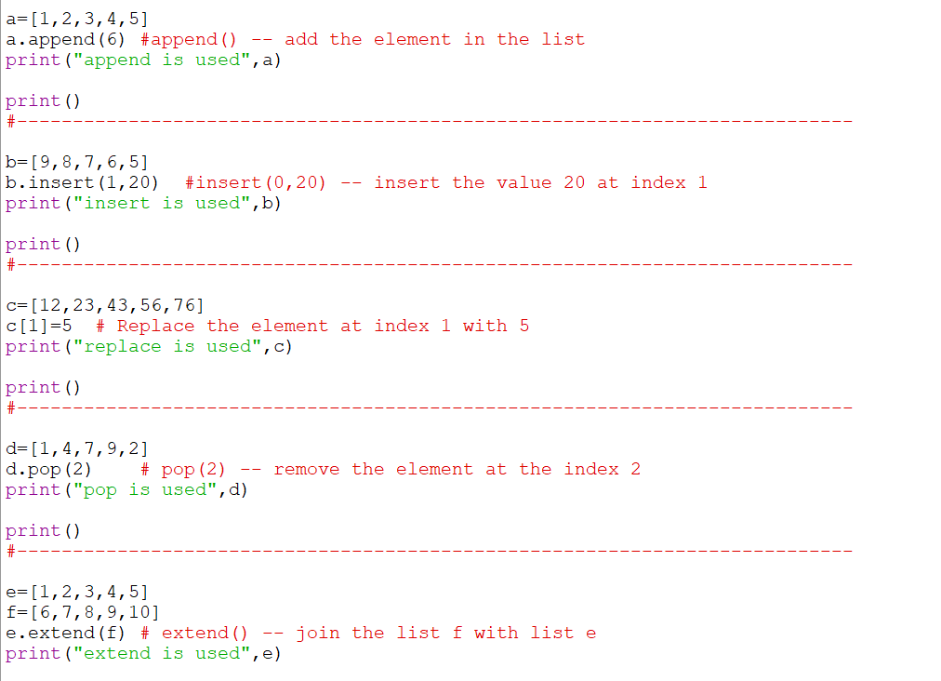

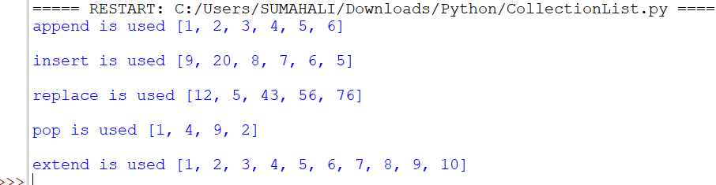

**TUPLE:**

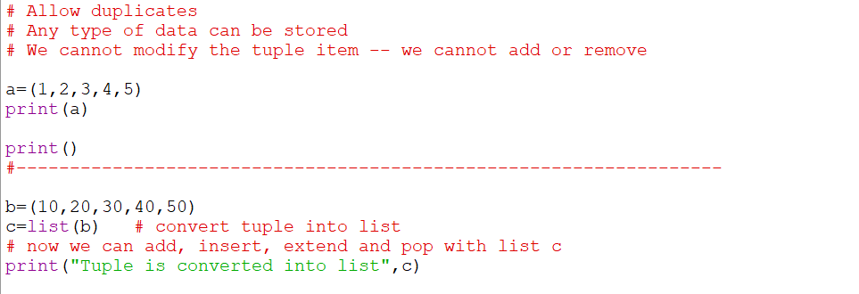

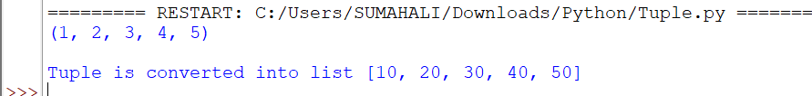

**SET:**

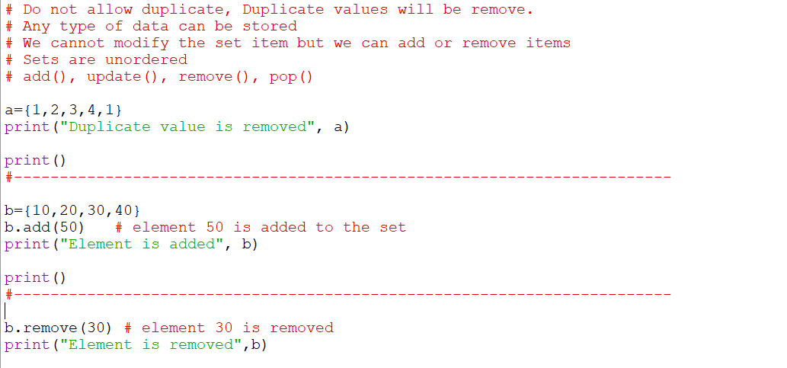

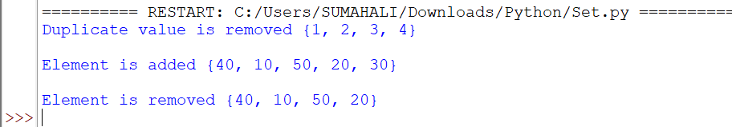

**DICTIONARY:**

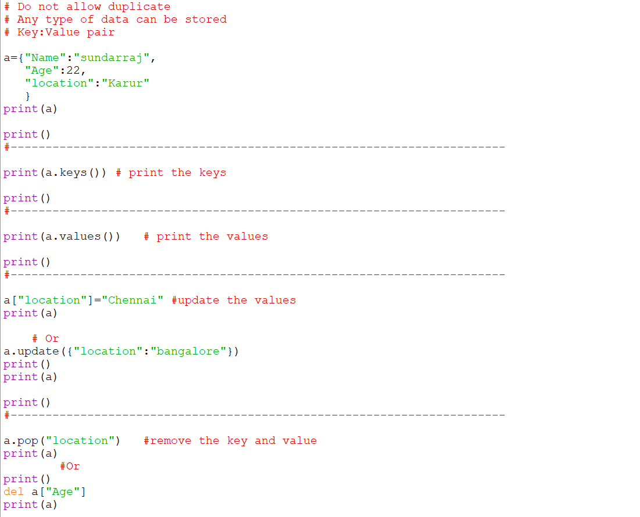

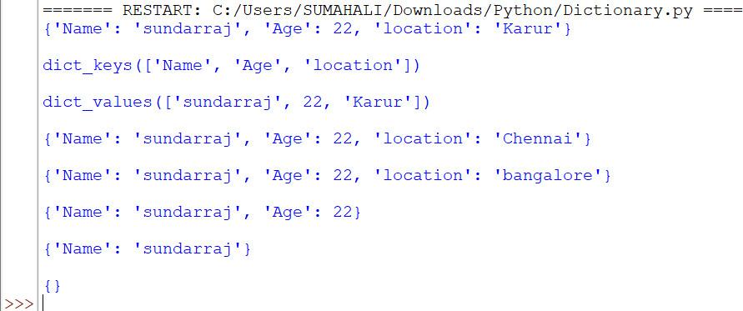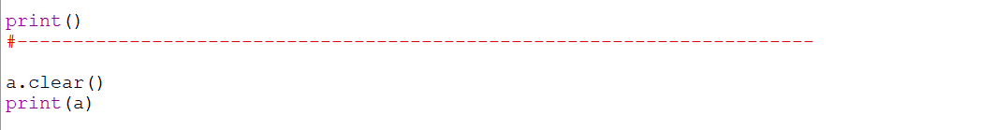

**FUNCTION:**

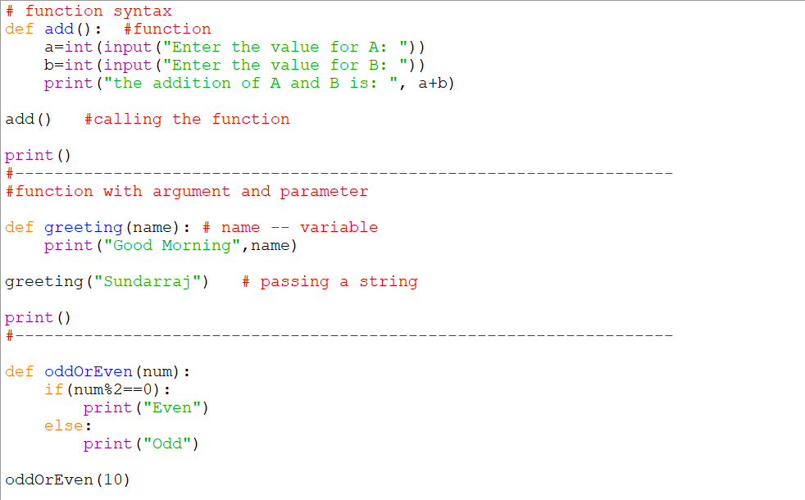

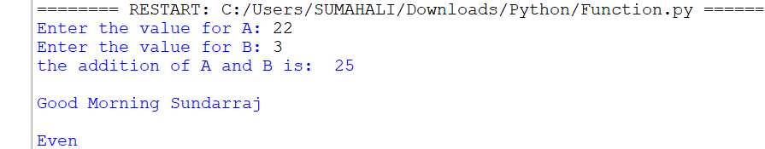

**RETURN STATEMENT:**

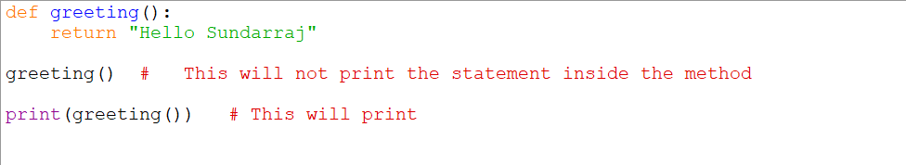



**CLASS AND OBJECT:**

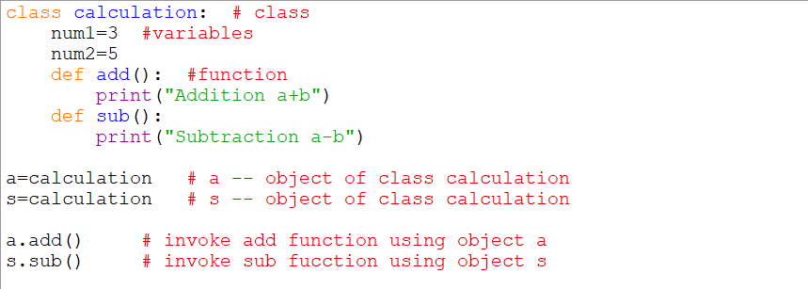



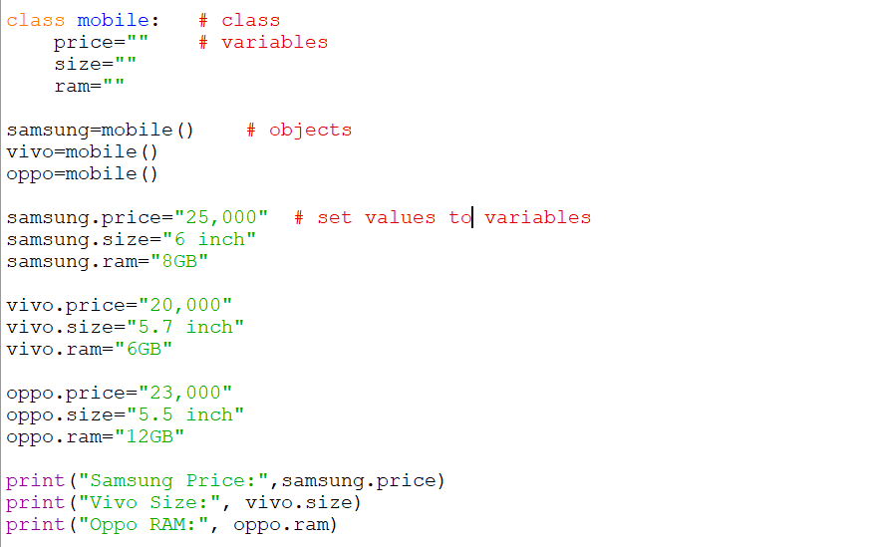

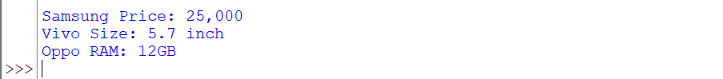

**CONSTRUCTOR:**

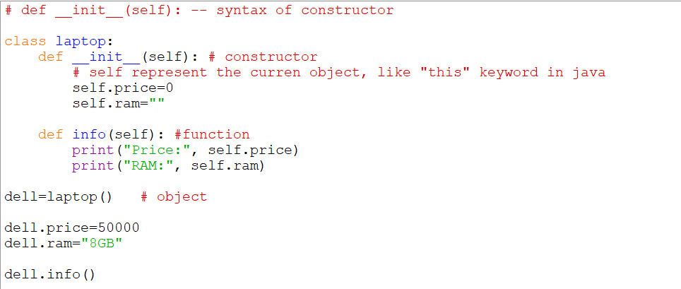



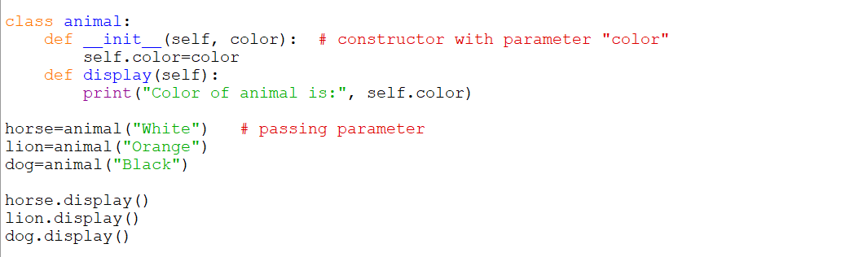

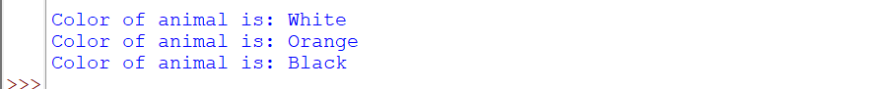

**INSTANCE VARIABLE:**

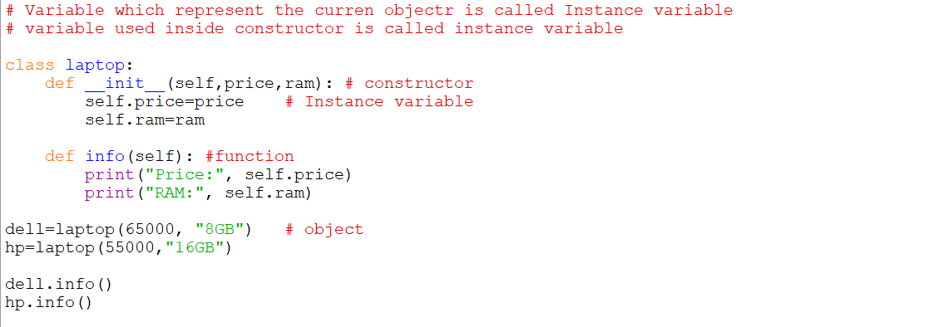

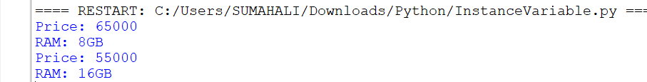

**CLASS VARIABLE:**

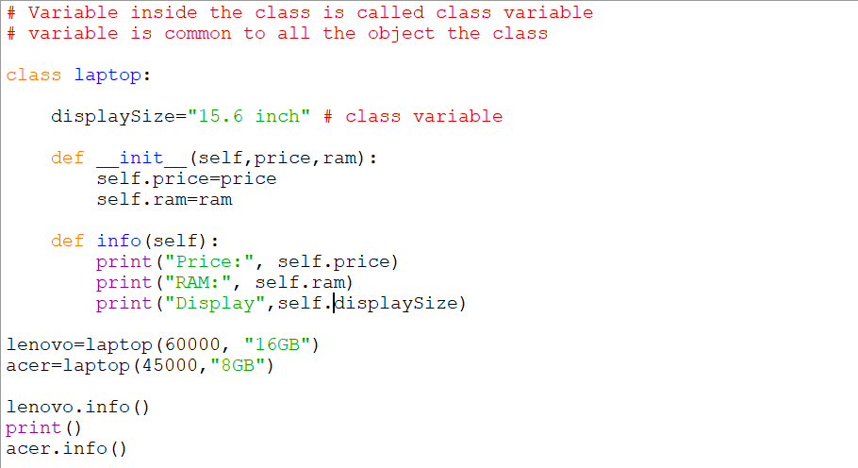

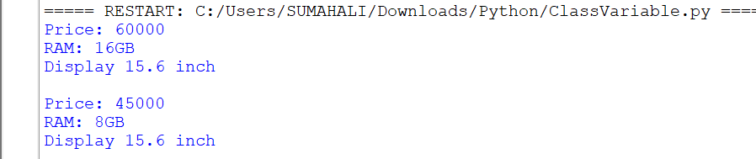

**INSTANCE FUNCTION:**

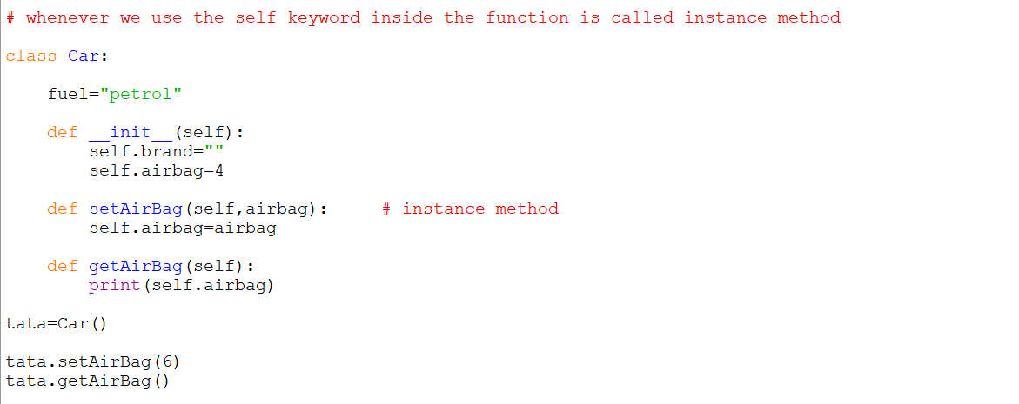



**CLASS FUNCTION:**

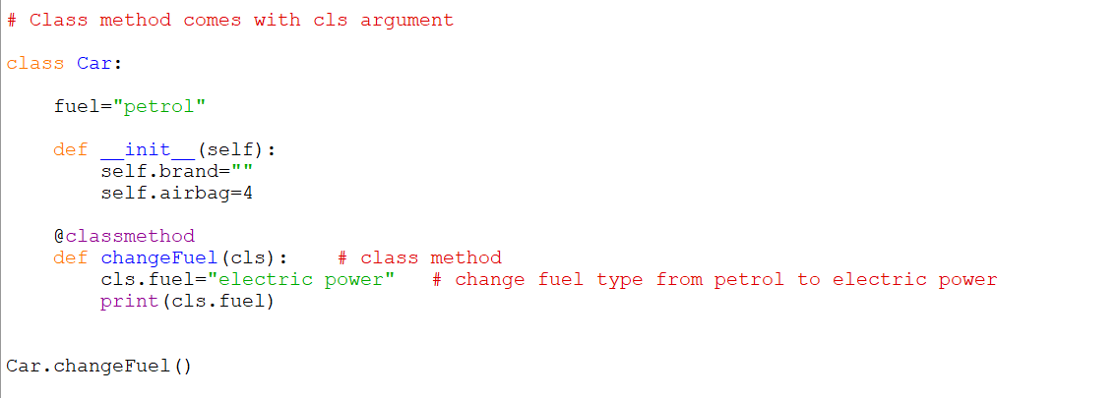



**STATIC METHOD:**

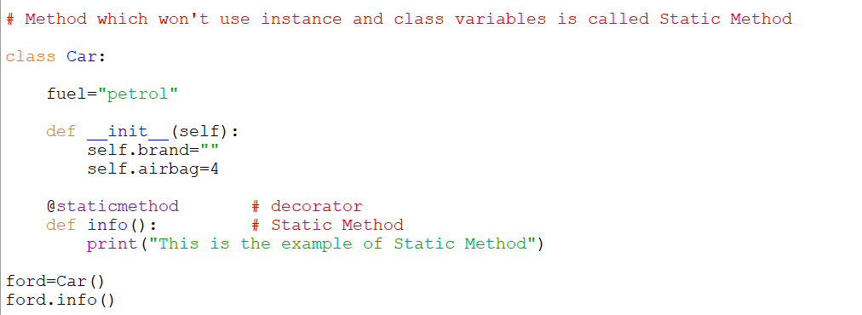



**SINGLE LEVEL INHERITANCE:**

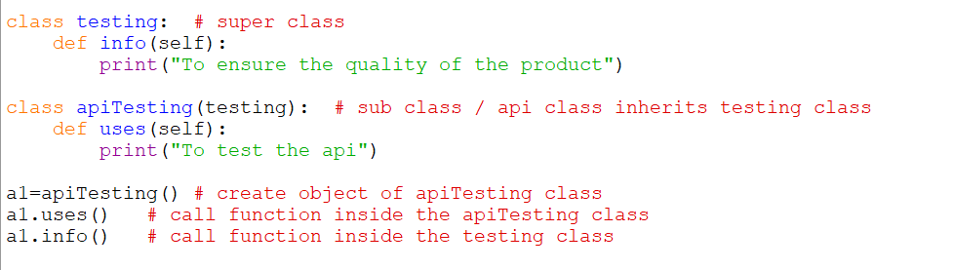



**MULTIPLE INHERITANCE:**

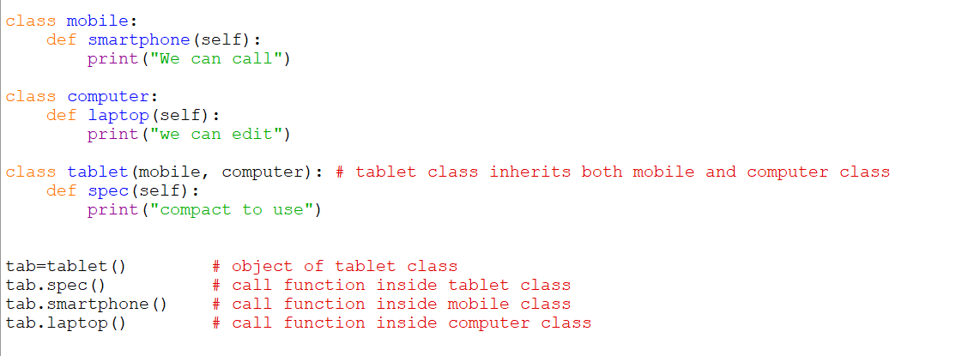



**MULTI LEVEL INHERITANCE:**

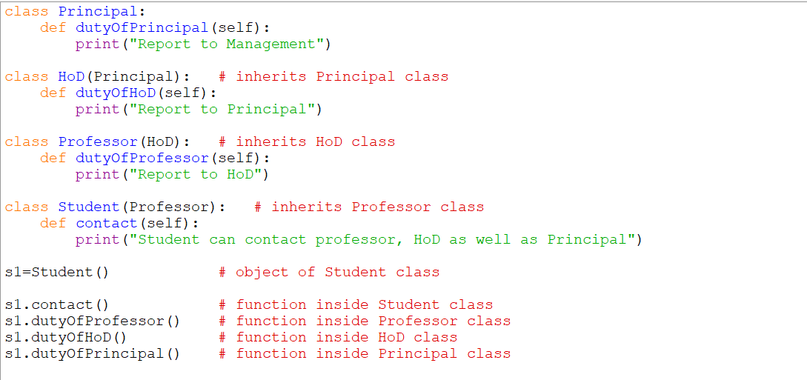

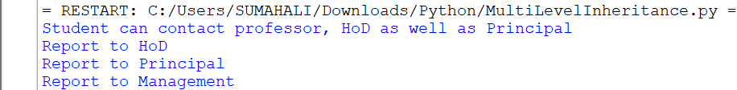

**HIERARCHICAL INHERITANCE:**

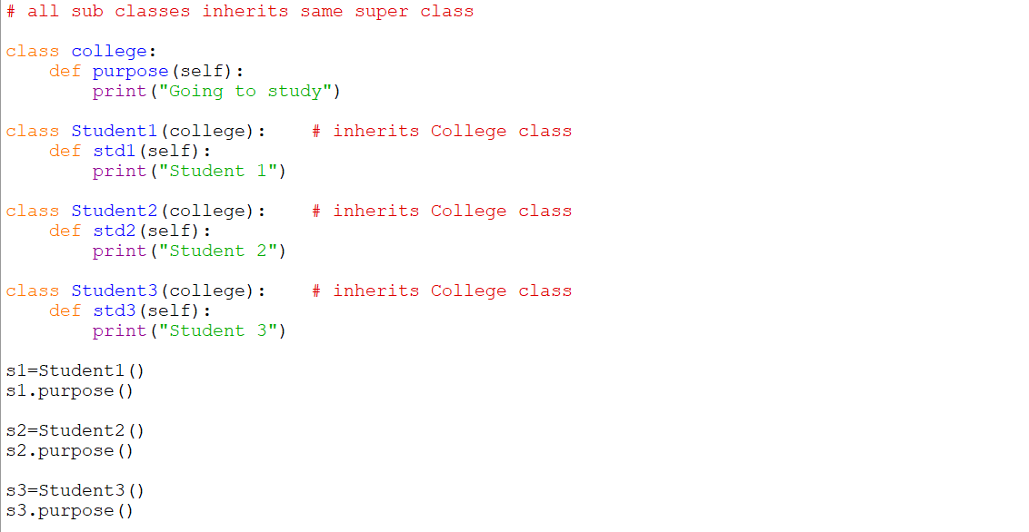



**SUPER KEYWORD:**

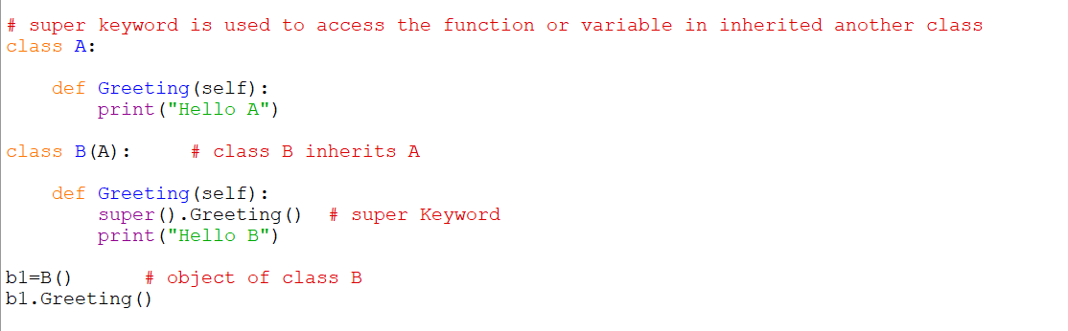



**ENCAPSULATION:**

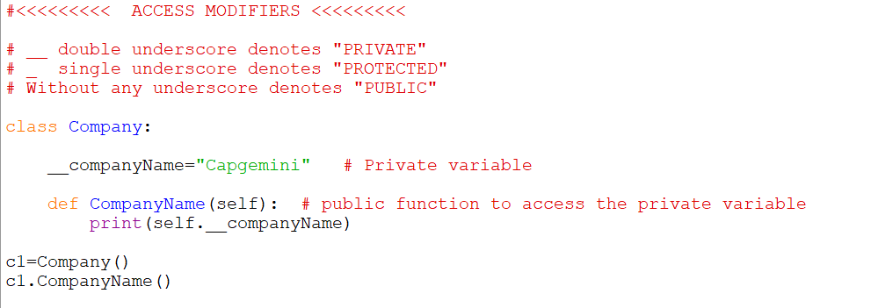



**EXCEPTION HANDLING:**

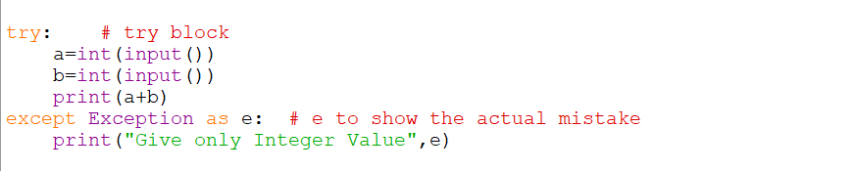

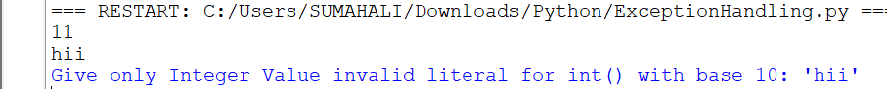

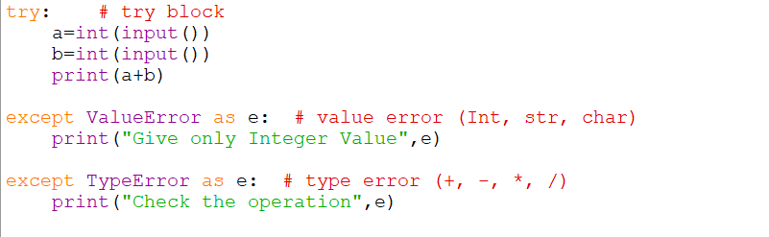

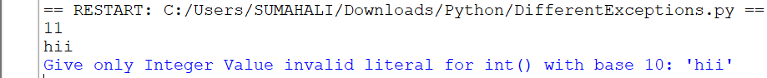

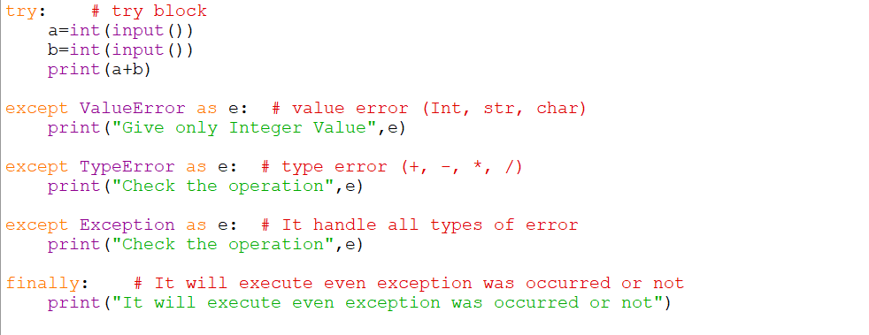

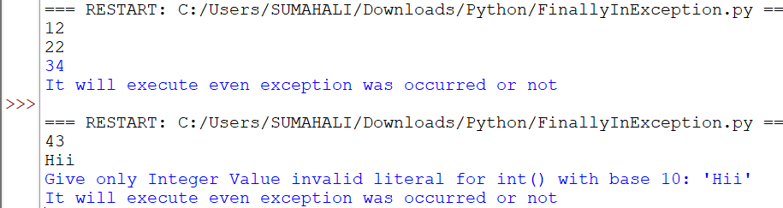

**FILE HANDLING:**



