From Telegram Learning Bot to Offline-First Educational Platform: Artifact-Inspected Evolution of CodeX
Proposed authors — pending confirmation of contribution, consent, eligibility and order: Yuvaraja A; Sabreeswaran S; Vignesh B; [One additional student identity requires reconciliation: Prasanth appears in stage and final-submission records but is absent from the controlled Student Roster and conflicts with the controlled identity record for Yuvaraja A]. [Project mentor identity requires reconciliation among Aiswaryadevi, AishwaryaDevi, and Aiswariya S before proposed-author inclusion.]
School of Innovation, KGiSL Institute of Technology, Coimbatore, Tamil Nadu, India [Complete per-author affiliations, corresponding-author designation and corresponding-author e-mail: TO BE PROVIDED.]
Abstract— This developmental case study reconciles an offline, gamified learning project across six controlled stages and one immutable repository snapshot. Problem and ideation records center on low-data access, a learning chatbot, offline content and teacher visibility. The proof-of-concept source is missing. The prototype reports a working Telegram bot and an Ollama model under development, but its numerical values belong to an unrelated non-education project and are excluded. MVP and final records describe Edu Mentor AI as a syllabus-aligned tutor with quizzes and optional Telegram synchronization. At commit 560a858a2fae7af52d940bf9f824f69db578c230, static inspection identifies FastAPI, SQLite, local Ollama integration, retrieval/content services, Tamil/English syllabus files, quizzes, progress interfaces and Telegram components. The 10,782-file, approximately 213-MB tree also includes duplicated versions and committed virtual environments, so third-party test files are not counted as project validation. Reported response time, answer relevance, offline stability, satisfaction, task completion and quiz/response accuracy remain unverified; consent and participant identity are unresolved. Verified gamification, educational-chatbot, large-language-model, local-first, accessibility and education-technology literature supports a prospective protocol for element-specific learning outcomes, curriculum-grounded answers, offline-device behavior, child safeguarding, consent, accessibility and reproducibility. The contribution is an evidence-bounded evolution from bot concept to offline-first educational artifact, not proof of learning effectiveness, accessibility conformance or safe child deployment.
Keywords— offline-first learning, gamification, educational chatbot, local language, child safety, artifact inspection

INTRODUCTION
Gamification is not one intervention: effects depend on design element, learner, context, duration and outcome. Meta-analytic, review and experimental work therefore supports element-specific hypotheses rather than a generic claim that points or quizzes improve learning [1]–[5]. P114 reports several affordances but has no controlled learning-outcome evidence.
Educational-chatbot and large-language-model literature describes opportunities alongside reliability, pedagogy and oversight risks [6]–[8]. Local-first design offers a useful architecture lens [9], while RAG defines a retrieval comparator [10]. UNESCO and WCAG provide prospective equity and accessibility requirements [11], [12]; neither establishes P114 inclusion or conformance.

EVIDENCE BASIS AND METHOD
The available stage records were reconciled under canonical P-2024-28-AD-012. The ideation row carries raw AD-010 but is mapped to P114 only because project title, team and narrative continuity establish the relationship; the raw/canonical distinction remains visible. No PoC source is mapped: the stage is not reconstructed from later records, and a hashed source record or a signed absence statement is required. Numerical values in the prototype record belong to an unrelated non-education project and are quarantined.
Repository inspection was static at commit 560a858a2fae7af52d940bf9f824f69db578c230 [13]. Potentially secret-bearing paths were not opened, code was not executed and third-party tests inside committed virtual environments were not treated as project-authored validation.

SIX-STAGE PROJECT EVOLUTION
Problem and ideation records describe low-data or offline learning, a chatbot, content access and a teacher view. The prototype reports a Telegram bot and an Ollama model under development, but its numerical row is unusable because it belongs to another project domain.
MVP and final records reframe the artifact as Edu Mentor AI, an offline syllabus-aligned tutor with quizzes and optional synchronization. The MVP and final records report eight and ten users respectively, with no crosswalk between the two cohorts, and record consent as No at MVP and Yes at final. Team and roll-number records also conflict, so authorship and human-study evidence require repair before any external use.
Table I lists the team-reported values described in this section; the stages are not compared, because no dated metric dictionary establishes equivalence.

- TEAM-REPORTED PRELIMINARY OBSERVATIONS AND VERIFICATION REQUIREMENTS; VALUES WERE NOT RECOMPUTED AND ARE NOT CROSS-STAGE PERFORMANCE ESTIMATES
Stage | Measure | Reported value | Evidence class | Required verification
MVP | Users | 8 | team-reported preliminary | Consent recorded No; no participant manifest.
MVP | Response time | 1.8–2.5 s | team-reported preliminary | Hardware/model/prompt and raw timings absent.
MVP | Answer relevance | ~88% | team-reported preliminary | Reference standard/rubric/case outputs absent.
MVP | Offline stability | 100% | team-reported preliminary | Duration, failure definition and logs absent.
MVP | Satisfaction | 86% | team-reported preliminary | Instrument and raw responses absent.
Final | Users; task completion | 10; 85% | team-reported preliminary | No valid child-study documentation.
Final | Response/quiz accuracy | ≥90%; 100% | team-reported preliminary | Endpoints, test sets and outputs absent.

ARTIFACT-OBSERVED IMPLEMENTATION
The pinned tree contains FastAPI, SQLite, local Ollama calls, retrieval/content services, Tamil/English syllabus JSON, quiz and progress interfaces, and Telegram-related components [13]. This supports an offline-first educational implementation direction, not successful installation, fully disconnected operation, syllabus correctness, response relevance or learning benefit.
The repository contains 10,782 files and about 213 MB, including duplicated versions and committed virtual environments. That packaging obscures the project-authored dependency surface and causes third-party tests to appear in the tree. A single clean publication tag that builds offline, a minimal dependency lock, content and license manifests, and a project-authored test suite, with committed environments and generated files removed, are required for reproducibility.
Fig. 1 visualizes the project-specific evidence boundary described in this section.

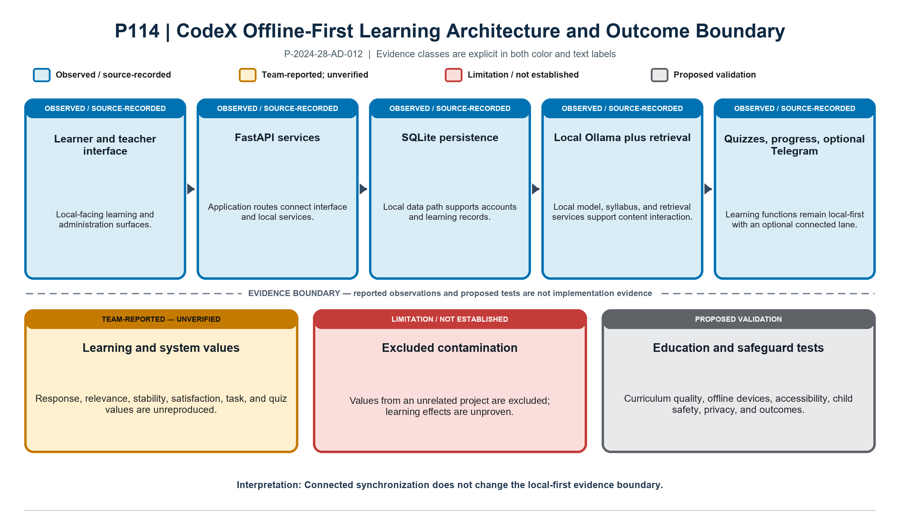
- Artifact-inspected P114 offline-first components and evidence boundary at commit 560a858 [13]. Unrelated-project prototype metrics are excluded; educational outcomes and safeguards remain prospective.

TEAM-REPORTED PRELIMINARY OBSERVATIONS
MVP records report eight users, 1.8–2.5-second response, about 88% relevance, 100% offline stability and 86% satisfaction. Final records report ten users, 85% task completion, at least 90% response accuracy and 100% quiz accuracy. No hardware/model/prompt log, reference-answer set, duration, failure definition, instrument, case output or valid participant evidence was supplied.
Table I preserves these numbers as team reports and excludes the contaminated prototype row entirely. Response relevance is not learning, quiz-generation accuracy is not learner knowledge, and a no-failure observation without duration and workload is not a general stability rate.

PROSPECTIVE EVALUATION PROTOCOL
Define the exact learner age range, curriculum, language, intended teacher role and game elements. Map each lesson and source to a curriculum edition, grade, language, license and expert review, and document retrieval and index construction so that educators can audit every answer against versioned authoritative material. Freeze content provenance and grade-specific expert reference answers; score retrieval recall [10], answer grounding and support, relevance, correctness, unsupported additions, readability, language quality, refusal of unsafe or out-of-scope prompts and quiz validity, and retain case-level prompts, retrievals, answers, ratings and adjudications. On a specified low-end device matrix, separately evaluate install size, installation, first-run behavior, RAM and CPU use, cold and warm latency, power, storage, model footprint, network isolation, synchronization conflicts, failure recovery and update behavior, and retain the raw logs [9].
With institutional ethics review, parental or guardian consent, child assent, school permission, a privacy plan, a safeguarding protocol and data minimization in place before any child data are used, run a small approved usability study before any learning trial, and reconcile the eight- and ten-user cohorts reported in earlier records. Evaluate learning only by comparing a specified version against a non-gamified but content-equivalent condition, using a prespecified pre/post knowledge instrument and retention outcomes; report usability values separately and never as learning gain, and record engagement without treating it as learning [1]–[5]. Test keyboard, screen-reader, contrast, language and cognitive accessibility against WCAG criteria [12] and report access constraints in the equity context of [11].

LIMITATIONS AND CONCLUSION
The missing PoC, ideation identifier remap, contaminated prototype metrics, authorship and consent conflicts, unexecuted repository, duplicated code and absent raw educational evidence limit the case. No learning-effectiveness, accessibility or child-safety conclusion is available.
P114 is most defensibly presented as an artifact-inspected evolution from a Telegram bot concept to a broader offline-first educational platform. Its contribution is the reconciled architecture and prospective evaluation protocol, not generic claims about gamification or AI tutoring.

REFERENCES
- Michael Sailer, Lisa Homner, “The Gamification of Learning: a Meta-analysis,” Educational Psychology Review, 2020. doi: 10.1007/s10648-019-09498-w.
- Douglas B. Clark, Emily E. Tanner-Smith, Stephen S. Killingsworth, “Digital Games, Design, and Learning,” Review of Educational Research, 2016. doi: 10.3102/0034654315582065.
- Juho Hamari, Jonna Koivisto, Harri Sarsa, “Does Gamification Work? -- A Literature Review of Empirical Studies on Gamification,” 2014 47th Hawaii International Conference on System Sciences, 2014. doi: 10.1109/HICSS.2014.377.
- Christo Dichev, Darina Dicheva, “Gamifying education: what is known, what is believed and what remains uncertain: a critical review,” International Journal of Educational Technology in Higher Education, 2017. doi: 10.1186/s41239-017-0042-5.
- Michael Sailer, Jan Ulrich Hense, Sarah Katharina Mayr, Heinz Mandl, “How gamification motivates: An experimental study of the effects of specific game design elements on psychological need satisfaction,” Computers in Human Behavior, 2017. doi: 10.1016/j.chb.2016.12.033.
- Sebastian Wollny, Jan Schneider, Daniele Di Mitri, Joshua Weidlich, Marc Rittberger, et al., “Are We There Yet? - A Systematic Literature Review on Chatbots in Education,” Frontiers in Artificial Intelligence, 2021. doi: 10.3389/frai.2021.654924.
- Enkelejda Kasneci, Kathrin Sessler, Stefan Küchemann, Maria Bannert, Daryna Dementieva, et al., “ChatGPT for good? On opportunities and challenges of large language models for education,” Learning and Individual Differences, 2023. doi: 10.1016/j.lindif.2023.102274.
- Ahmed Tlili, Boulus Shehata, Michael Agyemang Adarkwah, Aras Bozkurt, Daniel T. Hickey, et al., “What if the devil is my guardian angel: ChatGPT as a case study of using chatbots in education,” Smart Learning Environments, 2023. doi: 10.1186/s40561-023-00237-x.
- Martin Kleppmann, Adam Wiggins, Peter van Hardenberg, Mark McGranaghan, “Local-first software: you own your data, in spite of the cloud,” Proceedings of the 2019 ACM SIGPLAN International Symposium on New Ideas, New Paradigms, and Reflections on Programming and Software, 2019. doi: 10.1145/3359591.3359737.
- Patrick Lewis, Ethan Perez, Aleksandra Piktus, Fabio Petroni, Vladimir Karpukhin, et al., “Retrieval-Augmented Generation for Knowledge-Intensive NLP Tasks,” Advances in Neural Information Processing Systems 33, 2020. https://proceedings.neurips.cc/paper/2020/hash/6b493230205f780e1bc26945df7481e5-Abstract.html.
- UNESCO, “Global Education Monitoring Report 2023: Technology in Education—A Tool on Whose Terms?,” Global Education Monitoring Report, 2023. https://gem-report-2023.unesco.org/technology-in-education/.
- World Wide Web Consortium, “Web Content Accessibility Guidelines (WCAG) 2.2,” W3C Recommendation, 2023. https://www.w3.org/TR/WCAG22/.
- Codex, “Gamified learning for everyone,” public source repository, immutable commit 560a858a2fae7af52d940bf9f824f69db578c230, inspected 2026-08-22. https://github.com/prasanth-selva/EDU_AI.

P114-A09 | Human/learning study | MANDATORY BEFORE EXTERNAL SUBMISSION; OPEN IN INTERNAL DEVELOPMENTAL PACKAGE
Manuscript location: Project-specific evidence and evaluation sections
Exact source/evidence gap: P114-C05/P114-C06/P114-C07 — consent conflicts, eight/ten-user cohorts lack a crosswalk, and usability/accuracy/task values lack approved participant records, instruments, comparator, pre/post protocol, and raw evidence.
Required student/faculty action: Reconcile eight/ten-user cohorts and run approved usability first; evaluate learning only with a prespecified comparator and pre/post instrument.
Acceptance criterion: No usability value is presented as learning gain; participant and analysis records reproduce results.
Responsible person: ____________________________
Target date: ____________________________
P114-A10 | Repository hygiene | MANDATORY BEFORE EXTERNAL SUBMISSION; OPEN IN INTERNAL DEVELOPMENTAL PACKAGE
Manuscript location: Artifact-Observed Implementation
Exact source/evidence gap: P114-C08 — the repository contains multiple versions, committed environments, generated files, and broad claims; static inspection does not establish one clean licensed release, locked dependencies, offline build, or project-authored tests.
Required student/faculty action: Remove committed environments/generated files, choose one publication version, lock dependencies, add project tests and license manifests.
Acceptance criterion: A clean tag builds offline and passes project-authored tests without vendored environments.
Responsible person: ____________________________
Target date: ____________________________

