Submission Document - Design a Data Warehouse for Reporting and OLAP
Please include all of the required screenshots and SQL queries in this document. Resize the images as necessary to ensure the texts are readable.

A. Staging

1. Data architecture diagram showing all 8 files pointing to staging database to Operational Data Store (ODS) to Data Warehouse (DWH) to Reporting
You may create the diagram in Lucid.app, Draw.io, or similar services online.

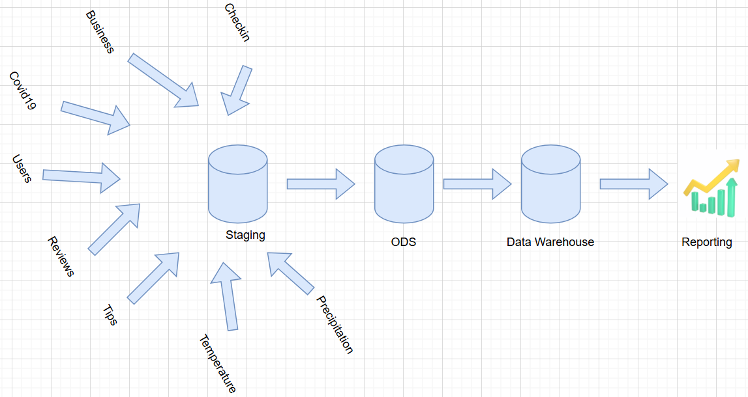

2. Screenshot showing the tables in the staging schema after extracting 6 Yelp files
The screenshot should have 6 tables with the correct respective row counts.

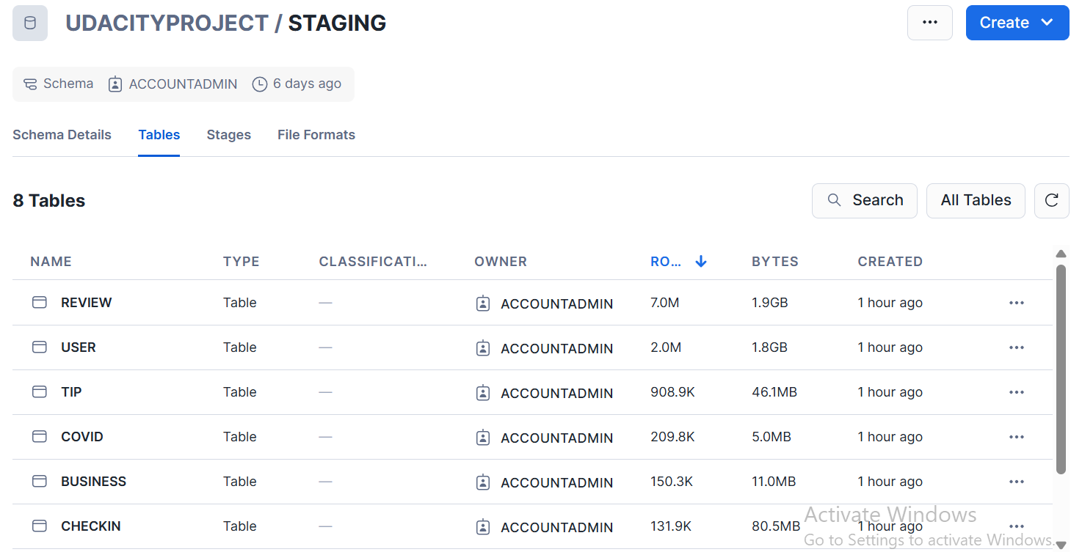

3. Screenshot showing the tables after extracting 2 files into the staging schema
The screenshot should have two tables - temperature and precipitation.

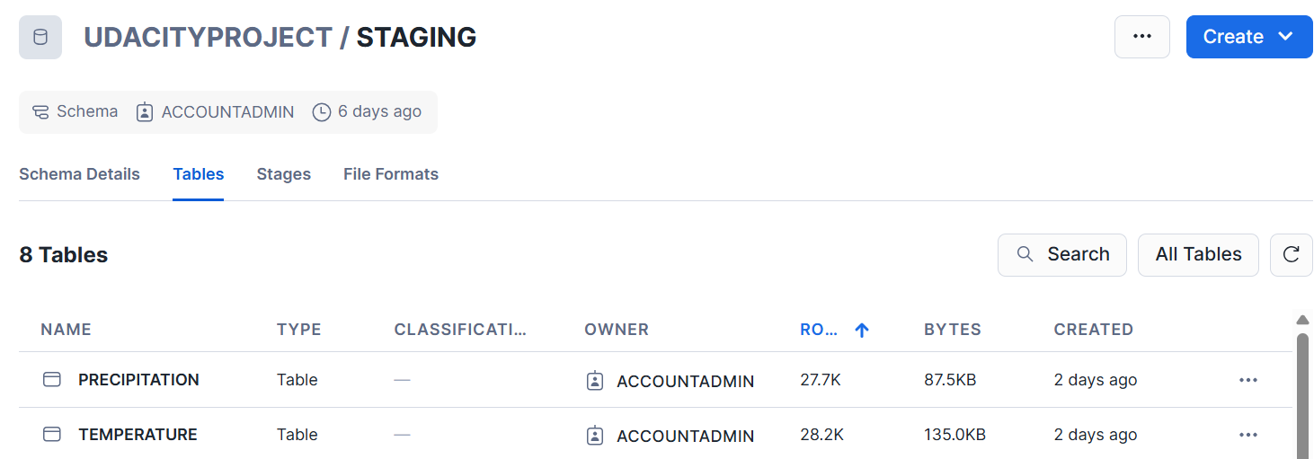

B. Operational Data Store (ODS)

1. ER diagram that includes one-to-one and one-to-many relationships for tables: Business, Customer, Tips, Review, Precipitation, Covid, Check_in, Temperature
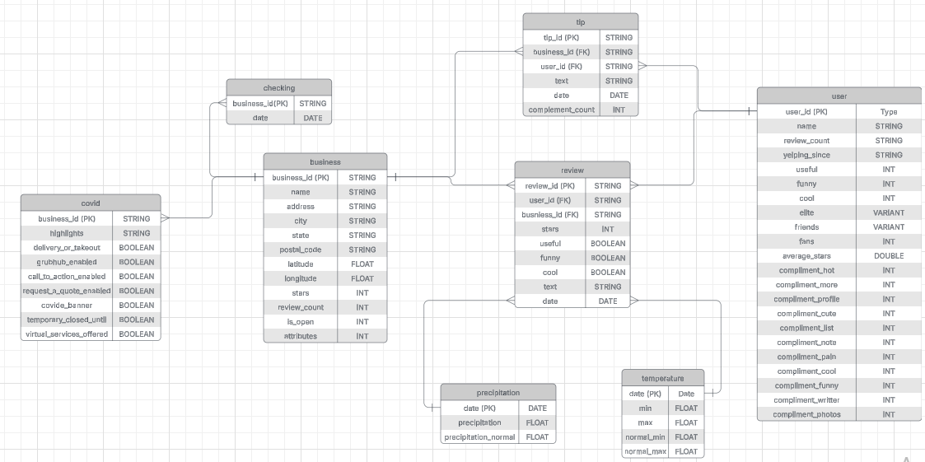

2. SQL queries that transform staging to ODS

3. Screenshot showing the queries were used successfully to transform the staging data to ODS

[Include the screenshot here]

4. SQL queries that use JSON functions to transform staging data from a single JSON structure into multiple columns for ODS

[Paste the SQL queries here]

5. Screenshot showing the queries were used successfully to transform staging data from a single JSON structure into multiple columns for ODS

[Include the screenshot here]

6. Screenshot showing different sizes/row_counts of raw, staging, and ODS tables in database

[Include the screenshot here]

7. SQL queries that integrate the climate and Yelp datasets

[Paste the SQL queries here]

8. Screenshot showing evidence that the SQL queries managed to integrate the datasets

[Include the screenshot here]

C. Data Warehouse (DWH)

1. Diagram of star schema with several dimensions and a fact table that connects dimensions

[Include the diagram here]

2. SQL queries that moves the data from ODS to DWH

[Paste the SQL queries here]

3. Screenshot showing evidence that the SQL queries managed to move the data from ODS to DWH

[Include the screenshot here]

4. SQL queries that produce a report showing the business name, temperature, precipitation, and ratings

[Paste the SQL queries here]

5. Screenshot showing the report produced by the SQL queries above

[Include the screenshot here]

