***SUNDAY O. SERATO MAY/06/2024***

***BSCS-1B ITE-121***

***Documentation***

***Title:*** *Simple Calculator using GUI*

***Benefits of your Code*:** *This code provides users with a practical substitute for hardware calculators by offering an intuitive interface for performing basic arithmetic calculations. It improves accessibility for a wide variety of users by enabling users to complete computations without the requirement for specialized mathematical knowledge. Through interactive involvement, it also promotes a visual grasp of mathematical ideas.*

***Objective:*** *Using Tkinter in Python, this code aims to create a simple calculator that can do addition, subtraction, multiplication, and division, among other fundamental arithmetic operations. By accomplishing this goal, the code shows how to use Python's Tkinter framework to implement GUI programming approaches in a real-world setting.*

***Purpose of your Code:*** *The sample demonstrates how to use Tkinter to create desktop Python applications with graphical user interfaces (GUIs). This code serves as an example of how to use Tkinter's features to create interactive and user-friendly programs, and it also serves as a learning resource for those who are interested in GUI development by producing a working calculator.*

***Significance of your Code/Study:*** *This code is noteworthy because it offers a hands-on illustration of creating a graphical user interface (GUI) using Tkinter, which might be beneficial for novices learning Python GUI programming. It also shows how to do calculations, manage user input, and show the results in a Tkinter application.*

***Features of your Code:*** *This code has a number of important features, such as an easy-to-use user interface that improves navigation and usability by having buttons for operators and digits properly defined. In order to provide a seamless user experience, the solution also has strong error handling techniques to handle situations like division by zero and erroneous expressions. Furthermore, users can benefit from increased adaptability and simplicity thanks to advanced features like character deletion, input cleaning, and percentage calculations.*

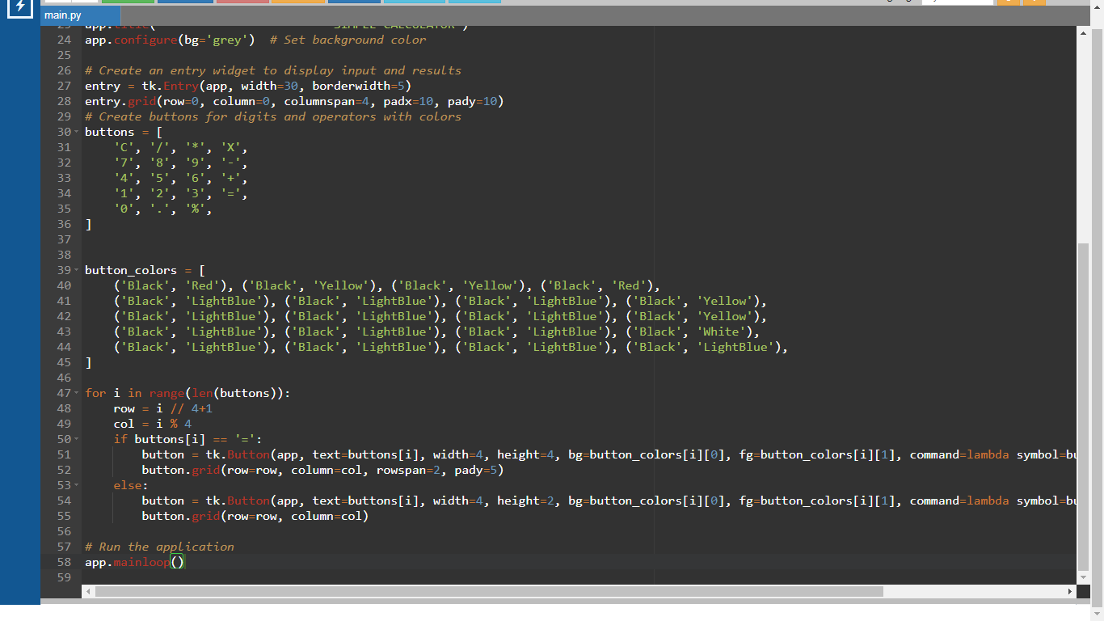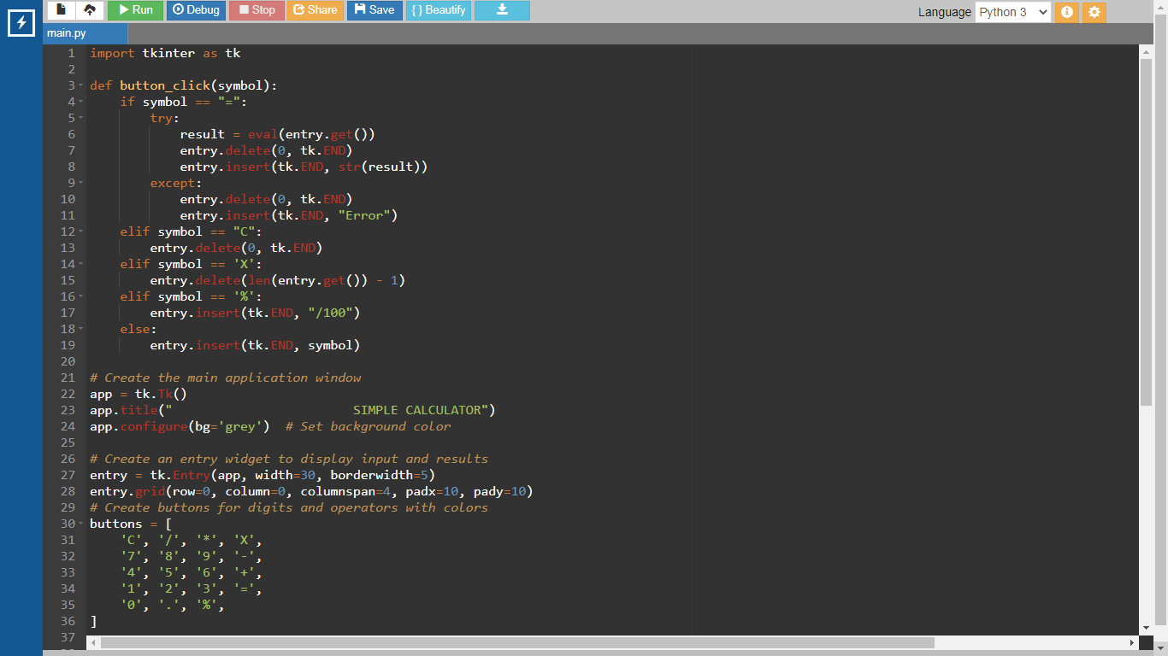***Code:***

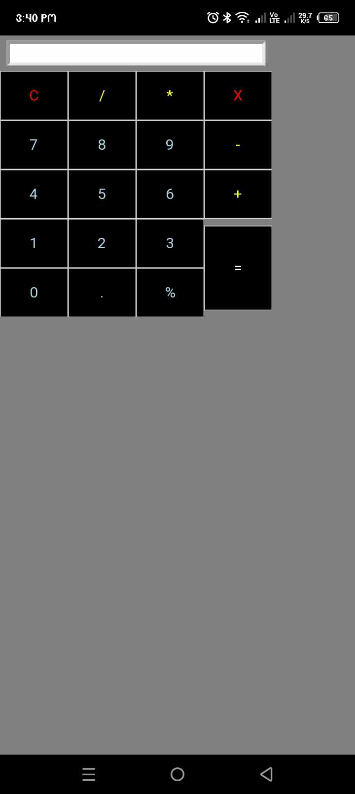***Output:***

**BIO DATA**

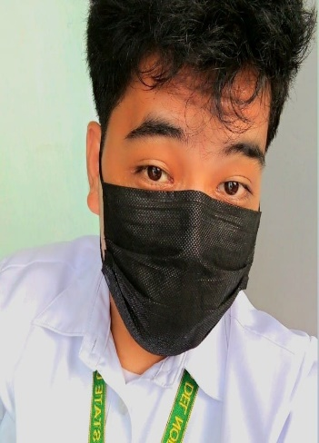**NAME : Sunday O. Serato**

**Contact Number : 09463422863**

**Email ID :** [**sundayserato@gmail.com**](mailto:sundayserato@gmail.com)

**Address : P-2 Brgy Poctoy Surigao City**

**Gender : Male**

**Date of Birth : January/25/2005**

**Place of Birth : P-2 Brgy Poctoy Surigao City**

**Age : 19 Years Old**

**Marital Status : Single**

**Father’s Name : Andy L. Serato**

**Mother’s Name : Suzette O. Serato**

**Sister’s Name : Cendie O. Serato**

**Religion : Roman Catholic**

**Nationality : Filipino**

**Language Known : Bisaya, Tagalog, English**

**Education:**

|  |  |  |
| --- | --- | --- |
| **Exam Name:** | **Year of Pass** | **Institution Name** |
| **Elementary** | **2016-2017** | **Justino R. Clavero M.E.S** |
| **Secondary** | **2022-2023** | **Wilfredo D. Rafols M.N.H.S** |
| **Tertiary** | **Still Studying** | **Surigao Del Norte State University** |

**Hobbies : Sports, Music, Cooking**

**Work Experience : Hotel Staff, Construction Worker**

**Declaration**

**I do hereby declare that the above information is true to the best of my knowledge.**