Contents
Task1 2
Task2 2
➢ Description of the chosen scenario 2
➢ Name of the classes, methods, and objects that exist in the program 3
➢ Explanation as to how multithreading functionality is achieved 3
➢ Discussion on why you implemented Synchronization to your objects 4
➢ Screenshot illustrating the execution of the program 5

Task1

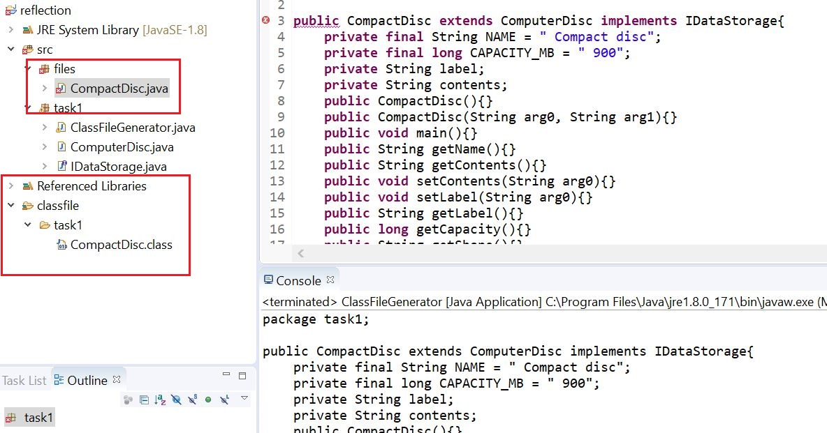

Task2

Description of the chosen scenario
I did this multithread program that supports concurrency based on the Master/Slave design pattern. I assumed one concurrency scenario that when many clients looked up the orders or something else from the website at the same time, the server must be under pressure, if the pressure could not be released, it might crash somehow. I made one master who does not handle the requests but assign all the requests to the slaves and they have to do all requests, when they finish, pass the result to the master and master give the result to clients.
There is simple figure to describe the structure as following:
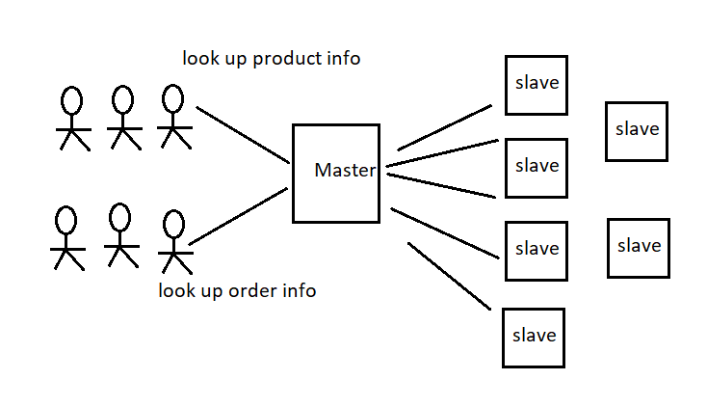

Name of the classes, methods, and objects that exist in the program
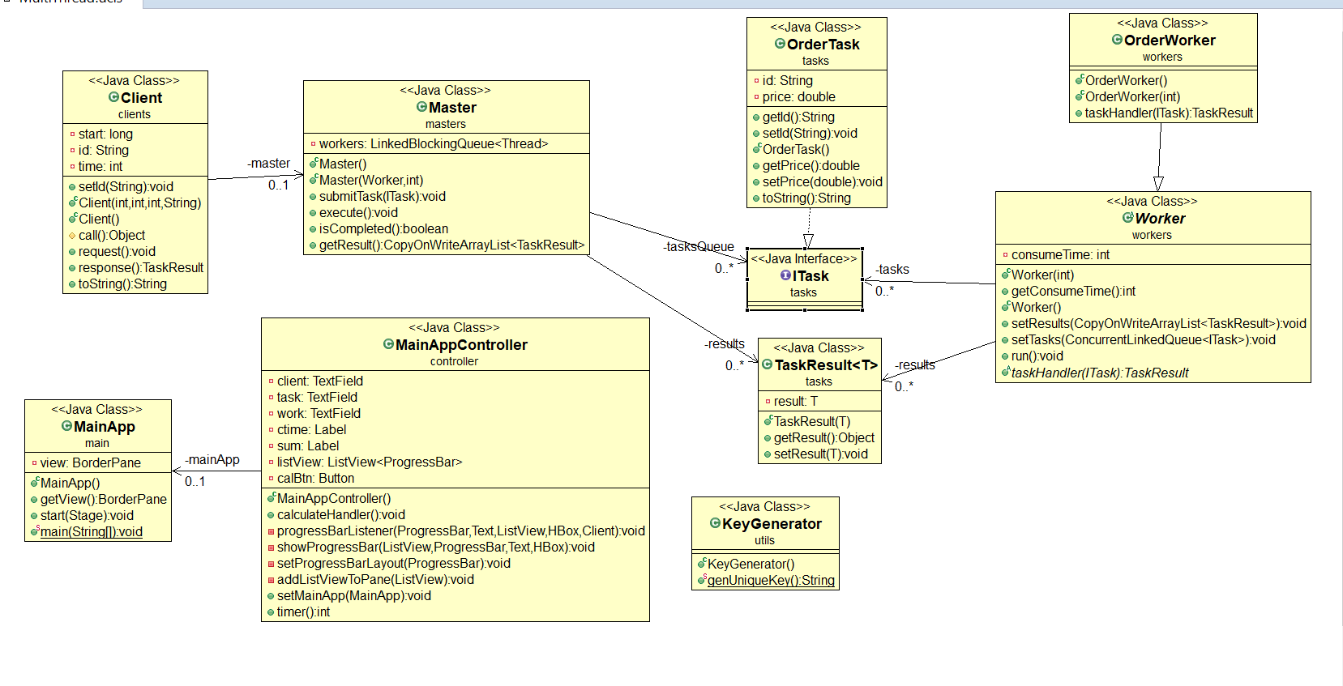

Explanation as to how multithreading functionality is achieved
For this task 2, I use synchronize and different collection supporting high concurrency that are from java concurrency package. They are respectively ConcurrentLinkedQueue (), CopyOnWriteArrayList () and LinkedBlockingQueue (). Using synchronize is because I need set id for clients and tasks if I do not use it, it will be produced to the same id for different clients or tasks. 3 collections are thread security and each one uesd is based on my understanding to them.
For instances, if clients often look up data from your program, better to use CopyOnWriteArrayList (), as it can improve efficiency if clients only select the data. On the other hand, if clients often do insert, delete and update, I need to change CopyOnWriteArrayList () to other container, considering the efficiency and CopyOnWriteArrayList () internal implementation mechanism.
LinkedBlockingQueue () is used to store workers. Because it is blocking queue, when master create many slaves at the same time, somehow, it should cause thread contention problem I think.

Discussion on why you implemented Synchronization to your objects
Because each slave means one thread, every time, many salves need to be created and they need to handle the tasks at the same time. if I do not use the collections supporting high concurrency and synchronize, which lead to thread conflict as the result of thread mutex and lose data integrity.

Screenshot illustrating the execution of the program
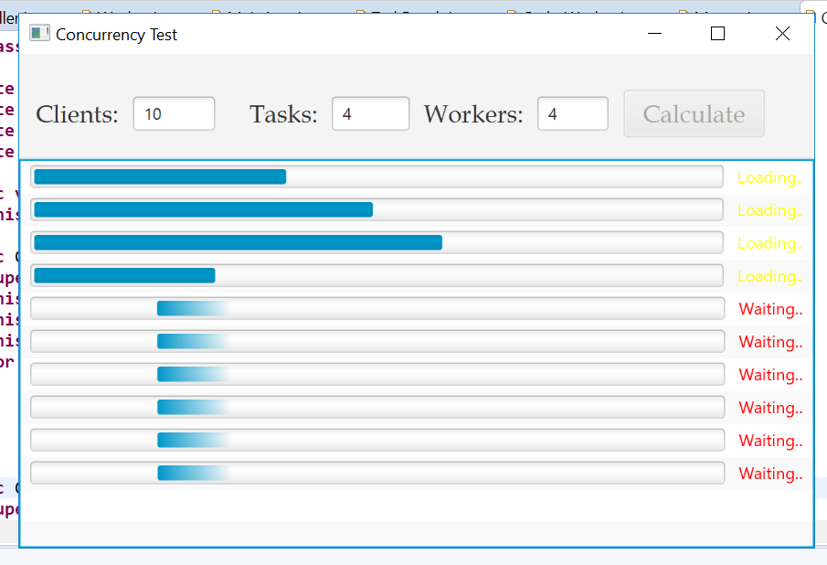

I use FixedThreadPool and set the number as 4, every time, only 4 threads can be executed, and rest of them saved into one collection that is from FixedThreadPool and they will be executed until the first 4 thread terminate or complete.
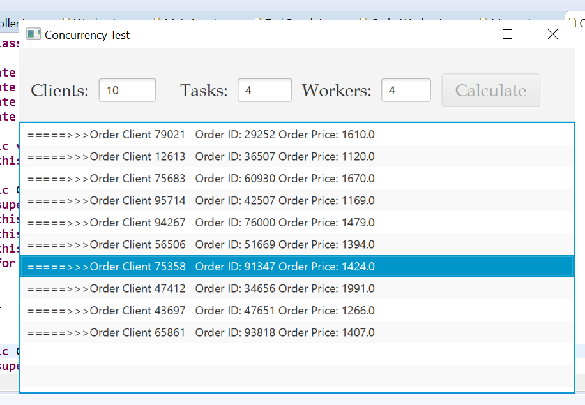
When client get response from the master, it will show the information on the listView.

