System design document for Jumpy Dash  
  
  
 Version: 1  
 Date: 2016-05-11  
 Author: Marcus, Johannes, Alex & Oscar

# 1 Introduction 1.1 Design goals

The design should be module and flexible in order to make it possible to change physics engine .

1.2 Definitions, acronyms and abbreviations

* Box2D, physics engine
* LibGDX, framework for 2D game design

2 System design  
  
2.1 Overview   
  
The application will be based on the MVC design pattern where every model has its own controller and view.  
  
2.2 Software decomposition

2.2.1 General

The application is decompsed into the following packages. The dotted lines indicate a dependency.

13180860_1151490284874517_244607736_n.png

* Controller, constains all the controller classes
* View, contains all the view classes
* Model, contains all the model classes

2.2.2 Decomposition into subsystems   
  
2.2.3 Layering  
  
2.2.4 Dependency analysis

Dependencies are as shown.

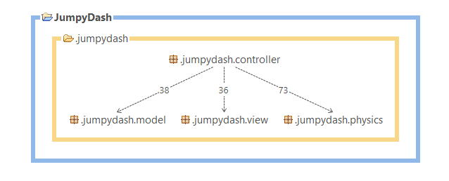

2.3 Concurrency issues  
  
2.4 Persistent data management  
  
2.5 Access control and security  
  
2.6 Boundary conditions

3 References

APPENDIX

Design model.

Controller:

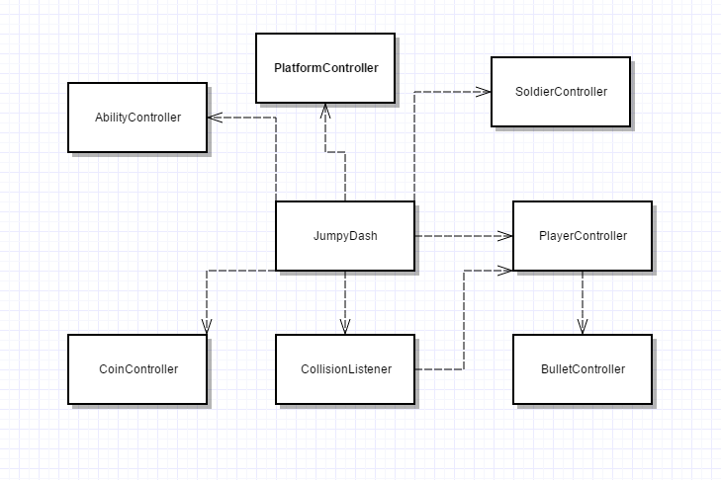

View:

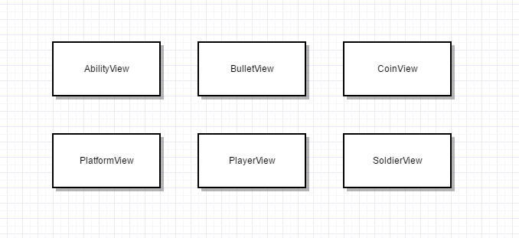

Model:

