CSCI 4550 Homework 1

In this first assignment, I expect you to create a static image on OpenGL. This image will contain several primitive shapes with colors. Please set your window size to 500x500 and use the orthographic projection. You are free to determine size (and location) of the viewing cube and the size of each object. I only expect you follow the ratio between these objects as shown below. You are free to choose any “n” value as long as it is consistent with your viewing cube.

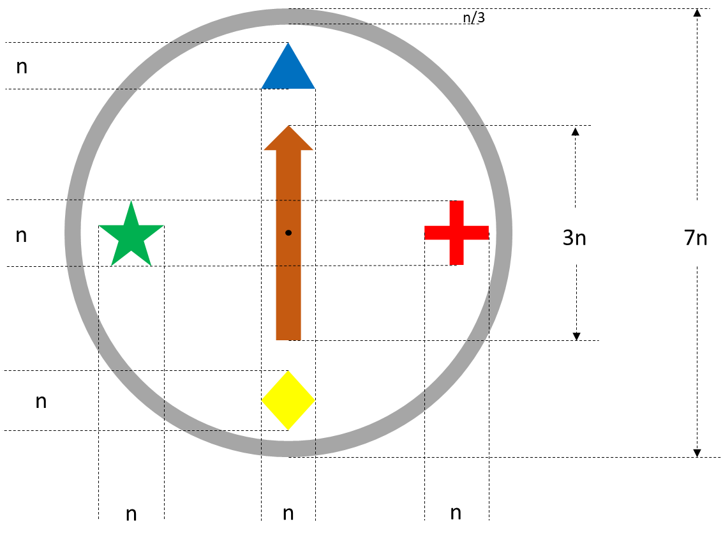

The image is similar to a compass including four shapes (blue triangle, red cross, yellow diamond, and green star) located at four directions (north, east, south, and west) and a brown arrow at the center pointing to the north. All shapes are in a gray ring shape.

Please keep in mind that you will reuse your program for the next assignment, so try to write your code as modular as possible. For instance, it is a good idea to create a function (for each shape) that allows drawing the shape at any location in the scene.

I would also recommend you to use an existing working project to start and modify it. Here is the link for textbook exercises (<http://www.sumantaguha.com/downloads>) in case you need. You will submit your source code in a single .cpp file to the blackboard. Please feel free to contact me if you have any questions.