Steps:

1. Login using link Attached.

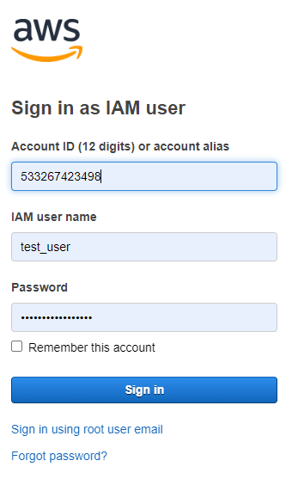

(Account ID: 533267423498)

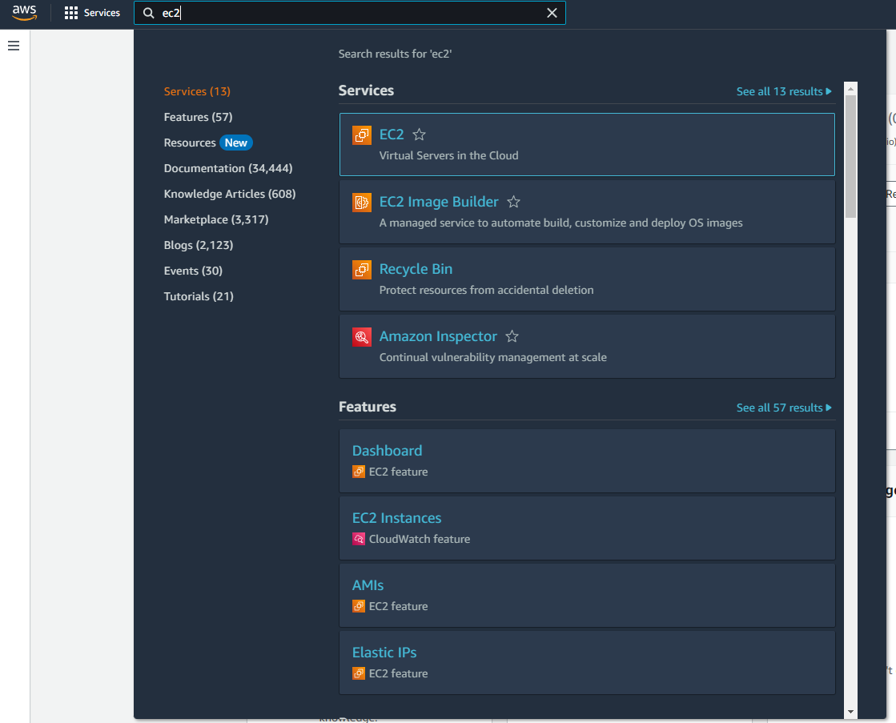

4) Go to EC2

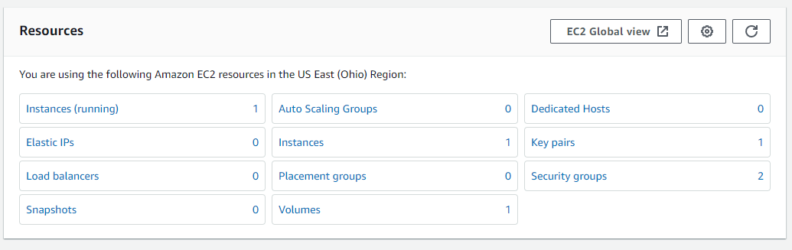

5) Go to Instances (running)

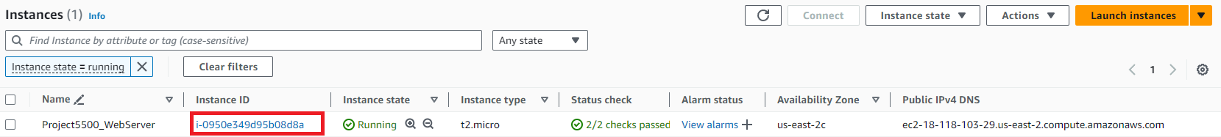

1. Select Project5500_WebServer (click Instance ID: [i-0950e349d95b08d8a](https://us-east-2.console.aws.amazon.com/ec2/home?region=us-east-2#InstanceDetails:instanceId=i-0950e349d95b08d8a))

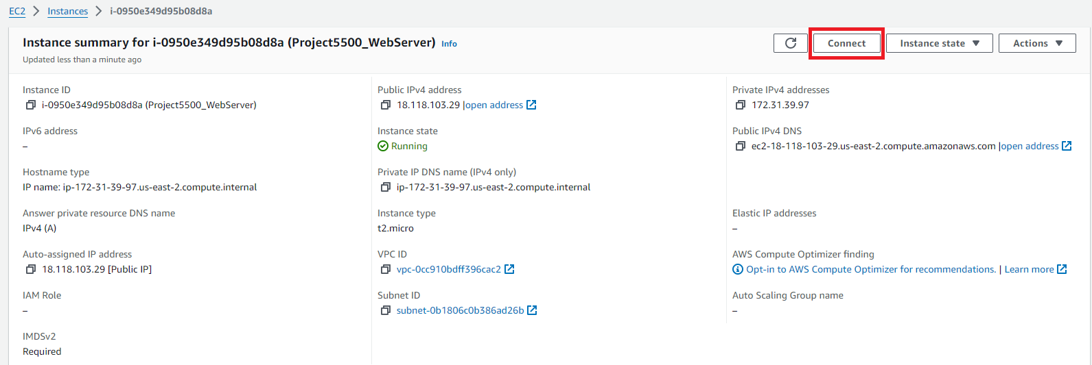

Upright hand corner, go to Connect

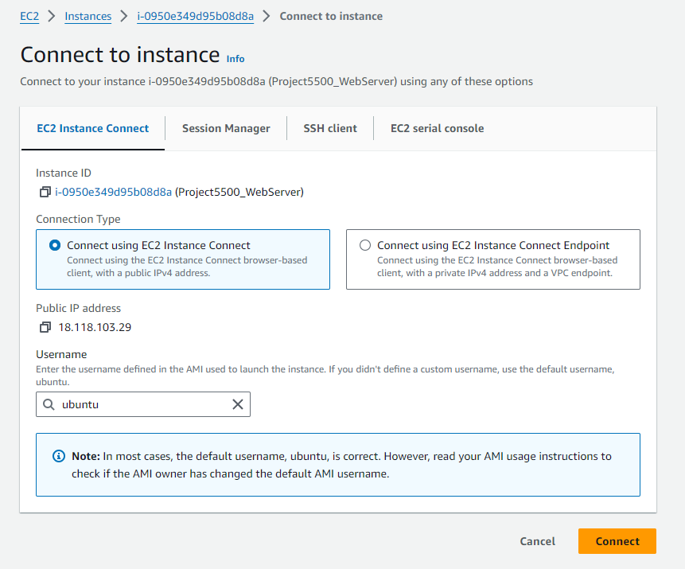

1. Connect using EC2 Instance, username ubuntu

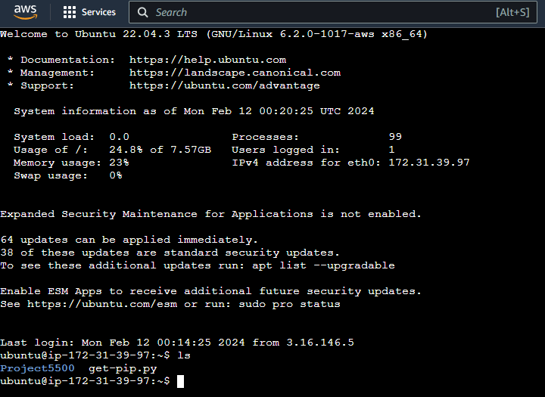

6) If you want to SSH to the instance via powershell

ssh -i .\Project5500.pem [ubuntu@ec2-18-118-103-29.us-east-2.compute.amazonaws.com](mailto:ubuntu@ec2-18-118-103-29.us-east-2.compute.amazonaws.com)

Linux/Mac

ssh -i Project5500.pem [ubuntu@ec2-18-118-103-29.us-east-2.compute.amazonaws.com](mailto:ubuntu@ec2-18-118-103-29.us-east-2.compute.amazonaws.com)

Note: I’ll need to generate the .pem sepately.