Task 2 — Advanced EDA & Text Mining
Vehicle infotainment warranty events: what fails, why, and what to do about it
Stakeholder report | Dataset: Hanuai_task2_assignment.csv (1,000 events) | Prepared 25 October 2026

1. Executive summary
We analysed 1,000 infotainment warranty events (radio, display, rear camera, satellite radio, phone and navigation) on 2020-model-year vehicles: 4 makes, 23 models, 8 build plants, claims opened between August 2019 and June 2021. Each event carries three free-text narratives (customer complaint, technician diagnosis, repair). We cleaned the data, converted roughly 68,000 words of narrative into structured tags, grouped them into issue categories and used clustering / topic modelling to propose root causes.

89%  of events end in a radio replacement | 38% / 37%  component failure / communication fault | 20%  of claims within 90 days of in-service | 30%  needed TAC / engineering escalation

- The radio (head unit) is where the cost concentrates. 89% of events are fixed by replacing it; 66% by replacing *and* reprogramming. Only 8% were fixed by reprogramming alone.
- Two mechanisms dominate: internal hardware failure (38%) and communication / network faults (37%), followed by software / calibration (12%), electrical / wiring (10%) and assembly quality (3%). Internal fault or failure is stated in 34% of technician narratives; shorted modules account for 24% of coded causes.
- Customers experience it as a dead or black screen: inoperative (32%), black / blank screen (25%), random shutdown or reboot (12%), no sound (11%). One in five complaints is intermittent, which makes diagnosis harder.
- The pattern looks systemic rather than local. The category mix is stable over the claim window (p = 0.30) and plant, make and model explain very little of it (Cramér’s V ≤ 0.11), which is consistent with a design or supplier issue rather than a single plant excursion. This needs production volumes to confirm.
- Diagnosis is expensive. 30% of events needed TAC or engineering support, and 18% explicitly record that no fault code was found.
Recommended focus: (1) failure analysis and supplier corrective action on radio internal electronics, (2) hardening of the Ethernet / CAN communication interface, (3) moving recurring reprogramming fixes to bulletin / OTA, and (4) a guided diagnostic path that reduces escalations. Details and sizing are in section 5.

2. Understanding of the data

2.1 What the dataset contains
Field group | Columns | Notes
Identification & timing | Event id, Opened date, Build date, In-service date | Event ids unique. Three different date formats (text) were parsed.
Product & plant | MAKE (4), MODEL (23), MODLYR, PLANT / BUILD_PLANT_DESC (8) | MODLYR is constant (2020); PLANT duplicates BUILD_PLANT_DESC. Each model maps to a single make.
Coded complaint & cause | COMPLAINT_CD_DESC (9 levels), CAUSAL_CD_DESC (38 levels) | Complaint is 94% Audio / Entertainment / Navigation. Causal code is “system – failure mode”.
Free text | CUSTOMER_, CAUSAL_, CORRECTION_VERBATIM | Avg. 17 / 22 / 29 words. ALL-CAPS, typos, shorthand (C/S, R&R, SPS, TAC, DTC); 1.3% Spanish or French.
Example tag columns | Trigger, Failure Component, Failure Condition, Additional Context, Fix Component, Fix Condition | Filled for only 5 rows by design. Used as the target schema and a mini validation set, then populated for all rows.

2.2 Data-quality issues found and how they were handled
Issue | Finding | Treatment
Missing values | Causal code 3, causal text 1, in-service date 1; two placeholder verbatims (“#”) | Causal code → “Unknown” (resolved from text rules). Placeholders → missing. In-service date imputed as build date + median lag (91 days) and flagged.
Impossible dates | 76 events (7.6%) have a claim opened before the in-service date | Flagged; days-in-service left blank (not imputed, to avoid distorting time-to-failure).
Duplicates | None: no duplicate rows, ids or verbatim triples | No action.
Inconsistent formats | Stray leading space in one complaint level; irregular whitespace; mixed languages | Trimmed and normalised; small ES/FR → EN lexicon applied before tagging.
Constant / redundant columns | MODLYR (one value), PLANT (duplicate of plant description) | Dropped from analysis, kept in export.
Masked fault codes | No raw DTC strings (P/U/B/C codes) survive in the text | Captured only whether codes were mentioned, found or absent.

2.3 Possible analysis outcomes and value for customers
- OEM quality and engineering: a ranked, evidence-based list of failure mechanisms and early-life failure signals, built from narrative that is normally unusable at scale.
- Suppliers (Tier-1): a data-backed case for corrective action, with failure categories and cause codes to focus teardown work.
- Service and warranty: guided diagnostics, fewer escalations and repeat visits, and clearer rules for when to replace versus reprogram.
- Software and connected-vehicle teams: identification of failures that can be fixed by update instead of hardware swap.
- Analytics and IT: a reusable tagging schema and pipeline that turns each new claim into structured, searchable data.

3. Approach in brief
The notebook (Hanuai_Task2_EDA_TextMining.ipynb) is annotated step by step. The workflow has four stages:
- EDA: schema and quality assessment, cleaning, summary statistics and distributions of the critical columns (complaint code, causal code, plant / make / model, build and in-service timing, days in service).
- Text mining: normalisation (case, accents, shorthand, Spanish / French key terms), then dictionary-and-regex entity extraction into the same six entity types as the example columns, plus symptoms, technician findings, process flags and fault-code status. Extraction is source-aware: customer text first for what failed, causal and correction text for findings and fixes, so test steps (“tested display – OK”) are not mistaken for failures.
- Issue categorisation: the coded cause drives the category when informative; mined tags resolve vague codes (“Registers Incorrectly”, “Follow operation”, missing). A separate symptom-area label (camera, XM, phone, display …) describes what the customer sees.
- Clustering: K-Means on TF-IDF of customer complaints (10 clusters) and LDA on technician narrative (6 topics), each profiled against coded fields.

Entity type (output column) | Tags | Examples | Coverage
Failure Component | 12 | Radio, Display, Backup Camera, Satellite Radio (XM), Bluetooth / Phone | Radio 71%, Display 37%, XM 12%, Camera 12%
Failure Condition (symptom + finding) | 12 + 9 | Inoperative, Black Screen, No Sound, Internal Fault, Lost Communication | Symptom tagged in 81% of events
Trigger / Additional Context | 5 / 5 | When Reversing, At Start-up / Intermittent, While Driving | Trigger found in 12%, context in 24%
Fix Component / Fix Condition | 9 / 4 | Radio, SPS, USB / Replaced, Programmed, Repaired | Fix condition tagged in 98%
Process flags, DTC status | 4 + 3 | TAC contacted, TSB referenced, Repeat visit / No DTC found | TAC 30%, no DTC 18%

Validation. The five example rows were used as a small gold set (n = 5, so this is a sanity check, not an accuracy estimate). Trigger tags matched fully, failing components scored precision 0.88 / recall 0.78, and fix tags 0.67–0.75. Failure Condition is the weakest field (precision 0.33, recall 0.67): the examples’ labels often come from deep inside the repair narrative, and our output also records technician findings the examples omit. Overall (excluding the symptoms-only variant) precision is 0.62 and recall 0.75.

4. What the data says

4.1 Most frequent failures
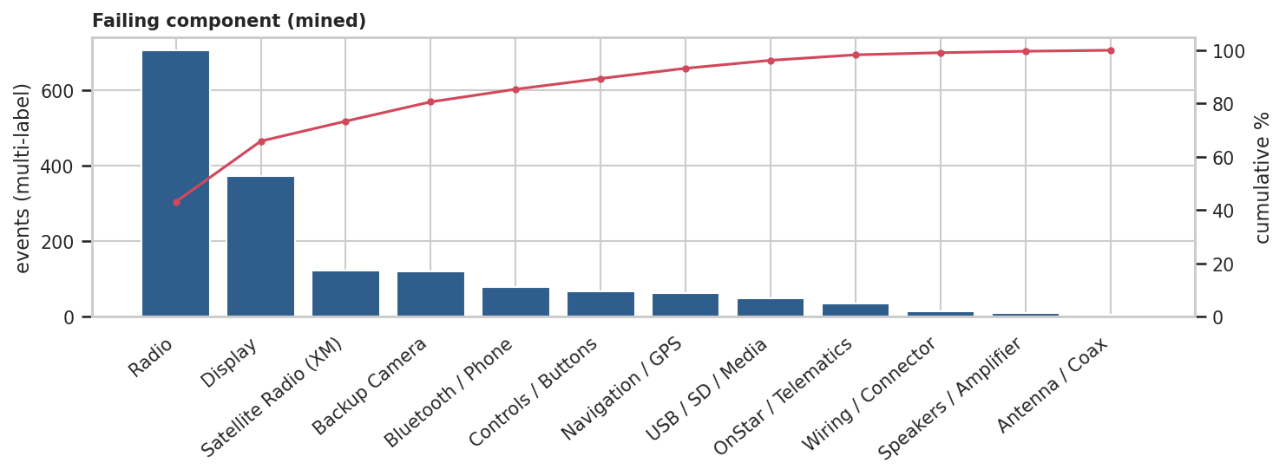
Figure 1. Failing components mentioned (multi-label; bars = events, line = cumulative %).
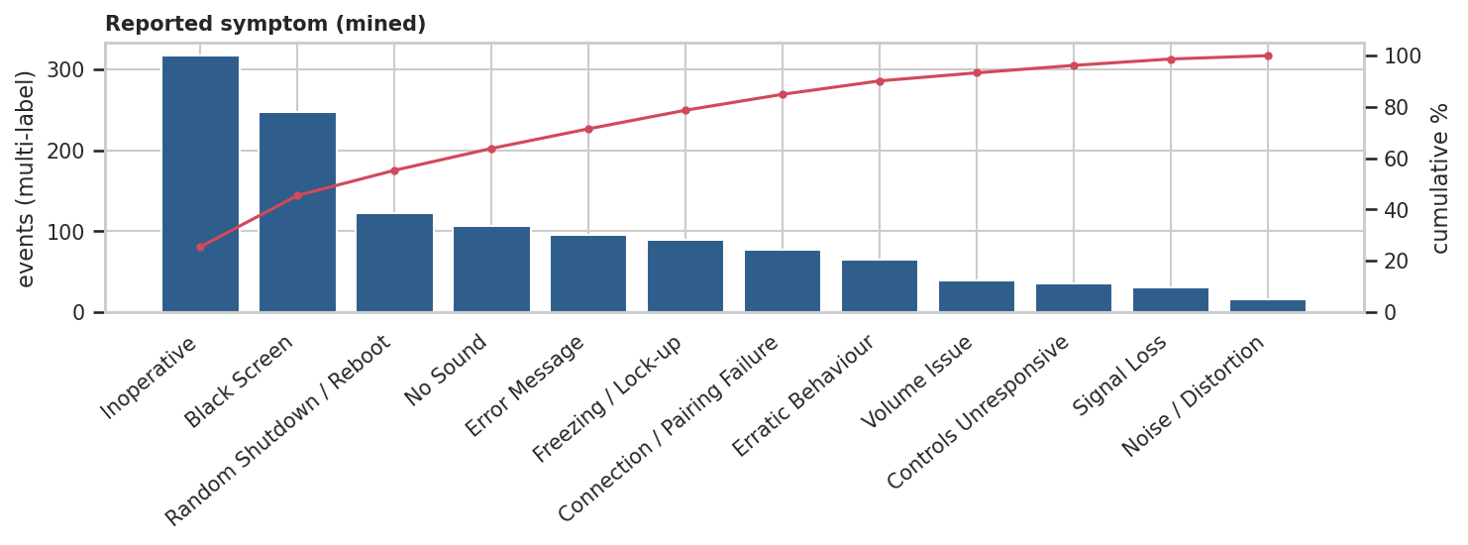
Figure 2. Reported symptoms. A further 19% of events had no recognisable symptom wording.
The radio and display are involved in most events, so the product question is less “which part” than “why does the head unit stop working or communicating”. Rear-camera loss (12%) is a safety-relevant function and appears as a “when reversing” trigger in 4% of events.

4.2 Types of issue
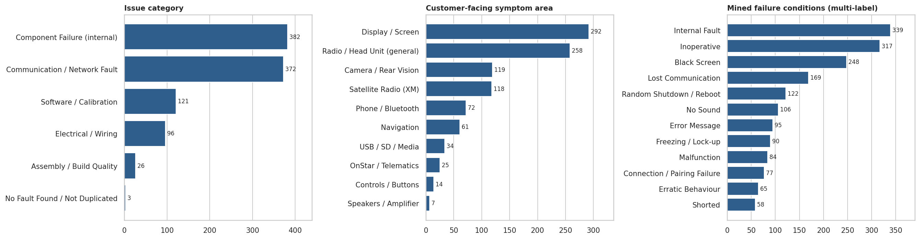
Figure 3. Issue category (cause-driven), customer-facing symptom area and mined failure conditions.
Component failure (38%) and communication / network faults (37%) account for three of four events. Software / calibration (12%) is the next largest group and the one most amenable to a non-hardware fix. Assembly / build quality is small (3%, 26 events) but concentrated in specific cause codes (loose, not clipped, routing).

4.3 Trends and significant changes
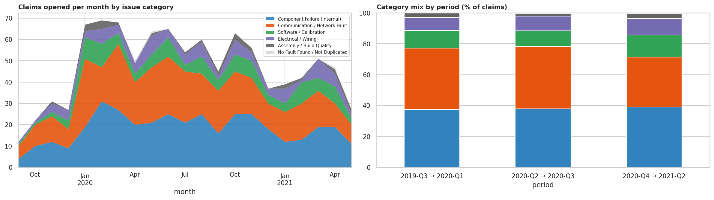
Figure 4. Monthly claims by issue category (partial first and last months excluded) and category mix by period.
- Monthly volume peaks in early 2020 (about 65–70 claims per month) and declines through 2021. This is not evidence of improvement: there are no sales or production denominators, and the most recent months are right-censored (vehicles have not had time to fail).
- The category mix is statistically stable across three equal-volume periods (χ² p = 0.30). The only notable drift is communication / network share falling 7.6 points (39.8% → 32.2%, p = 0.052) while software / calibration rose 3.0 points (not significant).
- Time to claim does not differ by category (Kruskal–Wallis p = 0.35). Overall, 20% of claims occur within 90 days of in-service and 39% within 180 days (median 228 days), pointing to early-life failure.

4.4 Plant, make and model
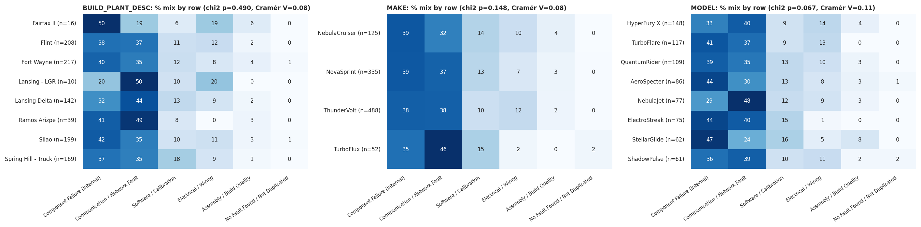
Figure 5. Category mix by plant, make and the eight largest models (row %; n shown per row).
Association with issue category is weak: plant p = 0.49 (V = 0.08), make p = 0.15 (V = 0.08), model p = 0.07 (V = 0.11). Small segments such as Fairfax II (n = 16) and Lansing LGR (n = 10) look extreme only because of low volume. Model-level hints worth watching are HyperFury X electrical / wiring (1.4× expected, n = 20) and NebulaJet communication faults (1.3×, n = 37). These are watch-list items, not conclusions.

4.5 Clusters, topics and potential root causes
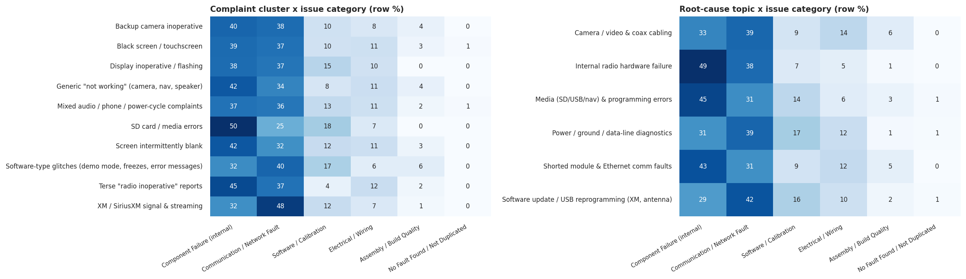
Figure 6. Complaint clusters (K-Means) and root-cause topics (LDA) against issue category (row %).
Complaint cluster | Events | Median days in service | Comment
Mixed audio / phone / power-cycle complaints | 299 (30%) | 214 | Broad catch-all of general audio, phone and shutdown complaints.
Black screen / touchscreen | 150 (15%) | 270 | Largest well-defined screen-failure group.
Software-type glitches (demo mode, freezes, errors) | 108 (11%) | 303 | Slowest to surface; over-indexes at Lansing Delta (1.4×). Candidate for software fix.
XM / SiriusXM signal & streaming | 82 (8%) | 168 | Earliest to surface; 48% communication faults.
Backup camera inoperative | 78 (8%) | 238 | Safety-relevant; over-indexes at Spring Hill Truck 1.4× (small n).
Screen intermittently blank | 73 (7%) | 228 | Intermittent; hardest to reproduce.
Generic “not working” (camera, nav, speaker) | 71 (7%) | 246 | Low-information complaints.
Display inoperative / flashing | 60 (6%) | 170 | Fails early in service.
Terse “radio inoperative” reports | 51 (5%) | 173 | 96% resolved by replacement.
SD card / media errors | 28 (3%) | 190 | Small, distinct cluster; half are component failures.

Reading the clusters. Complaint clusters align well with the customer-facing symptom area (NMI 0.40) but almost not at all with issue category (NMI 0.01): the same visible symptom is produced by different mechanisms, so symptom wording alone cannot triage root cause. Structure is soft (silhouette ≤ 0.10, seed-to-seed ARI 0.45–0.57), so clusters are descriptive groupings rather than sharply separated classes.
LDA on technician text yields six interpretable topics: internal radio hardware failure (22%), software update / USB reprogramming for XM and antenna (19%), power / ground / data-line diagnostics (19%), shorted module and Ethernet communication faults (15%), camera / video and coax cabling (12%) and media (SD / USB / navigation) programming errors (12%).
Potential root cause (hypothesis) | Evidence in the data | How to confirm
Radio internal electronics / power-stage short | Shorted code 24%; internal fault in 34% of narratives; 89% replaced | Teardown and failure analysis of returned radios; supplier 8D
Ethernet / CAN communication interface failure | “No / incorrect communication” 38% of coded causes; ethernet, data-link or lost-comm text in 17% | Bus-level diagnostics on returned units; link to hardware / firmware revision
Software defects or outdated calibration | 8% fixed by reprogramming alone; software category 12%; demo-mode / freeze cluster; bulletins in 5% | Compare software versions before and after update; OTA pilot
Wiring, connector, antenna / coax faults | Wiring / electrical code 9%; camera / coax topic; technician notes cite fretting corrosion | Harness and terminal inspection; dielectric-grease check
Assembly or handling quality | 3% of events (loose, not clipped, routing) | Line audit at build plants once volumes are available

5. Actionable recommendations and business impact
The extract has no cost data, so impact is sized in events per 1,000 claims that finance can multiply by unit cost (parts, labour, TAC time, loan vehicles).
Recommendation (owner, horizon) | Evidence | Business impact
P1. Failure analysis and supplier corrective action on radio internal electronics (Quality / Supplier, 0–3 months) | 89% replaced; Shorted code 24%; internal fault in 34% of narratives | Targets about 890 replacements per 1,000 claims; each 10% reduction avoids about 89 replacements
P1. Harden the Ethernet / CAN interface: bus fault-injection tests, firmware / hardware revision traceability (Engineering, 3–9 months) | No / incorrect communication 38% of coded causes; lost-comm text 17% | Addresses about 370 events per 1,000 and a common mechanism behind black-screen and inoperative symptoms
P2. Move recurring reprogramming fixes to bulletin / OTA and track repeat visits after update (Software / Service, 3–6 months) | 8% fixed by reprogramming only; software category 12%; slowest-surfacing cluster (median 303 days) | Up to about 120 events per 1,000 could avoid a hardware swap or extra dealer visit
P2. Guided diagnostic tree for “no communication / black screen”, with mandatory capture of fault codes and bus status before calling TAC (Service engineering, 1–3 months) | 30% TAC escalations; 18% no fault code found; 20% intermittent | About 295 escalations per 1,000: shorter repair time, fewer repeat visits
P2. Early-life quality gate: end-of-line communication and boot test, burn-in sampling (Manufacturing, 3–6 months) | 20% of claims within 90 days, 39% within 180 | About 195 early-life events per 1,000; protects customer satisfaction in the first months
P2. Safety review of rear-camera loss (Product safety / Compliance, immediate) | Camera in 12% of events; “when reversing” trigger in 4% | Reduces customer-risk exposure; rear-visibility rules apply in several markets (verify applicability)
P3. Watch-list monitoring of model / plant hot spots with control charts once production volumes are added (Quality analytics, 3 months) | HyperFury X electrical 1.4×, NebulaJet communication 1.3×; overall segment effects weak | Avoids false alarms and enables early warning on a true rate basis
P3. Fix data capture: date validation, retain fault codes, pick-lists for symptom / trigger / fix, language tag (IT / dealer systems, 3–6 months) | 7.6% impossible date pairs; fault codes masked; 19% of events with no symptom wording | Makes monitoring automatic and improves tagging accuracy over time

6. Key learnings and further improvements

Technical learnings
- Coded fields beat text for category assignment, text beats codes for nuance. Combining them (coded cause first, mined tags for vague codes) gave the most defensible categories.
- Source-aware extraction matters. Technician narratives contain long test procedures; taking components from customer text first and findings from diagnosis text avoided most false tags.
- Short, noisy, multilingual text gives weak clusters. Silhouette stayed below 0.10 at every k, so clusters were used for description and hypothesis generation, always profiled against coded fields.
- Gold-set validation was only possible on 5 rows, so reported tagging accuracy is directional.

Next steps
- Label about 300 events and fine-tune a small transformer NER model, or prompt an open-source LLM with a JSON schema; compare F1 against this dictionary baseline.
- Use multilingual sentence embeddings with BERTopic / HDBSCAN for sharper topics, keeping K-Means / LDA as interpretable baselines.
- Add production volumes and build-lot / supplier-lot data to convert counts to rates per 1,000 vehicles; apply survival (Weibull) analysis and p-chart / CUSUM monitoring.
- Add cost per claim to turn the event-based sizing above into a financial business case.

Limitations
No denominators or costs; one model year; recent months right-censored; 7.6% invalid date pairs; the tag dictionary is not exhaustive; weak cluster separation. Findings are directional and should be confirmed with failure analysis before large investments.

Appendix. Deliverables
File | Content
Hanuai_Task2_EDA_TextMining.ipynb | Annotated, fully executed notebook: EDA, text mining, entity extraction, categorisation, clustering and export.
Hanuai_task2_tagged.csv | All 1,000 events with the six example columns populated plus symptoms, findings, process flags, DTC status, issue category, symptom area, cluster and topic.
Hanuai_task2_tagged.xlsx | Same data with colour-coded headers (grey = original, green = extracted tags, blue = classification), example rows highlighted, and sheets for tag dictionary, tag frequency, category / cluster / topic profiles and gold-set validation.
Hanuai_Task2_Report (this document) | Synthesis, actionable points with business impact, and learnings.

