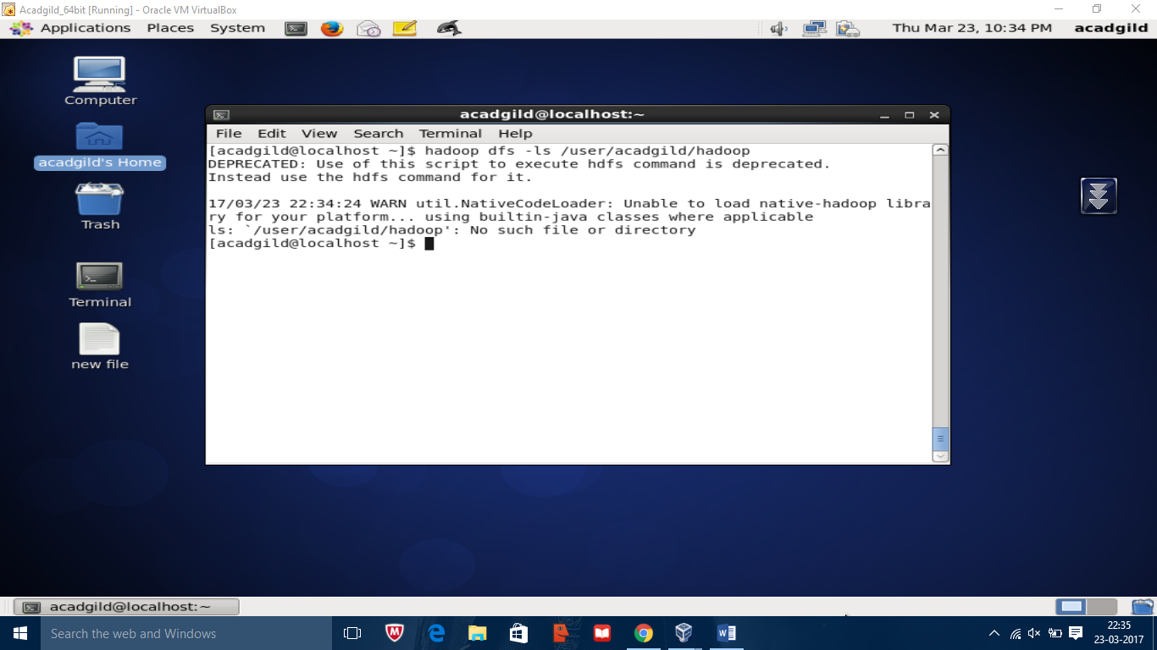

/user/acagild/hadoop is not in root directory



Directory created