1.Pwd - Pwd prints the current working directory.

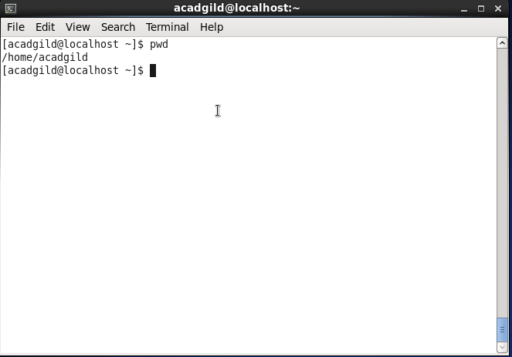

2.Vi - Vi is default editor.

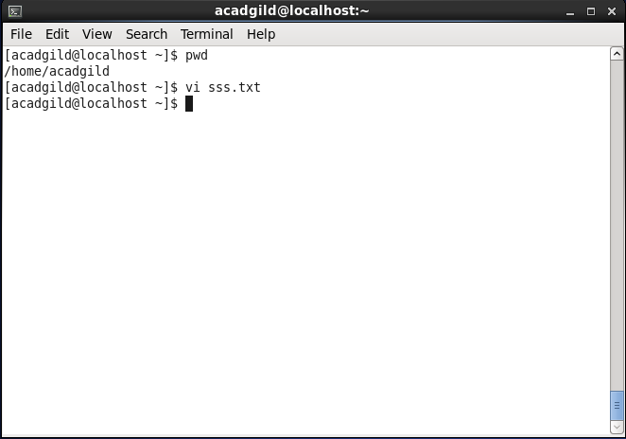

3.Touch - Touch command is the easiest way to create new, empty files. It is also used to change the timestamps

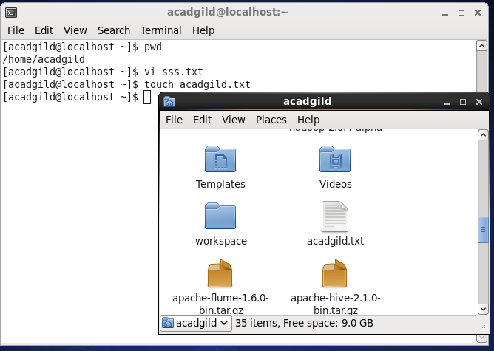

4.Mkdir - Mkdir is used to create new directory.

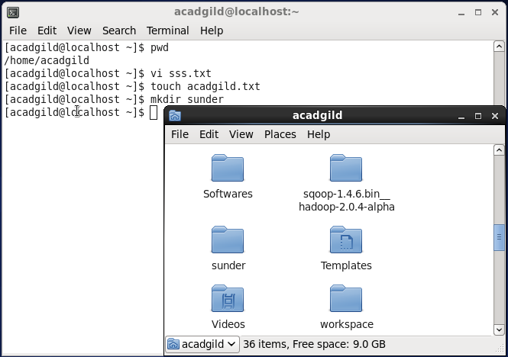

5.Rm - rm command removes a file in a directory.

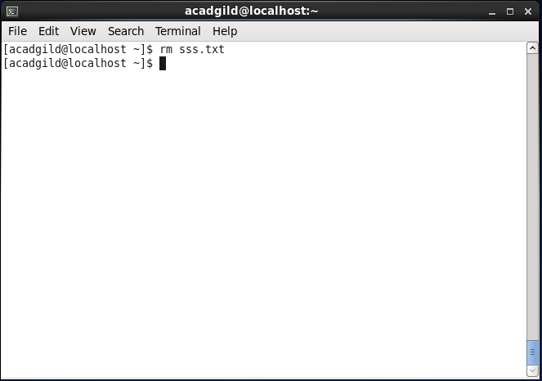

6.Ls - ls command is used for list the files in current directory.

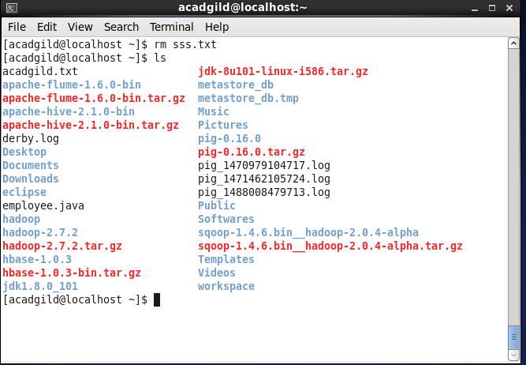

7.Echo - echo command is used for print.

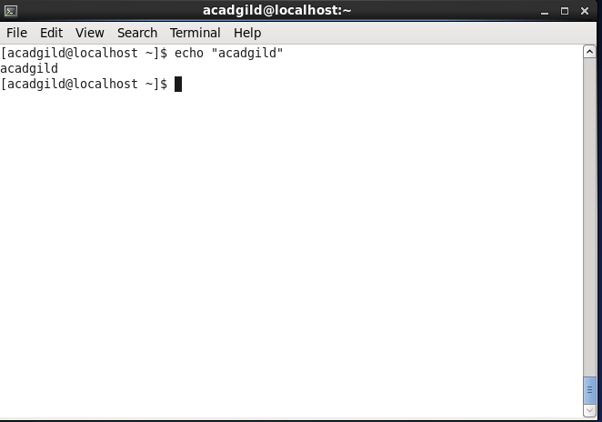

8.Cat - Cat command is used to display,copy and append text files.

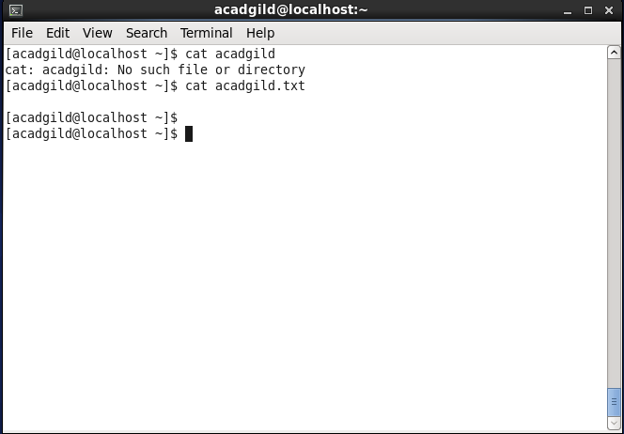

9.Who - This command gives the current user name

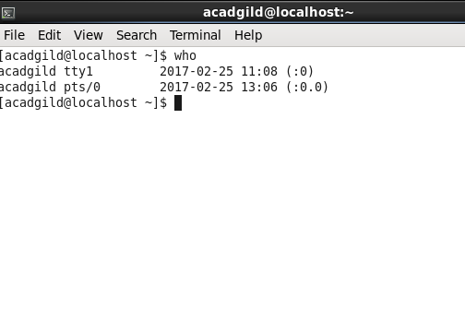

10.cd - change directory

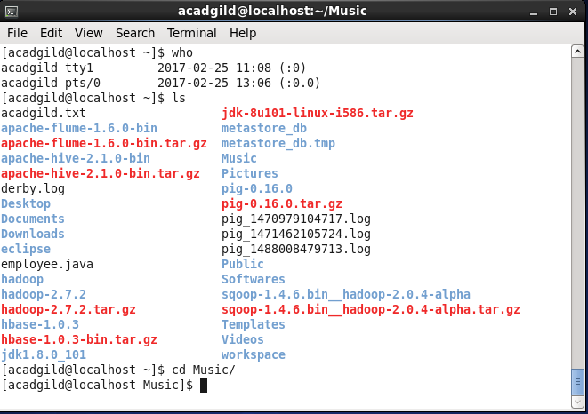

11.Date - This command display the system date

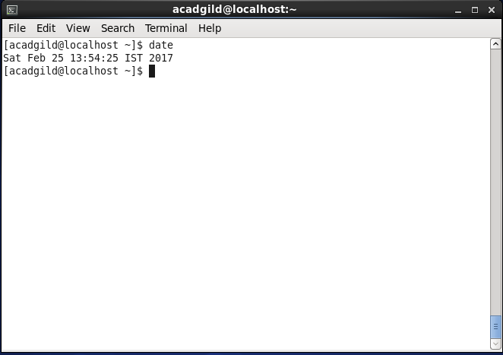

12.Cal - Display calander

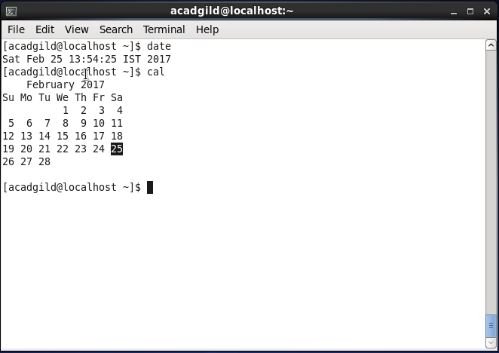

13.mv - move file

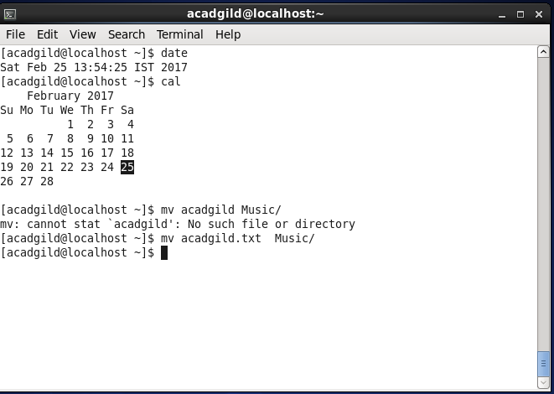

14.cp - copy files.

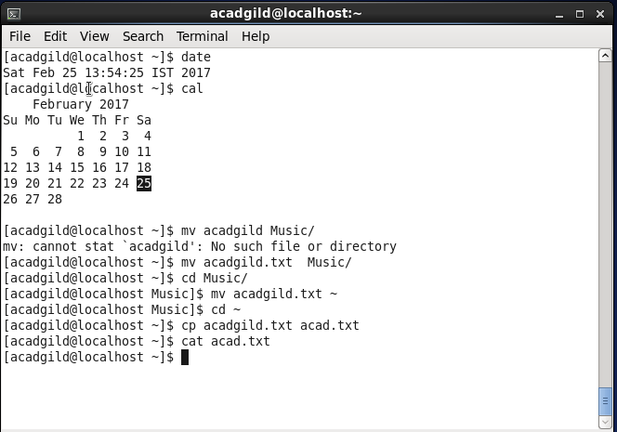

15.which - locate executables in system

