Need of hve

It provides us data warehousing facilities on top of an existing hadoop cluster. Along with thet ir provides an sql like interface which makes your work easier. In case if we are coming from sql background. We can also map existing hbase with hve.

2.No hive is not suitable for oltp systems because delete,insert and update at low level are not permitted in hive. It is used to store process data in large volume.

3.Hive meta store service stores the metadata for hive tables and partitions in a relational database and provides clients access to this information using the metastore service api

4.Yes hive supports unix commands

Ls

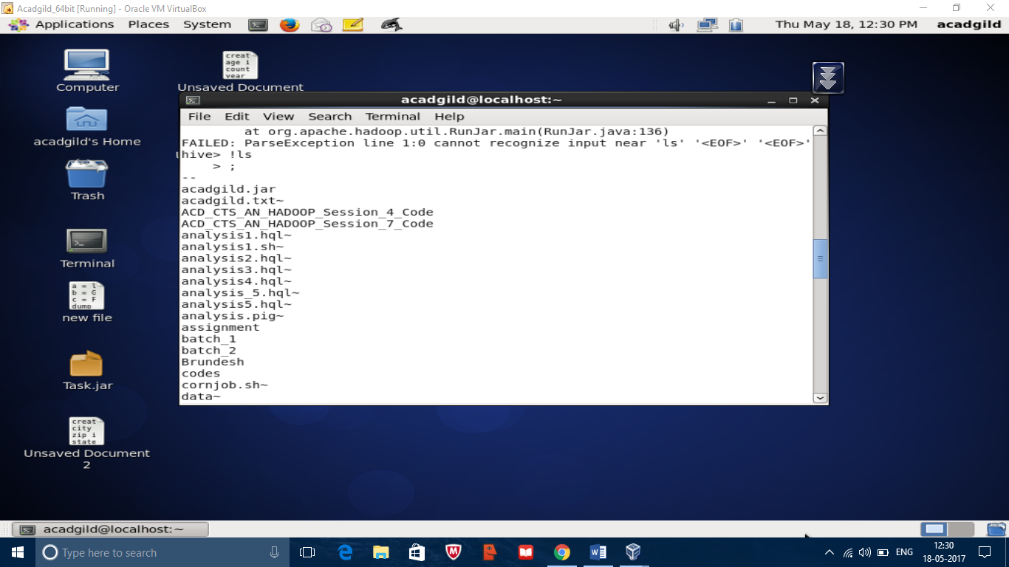

Date

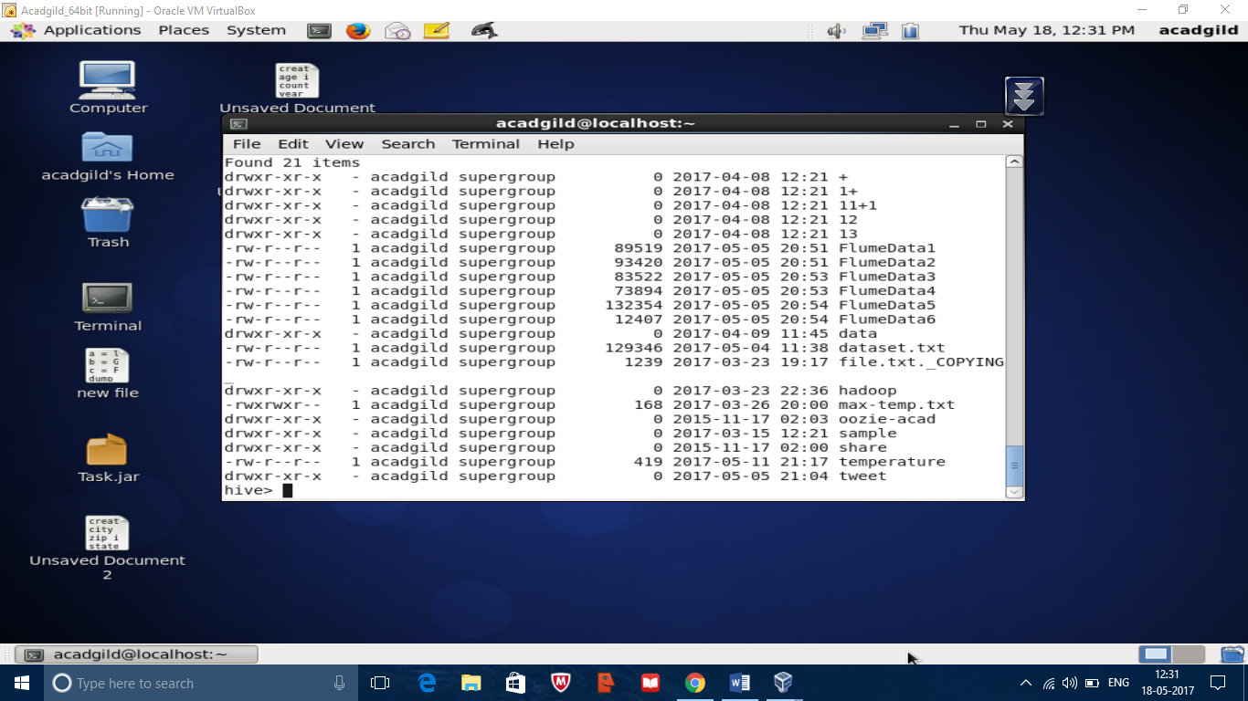

Mkdir

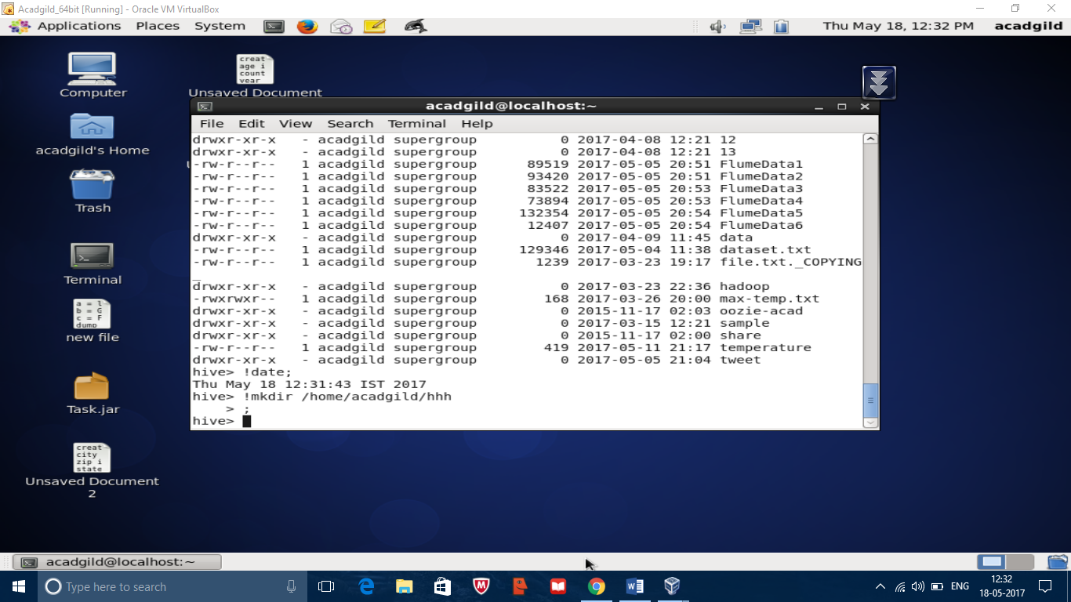

Who

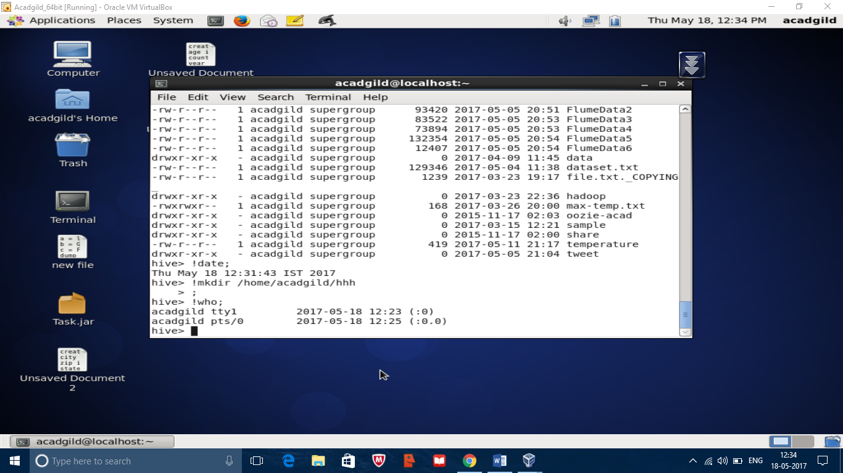

Rmdir

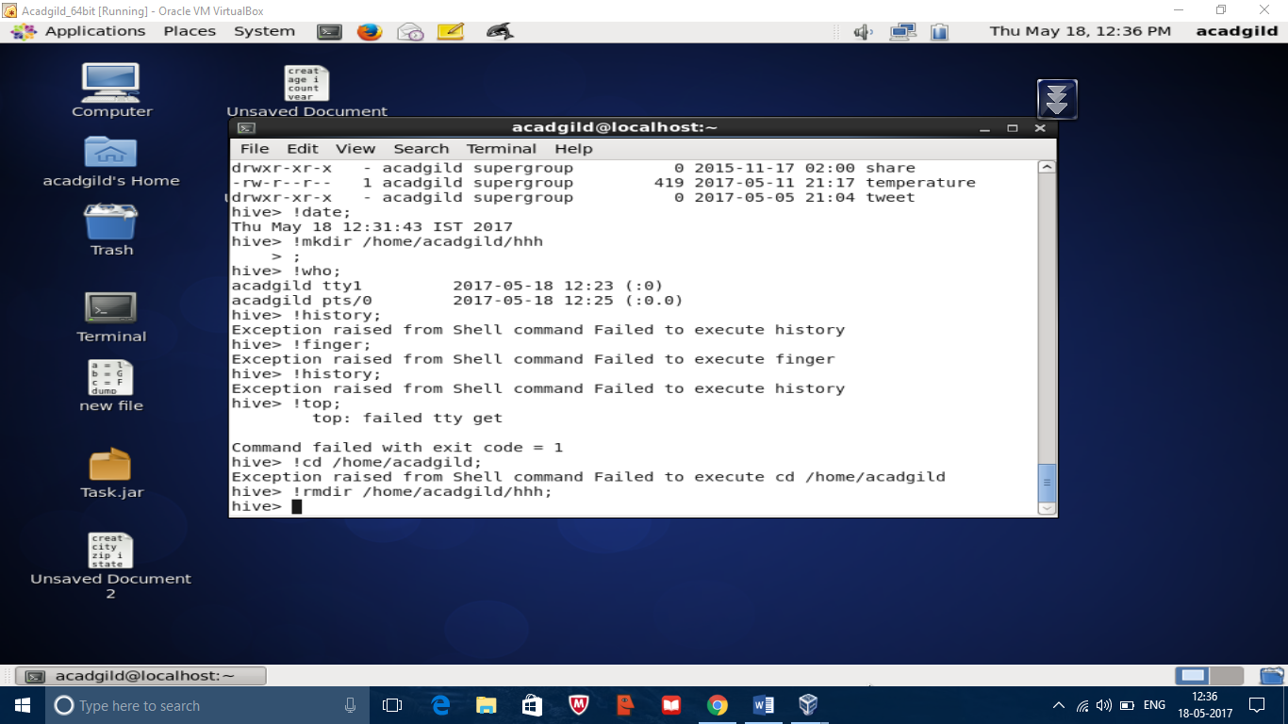

5.Yes hive can process any data format usin serde.

Serde is called as serializaer and deserializer. The deserializer interface takes a string or binary representation of record and translates it into a Java object that hive can manipulate. The serializer will take java objects that hive has been working with and turn it into something that hive can write to hdfs.example jsaon serde,