Inserting data into table emp in sql

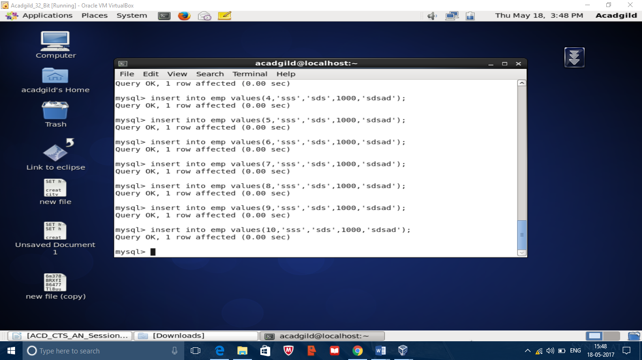

Importing data into hdfs

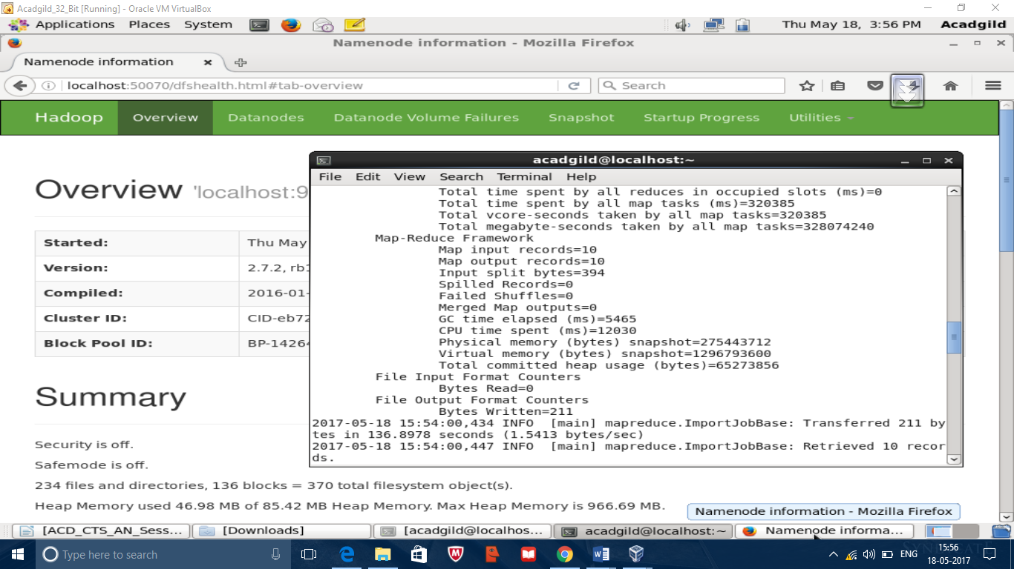

Sqoop code

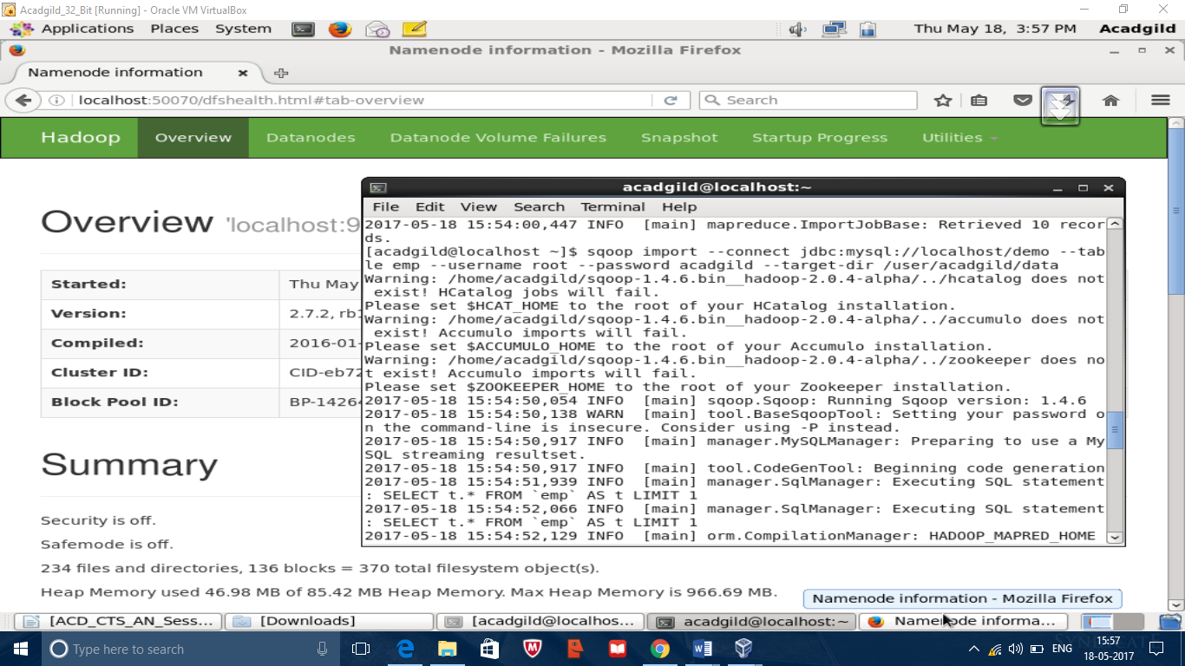

Data

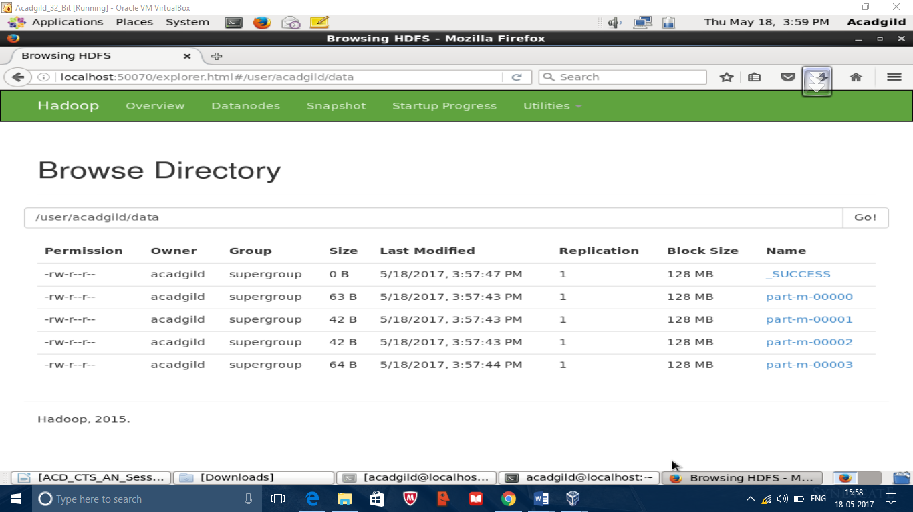

Hive import

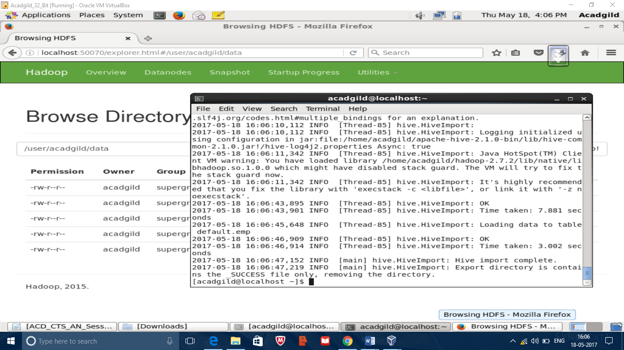

Sqoop code

Sqoop import –connect jdbc:mysql://loacal/demo –table emp --username root –password –hive-import –target-dir /user/acadgild/data

Output

