Sqoop incremental import

Sqoop import –connect jdbc:mysql://localhost/demo –table emp –username root –password –target-dir /home/acadgild/data1 –incremental append –check-column id

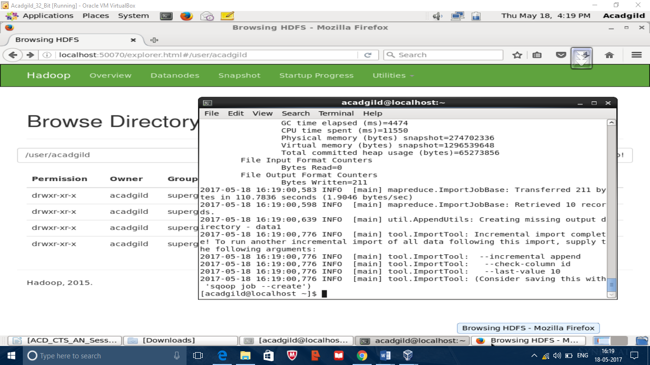

Data

