SQOOP:

Sqoop is abbreviated as sql to hadoop and hadoop to sql.

Id is tool wich is designed to transfer data between hadoop and relational database servers. It can import relational data base suh as mysql,orace to hadoop hdfs and export file system to relational database.

Tools in sqoop

Import

Export

Sqoop import

Sqoop import is a tool to import a set of data from relational database to hdfs. All records are stored as text data in text files or as binary data in Avro and sequence files.

Sqoop export

The sqoop export tool exports a set of file hdfs to rdbms. The files given as input to sqoop contain reords, which are called as rows in table. Those are rean and parsed into a set of records and delimited with user specified delimiter.

Sqoop load to hbase

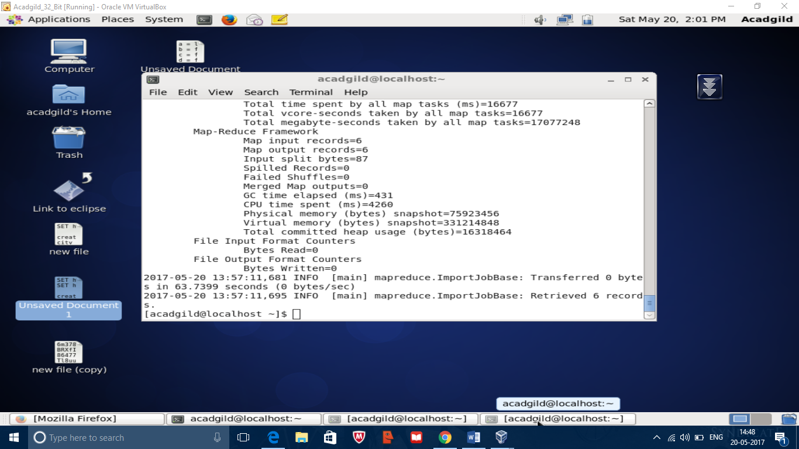

Hbase table

