Inserting in data in hdfs

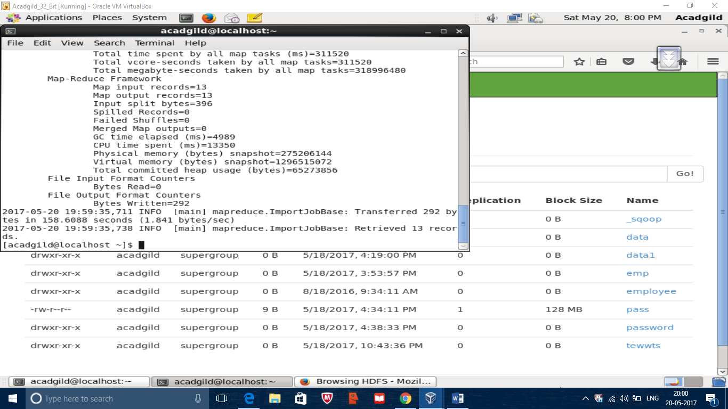

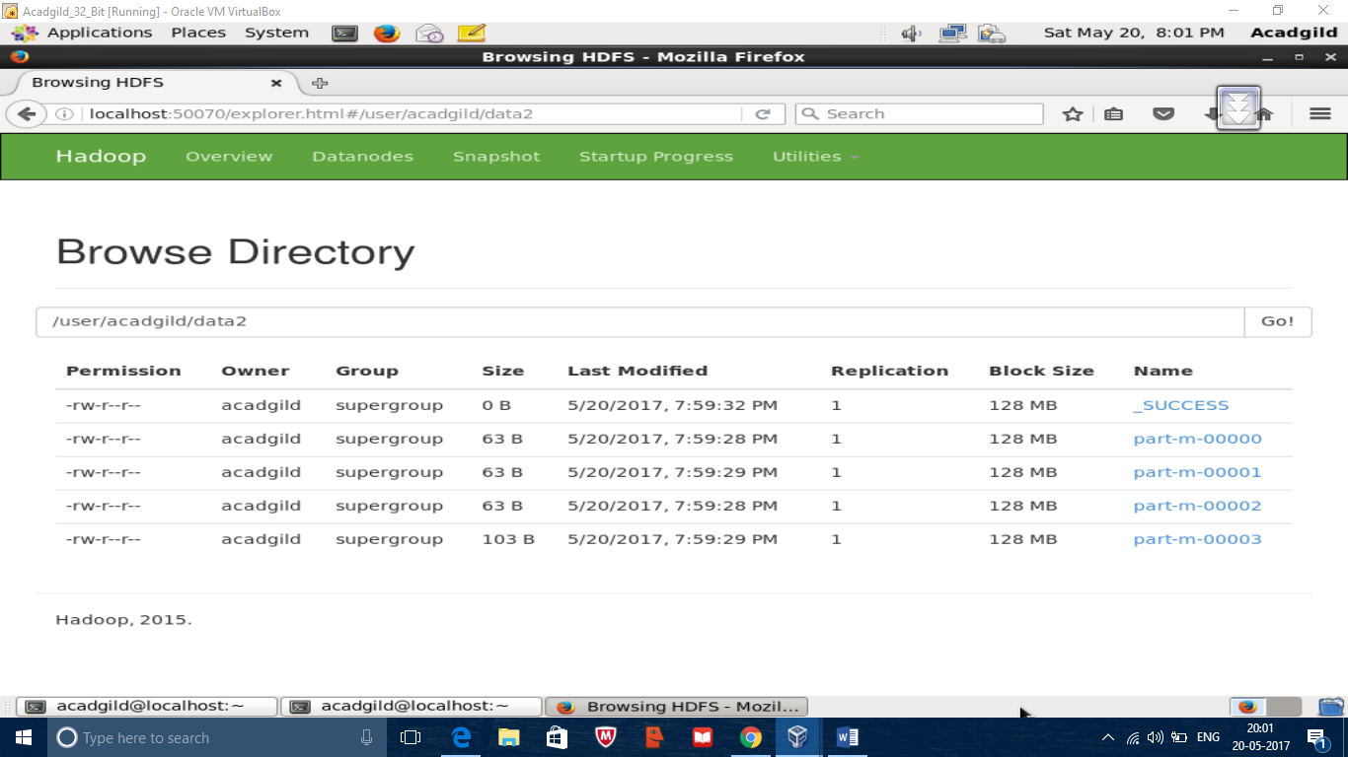

Incremental import

Code

Sqoop import –connect jdbe:mysql://localhost/demo –username root –p –table emp –incremental append –check-column id –target-dir /user/acadgild/data2

Output

