import java.util.\*;

import java.lang.\*;

import java.io.\*;

class Ideone

{

public static void main (String[] args) throws java.lang.Exception

{

int a,b;

Scanner sc = new Scanner(System.in);

a = sc.nextInt();

b = sc.nextInt();

for(int i=a;i<=b;i++)

{

if(i%2==0)

{

System.out.println("even"+i);

}

else{

System.out.println("odd"+i);

}

}

}

}

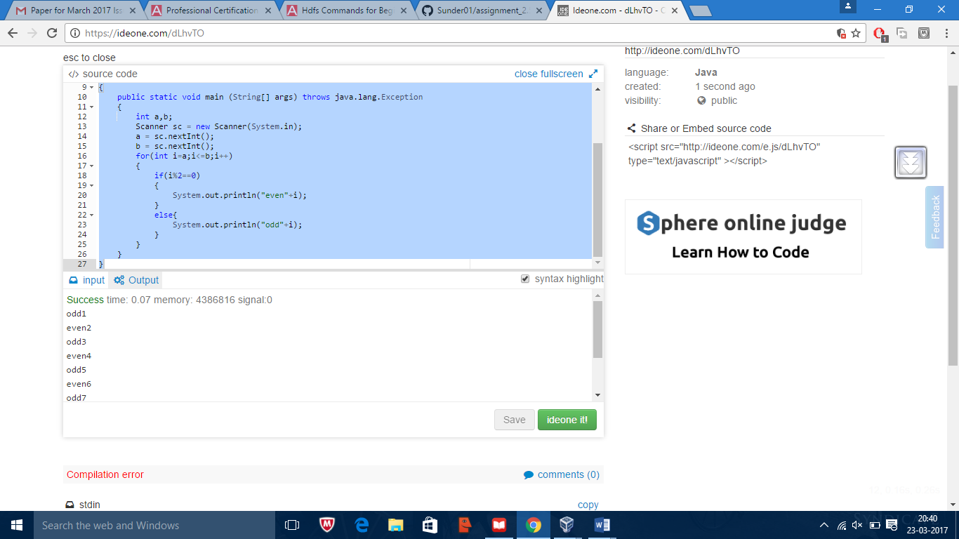

import java.util.\*;

import java.lang.\*;

import java.io.\*;

class Ideone

{

public static void main (String[] args) throws java.lang.Exception

{

int a,b;

Scanner sc = new Scanner(System.in);

a = sc.nextInt();

for(int i=1;i<=a;i++)

{

System.out.println(a+"X"+i+"="+(i\*a));

}

}

}

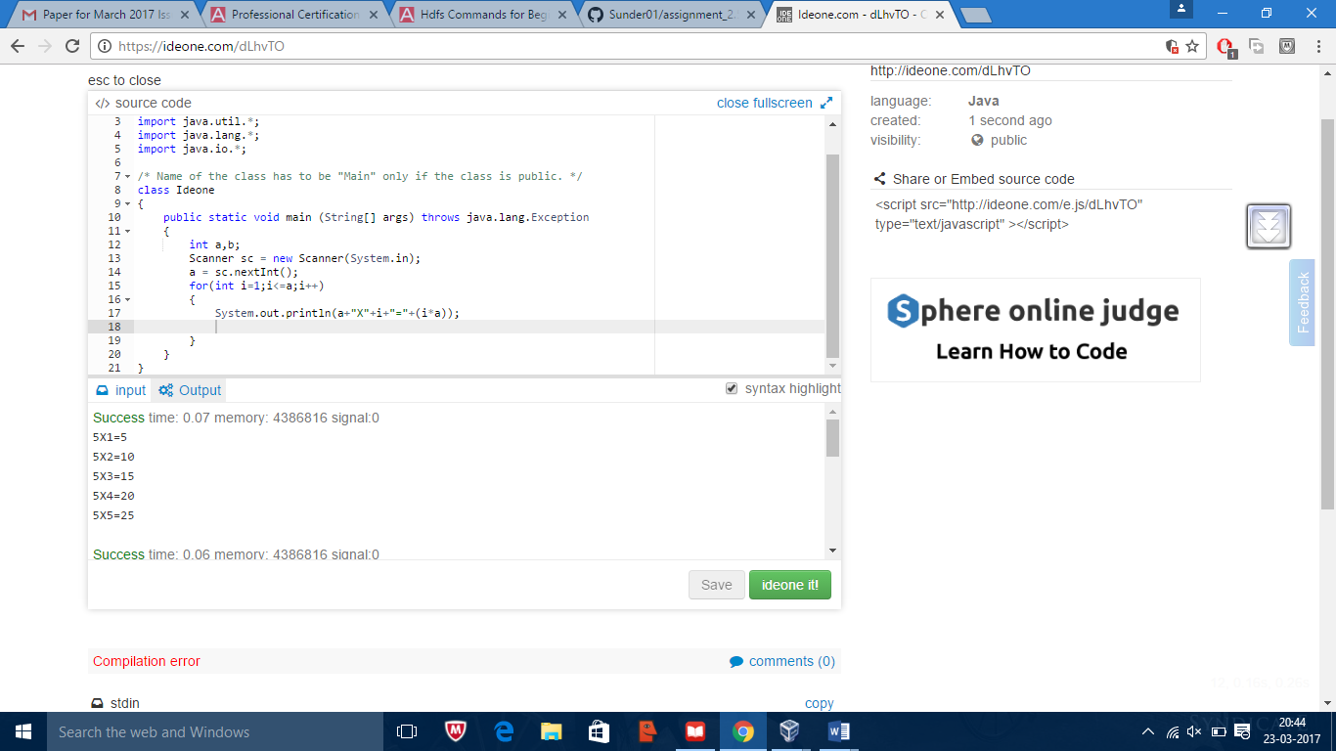

import java.util.\*;

import java.lang.\*;

import java.io.\*;

class Ideone

{

public static void main (String[] args) throws java.lang.Exception

{

int a,b;

Scanner sc = new Scanner(System.in);

a = sc.nextInt();

sum(a);

sum(a,10);

}

static void sum(int a)

{

System.out.println(a+100);

}

static void sum(int a,int b)

{

System.out.println(a+b);

}

}

