* 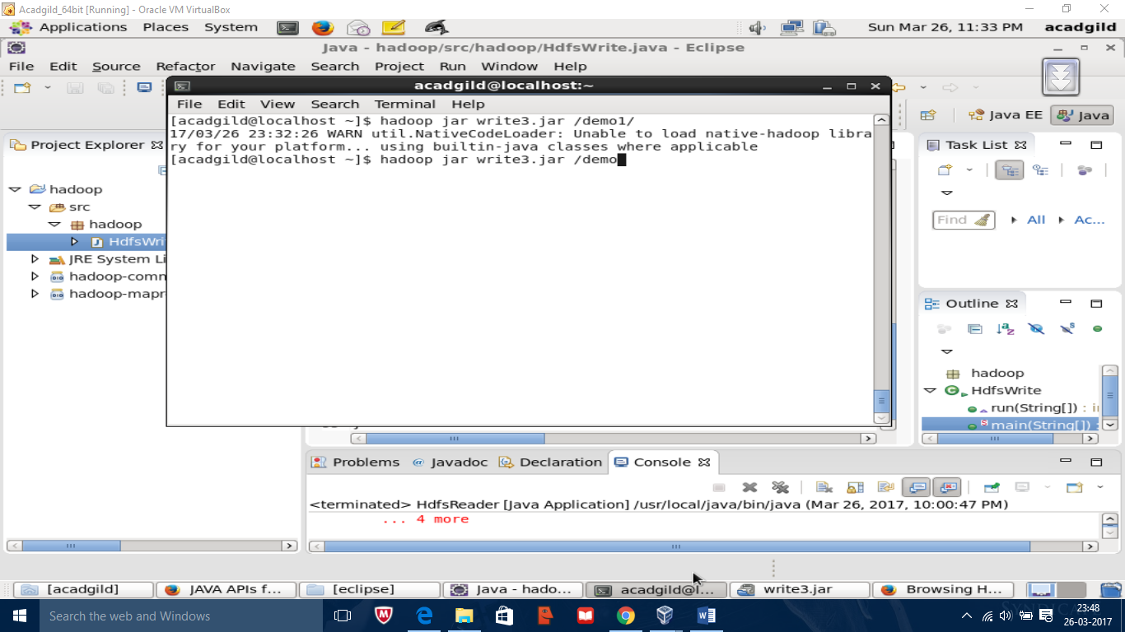

Copying file from local system to hdfs using command hadoop jar write3.jar /user/acadgild

Output

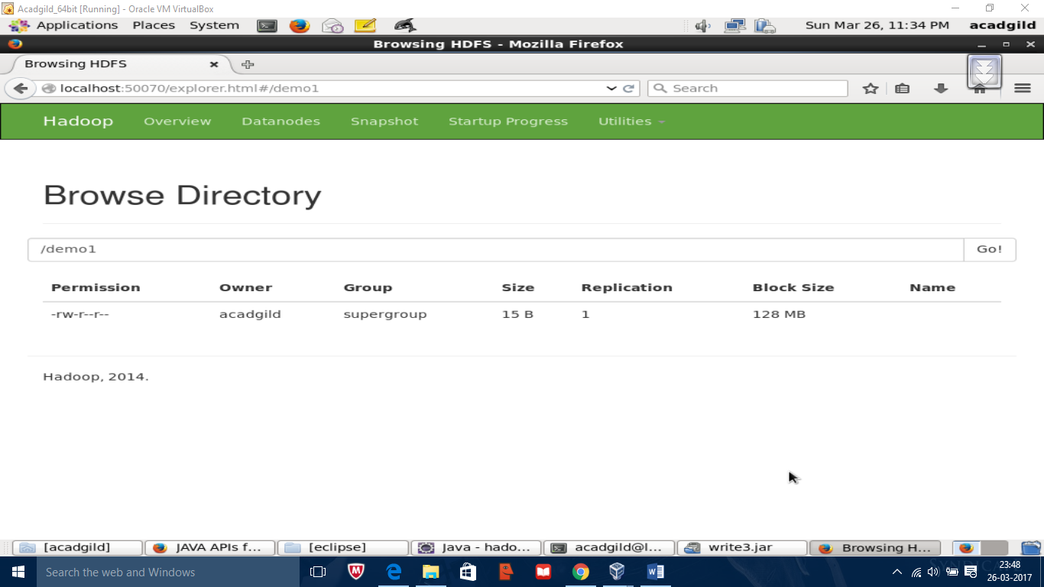

Getting file from hdfs to local file system using jar hadoop jar read3.jar /home/acadgild/music

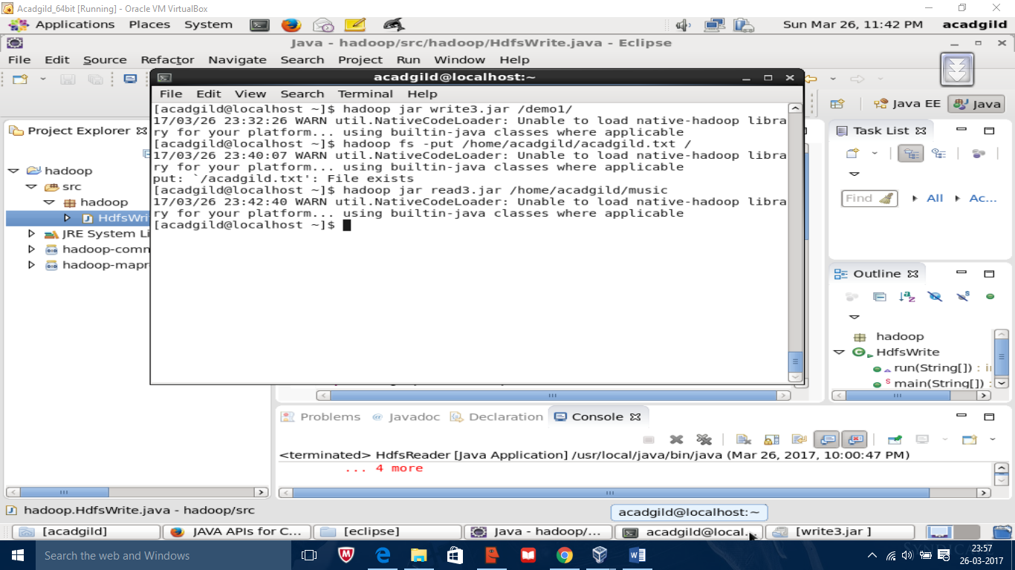

Output

