Q1.Fifo scheduler uses a queue to place the application and run them in first in first out manner. Request for first application is first satisfied and then next in the queue and so on. The fifo scheduler is quite simple to understand but it is not suitable for large clusters. Large applications will user more resources so application has to wait for its turn in the queue. On shared cluster we can use capacity cluster.

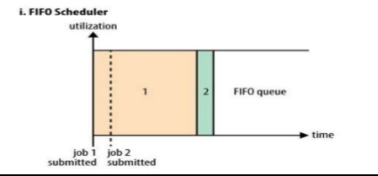

Q2.In capacity scheduler a separate queue is used for storing small jobs and allow it to start as soon as possible. This is done at the cost of overall cluster utilization since the queue capacity is reserved for jobs in that queue. If the queues are not used properly it may be over loaded or not utilized properly. Large execute late when compared to FIFO scheduler.

