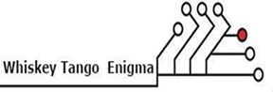

**Midwestern State University**

**Prof:** Dr. Catherine Stringfellow | Software Engineering

Andrew McKissick, Anderson Nwammadi, Tellon Smith, Johann Redhead, Devin Ritter

NAVIGATIONAL DIAGRAM

**LOGIN/LOGOUT**

**EDIT IMAGE**

**HOME**

**CREATE**

**MODIFY**

**BROWSE**

**GENERATE**