**Automated Testing of Reqres.in API using Cypress**

This repository contains an example of how to automate the testing of the Reqres.in API using the Cypress testing framework.

**Installation**

npm install

Running the Tests

**To run the tests, run the following command:**

Npx cypress open

This command will launch the Cypress Test Runner, where you can select which tests to run and see the results.

**Test Files**

The test files are in the cypress/e2e/1-getting-started directory. The test file is as follows:

* reqres.cy.js

**Running Tests in Headless Mode**

To run the tests in headless mode, run the following command:

npm run test: headless

This command will run the tests in the background without launching the Cypress Test Runner.

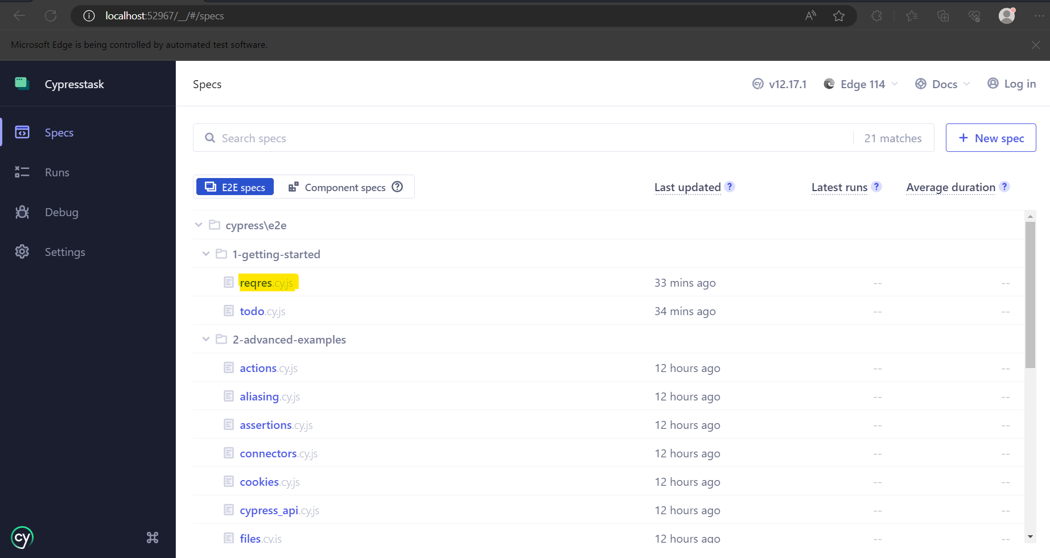

Additional Information

Cypress documentation: https://docs.cypress.io/guides/overview/why-cypress.html ↗

Reqres.in API documentation: https://reqres.in/ ↗