**Name: Sunduss Aamir Khan**

**Registration Number: BSE173047**

**Software Testing**

**Section: 2**

**Assignment 3**

**CASE STUDY**

Let the program check for quadrilateral type. The system will take width, height, and any two angles of the 4 sided figure. After calculating, the system will tell which 4 sided figure with the specific values is which one of the quadrilateral. The system can tell about square, rectangle, parallelogram, and rhombus. It is to note that condition for square will be both height and width will be equal and the two angle will be equal to 90 degrees. In case of rectangle height must not be equal to width. For rectangle all the angles must be equal to 90 degrees. Parallelogram is similar to rectangle, as height is not equal to width. The only difference of parallelogram and rectangle is the angles, two angles on one line, one must be lesser than 90 degrees while the other must be greater than 90 degrees, the angles must be in such a way that the maximum out of the two angles subtracting 180 will give the exact value as the other angle (let angle1= max so 180-max==angle2). Rhombus is similar to square, height and width are equal to each other. The angles in rhombus, two angles on one line, one must be lesser than 90 degrees while the other must be greater than 90 degrees. The condition for rhombus as the same as parallelogram (let angle1= max so 180-max==angle2). The condition for all the shapes is that the angles should be greater than 0 degrees and less than 180 degrees.

Another feature the system will do is to tell if the rhombus is to square or rectangle, and the parallelogram is similar to square or rectangle on the bases of the length given and any one angle. As rhombus has equal length of height and width so it is similar to square, while in parallelogram width and height are not equal, one is always greater than the other.

Another feature the system possess is compare the given lengths of width and height and tell which triangle can be made if the quadrilateral is divided diagonally If we divide a shape similar to square the triangle we will get will be similar to Isosceles triangle as height and width are equal so two sides equal to each other while the diagonal is slightly greater than the length of width or height. In case of shapes similar to rectangle, scalene triangle is preferable as height and width are not equal and diagonal can never be equal. As all sides are different the rectangle similar shapes will create scalene triangle if divided diagonally. This feature will take width and height as input to get the output as isosceles triangle or scalene triangle. Ideally the system will show square and rhombus as isosceles triangle while rectangle and parallelogram will be scalene triangle.

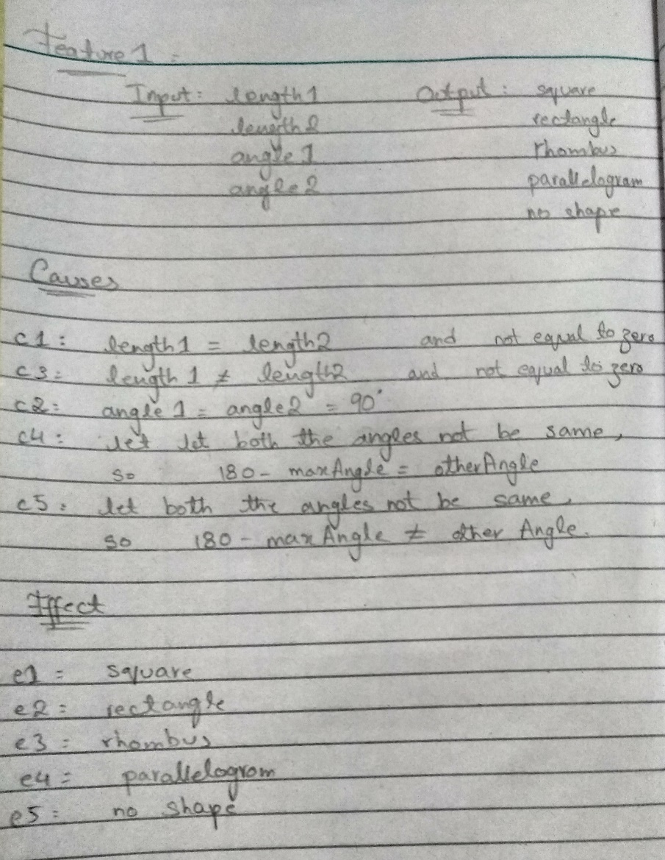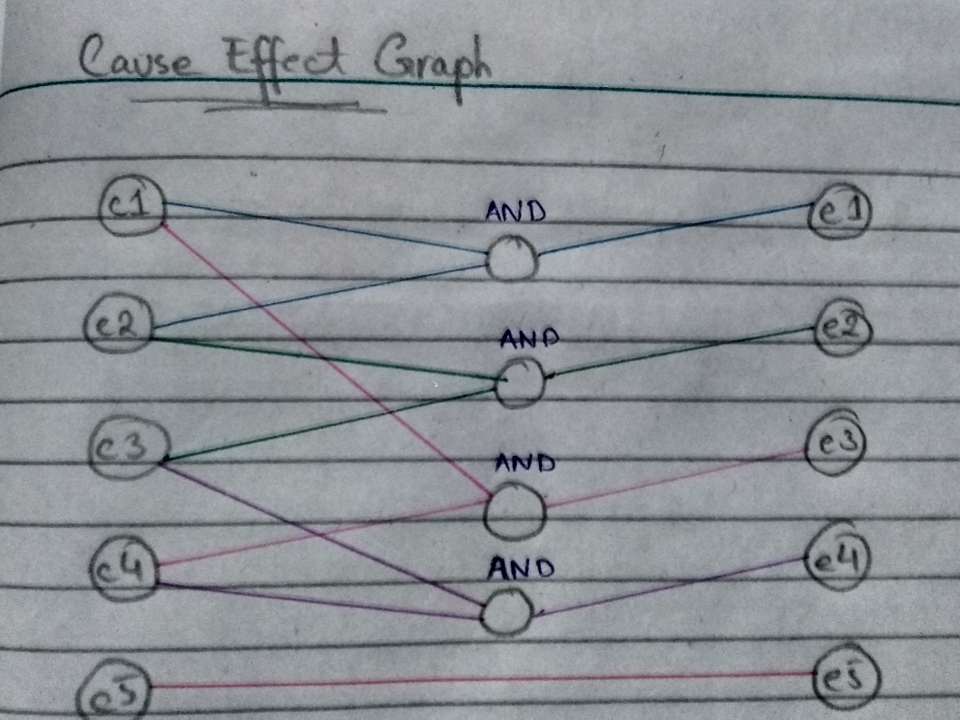For feature 1:

Decision table:

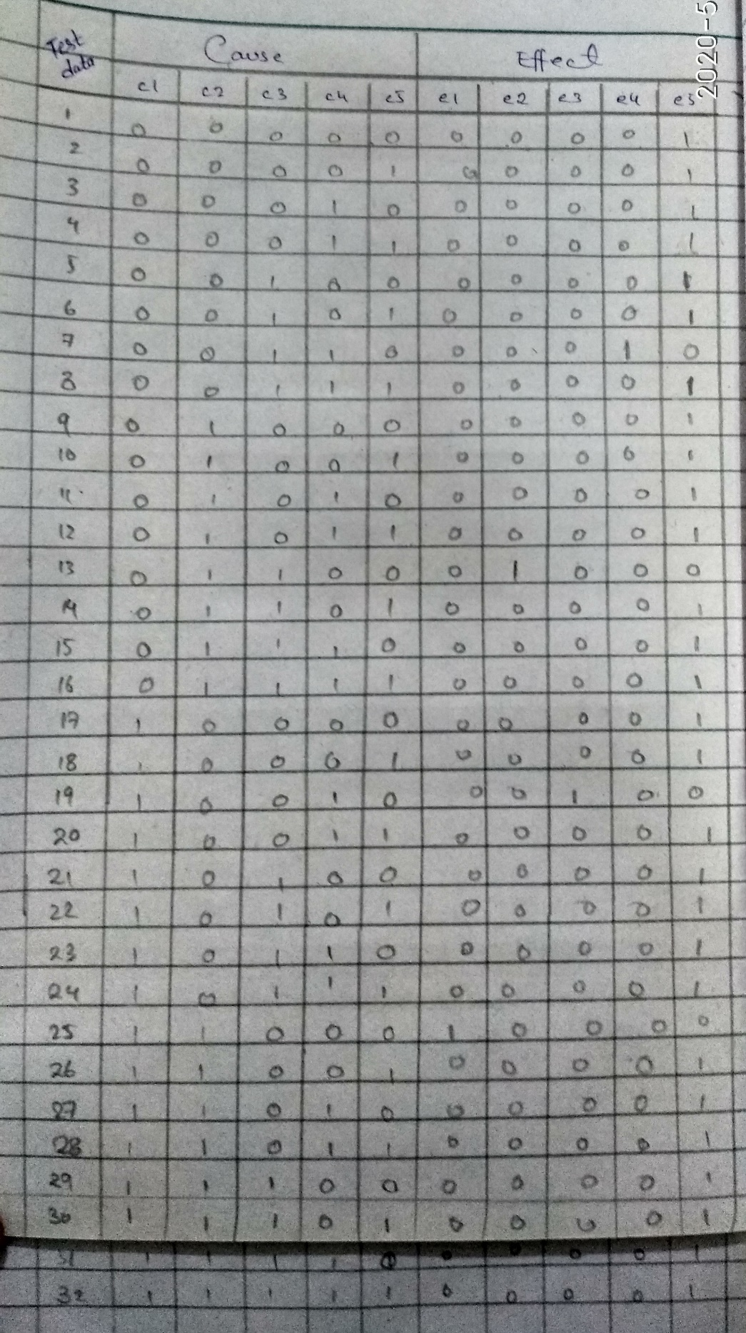

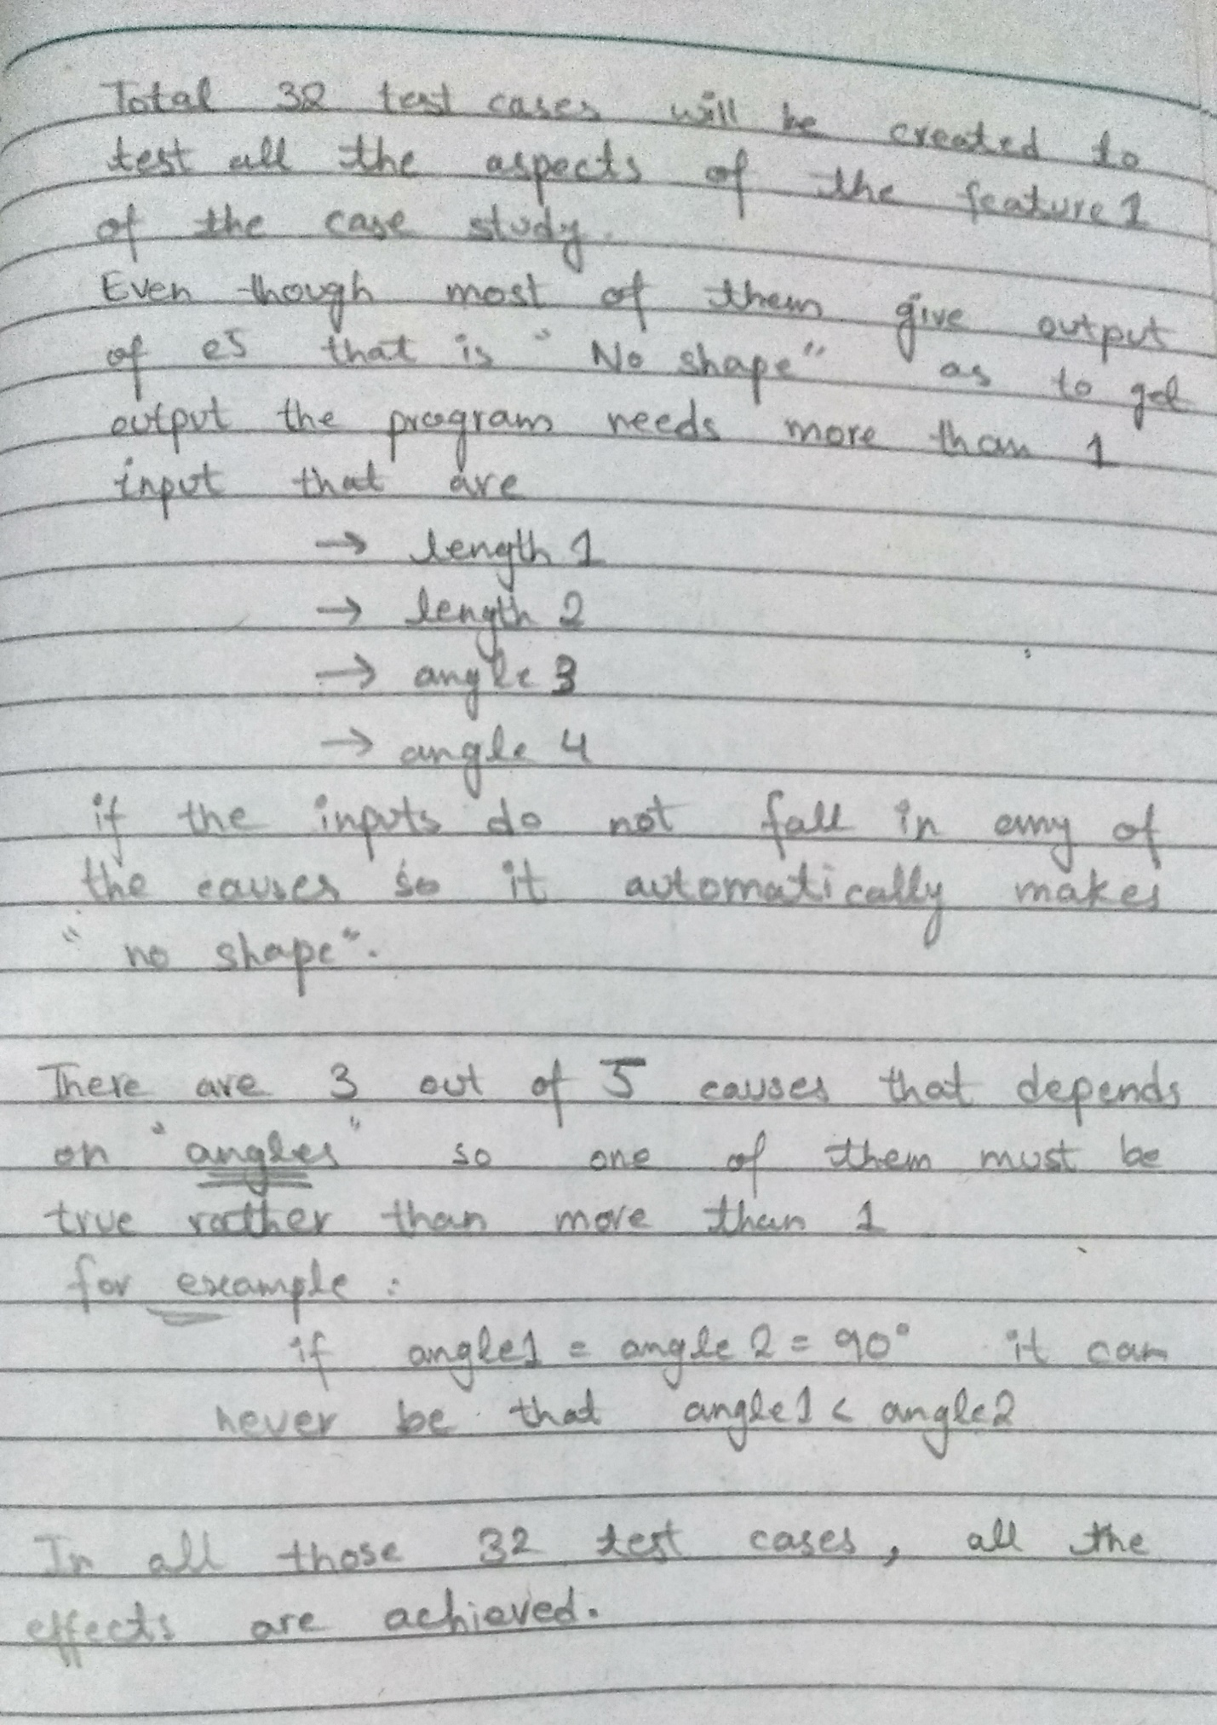

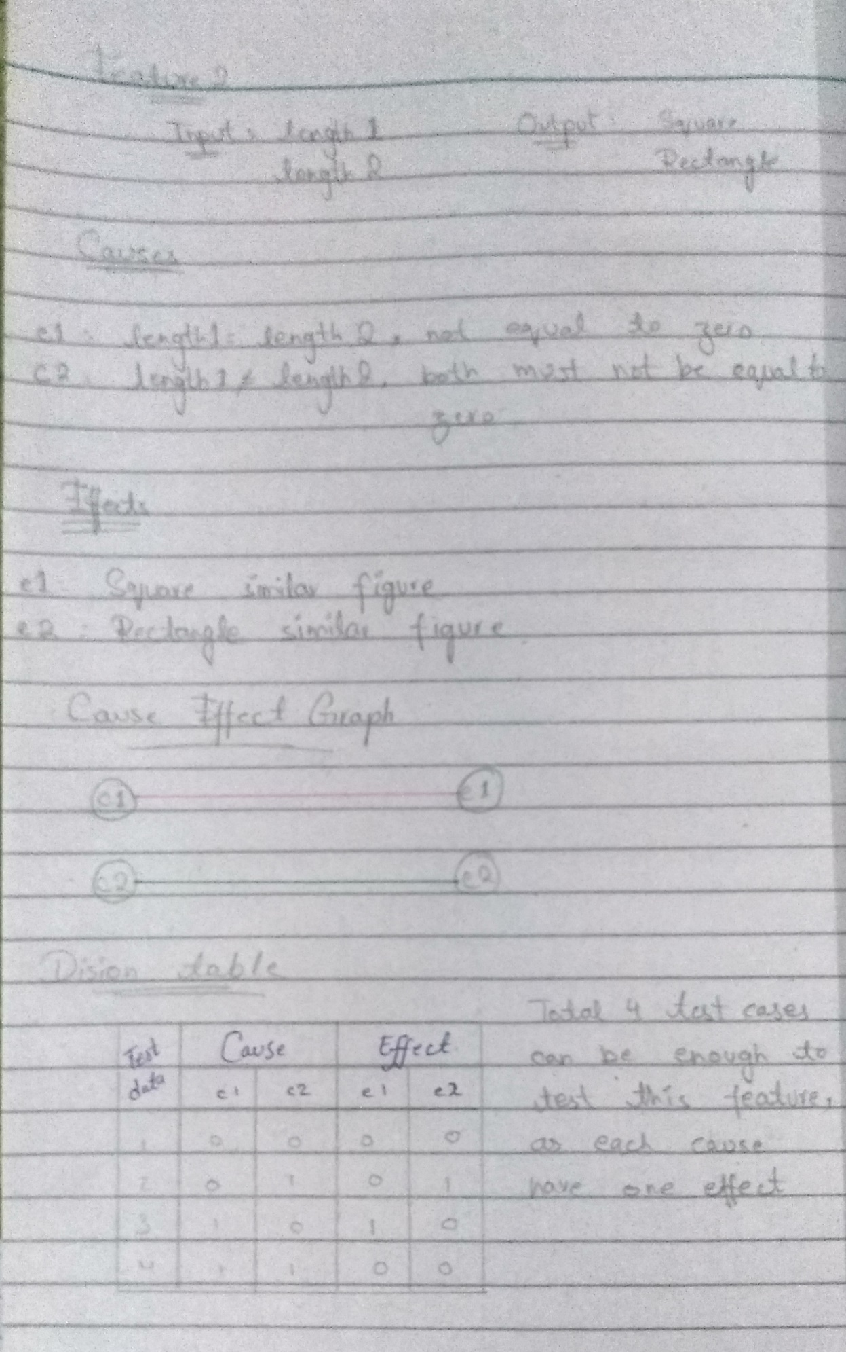For feature 2:

For feature 3:

