**Time Series Forecasting**

Student Name: Suneel Kumar Pentapalli

Date: 27/Oct/2023



Contents

**Executive Summary** 5

**1.** **Read the data as an appropriate Time Series data and plot the data.** 5

**2. Perform appropriate Exploratory Data Analysis to understand the data and also perform decomposition.** 6

**3. Split the data into training and test. The test data should start in 1991.** 13

**4. Build all the exponential smoothing models on the training data and evaluate the model using RMSE on the test data. Other models such as regression, naïve forecast models and simple average models. should also be built on the training data and check the performance on the test data using RMSE.** 15

**5. Check for the stationarity of the data on which the model is being built on using appropriate statistical tests and also mention the hypothesis for the statistical test. If the data is found to be non-stationary, take appropriate steps to make it stationary. Check the new data for stationarity and comment. Note: Stationarity should be checked at alpha = 0.05.** 22

**6. Build an automated version of the ARIMA/SARIMA model in which the parameters are selected using the lowest Akaike Information Criteria (AIC) on the training data and evaluate this model on the test data using RMSE.** 25

**7. Build a table (create a data frame) with all the models built along with their corresponding parameters and the respective RMSE values on the test data.** 29

**8. Based on the model-building exercise, build the most optimum model(s) on the complete data and predict 12 months into the future with appropriate confidence intervals/bands.** 29

**9. Comment on the model thus built and report your findings and suggest the measures that the company should be taking for future sales.** 30

**List of Figures**

|  |
| --- |
| Fig.1- Time Series data – Rose…………………………………………………………………………………………5 |
| Fig.2- Time Series data: Sparkling……………………………………………………………………………………..6 |
| Fig.3- Time Series plot after null imputation…………………………………………………………………………7 |
| Fig.4- Data Distribution Plot…………………………………………………………………………………………….8 |
| Fig.5- Data Distribution Plot across months…………………………………………………………………………9 |
| Fig.6- Decomposing Rose Data Plot……………………………………………………………………………….10 |
| Fig.7- Sparkling Data distribution Plot………………………………………………………………………………11 |
| Fig.8- Sparkling data distribution plot across the year………………………………………………………….12 |
| Fig.9- Plot for decomposing Rose data……………………………………………………………………………13 |
| Fig.10- Plot for Rose sales data by differentiating Test and train data………………………………………14 |
| Fig.11- Plot for Sparkling Sales Data by differentiating Test and train data…………………………….…..15 |
| Fig.12: Plot for Rose Time Series Prediction using SES, DES and TES Model…………………………………..17 |
| Fig.13: Plot for Rose Time Series Prediction using LR, NA and SA Model..…………………………………...18 |
| Fig.14: Plot for Sparkling Time Series Prediction using SES,DES and TES Model……………………………..21 |
| Fig.15: Plot for Sparkling Time Series Prediction using LR,NA and SA Model………………………………..22 |
| Fig.16- Rose Wine Sales Data………………………………………………………………………………………..24 |
| Fig.17- Sparkling Wine Sales data…………………………………………………………………………………..25 |
| Fig.18 – Rose sales data Plot using SARIMA Model………………………………………………………………30 |
| Fig.19 – Sparkling sales data Plot using TES Model………………………………………………………………30 |

**List of Tables**

|  |
| --- |
| Table 1: Rose dataset sample…………………………………………………………………………………………5 |
| Table 2: Sparkling dataset sample…………………………………………………………………………………...6 |
| Table 3: Rose data for null values…………………………………………………………………………………….7 |
| Table 4: Rose Data Values after null imputation………………………………………………………………….7 |
| Table 5: Rose Data description……………………………………………………………………………………….9 |
| Table 6: Sparkling Data Description………………………………………………………………………………. 11 |
| Table 7: Training and test data set plot for Rose…………………………………………………………………14 |
| Table 8: Training and test data set plot for Sparkling……………………………………………………………15 |
| Table 9: RSME Score on Rose Data using SES Model……………………………………………………………16 |
| Table 10: RSME Score on Rose Data using DES Model………………………………………………………….16 |
| Table 11: RSME Score on Rose Data using TES Model…………………………………………………………. 17 |
| Table 12: RSME Score on Rose Data using Linear Regression Model………………………………………...18 |
| Table 13: RSME Score on Rose Data using NaiveApproach Model………………………………………….18 |
| Table 14: RSME Score on Rose Data using SimpleAverage Model…………………………………………. 18 |
| Table 15: RSME Score on Sparkling Data using SES Model……………………………………………………. 19 |
| Table 16: RSME Score on Sparkling Data using DES Model…………………………………………………….20 |
| Table 17: RSME Score on Sparkling Data using TES Model……………………………………………………. 20 |
| Table 18: RSME Score on Sparkling Data using LinearRegression Model………………………………….. 21 |
| Table 19: RSME Score on Sparkling Data using NaiveApproach Model…………………………………… 21 |
| Table 20: RSME Score on Sparkling Data using SimpleAverage Model……………………………………..22 |
| Table 21: AIC Score of Rose Sales Data……………………………………………………………………………26 |
| Table 22: RSME Score on Rose Data using ARIMA Model……………………………………………………...26 |
| Table 23: AIC Score of all Parameters on Rose Data……………………………………………………………27 |
| Table 24: RSME Score on Rose Data using SARIMA Model…………………………………………………….27 |
| Table 25: AIC Score of Sparkling Sales Data……………………………………………………………………...27 |
| Table 26: RSME Score on Sparkling Data using ARIMA Model………………………………………………...28 |
| Table 27: AIC Score of all Parameters on Sparkling Data ……………………………………………………..28 |
| Table 28: RSME Score on Sparkling Data using SARIMA Model……………………………………………….28 |
| Table 29: RSME Score on Rose and Sparkling Data using all Models………………………………………...29 |

Problem 1

### **Executive Summary**

In the current business report, the data of different types of wine sales in the 20th century has been analyzed. Both of these data are from the same company but of different wines. As an analyst in the ABC Estate Wines, you are tasked to analyze and forecast Wine Sales in the 20th century.

### **Read the data as an appropriate Time Series data and plot the data.**

**Rose:**

Top 5 rows from Rose Sales data.

| **YearMonth** | **Rose** |
| --- | --- |
| **1980-01-01** | 112.0 |
| **1980-02-01** | 118.0 |
| **1980-03-01** | 129.0 |
| **1980-04-01** | 99.0 |
| **1980-05-01** | 116.0 |

Table 1: Rose dataset sample

Visual representation of given time series data

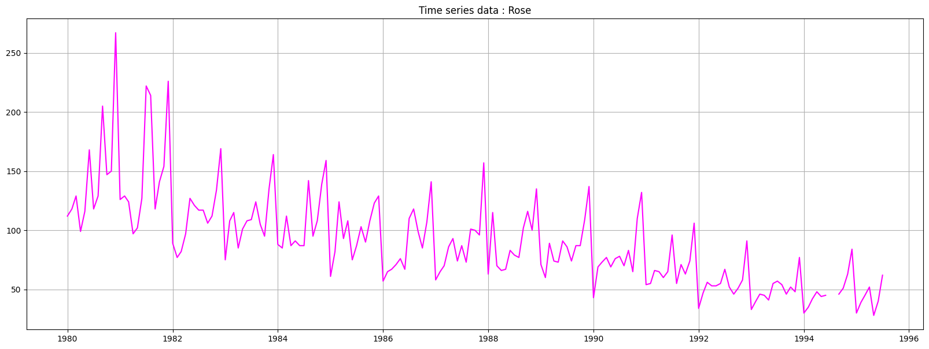

Fig.1- Time Series data: Rose

The gap in time series chart around 1994 represents missing data, which will be handled in further sections.

**Sparkling:**

Top 5 rows from Sparkling Sales data.

| **YearMonth** | **Sparkling** |
| --- | --- |
| **1980-01-01** | 1686 |
| **1980-02-01** | 1591 |
| **1980-03-01** | 2304 |
| **1980-04-01** | 1712 |
| **1980-05-01** | 1471 |

Table 2: Sparkling dataset sample

Visual representation of given time series data

Both rose and sparkling datasets have sales data starting from January 1980 to July 1995 with monthly frequency.

Fig.2- Time Series data: Sparkling

### **2. Perform appropriate Exploratory Data Analysis to understand the data and also perform decomposition.**

**Exploratory Data Analysis of Rose data:**

**Data Info:**

Rose dataset has 187 entries as shown below, with 2 nulls as mentioned already in 1994 July and August.

All the values in Rose column are of float datatype.

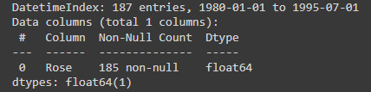

**Check for nulls:**

As shown below, series data is missing for time period July 1994 and August 1994. This must be handled in order to decompose our data. There are various methods to treat the null values in time series data, here we will go with quadratic interpolation to impute the null values.

Table 3: Rose data for null values

Null value check after quadratic interpolation method using python.



Values after null imputation

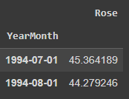

Table 4: Rose Data Values after null imputation

Time series plot after null imputation,

Fig.3- Time Series plot after null imputation

Thus, we have successfully removed nulls from the dataset and now we can proceed with data decomposition without any issues.

**Data description:**

The mean of the sales data is around 90.39 where 75% of the sales are below 112 with maximum sales being 267.

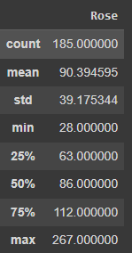

Table 5: Rose Data description Plot

**Data distribution:**

As mentioned in above description, 75% of the sales are below 112 and sales between 112 and 267 constitutes to around 25%

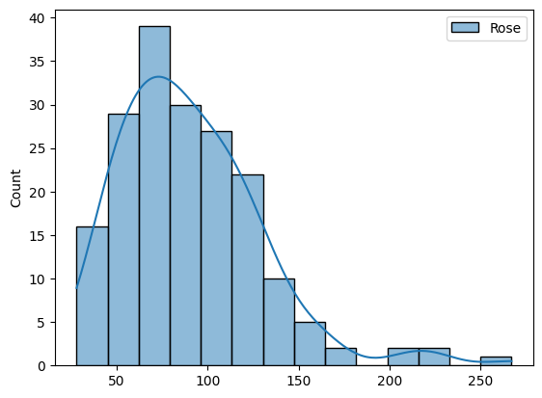

Fig.4- Data Distribution Plot

**Data distribution across months:**

Below chart shows the monthly sales distribution across all years.

From the data, it has been observed that the mean sales are highest in the month of December when aggregated among all the years, also the lowest sales are observed in the month of January.

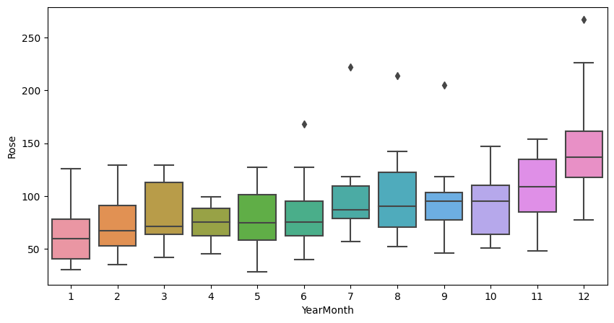

Fig.5- Data Distribution Plot across months

**Decomposing Rose data:**

Lets decompose the data to understand the trend, seasonality and error/residual components in our data.

Usually each data point is expressed as

Y(t) = Trend(t) + Seasonal(t) + Residual(t) for additive decomposition and

Y(t) = Trend(t) * Seasonal(t) * Residual(t) for multiplicative decomposition.

As the magnitude of peaks in our time series plot reducing at a non constant rate, we will go with multiplicative seasonality. Visual representation of the same is as follows.

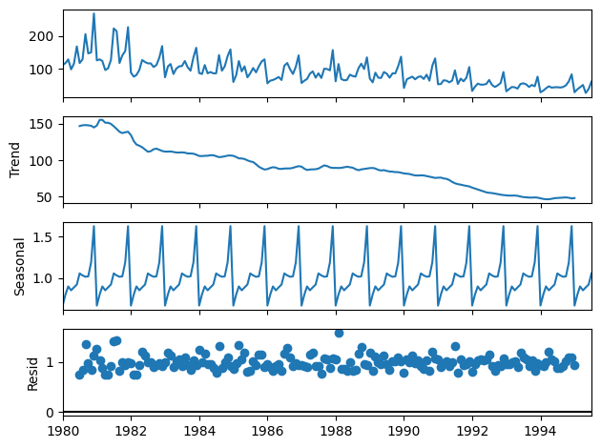

Fig.6- Decomposing Rose data Plot

From the above chart, it is evident that

* there is the downward trend over the years,
* almost a constant seasonality is observed across all the years, which indicates there are months where sales are high and month with low sales with a constant repletion of this pattern over years.

**Exploratory Data Analysis of Sparkling dataset:**

**Data Info:**

Sparkling sales dataset has 187 entries as shown below, with 0 nulls

All the values in Sparkling column are of int datatype.

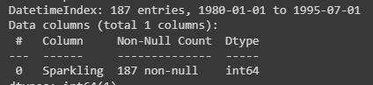

**Check for nulls:**

Given data has no nulls for the sparkling data which is evident from the below,



**Data description:**

The mean of the sparkling sales data is around 2402.41 where 75% of the sales are below 2549 with maximum sales being 7242.

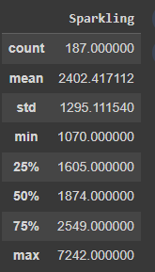

Table 6: Sparkling Data Description

**Data distribution:**

As mentioned in above description, 75% of the sales are below 2549 and sales between 2549 and 7242 constitutes to around 25%

Fig.7- Sparkling Data distribution Plot

**Data distribution across months:**

Below chart shows the monthly sales distribution across all years.

From the data, it has been observed that the mean sales are highest in the month of December when aggregated among all the years, also the lowest sales are observed in the month of June.

**Hence we can conclude that wine sales are hitting peak for both Rose and Sparkling types in the month of December.**

Fig.8- Sparkling data distribution plot across the year

**Decomposing Rose data:**

Lets decompose the data to understand the trend, seasonality and error/residual components in our data.

Usually each data point is expressed as

Y(t) = Trend(t) + Seasonal(t) + Residual(t) for additive decomposition and

Y(t) = Trend(t) * Seasonal(t) * Residual(t) for multiplicative decomposition.

As the magnitude of peaks in our time series plot are not varying at a constant rate, we will go with multiplicative seasonality. Visual representation of the same is as follows.

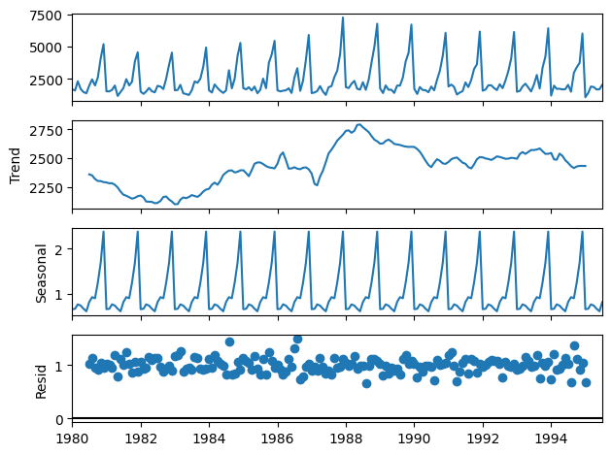

Fig.9- Plot for decomposing Rose data

From the above chart, it is evident that

* sales trend is not linear, infact sales have seen a rise around the year 1989 and from there on the trend has been shifted downwards.
* almost a constant seasonality is observed across all the years, which indicates there are months where sales are high and month with low sales with a constant repletion of this pattern over years.

### **3. Split the data into training and test. The test data should start in 1991.**

**Rose:**

Data has been split into training and test data set with test data starting from Jan 1991.

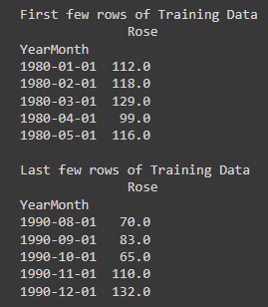

Table 7: Training and test data set Plot for Rose

**Plot for Rose sales data by differentiating Test and train data:**

In the below chart, data in blue indicates training data and the orange line indicates test data.

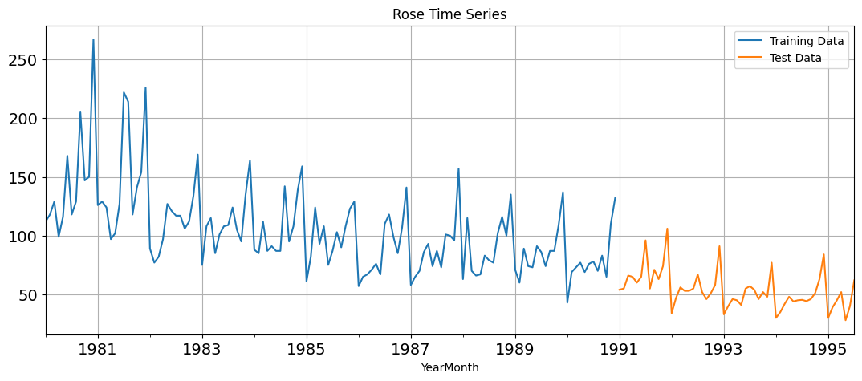

Fig.10- Plot for Rose sales data by differentiating Test and train data

**Sparkling:**

Data has been split into training and test data set with test data starting from Jan 1991.

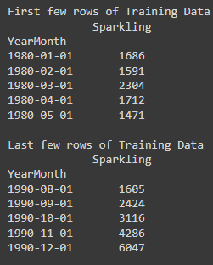

Table 8: Training and test data set plot for Sparkling

**Plot for Sparkling sales data by differentiating Test and train data:**

In the below chart, data in blue indicates training data and the orange line indicates test data.

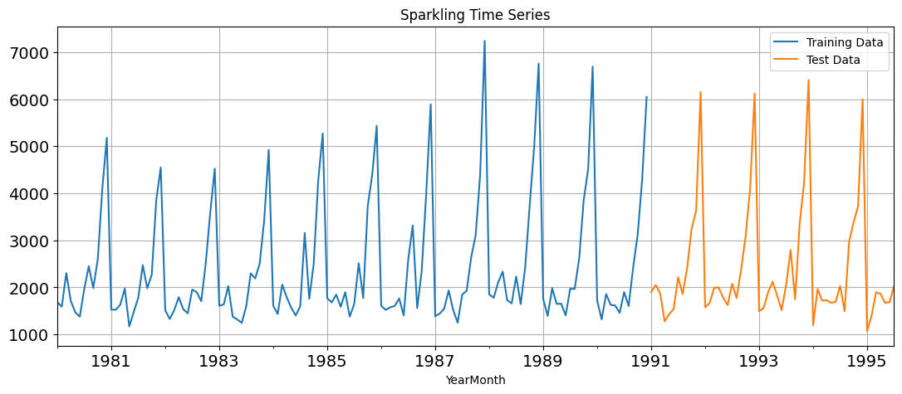

Fig.11- Plot for Sparkling Sales Data by differentiating Test and train data

### **4. Build all the exponential smoothing models on the training data and evaluate the model using RMSE on the test data. Other models such as regression, naïve forecast models and simple average models. should also be built on the training data and check the performance on the test data using RMSE.**

**Models on Rose Data:**

**Simple Exponential Smoothing:**A simple exponential smoothing is one of the simplest ways to forecast a time series. The basic idea of this model is to assume that the future will be more or less the same as the (recent) past. Thus, the only pattern that this model will learn from demand history is its level.

After fitting the Simple Exponential model from python’s statsmodel library, below parameters are picked as the best. As this is simple exponential smoothing, learning will be made based on smoothed level(alpha) only as shown below,

Now, we have passed the training data to fit the model and performed prediction on test length. RSME(Root mean squared error) calculated between actual test values(i.e., from 1991,Jan) and the predicted values for the same time range is as follows,

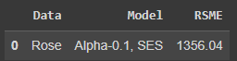

Table 9: RSME Score on Rose Data using SES Model

**Double Exponential Smoothing:**

Double exponential similar to simple exponential smoothing but in addition to level(alpha), this model also considers trend(beta) for learning and uses it for forecasting.

The best params picked by Holt(Double Exponential Smoothing) model are as follows,

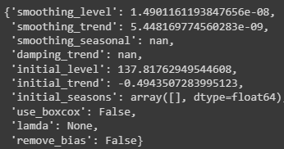

Now, we have passed the training data to fit the model and performed prediction on test length. RSME(Root mean squared error) calculated between actual test values(i.e., from 1991,Jan) and the predicted values for the same time range is as follows,

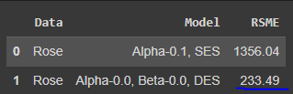

Table 10: RSME Score on Rose Data using DES Model

**Triple Exponential Smoothing:**

Triple Exponential Smoothing model learns from the data by going one step further as this model includes seasonality(gamma) also for learning and predictions as shown below,

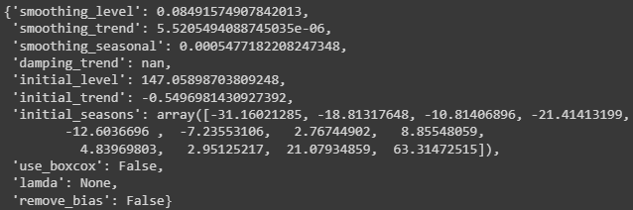

RSME Score on test data using TES model is as follows,

|  |  |  |  |
| --- | --- | --- | --- |
|  | **Data** | **Model** | **RSME** |
| **2** | Rose | Alpha-0.085, Beta-0.0, Gamma-0.001, TES | 203.57 |

Table 11: RSME Score on Rose Data using TES Model

**Plot for predicted and actual values for each model:**

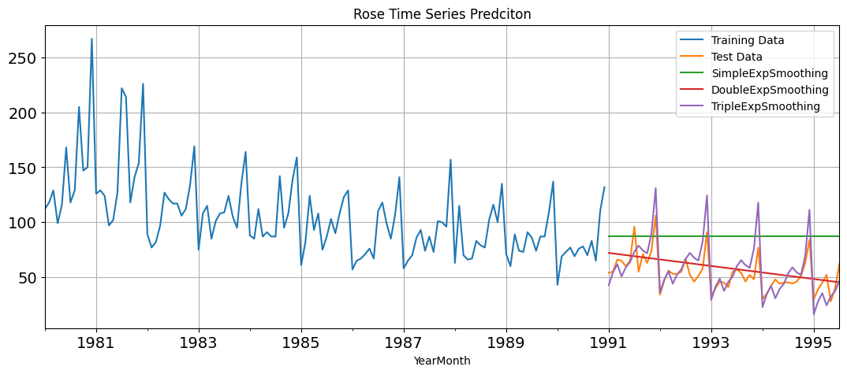

Fig.12: Plot for Rose Time Series Prediction using SES,DES and TES Model

Of all the above smoothing models, Triple exponential smoothing seems to have performed well with least RSME score of 203.57 which is obvious because our data has seasonality in it.

**Other models:**

**Linear Regression:**

A Linear Regression model forecasts a single values for entire test series by fitting a line equation model on training data, as it doesn’t consider any seasonality and trend, the predicted values will be less accurate.

|  |  |  |  |
| --- | --- | --- | --- |
|  | **Data** | **Model** | **RSME** |
| **3** | Rose | LinearRegression | 238.50 |

Table 12: RSME Score on Rose Data using Linear Regression Model

**Naïve Approach:**

For this particular naive model, we say that the prediction for tomorrow is the same as today and the prediction for day after tomorrow is tomorrow and since the prediction of tomorrow is same as today, therefore the prediction for day after tomorrow is also today.

|  |  |  |  |
| --- | --- | --- | --- |
|  | **Data** | **Model** | **RSME** |
| 4 | Rose | NaiveApproach | 315.56 |

Table 13: RSME Score on Rose Data using NaiveApproach Model

**Simple Average:**

For this particular simple average method, we will forecast by using the average of the training values.

|  |  |  |  |
| --- | --- | --- | --- |
|  | **Data** | **Model** | **RSME** |
| **5** | Rose | SimpleAverage | 2860.99 |

Table 14: RSME Score on Rose Data using SimpleAverage Model

Time series plots for all above three models on test data is as follows,

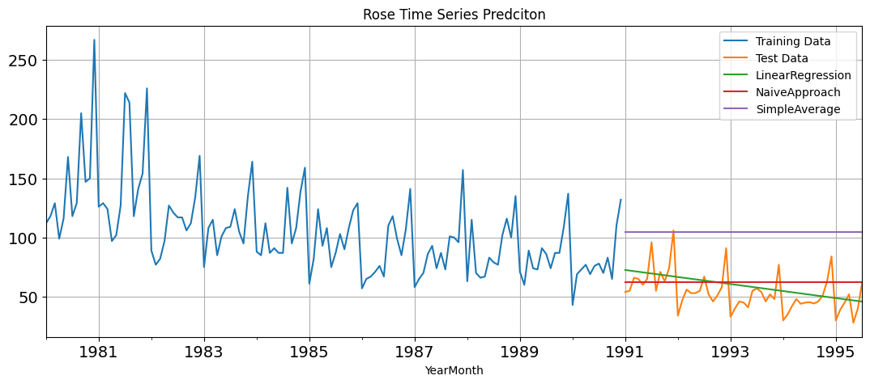

Fig.13: Plot for Rose Time Series Prediction using LR,NA and SA Model

Of all the models mentioned above, Triple exponential smoothing model is performing the best on rose sale data.

**Models on Sparkling Data:**

**Simple Exponential Smoothing:**

A simple exponential smoothing is one of the simplest ways to forecast a time series. The basic idea of this model is to assume that the future will be more or less the same as the (recent) past. Thus, the only pattern that this model will learn from demand history is its level.

After fitting the Simple Exponential model from python’s statsmodel library, below parameters are picked as the best. As this is simple exponential smoothing, learning will be made based on smoothed level(alpha) only as shown below,

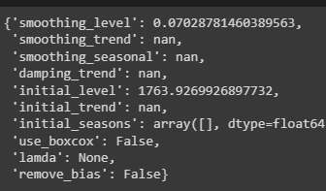

Now, we have passed the training data to fit the model and performed prediction on test length. RSME(Root mean squared error) calculated between actual test values(i.e., from 1991,Jan) and the predicted values for the same time range is as follows,

|  |  |  |  |
| --- | --- | --- | --- |
|  | **Data** | **Model** | **RSME** |
| **6** | Sparkling | Alpha-0.07, SES | 1790256.37 |

Table 15: RSME Score on Sparkling Data using SES Model

**Double Exponential Smoothing:**

Double exponential similar to simple exponential smoothing but in addition to level(alpha), this model also considers trend(beta) for learning and uses it for forecasting.

The best params picked by Holt(Double Exponential Smoothing) model are as follows,

Now, we have passed the training data to fit the model and performed prediction on test length. RSME(Root mean squared error) calculated between actual test values(i.e., from 1991,Jan) and the predicted values for the same time range is as follows,

|  |  |  |  |
| --- | --- | --- | --- |
|  | **Data** | **Model** | **RSME** |
| **7** | Sparkling | Alpha-0.665, Beta-0.0, DES | 28003992.17 |

Table 16: RSME Score on Sparkling Data using DES Model

**Triple Exponential Smoothing:**

Triple Exponential Smoothing model learns from the data by going one step further as this model includes seasonality(gamma) also for learning and predictions as shown below,

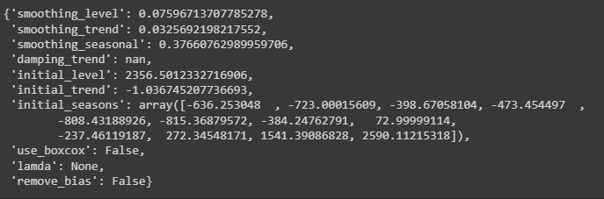

RSME Score on test data using TES model is as follows,

|  |  |  |  |
| --- | --- | --- | --- |
|  | **Data** | **Model** | **RSME** |
| **8** | Sparkling | Alpha-0.111, Beta-0.012, Gamma-0.461, TES | 143357.83 |

Table 17: RSME Score on Sparkling Data using TES Model

**Plot for predicted and actual values for each model:**

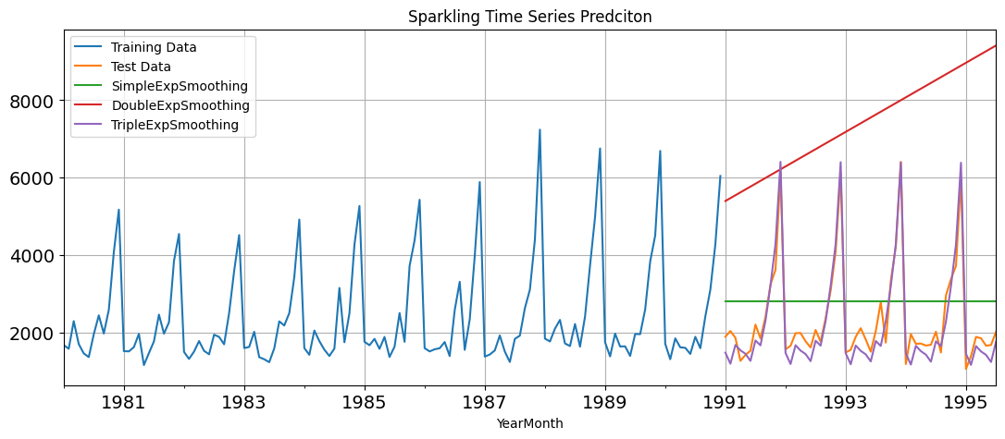

Fig.14: Plot for Sparkling Time Series Prediction using SES,DES and TES Model

Of all the above smoothing models, Triple exponential smoothing seems to have performed well with least RSME score of 143357.83 which is obvious because our data has seasonality in it.

**Other models:**

**Linear Regression:**

A Linear Regression model forecasts a single values for entire test series by fitting a line equation model on training data, as it doesn’t consider any seasonality and trend, the predicted values will be less accurate.

|  |  |  |  |
| --- | --- | --- | --- |
|  | **Data** | **Model** | **RSME** |
| **3** | Sparkling | LinearRegression | 1923314.76 |

Table 18: RSME Score on Sparkling Data using LinearRegression Model

**Naïve Approach:**

For this particular naive model, we say that the prediction for tomorrow is the same as today and the prediction for day after tomorrow is tomorrow and since the prediction of tomorrow is same as today, therefore the prediction for day after tomorrow is also today.

|  |  |  |  |
| --- | --- | --- | --- |
|  | **Data** | **Model** | **RSME** |
| 4 | Sparkling | NaiveApproach | 1761343.20 |

Table 19: RSME Score on Sparkling Data using NaiveApproach Model

**Simple Average:**

For this particular simple average method, we will forecast by using the average of the training values.

|  |  |  |  |
| --- | --- | --- | --- |
|  | **Data** | **Model** | **RSME** |
| **5** | Sparkling | SimpleAverage | 1625833.61 |

Table 20: RSME Score on Sparkling Data using SimpleAverage Model

Time series plots for all above three models on test data is as follows,

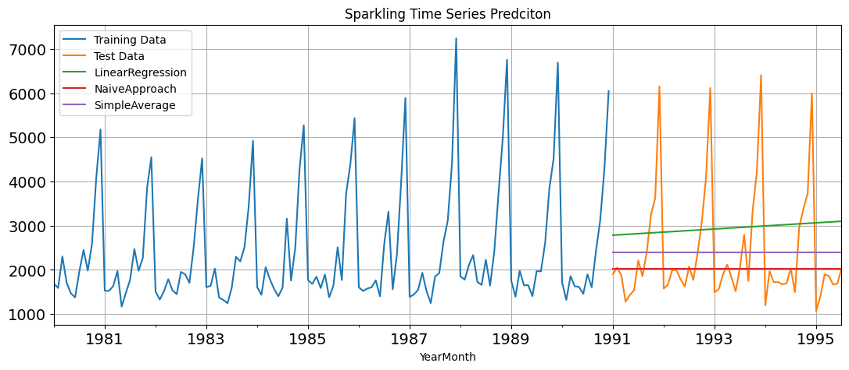

Fig.15: Plot for Sparkling Time Series Prediction using LR,NA and SA Model

By looking at prediction capabilities of all the models on sparkling dataset, TES model seems to be the best.

### **5. Check for the stationarity of the data on which the model is being built on using appropriate statistical tests and also mention the hypothesis for the statistical test. If the data is found to be non-stationary, take appropriate steps to make it stationary. Check the new data for stationarity and comment. Note: Stationarity should be checked at alpha = 0.05.**

A time series has stationarity when the observations are not dependent on the time. Statistical properties of these time series will not change with time thus they will have constant mean, variance, and covariance.

The time series which have trends or with seasonality, are not stationary. Because trends will have a change in the movement of data concerning time which will cause the change in mean over time. Whereas seasonality occurs when the pattern in time series shows a variation for a regular time interval which will cause the variance to change over time.

Stationarity can be checked using Augmented Dickey-Fuller (ADF) test.

Dickey-Fuller Test - Dicky Fuller Test on the timeseries is run to check for stationarity of data.

Null Hypothesis H0 : Time Series is non-stationary.

Alternate Hypothesis Ha : Time Series is stationary.

So Ideally if p-value < 0.05(given significance level) then null hypothesis: TS is non-stationary is rejected else the TS is non-stationary is failed to be rejected.

As forecasting models like ARIMA assumes the data to be stationary, it is always advisable to make the data stationary before fitting the model with data.

**Rose wine sales Data:**

Upon performing ADF test on entire Rose sales data, we got p-value as follows,



the p-value 0.34 is very large, and not smaller than 0.05 and therefore we donot have enough evidence to reject null hypothesis, thus our data is not a stationary series. But fortunately we can convert non-stationary data to stationary data by detrending the timeseries data using any of the below transformation techniques,

Log transforming of the data

Taking the square root of the data

Taking the cube root

Proportional change

Lets use log transform on entire rose data now and lets check the p-value again using ADF test,



After applying log transform, p-value has become less than 0.05 hence making our data stationary.

Visualization of transformed data is as follows,

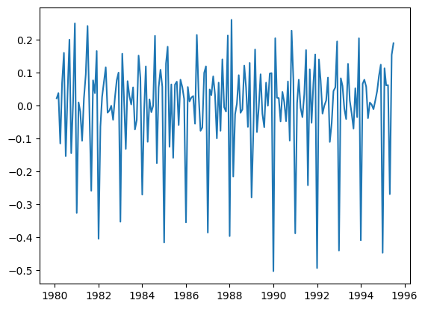

Fig.16- Rose Wine Sales Data

**Sparkling Wine Sales Data:**

Upon performing ADF test on entire Rose sales data, we got p-value as follows,



the p-value 0.6 is very large, and not smaller than 0.05 and therefore we donot have enough evidence to reject null hypothesis, thus our data is not a stationary series.

Again, lets use log transform on entire rose data now and lets check the p-value again using ADF test,



After applying log transform, p-value has become less than 0.05 hence making our data stationary.

Visualization of transformed data is as follows,

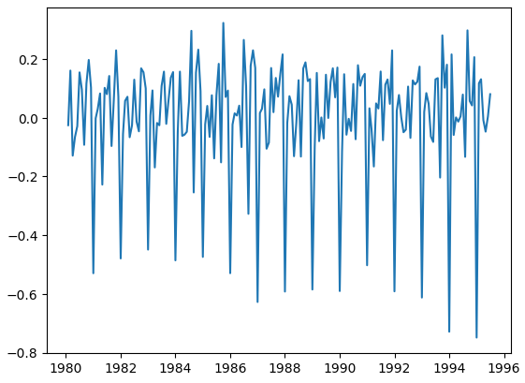

Fig.17- Sparkling Wine Sales data

### **6. Build an automated version of the ARIMA/SARIMA model in which the parameters are selected using the lowest Akaike Information Criteria (AIC) on the training data and evaluate this model on the test data using RMSE.**

ARIMA, short for ‘AutoRegressive Integrated Moving Average’, is a forecasting algorithm based on the idea that the information in the past values of the time series can alone be used to predict the future values.

ARIMA model takes two parameters as input before fitting the data, one is data and the other is order parameter.

Order parameter contains below,

p is the order of the AR term(how many past values to be considered)

q is the order of the MA term(how many past errors to be considered)

d is the number of differencing required to make the time series stationary

for the current problem statement, we tool values of p, d and q ranging from 0 to 3

Tools to check model performance:

The Akaike information criterion (AIC) is a mathematical method for evaluating how well a model fits the data it was generated from. In statistics, AIC is used to compare different possible models and determine which one is the best fit for the data. AIC is calculated from:

* the number of independent variables used to build the model.
* the maximum likelihood estimate of the model (how well the model reproduces the data).

For a model to be called a good fit, the AIC score should be as low as possible. We will use the AIC score in the below models in order to compare performance against other model.

**Rose Sales Data:**

**ARIMA:**

After fitting model with all combination of order parameters on train data, AIC score in ascending order on train data is as follows,

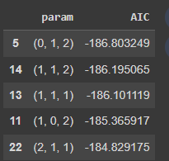

Table 21: AIC Score of Rose Sales Data

Order parameters(p,d,q) used:

[(0, 0, 0), (0, 0, 1), (0, 0, 2), (0, 1, 0), (0, 1, 1), (0, 1, 2), (0, 2, 0), (0, 2, 1), (0, 2, 2), (1, 0, 0), (1, 0, 1), (1, 0, 2), (1, 1, 0), (1, 1, 1), (1, 1, 2), (1, 2, 0), (1, 2, 1), (1, 2, 2), (2, 0, 0), (2, 0, 1), (2, 0, 2), (2, 1, 0), (2, 1, 1), (2, 1, 2), (2, 2, 0), (2, 2, 1), (2, 2, 2)]

Of all the orders, (p,d,q)=(0,1,2) performed best with AIC score of -186.8.

Hence lets build ARIMA model on rose data with above order parameter and check the RSME score on test data,

|  |  |  |  |
| --- | --- | --- | --- |
|  | **Data** | **Model** | **RSME** |
| **11** | Rose | ARIMA-(0,1,2) | 1189.68 |

Table 22: RSME Score on Rose Data using ARIMA Model

Now the RSME score is not better than previously built exponential smoothing models above. Lets proceed further with other models.

**SARIMA:**

An extension to ARIMA that supports the direct modeling of the seasonal component of the series is called SARIMA.

SARIMA model takes additional component called seasonality in order to learn from the data,

In our case, we have picked 12 months as seasonality parameter as it is evident from our data,

In addition to above order parameters, for SARIMA, below seasonal params have been used,

[(0, 0, 0, 12), (0, 0, 1, 12), (0, 0, 2, 12), (0, 1, 0, 12), (0, 1, 1, 12), (0, 1, 2, 12), (0, 2, 0, 12), (0, 2, 1, 12), (0, 2, 2, 12), (1, 0, 0, 12), (1, 0, 1, 12), (1, 0, 2, 12), (1, 1, 0, 12), (1, 1, 1, 12), (1, 1, 2, 12), (1, 2, 0, 12), (1, 2, 1, 12), (1, 2, 2, 12), (2, 0, 0, 12), (2, 0, 1, 12), (2, 0, 2, 12), (2, 1, 0, 12), (2, 1, 1, 12), (2, 1, 2, 12), (2, 2, 0, 12), (2, 2, 1, 12), (2, 2, 2, 12)]

The least AIC scores of all above parameters on rose training data is as follows,

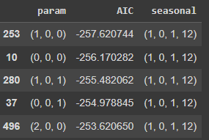

Table 23: AIC Score of all Parameters on Rose Data

Parameter combination, order=(1, 0, 1) and seasonal_order=(1, 0, 1, 12) has given the least AIC score, hence lets build our model using the same and lets find the RSME score on test data.

|  |  |  |  |
| --- | --- | --- | --- |
|  | **Data** | **Model** | **RSME** |
| **12** | Rose | SARIMA-(1, 0, 1, 12) | 184.77 |

Table 24: RSME Score on Rose Data using SARIMA Model

The RSME score is 184.77 which is the least of all our previously models built. Hence we will use this model only to predict future sales going further.

**Sparkling Sales Data:**

Similarly lets follow the same process to find the best parameters and models to forecast our Sparkling data.

**ARIMA:**

After fitting model with all combination of order parameters on train data, AIC score in ascending order on train data is as follows,

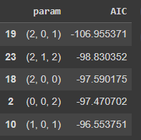

Table 25: AIC Score of Sparkling Sales Data

Order parameters(p,d,q) used:

[(0, 0, 0), (0, 0, 1), (0, 0, 2), (0, 1, 0), (0, 1, 1), (0, 1, 2), (0, 2, 0), (0, 2, 1), (0, 2, 2), (1, 0, 0), (1, 0, 1), (1, 0, 2), (1, 1, 0), (1, 1, 1), (1, 1, 2), (1, 2, 0), (1, 2, 1), (1, 2, 2), (2, 0, 0), (2, 0, 1), (2, 0, 2), (2, 1, 0), (2, 1, 1), (2, 1, 2), (2, 2, 0), (2, 2, 1), (2, 2, 2)]

Of all the orders, (p,d,q)=(2,0,1) performed best with AIC score of -106.9.

Hence lets build ARIMA model on rose data with above order parameter and check the RSME score on test data,

|  |  |  |  |
| --- | --- | --- | --- |
|  | **Data** | **Model** | **RSME** |
| **13** | Sparkling | ARIMA-(2,0,1) | 1661576.41 |

Table 26: RSME Score on Sparkling Data using ARIMA Model

Now the RSME score is not better than previously built exponential smoothing models above. Lets proceed further with other models.

**SARIMA:**

In addition to above order parameters, for SARIMA, below seasonal params have been used,

[(0, 0, 0, 12), (0, 0, 1, 12), (0, 0, 2, 12), (0, 1, 0, 12), (0, 1, 1, 12), (0, 1, 2, 12), (0, 2, 0, 12), (0, 2, 1, 12), (0, 2, 2, 12), (1, 0, 0, 12), (1, 0, 1, 12), (1, 0, 2, 12), (1, 1, 0, 12), (1, 1, 1, 12), (1, 1, 2, 12), (1, 2, 0, 12), (1, 2, 1, 12), (1, 2, 2, 12), (2, 0, 0, 12), (2, 0, 1, 12), (2, 0, 2, 12), (2, 1, 0, 12), (2, 1, 1, 12), (2, 1, 2, 12), (2, 2, 0, 12), (2, 2, 1, 12), (2, 2, 2, 12)]

The least AIC scores of all above parameters on sparkling training data is as follows,

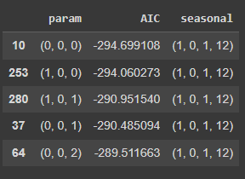

Table 27: AIC Score of all Parameters on Sparkling Data

Parameter combination, order=(0, 0, 0) and seasonal_order=(1, 0, 1, 12) has given the least AIC score, hence lets build our model using the same and lets find the RSME score on test data.

|  |  |  |  |
| --- | --- | --- | --- |
|  | **Data** | **Model** | **RSME** |
| **14** | Sparkling | SARIMA-(1, 0, 1, 12) | 152824.75 |

Table 28: RSME Score on Sparkling Data using SARIMA Model

The RSME score is 152824.75 which is the not the least of all our previously models built but second least RSME score after Triple exponential model.

### **7. Build a table (create a data frame) with all the models built along with their corresponding parameters and the respective RMSE values on the test data.**

The RSME scores of all the models built so far along with the parameters used are as follows,

|  |  |  |  |
| --- | --- | --- | --- |
|  | **Data** | **Model** | **RSME Score** |
| **12** | Rose | SARIMA-(1, 0, 1, 12) | 184.77 |
| **2** | Rose | Alpha-0.085, Beta-0.0, Gamma-0.001, TES | 203.57 |
| **1** | Rose | Alpha-0.0, Beta-0.0, DES | 233.49 |
| **3** | Rose | LinearRegression | 238.50 |
| **4** | Rose | NaiveApproach | 315.56 |
| **11** | Rose | ARIMA-(0,1,2) | 1189.68 |
| **0** | Rose | Alpha-0.1, SES | 1356.04 |
| **5** | Rose | SimpleAverage | 2860.99 |
| **8** | Sparkling | Alpha-0.111, Beta-0.012, Gamma-0.461, TES | 143357.83 |
| **14** | Sparkling | SARIMA-(1, 0, 1, 12) | 152824.75 |
| **10** | Sparkling | SimpleAverage | 1625833.61 |
| **13** | Sparkling | ARIMA-(2,0,1) | 1661576.41 |
| **9** | Sparkling | NaiveApproach | 1761343.20 |
| **6** | Sparkling | Alpha-0.07, SES | 1790256.37 |
| **15** | Sparkling | LinearRegression | 1923314.76 |
| **7** | Sparkling | Alpha-0.665, Beta-0.0, DES | 28003992.17 |

Table 29: RSME Score on Rose and Sparkling Data using all Models

### **8. Based on the model-building exercise, build the most optimum model(s) on the complete data and predict 12 months into the future with appropriate confidence intervals/bands.**

From the above table of RSME scores, we can conclude that for **forecasting Rose sales data, SARIMA model would be optimal with parameters (1,0,1,12).**

Similarly **for forecasting Sparkling sales data, Triple Exponential Smoothing model is the best with least RSME score of 143357.83** followed by SARIMA model with parameter (1,0,1,12) with RSME score of 152824.75

**Using SARIMA Model to forecast next 12 months(i.e., from Aug,1995 to July,1996) Rose sales data with confidence interval of 5%:**

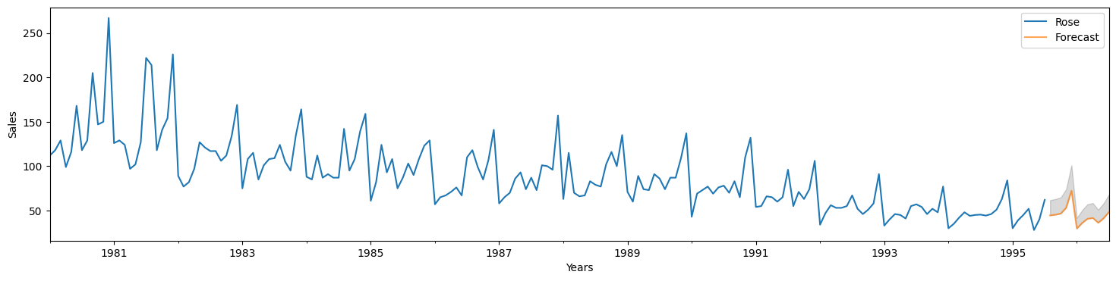

Fig.18 – Rose sales data Plot using SARIMA Model

**Using TES Model to forecast next 12 months(i.e., from Aug,1995 to July,1996) Sparkling sales data with confidence interval of 5%:**

Fig.19 – Sparkling sales data Plot using TES Model

### **9. Comment on the model thus built and report your findings and suggest the measures that the company should be taking for future sales.**

**Steps Followed:**

* Read time series data with appropriate index and date parameters.
* Performed EDA and imputed identified nulls in dataset.
* Visualized Time series data to check trends and seasonality.
* Decomposed data of both the time series to view trend and seasonal components individually.
* Have split the data into training and test sets.
* Fitted data in all the exponential models and calculated RSME scores on test data and predicted values.
* Created automated models to find the best ARIMA/SARIMA models using the least (Akaike Information Criterion)AIC score.
* Found the optimum models based on all the above created models and forecasted next 12 months sales.

**Conclusion and Suggestions based above models:**

**Rose Sales Forecasting:**

The sales for rose wine has been continuously declining over the years and its predicted to decline further.

Hence necessary steps to be taken to bring back the rose wine sales upwards.

Even the amount/number of sales for Rose wines is comparatively lower than that of Sparkling wine sales.

**Sparkling Sales Forecasting:**

Sales for Sparkling wines is pretty much consistent over the years and sales in future are also predicted to be consistent.

For both of the wines, December has been the peak month with highest number of sales.

Hence any necessary steps can be taken to further increase the sales in those months by producing more and catering to more customers.

Also, in contrary, we can plan man power, inventory and production accordingly in less demand seasons like January for Rose wines and June for Sparkling wine.