India Claims Automation Platform

Architecture & Project Context
Purpose: Build an enterprise-grade healthcare claims automation platform for HCG Hospitals with reusable architecture supporting multiple payer portals.

1. Vision
Create a reusable platform supporting claim submission, claim tracking, document upload, status synchronization, Excel/PDF reporting, scheduled jobs and notifications.

2. Business Objectives
Initial: IHX and NHA/CGHS. Future: MediAssist, FHPL, Star Health, Future Generali and additional payers.

3. Technology Stack
Frontend: ReactJS
Backend: FastAPI
Automation: Playwright
Email/OTP: Microsoft Graph API
Database: PostgreSQL
IDE: PyCharm
DB Tool: DBeaver

4. High-Level Architecture
ReactJS ↔ FastAPI ↔ Services/Connectors ↔ Playwright & Microsoft Graph ↔ PostgreSQL

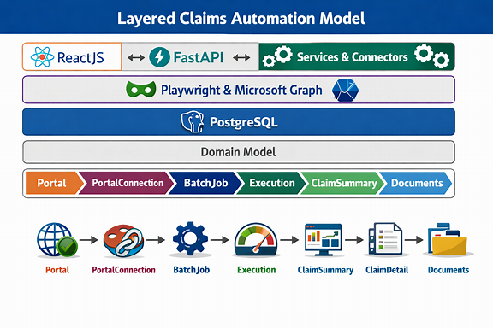

Entity | Functional Role
🏢 Portal | External payer portal initiating claim data exchange.
🔐 PortalConnection | Represents a hospital/customer connection to the payer portal.
⚙️ BatchJob | Scheduled automation job that triggers claim extraction or processing.
🚀 Execution | Actual run instance of a batch job — logs, status, and outcomes.
📊 ClaimSummary | Aggregated claim-level metrics (counts, totals, statuses).
🧾 ClaimDetail | Individual claim line items with codes, amounts, and adjudication details.
📎 Documents | Supporting PDFs, EOBs, or scanned documents linked to each claim.

5. Architectural Principles
Separation of concerns, connector-based design, configuration-driven development, reusable services, SQLAlchemy ORM, minimal logic in main.py.

6. Backend Structure
app/{api,connectors,graph,models,reports,scheduler,services}, config.py, database.py, main.py

7. Domain Model
Portal → PortalConnection → BatchJob → Execution → ClaimSummary → ClaimDetail → Documents

8. Connector Architecture
Each connector supports login, OTP, submission, tracking, upload, reporting and synchronization.

9. Database Strategy
PostgreSQL + SQLAlchemy ORM. Models are the source of truth; schema generated from models.

10. Portal & PortalConnection
Portal represents an external payer. PortalConnection represents one hospital/customer login. Relationship: Portal (1) to PortalConnection (many).

11. Microsoft Graph
Read OTP emails and send reports. OAuth client credentials configured.

12. IHX Integration
Ant Design portal, HTML table, Ant pagination, username/password + 5-digit OTP, ~99 pages. Phase-1: summary extraction. Phase-2: 60+ detailed fields.

13. Reporting
Excel and PDF generation followed by email distribution.

14. Scheduler
Future support for schedules, recipients, report formats, execution history.

15. Current Status
Completed: project skeleton, FastAPI, config, PostgreSQL connectivity, SQLAlchemy base, health endpoint, Portal model. Current: PortalConnection.

16. Recommended Documentation
Keep this document under architecture/ and maintain additional Architecture.md, Database.md, API.md, Connectors.md, Roadmap.md and ADRs.
17. Project structure
india-claims-automation/
│
├── backend/
│
├── frontend/
│
├── architecture/
│ ├── India_Claims_Automation_Platform_Architecture_and_Project_Context.docx
│ ├── Architecture.md
│ ├── Database_Design.md
│ ├── API_Design.md
│ ├── Connector_Architecture.md
│ ├── Roadmap.md
│ └── ADR/
│ ├── ADR-001-FastAPI.md
│ ├── ADR-002-Portal-vs-PortalConnection.md
├── scripts/
│
└── README.md
Components purpose:
ihx_connector.py -> login, OTP, table scraping
ihx_router.py -> manual API trigger from FastAPI

